APPENDIX 3
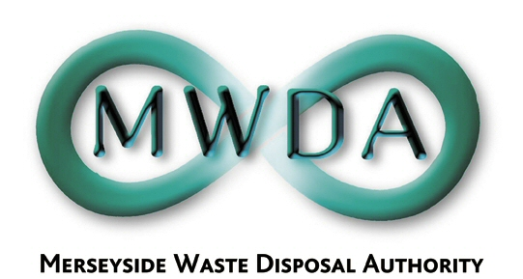

Statement of Internal Control

2006/07

- Have the key risks to the achievement of the Authority’s objectives been subject to identification and review during the year together with the adequacy of related internal controls? Are these reflected in the Council’s Corporate Risk Register?

Yes, the Corporate Risk Register identifies the risks which may affect the delivery of the Authority’s corporate objectives and it is also used to identify key projects which will manage or mitigate risk.

- Have agreed actions of Internal Audit reports been implemented or are still subject to planned implementation?

Yes.

- Have agreed actions of External Audit reports been implemented or are still subject to planned implementation?

Yes.

- Have agreed actions resulting from key external inspection agencies i.e. Audit Commission, OFSTED, SSI , HSE, Food Standards Agency or any other relevant inspectorates, been implemented or are still subject to planned implementation?

Yes, the recommendations resulting from the Audit Commission Inspection were incorporated into the Corporate Planning.

- Has the Authority considered and reviewed compliance with the Corporate Governance Framework, based upon the CIPFA/SOLACE guidelines?

A Code of Corporate Governance was approved and implemented in 2006.

- From your review, have any weaknesses or non compliance been identified and what remedial has been taken? Are there any areas for improvement or amendment to the Code arising from your deliberations? (Please provide details below where relevant)

Areas of improvement have been identified as part of the annual review of governance and internal control and are included as actions within the annual assessment document attached to the Code of Corporate Governance.

- In your opinion, are there any significant internal control issues that you consider should be brought to the attention of the Authority?

No.

Signed: Date:

DIRECTOR:

CORPORATE SERVICES MANAGER

BUSINESS SUPPORT MANAGER

