APPENDIX 1
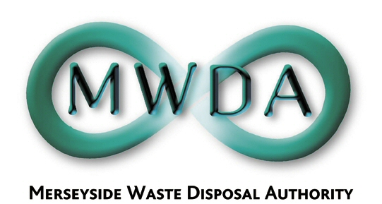

PRIMARY ASSURANCE GROUP - TERMS OF REFERENCE

PURPOSE

The purpose of the Primary Assurance Group is to: -

- Obtain, document and evaluate, from all relevant sources, an annual assessment of the MWDA's internal control and governance framework including examples of assurance and supporting evidence
- Provide an annual assurance regarding the assessment of the internal control environment and corporate governance arrangements
- Draft the annual combined Statement of Internal Control and Code of Corporate Governance including the reporting of any significant internal control issues
- Recommend an Action Plan for Improvements where any are identified by the above actions
- Review the published Statement of Internal Control and Review of Corporate Governance and monitor any Action Plan arising on at least a biannual basis

MEMBERSHIP

The group will consist of the Business Support Manager and the Corporate Services Manager, in consultation with the Director and the Treasurer.

LIMITATIONS

The findings of the annual review and subsequent action plan emanating from the group will require Authority approval.

FREQUENCY

The group will meet on at least a biannual basis.

