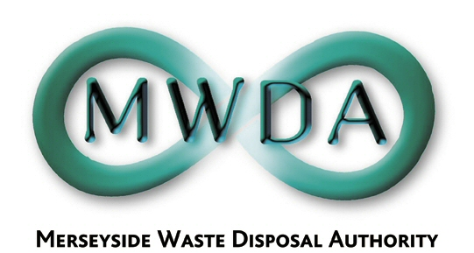

MERSEYSIDE WASTE DISPOSAL AUTHORITY

NOTICE OF INTENTION TO SUSPEND PROCEDURAL RULE

That this Authority agrees to suspend procedural rule 2(2) (a))to enable the following motion to be considered.

NOTICE OF MOTION

PROPOSED BY COUNCILLOR R QUINN

TO BE PUT TO THE FULL MEETING OF THE MERSEYSIDE WASTE DISPOSAL AUTHORITY ON 1ST FEBRUARY 2008

Given the Authority is currently undertaking a procurement process via a 4 contract structure to deliver a £3bn waste management strategy over the next 25 years, the Authority agrees to undertake the following.

- Publishes the list of sites that are currently being considered for procurement to deliver both landfill and other methods of waste management in accordance with the strategy.

- That a public consultation process be undertaken with those communities who would be affected by the strategy.

- That the outcomes of such consultation be placed before Authority Members and taken into consideration when the contracts currently under consideration are decided.

- That the Authority not proceed with the proposed CPO strategy which has been included in the forward plan for February 08.

