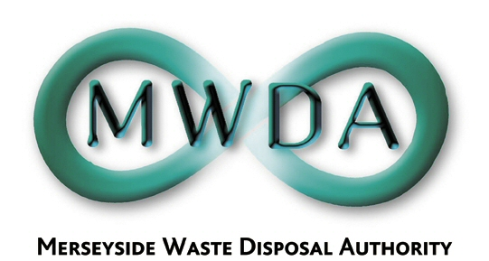

QUESTION SUBMITTED BY A MEMBER OF THE AUTHORITY UNDER PROCEDURAL RULE 9

Submitted By: | Councillor David Lonergan  MWDA Member nominated by Knowsley Council
Meeting Date: | Friday 5 October 2007
Submitted in accordance with MWDA Procedural Rule 9.1 to: | Mandy Valentine  Corporate Services Manager and Proper Officer of the Merseyside Waste Disposal Authority  Copy to:  Carl Beer, Director of the Merseyside Waste Disposal Authority
Question: | Chairperson,  I am concerned that Minutes of the Authority’s meetings do not necessarily reflect the questions asked or the debate that has taken place at the meeting, focusing mainly upon just a brief description of the issue and the decision made. There also does not appear to be available any other verbatim note of the proceedings.  I would ask therefore whether, for the purposes of clarity and transparency, the minutes should be more detailed or, alternatively, a verbatim note made available of the meeting, especially when significant issues are being discussed.
Submission Date: | Tuesday 25 September 2007  Questions must be submitted at least seven clear working days prior to the meeting.
Please submit your question by post or email to Mandy Valentine, Merseyside Waste Disposal Authority, 6th Floor, 17 North John Street, Liverpool L2 5QY
Email: (mandy.valentine@merseysidewda.gov.uk )

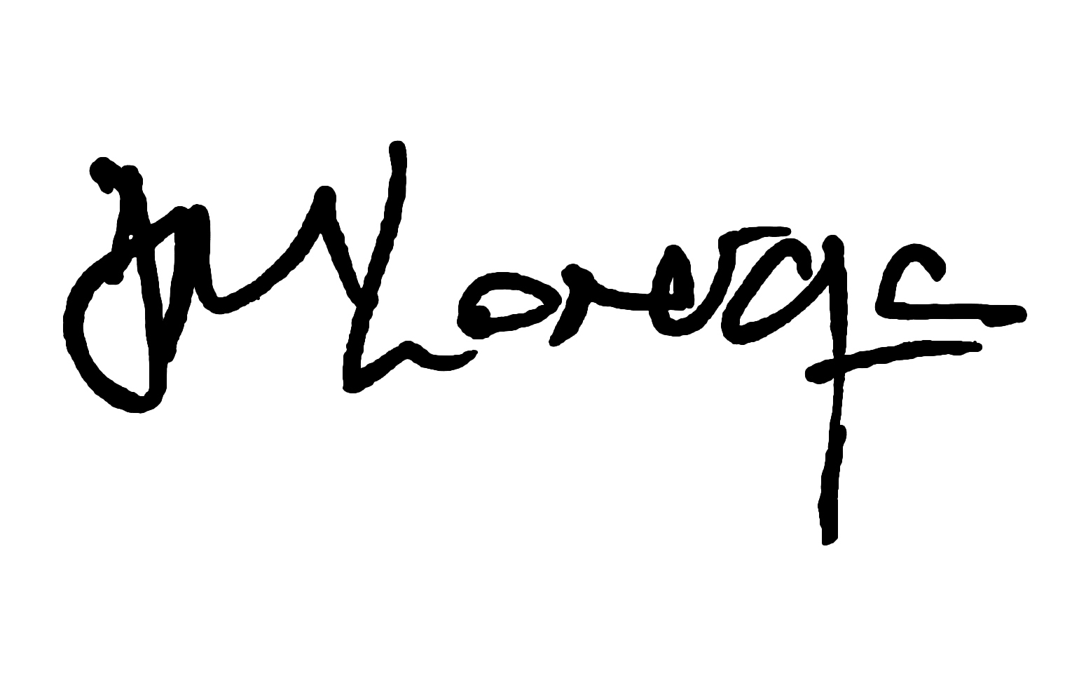
24/09/07

