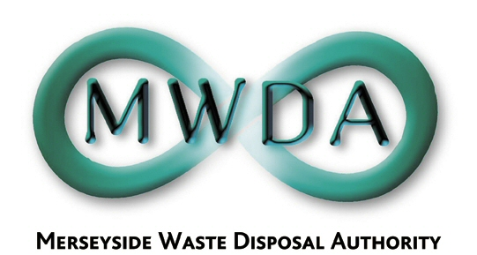

GOVERNANCE AND AUDIT COMMITTEE AGENDA

Date: 24th September 2007 Time: 2.00 pm Venue: North House

Membership:- Knowsley Borough Council - Councillors D Lonergan
Wirral Borough Council - Councillor J Salter
Liverpool City Council - Councillor B Turner
Sefton Borough Council - Councillor D Tattersall

Item No. | Title | Page
1 | Appointment of Chairperson
2 | Appointment of Deputy Chairperson
3 | Apologies for Absence
4 | Declaration of Interests by Members and Officers
5 | Audit Commission ISA 260 (UK&I) Audit and Amended Statement of Accounts 2006/07  WDA/27/07  APPENDIX 1 – AUDIT COMMISSION REPORT  TO FOLLOW | 1

6th Floor, North House, 17 North John Street, Liverpool,Merseyside,L2 5QY
Tel: 0151 255 1444 Fax: 0151 227 1848
Email:enquiries@merseysidewda.gov.uk
www.merseysidewda.gov.uk

