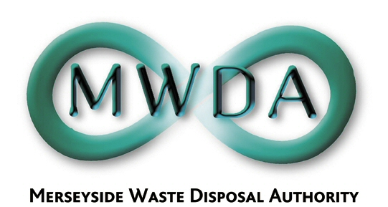

AGENDA

Date: 19th December 2005 Time: 2.00 pm Venue: North House

Membership:- Knowsley Borough Council - Councillor B Swann
Liverpool City Council - Councillors
R Oglethorpe
P Keaveney
N Small
St. Helens Borough Council - Councillor J Fletcher
Sefton Borough Council - Councillors
D Tattersall
K Cluskey
Wirral Borough Council - Councillors
J Salter
S Moseley

Item No. | Title | Page
1. | Apologies
2. | Declaration of Interests by Members and Officers
3. | Minutes of the Meeting held 14th October 2005 | 1
4. | Exclusion of the Public:  Recommendation that the Public be excluded from the meeting during consideration of the following item for the reason stated:-  Item: Reason:  5 The proposed expenditure under any particular contract to acquire property or obtain goods or services.
5. | Waste Management Contracts Procurement Project  PFI – Expression of Interest  WDA/32/05 | 3
6th Floor, North House, 17 North John Street, Liverpool,Merseyside,L2 5QY
Tel: 0151 255 1444 Fax: 0151 227 1848
Email:enquiries@merseysidewda.gov.uk
www.merseysidewda.gov.uk

