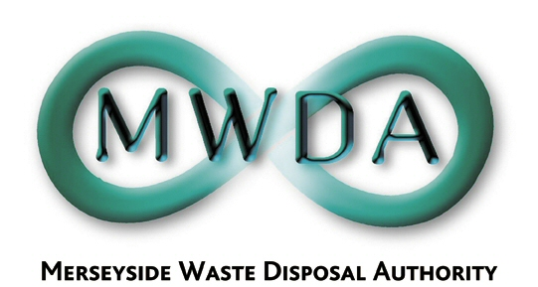

AGENDA

Date: 17th November 2006 Time: 2.00 pm Venue: North House

Membership:- Knowsley Borough Council - Councillor B Swann
Liverpool City Council - Councillors
N Small
B Turner
P Keaveney
St. Helens Borough Council - Councillor D Crowther
Sefton Borough Council - Councillors
D Tattersall
K Cluskey (Chairman)
Wirral Borough Council - Councillors
J Salter
S Moseley

Item No. | Title | Page
1 | Apologies for absence
2 | Declaration of Interests by Members and Officers
3 | Minutes of the Meeting held on 1st September 2006 | 1
4 | Minutes of the Meeting held on 29th September 2006 | 5
5 | Minutes of Appeals Hearing held on 3rd October 2006 | 7
6 | Invitation to Halton Borough Council Representative
7 | Waste Management Contracts Procurement Project Progress Report  WDA/37/06 | 9
8 | Bidston Materials Recovery Facility (MRF) Capacity and Future MRF Requirements on Merseyside  WDA/35/06 | 27
9 | Revised Prudential Indicators 2006/07 to 2008/09  WDA/32/06 | 43
10 | Organisational Review of the Authority  WDA/36/06 | 59
11 | Appointment to the Board of MWHL  WDA/38/06 | 69
12 | To hear and respond to any question submitted by a Member of the Public in accordance with Procedural Rule 10.
13 | Exclusion of the Public  Recommendation that the Public be excluded from the meeting during consideration of the following items for the reason stated:-  Item: Reason (under Local Government Act)  13 & 14 The financial or business affairs of a particular company (Para 3)
14 | Waste Management Contracts Procurement Project Professional Advisors Fees  WDA/33/06 | 73
15 | Procurement Programme – Land Acquisition and Planning Delivery Strategy  WDA/34/06 | 85

6th Floor, North House, 17 North John Street, Liverpool,Merseyside,L2 5QY
Tel: 0151 255 1444 Fax: 0151 227 1848
Email:enquiries@merseysidewda.gov.uk
www.merseysidewda.gov.uk

