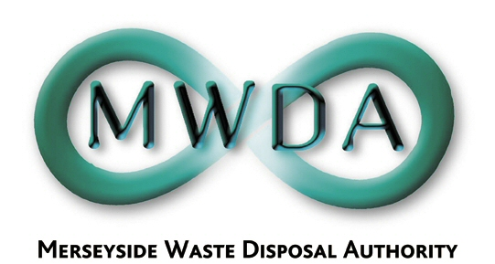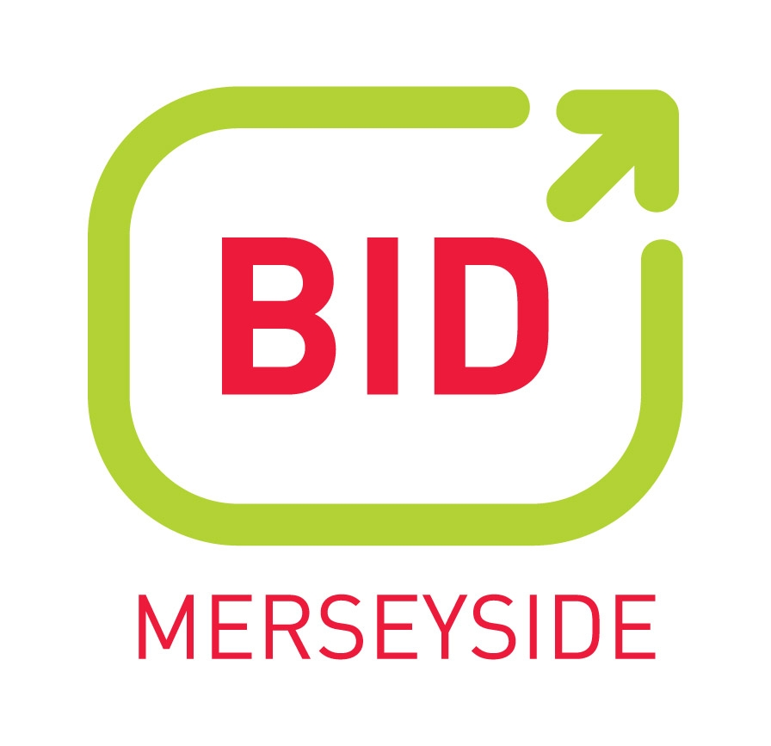

DRAFT
Confidentiality and Freedom of Information Protocol

The Merseyside Waste Partnership Procurement Process

January 2007 Version 2.0
Author: Colette Gill
Disclaimer

This document does not constitute professional legal advice on Confidentiality or Freedom of Information matters but has been formulated based on current good practice, current UK policy and, guidelines issued in relation to Confidentiality and Freedom of information when using a Competitive Dialogue process.

This Protocol is approved by Merseyside Waste Disposal Authority, who are the decision making body for the Merseyside Waste Partnership Procurement Process. Specific contacts for the Process can be found in Section 6 of this document.
Contents

- Introduction and Overview

1.1. The Current Situation
  - The Procurement Process

2.0. Purpose of the Protocol

- Stakeholders Map

- Guidelines for Confidentiality and Freedom of Information (FOI) - as part of law and the Competitive Dialogue process

- MWDA’s approach to Confidentiality and FOI

  - Overview
  - Information flow and using the Protocol
  - Use of the Data Room
  - Guidelines for Confidentiality and FOI during Competitive Dialogue Process (CDP)

- Contacts
1.0. Introduction and Overview

The Authority intends to fully embrace the opportunities that Competitive Dialogue provides to all parties during its Procurement Process and intends to engage in open and constructive discussions with all Bidders regarding the development of their proposals.

However the Authority recognises that to enable this to effectively take place a clear and precise Protocol needs to be established both to cover how the Authority will itself deal with these discussions and resulting information, as well the approach to be adopted within the Dialogue itself and information that will need to be shared with a variety of stakeholders at certain stages.

1.1. The Current Situation

Merseyside Waste Disposal Authority and the Merseyside Waste Partnership are currently undertaking a major procurement process for a new waste management contract for the Merseyside region.

The £3billion contracts will deliver, via a three contract structure, the waste management needs for the region for the next 25 years. The basis for the new contracts is the Joint Municipal Waste Management Strategy for Merseyside which was published in 2005 and provides not only the basis for the contracts need but also provides the recycling targets for the Partnership if it is to avoid massive LATS penalties and subsequent fines.

1.2. The Procurement Process

MWDA is currently pursuing a four contract structure for its Procurement Process;

(i) Landfill Contract - to provide landfill for the disposal of residual waste. This contract is intended to be flexible and to fit around the development of new residual waste facilities that are estimated to be developed between 2011 and 2015. This contract will be procured through the traditional tendering process and not through Competitive Dialogue. The results of this tender are expected in March 2007.

(ii) Intermediate Contract - to provide intermediate recycling and waste management services and capacity for the 2008 – 2011 period. This contract is at PIN stage and a decision will be made whether to take this through to OJEU stage in February 2007.

(iii) Waste Management and Recycling Contract ((WMRC) – To provide management services to existing residual waste and Household Waste recycling centres (HWRCs) and transport. This contract will be procured through Competitive Dialogue.

(iv) Resource/Recovery Contract - this will be PFI/PPP funded contract primarily for the development of residual waste facilities. This contract will be procured through Competitive Dialogue

2.0. Purpose of the Protocol

The purpose of this Protocol is to provide guidance on matters of Confidentiality and Freedom Of Information to all stakeholders within the Procurement Process and in particular during the Competitive Dialogue actions. As stated in the disclaimer at the beginning of the document this Protocol does not replace professional legal advice but aims to give a clear indication at each stage as to which stakeholder should have information at that stage.

3.0. Stakeholders Map

There are numerous stakeholders within the Procurement Process – both internal and external that will need to be aware of the Confidentiality Protocol and will need to be advised of the guidelines.

DC Officers

Procurement Group
Bidders
MWDA Members
Advisors

General Public

MWDA Staff

MWDA Procurement Process

The Merseyside Waste Partnership

CEs and Leaders

rs
Mersey Waste Holdings Ltd and the Trade Unions

Local Members
Media

4.0. Guidelines for Confidentiality and Freedom of Information (FOI) - as part of law and the Competitive Dialogue process

  - Confidentiality

Where the Authority and a Bidder agree that information is to be treated as confidential, the following safeguards shall apply:-
- Statutory Protection: The Authority will abide by Regulation 18(21) (c) of the Public Contracts Regulations 2006, which precludes the Authority from revealing to other Bidders “solutions proposed or any confidential information communicated by a participant without that participant's agreement.”
- Common Law Protection: The law prohibits the disclosure of information that has been provided in circumstances that create an obligation of confidence and which has the necessary quality of confidence about it.
- Parallel Dialogue: Competitive Dialogue takes place in a series of parallel discussions between the Authority and Bidders and there is no communication between the parallel discussions.
- Confidentiality Agreements: To provide an added safeguard, the Authority will enter into confidentiality agreements with Bidders.
- Internal Protocol: The Authority will establish procedures, internally and with external advisors, to protect confidential information.
4.2. Freedom of Information
The Authority is bound by the Freedom of Information Act 2000 (FIOA) and the Environmental Information Regulations 2004 (EIR) which provide a duty on the Authority to respond to a request for information from any member of the public by telling the applicant whether it holds that information and supplying a copy to the applicant.
There are a number of exemptions to the disclosure of information under both FOIA and EIR. For the purposes of Competitive Dialogue, the following are the most relevant.
Exemptions under FOIA -Information is exempt from disclosure where:
- It has been provided in confidence;
- Disclosure would be likely to prejudice the commercial interests of any person;
- The information is a trade secret;
Exemptions under EIR - Information is exempt from disclosure where:
- It is commercial or industrial information, which is legally protected as confidential so as to protect a legitimate economic interest;
- Release of the information would adversely affect intellectual property rights;

In practice, confidential information provided during Competitive Dialogue, will be exempt from disclosure under FOIA and EIR. However, under both FOIA and EIR, it is for the Authority alone to decide whether an exemption applies.

5.0. MWDA’s approach to Confidentiality and FOI

5.1. Overview

Each stage of the Procurement Process will have is own issues relating to Confidentiality and Freedom Of Information. MWDA is required by the terms of the Competitive Dialogue process, to maintain confidentiality with Bidders as to their proposals throughout Competitive Dialogue.

MWDA will however wish to advise members of progress during this time, and announce the progress of Competitive Dialogue. In addition MWDA has taken into account current UK guidelines, policy and law in relation to Freedom of information and makes its own recommendations for all stakeholders at each stage of the process

Through the Project Team, MWDA will have colleagues from the Waste Collection Authorities and Halton Borough Council, Advisors and Members involved at various stages of the Procurement Process. There will also reporting needs to Authority meetings for decisions and reports on progress, to the media were appropriate and to the general public. In addition MWDA will be entering the public consultation phase in respect of sites and planning applications.

5.2. Information Flow and using the Protocol
Confidential information may only be communicated to authorised people. These will be those to whom the information has been provided and any others who the provider of the confidential information has authorised to receive the confidential information.
Under no circumstances should confidential information be disclosed to an unauthorised person, including advisors, senior officers or members of MWDA or officers or members of the Waste Collection Authorities or Halton Borough Council.
If someone claims to be entitled to see confidential information reference, in the first instance, should be made to this Protocol and if clarification is not given then the matter should be referred to the Procurement Director, who will have final responsibility within MWDA for determining any issues regarding confidential information.
In relation to FOI or EIR requests, there is an official method for response to these requests that exist within MWDA’s FOI guidance. Futrher clarification may be sought from legal advisors to the Authority and or the Procurement Process.
Certain information will only be accessed electronically and will be password protected (see section 5.3 – Use of the Data Room). In such cases, access will be restricted to authorised personnel and under no circumstances should passwords be shared with anybody

  - Use of the Data Room

In order to provide both secure information on the Procurement Process, and a confidential forum for both MWDA and Bidders to discuss issues and ask questions, as well as an opportunity for Bidders to engage with other Bidders when appropriate, a Data Room has been established by MWDA.

The Data Room will be a web based data access point which will hold a wide range of information regarding the Procurement Process e.g assets of the LAWDC and will also act as a communications network for the submission of questions, queries and discussion within a confidential arena.

The Data Room will be available post PQQ stage and will have a set of security rules and operational guidelines. The Data Room will be used in the most part by Bidders, Professional Advisors and staff and is not intended as a public domain information source.
5.4. Guidelines for Confidentiality and FOI during Competitive Dialogue Process (CDP)

TABLE ONE: STAKEHOLDERS: Staff, Professional Advisors, Procurement Group and MWDA Members

Stage of CDP | Risk/Issue | MWDA Staff/Officers | Professional Advisors | Procurement Group | MWDA members
Issue OJEU | OJEU is a public document - no issues of confidentiality for notice or contents. | Public document | Public document | Public document | Public document
Issue Pre Qualification Questionnaire (PQQ) and Descriptive Document | PQQ is not a confidential document, it does not contain commercially sensitive information. Evaluation criteria are not confidential ,  Descriptive Document is a document which could be published under FOIA because it does not contain information that is commercially sensitive and its publication would be in the public interest. | Public document  Available to MWDA staff | Public document  Available to Professional Advisors | Public document  Public document | Public document  Public document
PQQ Evaluation | Replies to the PQQ will be confidential because they contain comercially sensitive information and publication would not be in the public interest because it could prejudice procurement process. | Available to staff and Project Team | Available to Professional Advisors | Not public but a report review will be produced for the Procurement Group | Yes – the evaluation will be reported to the Authority as private item
Long List of Qualified Bidders | Long list of Bidders is a public document | Available to all staff | Available to all Professional Advisors | Yes – the long list of qualified Bidders will be in the public domain | Yes – the long list of qualified Bidders will be in the public domain
ISOS
Competitive Dialogue |  | Available to Project Team | Available to Professional Advisors | Private review report to Group | Private report to Authority
ISOS Evaluation |  | Available to Project Team | Available to Professional Advisors | Private review report to Group | Private report to Authority
Feedback to bidders |  | Available to Project Team | Available to Professional Advisors | Private review report to Group | Private report to Authority
Shortlist of Bidders |  | Public document | Public document | Public document | Public document
ISDS
Competitive Dialogue |  | Available to Project Team | Available to Professional Advisors | Private review report to Group | Private report to Authority
ISDS Evaluation |  | Available to Project Team | Available to Professional Advisors | Private review report to Group | Private report to Authority
Report
Feedback to bidders |  | Available to Project Team | Available to Professional Advisors | Private review report to Group | Private report to Authority
Shortlist |  | Public document | Public document | Public document | Public document
ISFT
Evaluation |  | Available to Project Team | Available to Professional Advisors | Private review report to Group | Private report to Authority
Report
Feedback
Preferred Bidder clarification and confirm commitments |  | Available to Project Team | Available to Professional Advisors | Private review report to Group | Private report to Authority
Contract Award Decision (one all material issues agreed) |  | Available to Project Team | Available to Professional Advisors | Private review report to Group | Private report to Authority
Financial Close |  | Available to Project Team | Available to Professional Advisors | Private review report to Group | Private report to Authority

TABLE TWO: STAKEHOLDERS: Bidders, CEs and Leaders, Local Members, Officers, Media, Mersey Waste Holdings/Trade unions and General Public

Stage of CDP | Risk/Issue | Bidders | CEs and Leaders | District Council/Local Members | Mersey Waste Holdings Ltd/Trade Unions | District Council Officers | Media | General Public
Issue OJEU | OJEU is a public document - no issues of confidentiality for notice or contents. | Public document | Public document | Public document | Public document | Public document | Public document | Public document
Issue Pre Qualification Questionnaire (PQQ) and Descriptive Document | PQQ is not a confidential document, it does not contain commercially sensitive information. Evaluation criteria are not confidential ,  Descriptive Document is a document which could be published under FOIA because it does not contain information that is commercially sensitive and its publication would be in the public interest. | Public document  Request as part of PQQ process | Public document  Request under FOIA | Public document  Request under FOIA | Public  Request under FOIA document | Public document  Request under FOIA | Public document  Request under FOIA | Public document  Request under FOIA
PQQ Evaluation |  | Not in the public domain | Briefing report provided | Not in the public domain | Not in the public domain | Not in the public domain | Not in the public domain | Not in the public domain
Long List of Qualified Bidders |  | Public document | Public document | Public document | Public document | Public document | Public document | Public document
ISOS
Competitive Dialogue |  | Not in the public domain | Not in the public domain | Not in the public domain | Not in the public domain | Not in the public domain | Not in the public domain | Not in the public domain
ISOS Evaluation | As with previous stages, information can be released insofar as it is not commercially sensitive. | Not in the public domain | Briefing report provided | Not in the public domain | Not in the public domain | Not in the public domain | Not in the public domain | Not in the public domain
Report
Feedback
Shortlist |  | Public document | Public document | Public document | Public document | Public document | Public document | Public document
ISDS
Competitive Dialogue |  | Not in the public domain | Not in the public domain | Not in the public domain | Not in the public domain | Not in the public domain | Not in the public domain | Not in the public domain
ISDS Evaluation |  | Not in the public domain | Not in the public domain .Briefing report provided | Not in the public domain | Not in the public domain | Not in the public domain | Not in the public domain | Not in the public domain
Report
Feedback
Shortlist |  | Public document | Public document | Public document | Public document | Public document | Public document | Public document
ISFT
Evaluation |  | Not in the public domain | Not in the public domain Briefing report provided | Not in the public domain | Not in the public domain | Not in the public domain | Not in the public domain | Not in the public domain
Report
Feedback
Preferred Bidder clarification and confirm commitments |  | Not in the public domain | Not in the public domain.Briefing report provided | Not in the public domain | Not in the public domain | Not in the public domain | Not in the public domain | Not in the public domain
Contract Award Decision (once all material issues agreed) |  | Public document | Public document | Public document | Public document | Public document | Public document | Public document
Financial Close

- Contacts

MWDA Procurement Team

Tel: 0151 244 1444
Email: procurement@merseysidewda.gov.uk

Carl Beer Director of the Waste Disposal Authority
Terry Bradley Procurement Director
Colin McKenzie Project Manager

John Connell Contracts Manager
Jeff Sears Assistant Contracts Manager

Richard Abbott Solicitor to the Authority
Nicola Stewart Project Assistant Panning
Kerry Harvey Project Assistant Administration

Colette Gill PR and Communications Officer

