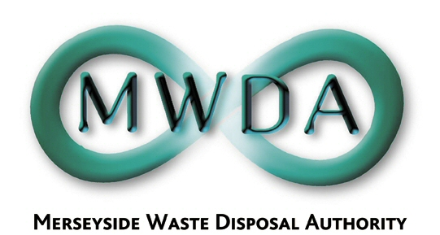
AGENDA

Date: 7th December 2007 Time: 2.00 p.m.

Venue: Herculanium Room, Millenium House, Victoria Street, Liverpool

Membership:- Sefton Borough Council - Councillors:
K Cluskey (Chairperson)
D Tattersall
Knowsley Borough Council - Councillor D Lonergan
Liverpool City Council - Councillors:
R Quinn
B Turner
A Dean
St. Helens Borough Council - Councillor D Crowther
Wirral Borough Council - Councillors:
J Salter
A Bridson

Item No. | Title | Page
1 | Apologies for absence
2 | Minutes of Authority Meeting held 5th October 2007 | 1
3 | Declaration of Interests by Members and Officers
4 | Questions by Members under Procedural Rule 9
5 | Motion proposed by Councillor Lonergan under Procedural Rule 15 | 7
Annual Audit and Inspection Letter 2006/07
TO FOLLOW

6 | Capital Strategy Programme  WDA/33/07 | 9
7 | Operations Group Structural Review  WDA/35/07 | 39
8 | Procurement Report  WDA/38/07 | 53
9 | Exclusion of the Public:  Recommendation that the Public be excluded from the meeting during consideration of the following items for the reason stated:-  Items: Reason (under Local Government Act 1972)  10 Information in respect of which a claim to legal professional privilege could be maintained in legal proceedings  (Para 5 of Schedule 12)  11,12 Information relating to the financial  13 & 14 or business affairs of any particular person (including the Authority holding the information (Para 3 of Schedule 12)
10 | Holt Lane HWRC  WDA/32/07 | 89
11 | Procurement Programme Sites and Planning  WDA/34/07 | 95
12 | Mersey Waste Holdings Ltd  WDA/39/07 | 107
13 | Business Review of Mersey Waste Holdings Ltd  WDA/37/07 | 113
14 | Proposed Development of additional MRF  WDA/36/07 | 169

6th Floor, North House, 17 North John Street, Liverpool,Merseyside,L2 5QY
Tel: 0151 255 1444 Fax: 0151 227 1848
Email:enquiries@merseysidewda.gov.uk
www.merseysidewda.gov.uk

