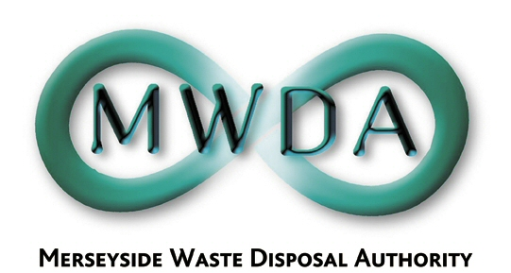

AGENDA

Date: 5th October 2007 Time: 2.00 p.m.
Venue: Herculanium Room, Millenium House, Victoria Street, Liverpool

Membership:- Sefton Borough Council - Councillors:
K Cluskey (Chairperson)
D Tattersall
Knowsley Borough Council - Councillor D Lonergan
Liverpool City Council - Councillors:
R Quinn
B Turner
A Dean
St. Helens Borough Council - Councillor D Crowther
Wirral Borough Council - Councillors:
J Salter
A Bridson

Item No. | Title | Page
1 | Apologies
2 | Minutes of Authority Meeting held 10th August 2007 | 1
3 | Declaration of Interests by Members and Officers
4 | Questions by Members under Procedural Rule 9
5 | Minutes of Audit and Governance Meeting held 24th September 2007 | 5
6 | Urgent Action taken under Delegated Powers  WDA/28/07 | 7
7 | Waste Flow Modelling Report  WDA/29/07 | 11
8 | Appointment of Directors to Mersey Waste Holdings Ltd.  WDA/31/07 | 15
9 | Exclusion of the Public:  Recommendation that the Public be excluded from the meeting during consideration of the following items for the reason stated:-  Items: Reason (under Local Government Act 1972)  - Information in respect of which a claim to legal professional privilege could be maintained in legal proceedings  (Para 5 of Schedule 12A)
10 | Progress of Contract Procurement  WDA/30/07 | 25

6th Floor, North House, 17 North John Street, Liverpool,Merseyside,L2 5QY
Tel: 0151 255 1444 Fax: 0151 227 1848
Email:enquiries@merseysidewda.gov.uk
www.merseysidewda.gov.uk

