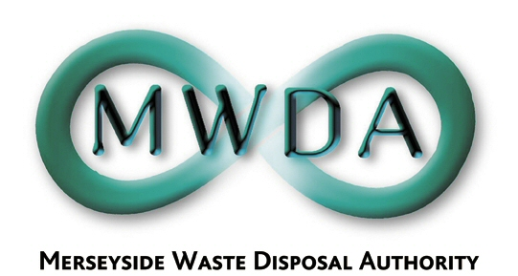

AGENDA

Date: 3rd March 2006 Time: 10.30 am Venue: North House

Membership:- Knowsley Borough Council - Councillor B Swann
Liverpool City Council - Councillors
B Ousby
N Small
St. Helens Borough Council - Councillor J Fletcher
Sefton Borough Council - Councillors
D Tattersall
K Cluskey
Wirral Borough Council - Councillors
J Salter
S Moseley

Item No. | Title | Page
1. | Apologies
2. | Declaration of Interests by Members and Officers
3. | Minutes of the Meeting held on 3rd February 2006 | 1
4. | Exclusion of the Public  Recommendation that the Public be excluded from the meeting during consideration of the following item for the reason stated:-  Item: Reason(under Local Government Act 1972):  5 & 7 The financial or business affairs of a particular  company (Para 3)  6 in respect of which a claim to legal profession  privilege could be maintained in legal proceedings  (Para 5)

5. | Waste Management Contracts Procurement Project  Progress Report  WDA/07/08
6. | Waste Management Contracts Procurement Project  Procurement Overview  WDA/08/06
7. | Waste Management Contracts Procurement Project  Procurement Strategy  WDA/09/06

6th Floor, North House, 17 North John Street, Liverpool,Merseyside,L2 5QY
Tel: 0151 255 1444 Fax: 0151 227 1848
Email:enquiries@merseysidewda.gov.uk
www.merseysidewda.gov.uk

At a meeting of the Authority
held on Friday 3rd February 2006

Present: Councillor Fletcher
Councillor Swann
Councillor Small
Councillor Tattersall
Councillor Cluskey
Councillor Salter
Councillor Moseley
Councillor Ousby

34. Apologies for Absence

There were no apologies for absence.

35. Declaration of Interest by Members and Officers

There were no declarations of interest.

36. Minutes of Meeting held on 19th December 2005

Resolved that the minutes of the meeting held on 19th December 2005 be approved and signed as a correct record.

37. Annual Meeting and Timetable of Meetings 2006/07
WDA/02/06

A report was submitted requesting that the Authority set a date for its Annual Meeting for 2006/07 and a programme of meetings throughout the year. An issue was highlighted regarding the proposed date of the Annual Meeting.

Resolved that:

- the Annual Meeting to be determined by the Clerk in consultation with the Chairman;
- further meetings to take place on 6th October 2006, 2nd February 2007 (Budget and Ordinary) and 20th April 2007; and

- delegated powers of the Authority be granted to the Clerk to the Authority to make any future alterations to the timetable of meetings as deemed appropriate, in consultation with the Chairman and Deputy Chairman of the Authority.

38. Revenue Budget 2006/07 and Prudential Indicators 2006/07 to 2008/09
WDA/04/06

A report was submitted seeking Members’ approval to a revised Revenue Budget 2005/06 and to set the Revenue Budget 2006/07. Members were informed of significant progress in meeting the financial pressures facing the Authority resulting in an overall increase of 5.1%, significantly less than previously indicated. Members were also informed of the introduction of a new apportionment methodology, agreed by all Merseyside districts and applied to the Revenue Budget 2006/07.

Resolved that:

- the Revised Revenue Budget for 2005/06 be approved;

- a Revenue Budget for 2006/07 amounting to £47,516,594 be approved;

- pursuant to Section 74 of the Local Government Act 1988 (as amended by the local Government and Housing Act 1989) and having regard to the budget, the Authority determines that a levy of £47,516,594 for 2006/07 be made, to be distributed between each District Council on the basis of Council Tax Base, as follows:

Knowsley £ 4,994,429
Liverpool £14,801,228
St Helens £ 6,161,579
Sefton £ 10,130,810
Wirral £ 11,428,648
£47,516,594

39. Annual Audit Letter 2004/05 and Partnership Review Outcomes
WDA/01/06

Members were presented with the Annual Audit Letter 2004/05 detailing the Audit Commissions findings from their annual review. The report also outlined the results of a review undertaken by the Audit Commission on Partnership and Performance. An action plan had been identified in relation to this review and was submitted to Members for their approval.

Resolved that:

- Members note the contents of the Annual Audit Letter 2004/05; and
- The Partnership Working and Performance Management Action Plan attached to the report be approved.

40. Communications Policy
WDA/03/06

A report was submitted seeking Members’ endorsement of a Communications Policy. The policy would be further supported by a Communications Strategy to be presented to Members at a later date.

Resolved that the Communications Policy attached at Appendix 1 be approved.

41. Whistleblowing Policy
WDA/05/06

A report was submitted seeking Member approval to a Whistleblowing Policy which aimed to formalise whistleblowing arrangements for employees, Members and those who have dealings with the Authority.

Resolved that the Whistleblowing Policy and Procedure attached to the report be adopted.

