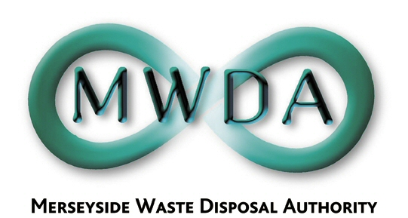

At the Meeting of the Audit and Governance Committee
held on Monday 24th September 2007

Present : Councillor Salter
Councillor Turner
Councillor Tattersall

1. Appointment of Chairperson

It was moved and seconded that Councillor Salter be appointed Chairperson of the Governance and Audit Committee.

Resolved that Councillor Salter be appointed Chairperson.

2. Appointment of Deputy Chairperson

It was moved and seconded that Councillor Tattersall be appointed Deputy Chairperson of the Governance and Audit Committee.

Resolved that Councillor Tattersall be appointed Deputy Chairperson.

3. Apologies for Absence

An apology for absence was received from Councillor Lonergan.

4. Declarations of Interests by Members and Officers

There were no declarations of interests.

5. Audit Commission ISA 260 (UK&I) Audit and Amended Statement of Accounts 2006/07
WDA/27/07

The Auditor Commission presented a report on its findings in relation to the audit of the Authority’s Accounts for 2006/07 and a Value for Money conclusion. Subject to material amendments to the Statement of Accounts 2006/07, the auditor provided an unqualified opinion.

Resolved that:

- the Auditor’s findings attached at Appendix 1 to the report be noted;

- the areas of improvement for action by the Director proposed by the Audit Commission and contained within their report be noted;

- the Chairperson of the Governance and Audit Committee and the Treasurer of the Authority sign the letter of representation attached at Appendix 2; and

- the amended Statement of Accounts 2006/07 attached at Appendix 3 be approved and signed by the Chairperson of the Governance and Audit Committee and the Treasurer on behalf of the Authority.

