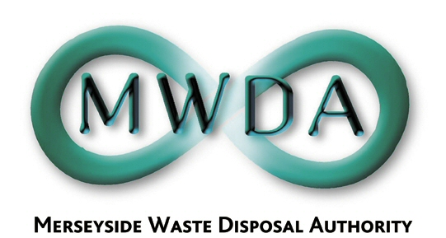

At a meeting of the Authority
held on Friday 22nd July 2005

Present: Councillor Fletcher
Councillor Swann
Councillor Keaveney
Councillor Tattersall
Councillor Small
Councillor Cluskey
Councillor Salter
Councillor Moseley

14. Apologies for Absence

Apologies for absence were received from Councillor Oglethorpe and Carole Hudson, Clerk to the Authority.

15. Declaration of Interest by Members and Officers

The following declarations of interest were received:

Councillor Swann declared a non-prejudicial interest in item 5, recorded herewith as Resolution 18, in his role as a Non-Executive Director of Mersey Waste Holdings Limited.

Councillor Fletcher declared a non-prejudicial interest in item 5, recorded herewith as Resolution 18, in his role as a board member of Bidston Methane Limited.

Councillor Salter declared a non-prejudicial interest in item 5, recorded herewith as Resolution 18, in his role as a board member of Bidston Methane Limited.

16. Minutes of Meeting held on 24th June 2005

Resolved that the minutes of the meeting held on 24th June 2005 be approved and signed as a correct record.

17. Outturn Report 2004/05
WDA/26/05

The Authority considered a report advising Members of the final outturn with regard to the Authority’s Capital and Revenue expenditure in 2004/05. The report also included the final outturn of the Authority’s Prudential Indicators to enable Members to view changes in the Authority’s spending on the Capital Programme and consequently its financing.

Resolved that:

- the final outturn position with regard to the Authority’s Capital and Revenue Expenditure for 2004/05 be noted; and

- the final outturn with regard to the Authority’s Prudential Indicators as included in Appendix 3 to the report be noted.

Councillors Swann, Fletcher and Salter declared non-prejudicial interests in the following item, recorded herewith as Resolution 18, and in accordance with the Code of Conduct, remained in the meeting.

18. Statement of Accounts 2004/05
WDA/27/05

Members were presented with the Authority’s Statement of Accounts for 2004/05, prepared in accordance with the Accounts and Audit Regulations 2003.

Resolved that:

- the Authority’s Statement of Accounts for 2004/05 be approved; and

- the Chairman of the Authority sign and date the Statement of Accounts for 2004/05.

19. Exclusion of the Public

Resolved that the public be excluded from the meeting during
consideration of the following items for the reason stated.

Minute Reason (under the Local Government Act 1972)

20 Exempt information relating to the proposed expenditure under a particular contract (Paragraph 8 of Schedule 12A)

21 Exempt information concerning the proposed terms in the course of negotiations for a contract (Paragraph 9 of Schedule 12A)

- Joint Municipal Waste Management Strategy
Appointment of Professional Advisors
WDA/29/05

A report was considered seeking Members’ confirmation of the appointment of legal, financial, planning and technical advisors to support the Authority in procuring service contracts, under a long term Public Private Partnership (PPP) scheme, possibly funded by Private Finance Initiative (PFI) credits, to implement the Joint Municipal Waste Management Strategy for Merseyside. Members were advised at the meeting that further negotiation was required with some of the preferred bidders regarding the terms of engagement, most notably the level of indemnity being provided. The Director proposed an additional recommendation to grant delegated powers to complete these negotiations.

Resolved that:

- the decision of the Procurement Group to appoint advisors to provide financial, legal, planning and technical services be approved in principle;

- delegated powers of the Authority be granted to the Director in consultation with the Lead Member for Procurement to finalise negotiations regarding the terms of engagement and appoint advisors;

- the Procurement Group be authorised to move to the next project stage of the Waste Management Contracts Procurement Project to secure funding; and

- the earmarking of resources from reserves to cover the anticipated costs of employing the professional advisors be approved subject to any potential budgetary overspend on the above contracts being approved in accordance with the Authority’s Financial Procedural Rules.

- Capital Programme 2005/06
WDA/28/05

A report was submitted seeking Members’ approval to set the overall Capital Programme for 2005/06, reflecting present circumstances and needs.

Resolved that a programme of capital expenditure in the sum of £13,971,000 for 2005/06 be approved.

