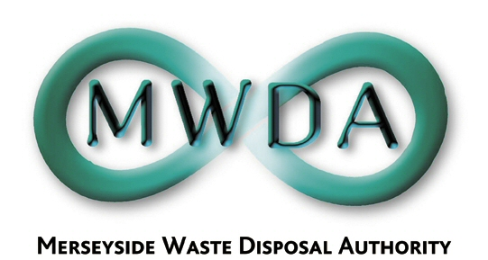

At the Meeting of the Authority
held on Friday 16th March 2007

Present : Councillor Cluskey
Councillor Swann
Councillor Keaveney
Councillor Crowther
Councillor Salter
Councillor Moseley

53. Apologies for Absence

Apologies for absence was received from Councillors Turner, Small and Tattersall.

54. Declarations of Interests by Members and Officers

There were no declarations of interest.

55. Minutes of the Meeting held on 2nd February 2007

Resolved that the minutes of the meeting held on 2nd February 2007 be approved and signed as a correct record.

- Exclusion of the Public

Resolved that the public be excluded from the meeting during
consideration of the following item for the reason stated.

Minute Reason (under the Local Government Act 1972)

57 Exempt information concerning the financial or business affairs of a particular company (Paragraph 3 of Schedule 12A)

- Waste Management Contracts Procurement Project
Progress Report
WDA/08/07

A report was submitted informing Members of the progress to date in the implementation of the Waste Management Procurement Project. Terry Bradley informed Members of a minor correction to the text of the report.

Resolved that:

- the evaluation of the Pre Qualification Questionnaire returns for the Waste Management and Recycling Contract be noted; and

- the proposed list of companies detailed in the report, to be carried forward into the Competitive Dialogue stage of the Waste Management and Recycling Contract procurement, be approved.

