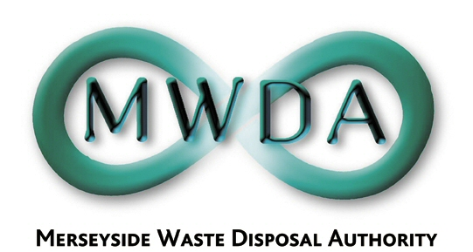

At the Meeting of the Authority
held on Friday 1st September 2006

Present : Councillor Cluskey
Councillor Swann
Councillor Keaveney
Councillor Crowther
Councillor Salter
Councillor Small

21. Apologies for Absence

Apologies for absence were received from Councillors Moseley, Turner and Tattersall.

22. Declarations of Interests by Members and Officers

Councillor Swann declared a non-prejudicial interest in items 6, recorded herewith as minute 26 in so far as it relates to his capacity as a director of Mersey Waste Holdings Limited.

23. Minutes of the Meeting held on 28th June 2006

Resolved that the minutes of the meeting held on 28th June 2006 be approved and signed as a correct record.

- Inter Authority Agreement
WDA/28/06

The Authority considered report seeking Members agreement to approve in principle the purpose, guiding principles and objectives of the Inter Authority Agreement (IAA).

Resolved that members approve in principle the purpose, guiding principles and objectives of the Inter Authority Agreement (IAA).

25. Exclusion of the Public

Resolved that the public be excluded from the meeting during
consideration of the following item for the reason stated.

Minute Reason (under the Local Government Act 1972)

26 & 27 Exempt information concerning the financial or business affairs of a particular company (Paragraph 3 of Schedule 12A)

Councillor Swann declared a non-prejudicial interest in the following item, recorded herewith as Resolution 26, and in accordance with the Code of Conduct, remained in the meeting.

26. Progress Report on Procurement

A report was submitted to advise the Authority of progress in relation to the submission of its Outline Business Case and in relation to its contract procurement strategy. A further update report was also submitted at the meeting in relation to the outcome of the waste flow and financial modeling.

Resolved that :

1. the progress in the submission of the OBC to DEFRA for PFI credits and in the development of the three contracts procurement be noted

2. that the proposed action in advising District Council Leaders and Chief Executives of the development in relation to identifying potential sites for major facilities in the Merseyside area be agreed and noted.

3. the need for detailed discussions with Mersey Waste Holdings Ltd be noted

4. progress to date in reviewing Halton BC request to join the MWDA Procurement be noted

6. Members approve the continuation of dialogue with GMWDA into the possibility of a Regional Procurement of an outlet for RDF

7. comments in respect of the governance of the Procurement Project and the need for further meetings at which progress in the Procurement and consideration of the details of the future of Mersey Waste Holdings Ltd can be dealt with be noted

8. the proposal that a communications strategy be developed to ensure that District Councils and MP’s are appraised of the development of the Procurement Strategy and kept in touch with the progress as the programme is implemented be noted

9. that the revisions to the report in relation to waste flow and financial modeling be noted and, that the revised affordability be endorsed and agreed and forwarded to DEFRA as part of the consideration of the OBC submission.

27. New Technologies Demonstrator – Land Acquisition
WDA/29/06

A report was presented to inform Members of the progress in securing a property to facilitate the DEFRA New Technologies Demonstrator Project and to seek Members approval to acquire a freehold in a property at Huyton.

Resolved that :

- Members agree Option 2 of the recommended options and approve to proceed with site acquisition

- delegated powers be granted to the Director of Waste Disposal in consultation with the Treasurer and Solicitor to the Authority to finalise the site acquisition process

- a further report will be provided to Members submitting a revised Capital Programme, Prudential Indicators and revenue implications.

