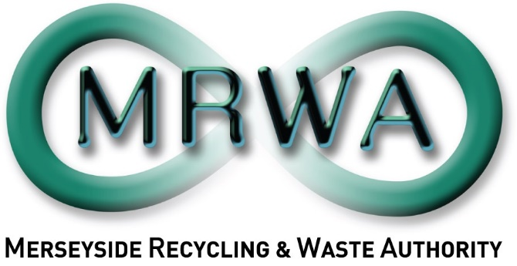
JOB DESCRIPTION
SECTION | Contracts & Operations
JOB TITLE | Contracts Commercial Manager
SALARY RANGE | £60,851 to £65,299
LOCATION | Mann Island
PRIMARY PURPOSE OF THE JOB | To manage commercial risks relating to contract management & service provision, ensuring that contracted commercial arrangements deliver on agreed terms, provide excellent value for money and are managed effectively for the residents and Councils of the Liverpool City Region.  To support the Authority and Contracts section with the delivery of major projects and significant changes to contract terms and arrangements.
DIRECTLY RESPONSIBLE TO | Director - Operations
DIRECTLY RESPONSIBLE FOR | None

PRINCIPLE DUTIES

- To lead on all commercial matters relating to the management of Authority’s main waste management contracts, ensuring key contract commercial risks are identified and appropriately managed to ensure optimum outcomes for the Authority, residents and District Councils of the Liverpool City Region.

- Working with all areas of the Authority and our District Council partners, ensure a holistic approach to commercial optimisation of the contract services across the organisation.

- Lead the development and implementation of appropriate controls, treatments and active management for commercial risks and associated issues in the near and long-term.

- To co-ordinate contract Payment Mechanism and contract commercial related interpretation and application with internal colleagues, ensuring accurate and auditable outcomes.

- Lead on the management and delivery of contract insurance matters, including annual insurance updates, contractual Joint Insurance Costs Report reviews and claims management processes.

- To lead on the delivery of significant contract change processes, ensuring high standards of contractual and legal compliance and negotiation of beneficial outcomes that ensure value for money for the Authority.

- Working with the Director of Operations and Senior Leadership Team to continue to set the framework, standards and governance for commercial contracting, due diligence, contracts negotiation and handling of major contractual disputes.

- Working with the Contracts Team, identify areas of potential financial and commercial efficiencies and implement contract changes to ensure delivery of Best Value for the Authority’s contract arrangements.

- Engage and develop strong relationships with other waste disposal authorities, government bodies and industry organisations at a senior level to develop market & organisational awareness and development of best contract commercial practice.

OTHER DUTIES

- To support the Authority and Contracts Team with effective management and delivery of major projects that may arise from time to time.

- Lead on the handling of major contractual disputes as and when they arise.

- The above duties do not include or define all tasks that may be required by the postholder. The Post holder may be directed to work flexibly in other areas where responsibility levels are commensurate with the employees’ grade of pay in order to ensure that resources are deployed effectively and where necessary across the Authority.

General Statement

The above duties do not include or define all tasks that may be required by the postholder. The duties may vary without changing the general character of the duties or the level of responsibility entailed. These factors are reflected in the grading of the post.

Health and Safety at Work

The Health and Safety at Work Act stipulates that it is the responsibility of every employee to observe all rules governing health and safety and such safety equipment as provided must be used.

Equal Opportunities

The Waste Disposal Authority is an Equal Opportunities Employer and has equal opportunities policies with which you are expected to comply at all times. The Authority condemns all forms of harassment and is actively seeking to promote a workplace where employees are treated with dignity, respect and without bias.

Risk Management

To support and contribute to the delivery of the Authority’s Risk Management Strategy and to effectively manage those strategic and operational risks for which the manager has responsibility.

Sustainable Procurement

To effectively requisition goods and services in line with the Authority’s sustainable procurement policy.

 | Date | Name | Post Title
Drafted | August 2025 | Ian Stephenson | Director – Operations

