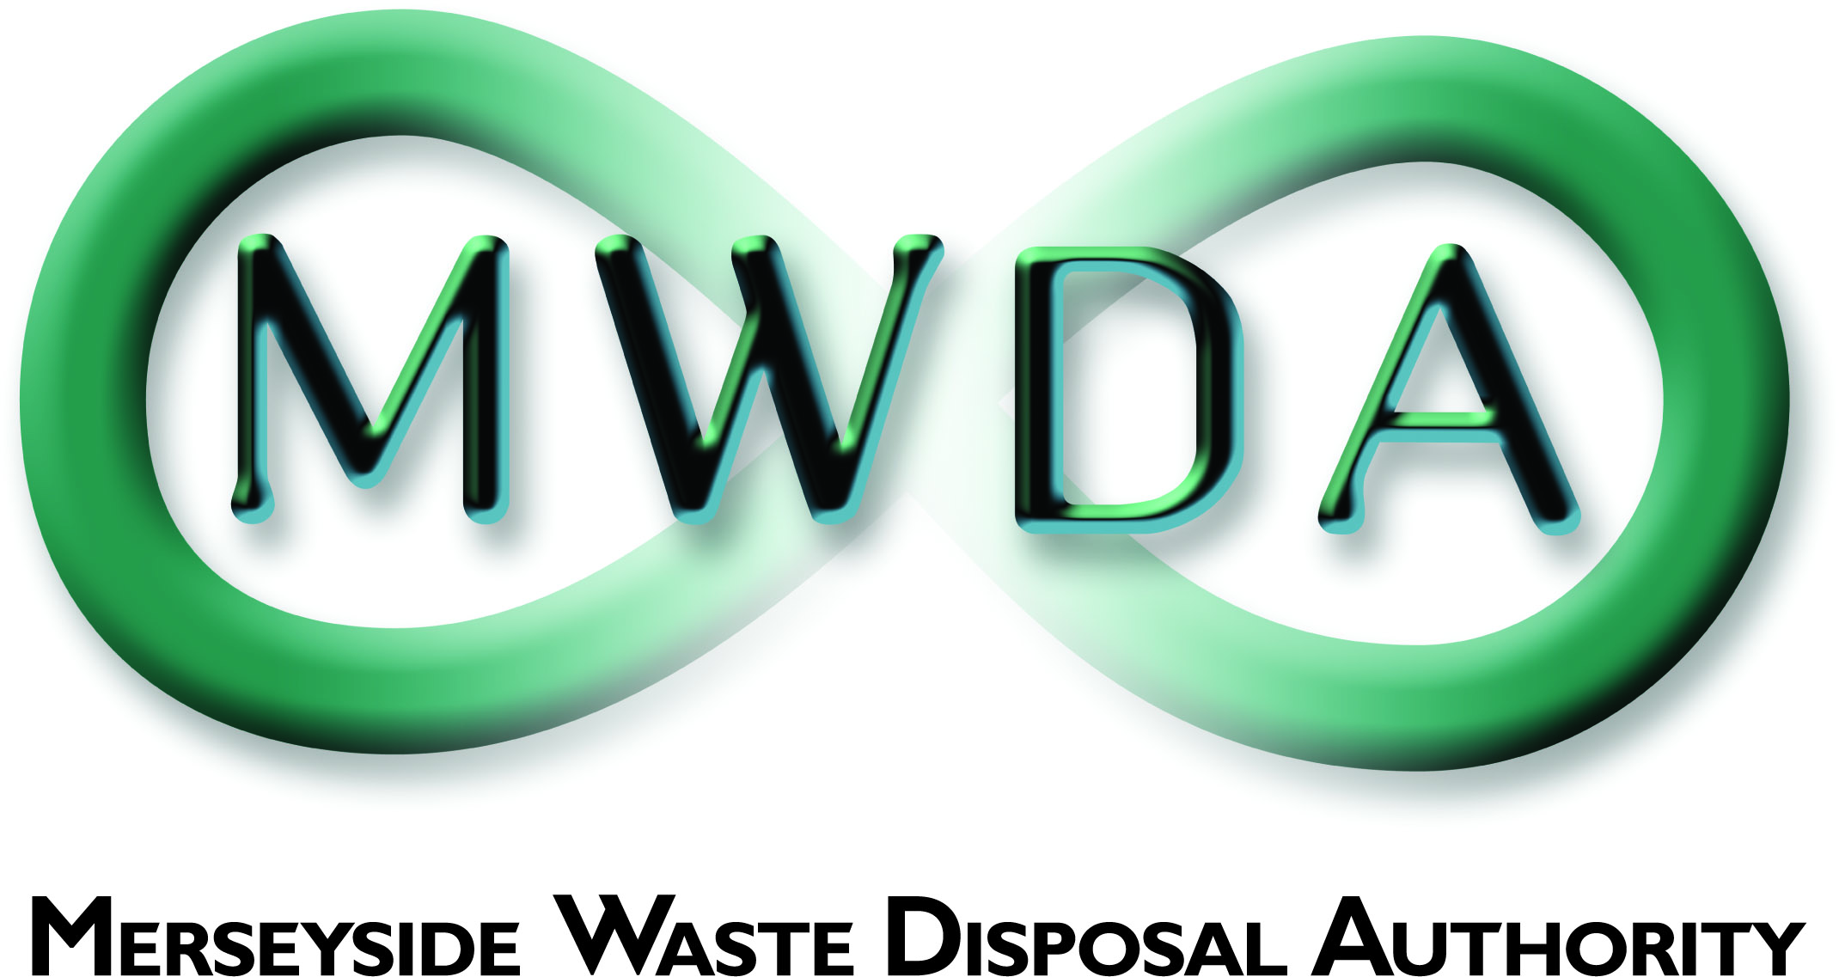

**JOB DESCRIPTION**

|  |  |
| --- | --- |
| **SECTION** | Estates Management |
| **JOB TITLE** | **ENVIRONMENTAL COMPLIANCE OFFICER** |
| **GRADE** | Band D/E |
| **SALARY RANGE** | £33,366 - £38,626 |
| **LOCATION** | Mann Island Liverpool  - but will be required to work outdoor at various other locations within Merseyside. |
| **PRIMARY PURPOSE OF THE JOB** | To support the Estates Manager in the provision of a contract monitoring and administration, and environmental monitoring & maintenance service, with particular regard the Authority’s closed landfill sites. |
| **DIRECTLY RESPONSIBLE TO** | Estates Manager |
| **DIRECTLY RESPONSIBLE FOR** | N/A |

**PRINCIPAL DUTIES**

1. To lead in the provision of an effective environmental management service across the Authority’s closed landfill sites that incorporates, environmental monitoring and maintenance, testing and analysis, and reporting. All in compliance with relevant obligations, legal requirements, and duty of care.

2. Supervise environmental monitoring and associated environmental undertakings, to ensure results are interpreted correctly, and remediation works completed accordingly.

3. Monitor, appraise, and report against the environmental undertaking of the Authority’s appointed contractors.

4. Supervise, administer, deliver, and develop, the Authority’s external service contracts in relation to the aftercare of its closed landfill sites.

5. Review and report on the contractors’ performance, contract compliance, service delivery, and invoice validity.

6. Provision of scientific and technical support to undertake environmental monitoring, data analysis and reporting, in respect of the Authority's closed landfill sites.

7. Contribute to the preparation of environmental monitoring programmes for the Authority’s closed landfill sites.

8. Contribute to the preparation of designs and specifications, and supervision of works, with regard to environmental monitoring and maintenance, and environmental control works.

9. Procurement of works, goods, and services relating to the Authority’s estates, and environmental monitoring infrastructure and equipment.

10. Maintain records of data, and compile reports to support the systems and functions of the Estates Section.

11. Support the Manager in the preparation and management of financial budgets

12. Research and implementation of best practice techniques and initiatives to minimise the impact of the Authority’s activities on the environment, and to improve upon efficiency.

**OTHER DUTIES**

1. Proactively manage with the assistance of the Manager, procedures and practices ensuring that all Health and Safety (H&S) regulations are adhered to.
2. To comply with the requirements of the Authority’s accredited ISO 14001: 2015 Environmental Management System, and Competence Management System, for activities associated with the monitoring and maintenance of its waste management facilities and associated office activities.
3. Keep abreast of legislation pertaining to the functions of the post.
4. To maintain personal and professional development to meet the changing demands of the post and participate in appropriate training activities.
5. The above duties do not include or define all tasks that may be required by the postholder.  The Post holder may be directed to work flexibly in other areas where responsibility levels are commensurate with the employees’ grade of pay in order to ensure that resources are deployed effectively and where necessary across the Authority.

A full UK valid driving licence is essential for this role.

General Statement

The above duties do not include or define all tasks that may be required by the postholder. The duties may vary without changing the general character of the duties or the level of responsibility entailed. These factors are reflected in the grading of the post.

Health and Safety at Work

The Health and Safety at Work Act stipulates that it is the responsibility of every employee to observe all rules governing health and safety and such safety equipment as provided must be used.

Equal Opportunities

The Waste Disposal Authority is an Equal Opportunities Employer and has equal opportunities policies with which you are expected to comply at all times. The Authority condemns all forms of harassment and is actively seeking to promote a workplace where employees are treated with dignity, respect and without bias.

Risk Management

To support and contribute to the delivery of the Authority’s Risk Management Strategy and to effectively manage those strategic and operational risks for which the manager has responsibility.

Sustainable Procurement

To effectively requisition goods and services in line with the Authority’s sustainable procurement policy

|  |  |  |  |
| --- | --- | --- | --- |
|  | Date | Name | Post Title |
| Revised |  |  |  |
| Revised | 12th February 2025 | Tony Byers | Estates Manager |