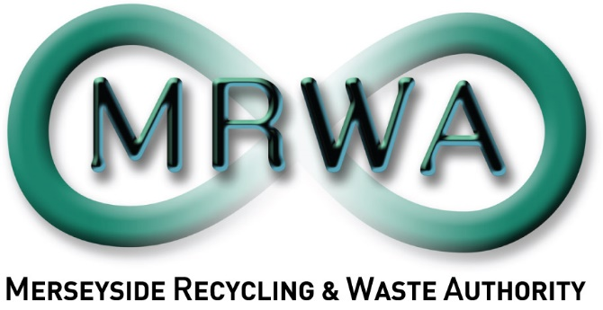

Phase 2 Composting in the Community Pilot Project

Application Form

April 2024

Pack includes:
- Your Organisation
- Meeting the Project Objectives
- Finance
- Evaluation
- Conflict of Interest
- Other Issues
- Appendix 1: Timescales
- Appendix 2: Scoring Evaluation
Applications must be sent to laura.gilmore@merseysidewda.gov.uk by 5pm Sunday 5th May 2024. If you have any questions, please contact laura.gilmore@merseysidewda.gov.uk

- Please ensure to read all of the associated documents entirely before completing this application.

  - Name of the organisation making this proposal. If you are working in partnership, please list all partners and indicate who will be the lead partner.

  - Contact name, and email address for enquiries about this proposal. If this is a partnership proposal, please list the lead contact.

  - If applicable, please provide your charity or company number below.

Company Number: |  | Charity Number:

Application

Title of project:
Date of proposal:

- About your Organisation(s):

- Meeting the Project Objectives:
This section evaluates your skills and experience in relation to the specific project objectives.
  - Who would you engage with to begin making links with relevant communities?

Please give the total number of communities, households and residents you expect to engage with.
Nº Communities | Nº Households | Nº Residents

2.2 Zero Waste / Community Composting knowledge and understanding.
Please tell us your experience/knowledge in the topics of zero waste and community composting. (Max 300 words).

2.3 Project Planning and Delivery
Please tell us about your experience in delivering composting workshops, developing engaging resources, and planning, setting up and running a community composting facility.
Composting workshops:

Developing composting resources:

Planning, setting up and running a community composting facility:

2.4 Design of pilot project:
Please share your plans for how to deliver the first phase of the MRWA Phase 2 Composting in the Community Pilot Project 2024-2025.

2.5 Implementation Plan and Timetable
Please describe each task you will undertake to deliver the project within time scales, ensure to show the key tasks involved in delivering the project, including when each task will happen, and demonstrating how the work will fit the planned start and finish date.
You will need to: | Approach and how will you record this?
Describe how will you engage with relevant communities:
Describe how you will you ensure that households and residents can get involved:
Describe where/how you will conduct the project:
Describe how you will report anything extra outside the criteria that could be useful for added social value:

- Finance:
This section covers the financial request for the Phase 2 Composting in the Community Pilot Project.
3.1 Your Organisation
Please indicate the amount which your organisation wishes to quote in order to deliver the project:
Total:

(Please remember we are supportive of paying Living Wage to any employees involved in delivering services as part of this contract.)
Please identify the three districts you plan to deliver the project in:

3.2 Cost breakdowns
Please provide a breakdown of these costs in the following table:
 | Costs. | Hourly rate: | No. of hours: | Total costs £:
3.2a | Staff Time: please provide details for which staff would be involved for how much time:
3.2b | Other Costs: please list costs associated with delivery and reporting:
Management Overheads:
(Max 10%)
 | Total Costs:

- Evaluation

Please explain why your organisation is best placed to deliver this project: (Max 250 words).

- Conflict of interest

  - Please indicate whether any known actual or potential conflicts of interest may arise in the provision of carrying out this engagement.
Potential Conflict: |  | No Conflict:

If there are actual or potential conflicts, please provide full details including:
- Brief description of the nature of connections creating actual or potential conflicts of interest.
- The full name of any people or bodies whose involvement gives rise to the actual or potential conflicts of interest.
- Mark with an (*) an organisation, people or bodies that are connected with MRWA.
- An explanation of how the Applicant proposes to deal with actual or potential conflicts so that they do not prejudice a fair and competitive procurement process or the position of MRWA.

  - Please indicate whether your organisation, or partners, have been recipients of MRWA and Veolia’s 2023-2024 Community Fund.
Yes: |  | No:

If your organisation, or partners, have been recipients of MRWA and Veolia’s 2023-24 Community Fund, please provide details including:
- Title of successful Community Fund 2023-24 project
- Confirmation there is no overlap between this project and your community fund project.

Please note if you have successfully been awarded any funding from MRWA and Veolia’s Community fund 2023-2024, you must show evidence there is no overlap of delivery with Phase 1 Composting in the Community Pilot Project, including participants, targets, or engagements.
- Other Issues: Not for scoring.

Please use this space to highlight any other useful information for MRWA to consider in this project. (Max 150 words).

Please note the selected organisation will be expected to have all of the necessary accreditation/checks in place to undertake this project as described.

Appendix 1: Time Scales

Activity Detail: | Dates:
Project tender goes live | Friday 19th April 2024
Project tender closes | Sunday 5th May 2024
Tender applications evaluated | w/c 6th May
Organisation selected | Friday 10th May 2024
Due diligence | Following acceptance
Project initiation meeting | w/c 13th May 2024
Final reports received | February 2025

Appendix 2: Scoring Evaluation

Score: | Scoring Principles:
10 | Excellent – there is ample evidence to support the response.
8 | Good – there is sufficient evidence to support the response.
6 | Average – there is some evidence to support the response.
4 | Fair – there is little evidence to support the response.
2 | Poor – there is no evidence to support the response.
0 | Very poor – there is no evidence to support the response.

