Promoting your project

Communications is an important part of a successful project. We want to help you promote your project as much as we can. We’re happy to give communications advice and help. Please contact John.Lally@merseysidewda.gov.uk or Danni.Millar@merseysidewda.gov.uk

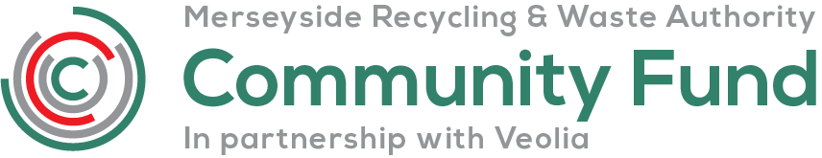
Community Fund logo

By using our logo, we hope it can help you reach as many people as possible. We ask you to use the Community Fund logo on any publication you produce relating to or supported by the grant.
You can download

- Community Fund colour LOGO (link)

- Community Fund black and white LOGO (link)

The recommended minimum size of the logo is 40mm. The logo should appear in isolation and comply with the guidelines below. We’d like the logo to stand out if possible. It must not be hand-drawn or re-created any way.

All resources that use the Community Fund’s name and logos should be approved by the Authority before publication. This allows the Authority to provide any extra information.

If your document or communications are:
- A5 = the logo should be minimum 40 mm width
- A4 = the logo should be minimum 50 mm width
- A3 = the logo should be minimum 70 mm width
- Pop up exhibition stand – the logo should be minimum 480 mm width
- Web/email = 120 pixels width

There should be a minimum area of clear space around it, which is equal to 1x - as shown on the diagram below. The ‘x’ is equal to half the height of the logo itself, e.g., if the height on your document is 4cm (40mm) then the clearance space at the top, sides and bottom of the logo needs to be 20mm.
1X
1X
1X
1X

Where can I use the logo?
Use the Community Fund logo for the communication materials that support your project.
- On Websites.
- Advertising, e.g., for Events.
- Any marketing materials – leaflets, posters etc.
- Social media posts relating to the project.
- Equipment and funded building refurbishments.
- Press releases.

Media and press releases
Local journalists are interested in your project and a good way to tell them about it is by a press release. This can be a short summary of your story or of your proposed event or activity. It’s written in a ‘newsy’ slightly informal way.
Making sure that your press release gets to the right person is key. News is now more immediate – not just newspapers, television, and radio. We can help you with preparing your media and press releases, and with getting it to the right news outlet.

Photographs
The right picture can sell a story, it’s a good idea to include a good image with your media and press releases. Newspapers, magazines and websites will publish good quality images supplied with stories. Set your camera's to high quality at the highest resolution possible and save in jpeg format.

Tips
- Check the most interesting bit of your press release story is in your first paragraph.

- Include your phone number at the end, Journalists might want a chat for more details.

- Make sure you send photographs as attachments, not embedded in an email.

- If your story is advertising a future event, send it to the journalist in plenty of time!

Social Media
Social media makes it easy to share information with a wider cross section of the public, its good to consider what role it could play in your project. Social media can link people together, build networks and create a buzz around your project. It’s a great way to promote your project and engage with the public.
If you’re using social media, we ask you to tag and follow us – we’ll follow you back!
Websites www.merseysidewda.gov.uk
www.zerowastelcr.com
www.recycleright.org.uk/

Twitter www.twitter.com/merseysiderwa

Facebook www.facebook.com/merseysiderwa

Social media tips
- Make messages regular but interesting. Post updates when you’ve something new to say, e.g., a new volunteer starting on the project or you’ve delivered a key part of the project.

- If it’s a quiet time for activities think about offering a peek ‘behind the scenes’ of your project, or ‘the day in the life of’ one of your volunteers.

- Generate feedback – try and get conversations going, consider snapshot polls etc.

- Join other conversations - follow users with similar interests and join in with what they have to say about key issues.

- Photos are great way of updating pages and getting messages out.

- Create mini campaigns, that could be a push to collect ‘xx’ material in a set time, or asking supporters to recommend you to a friend.

If you have any questions regarding logos or promoting your project, please contact our Marketing & Communications Team John.Lally@merseysidewda.gov.uk or Danni.Millar@merseysidewda.gov.uk

