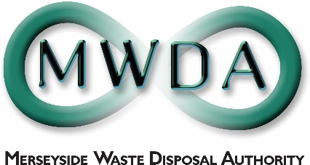
JOB DESCRIPTION
SECTION | Strategy & Development
JOB TITLE | Development Officer (Maternity Cover 10 months)
GRADE | SO1
SALARY RANGE | £26,999 to £28,785
LOCATION | Mann Island
PRIMARY PURPOSE OF THE JOB | To support the Assistant Director/Chief Executive & Strategy & Development Manager in promoting, facilitating and fulfilling the Authority’s Circular Economy Strategy.
DIRECTLY RESPONSIBLE TO | Strategy & Development Manager
DIRECTLY RESPONSIBLE FOR | N/A

PRINCIPAL DUTIES

- To assist in the development of new circular economy initiatives to provide a comprehensive, integrated and planned approach to the generation and use of resources that supports and enables the Authority’s vision.

- To assist in the development of effective partnership working with the community, government, local authorities, contractors and other appropriate bodies to ensure the promotion and delivery of the Authority’s waste minimisation, reuse and recycling initiatives.

- To assist in the research and application of strategic funding opportunities which can support new initiatives and research and development.

- To maintain baseline data on a range of waste activity, to enable performance management information and benchmarking on behalf of the Authority and third parties, including performance indicators.

- To work with colleagues on operational and service issues and providing sustainable solutions.

- To support the Authority’s Behavioural Change Programme with sustainable waste prevention methods.

OTHER DUTIES

1. To undertake any duty of a similar nature which may be assigned from time to time.

General Statement

The above duties do not include or define all tasks that may be required by the postholder. The duties may vary without changing the general character of the duties or the level of responsibility entailed. These factors are reflected in the grading of the post.

Health and Safety at Work

The Health and Safety at Work Act stipulates that it is the responsibility of every employee to observe all rules governing health and safety and such safety equipment as provided must be used.

Equal Opportunities

The Waste Disposal Authority is an Equal Opportunities Employer and has equal opportunities policies with which you are expected to comply at all times. The Authority condemns all forms of harassment and is actively seeking to promote a workplace where employees are treated with dignity, respect and without bias.

Risk Management

To support and contribute to the delivery of the Authority’s Risk Management Strategy and to effectively manage those strategic and operational risks for which the manager has responsibility.

Sustainable Procurement

To effectively requisition goods and services in line with the Authority’s sustainable procurement policy

 | Date | Name | Post Title
 | 10th June, 2019 | Paula Pocock | AD Business Services & Strategy

