Service Delivery Plan 2020/21

WDA/15/20

Recommendation

That:

- Members note the progress made during 2019/20 in the delivery of the Corporate Plan; and
- Members approve the proposed Service Delivery Plan for 2020/21.

THIS PAGE INTENTIONALLY BLANK

Service Delivery Plan 2020/21

WDA/15/20

Report of the Treasurer

Purpose of the Report
  - To note the initial outcomes of the previous year’s performance and to seek Members approval of the proposed Service Delivery Plan for 2020/21.

Background
  - The Performance Management Framework includes a Corporate Plan which sets out the Authority’s aims and objectives as well as a Service Delivery Plan which is developed annually.
  - The purpose of the Service Delivery Plan is to establish priorities and set objectives for the coming year. The Service Delivery Plan identifies the actions required to deliver Corporate Plan whilst reflecting available resources in line with approved budget constraints.
  - A Service Delivery Plan is approved by the Authority each year and the outcome reported through Seasonal Updates and an Annual Report.

Corporate Plan
Merseyside Waste Disposal Authority
26 June 2020
  - The Corporate Plan is a key part of the Authority’s Performance Management Framework and is the document which underpins the Authority’s annual plans. The Corporate Plan was approved at the Authority meeting on 22nd November 2019. The budget which reflects the plan’s objectives was subsequently approved at the Authority meeting on 7th February 2020.
  - The Corporate Plan is fundamental to the delivery of the Authority’s objectives and sits within the Authority’s Performance Management Framework as illustrated below:
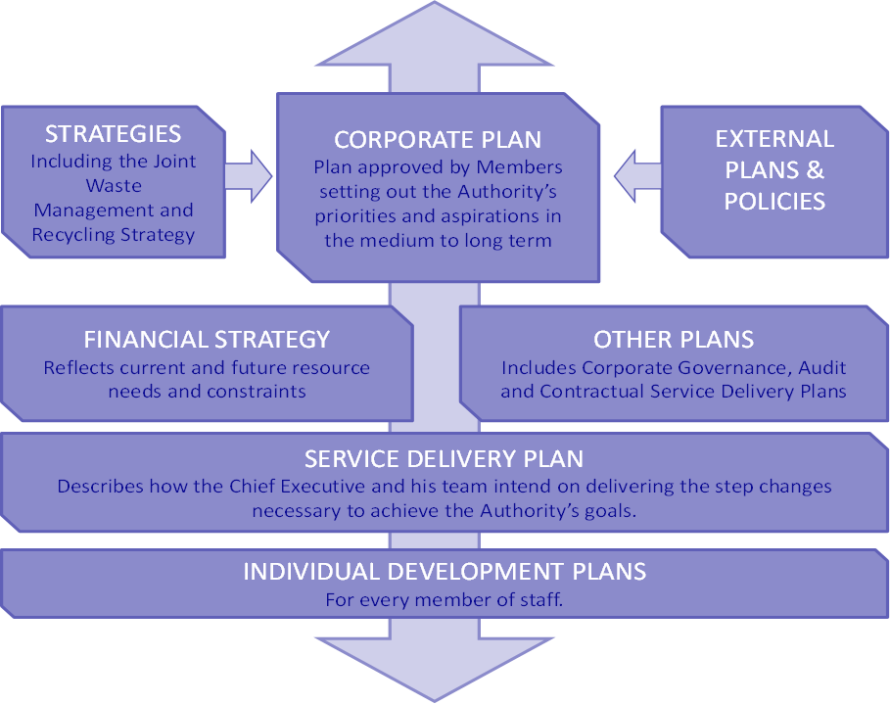

  - The corporate plan approved for 2020/21 revised the Authority’s objectives, recognising that an earlier meeting of the Authority (18th October 2019) a Climate Emergency had been declared. The revised Corporate objectives for 2020/21 are as follows:

MISSION STATEMENT 2020-21:

“To ensure that we reduce the impact of our actions on climate change and improve the sustainable management of waste and resources.”

Corporate aims

We will:-

- Improve the sustainable management of waste and resources
- We will deliver effective waste services
- Co-operate to improve working arrangements
- Measure and report on climate change impacts and sustainability improvements

Progress against the Service Delivery Plan for 2019/20
  - The Service Delivery Plan for 2019/20 was approved by Members on 26th April 2019.
  - The final outcomes of the 2019/20 Service Delivery Plan have been collated, and the initial results are attached at Appendix 1 in the form of a summary of a “tracker” and show that the majority of the objectives set for 2019/20 have been achieved (94% completion).
  - The Authority has 24 main objectives within the service delivery plan which are delivered through a series of tasks which managers plan to deliver through the year. While the majority of the tasks have been delivered, which gives the 94% completion rate; those that have not been completed by the end of the year are spread across a number of the objectives which means that some of the objectives are not fully complete. For 5 of the objectives there are a small number of sub-tasks that have not been completed and so they are reported as behind plan. For one of the objectives that has been deferred completely.
  - For those objectives assessed as not being completed, the reasons are summarised as follows:
Deliverability:
- the projects behind plan include contractual discussions an legal works and legal works on agreements, including contingencies for landfill and MRF recyclable income. Both of these strands of work require third party negotiation and discussion and may not be concluded independently.

Sustainability:
- future options for the review of the Authority’s joint venture in Bidston Methane Ltd are ongoing but have been delayed as the third party working alongside the Authority has amended its proposals in light of their response to the capacity market, discussions are ongoing.
- The work on developing a Zero Waste Strategy has been deferred due to Covid19 delaying the Waste Composition Analysis which was to inform the work over a two year timeframe.

Partnership and Governance;
- The work with partner Authorities on options for joint working arrangements has not been progressed and will be deferred. This is despite good work during the year on a number of projects but decisions on joint working are not the Authority’s to make alone.

Accountability;
- the majority of the staff training and development programme was delivered, but due to staffing issues some elements were delayed.

  - Whilst the issues above have led to some delays in delivery of some plans the majority (94%) have been fully delivered and the remainder are being carried forward into the next SDP.
  - A more complete update on performance for 2019/20 will be provided in the Annual Report later in the year when the measurable outcomes are finalised.

Service Delivery Plan 2020/21
  - The proposed Service Delivery Plan for 2020/21 is attached at Appendix 2. The plan follows the Corporate Plan and is divided into four sections as follows:
- Improve the sustainable management of waste and resources

- We will deliver effective waste services

- Co-operate to improve working arrangements

- Measure and report on climate change impacts and sustainability improvements

  - The Service Delivery Plan sets out the key priorities for the year and subsequently a series of objectives have been established. These objectives provide the measures by which we will track the Authority’s performance and on which we will be monitored throughout the year. Members will receive information on performance through the year.
  - The plan has been developed through a number of detailed discussions with Managers about how they propose to deliver their services in accordance with the objectives of the Corporate Plan. A small number of areas of the proposed plan may be subject to further development and clarification, where this is the case Members will be informed; any changes will be unlikely to be fundamental.
  - Our key priorities are as follows:
Improve the sustainable management of waste and resources
To achieve this, we will:

- Develop and implement a new waste strategy to address climate change and maximise the value of otherwise wasted resources in terms of economic, environmental and social benefits;
- Work together with stakeholders to provide services that improve the environment, support the local economy and benefit the local community; and
- Reduce waste and promote unwanted materials as a valuable resource.

We will deliver effective waste services
We will ensure that waste is managed sustainably by:
- Managing our services to deliver continuous improvement in sustainability;
- Managing the Authority’s waste services in a safe, efficient and cost effective manner.

Co-operate to improve working arrangements
We will do this by:
- Considering how waste services can be best aligned to deliver climate change objectives; and
- Work collaboratively to identify and deliver more impactful ways of working.

Measure and report on climate change impacts and sustainability improvements
We will measure the climate change impacts of waste and sustainability improvements and will report against the United Nations ‘Sustainable Development Goals’ (SDGs) as an additional part of our business management by:
- Reducing the climate change impacts of waste through a programme of reviewing, benchmarking and reporting;
- Establishing targets that stretch performance to bring improvements;
- Reporting on all our activities openly and transparently; and
- Ensuring that our staff are deployed effectively and have opportunities to develop the new skills needed.
  - Subject to Members approval the plan will be disseminated to all staff. Managers in particular will be able to use the Service Delivery Plan to establish work programmes in the coming year.
  - For the year 2020-21 Members will understand that the detailed objectives set out in Appendix 2 may be subject to some amendment and change where circumstances dictate that a more flexible approach is required.
  - The impacts of the Covid19 pandemic have been felt across the City Region and have already had a significant impact on the way the Authority is able to deliver its objectives. EMT have been working with managers across the Authority to re-evaluate the way work should be delivered and have had to identify new ways of working adapt as a consequence. Enabling staff to work remotely has been important and during this social distancing phase of the pandemic the head office has had very few staff in attendance and even then only on an irregular basis. When we are advised that the offices can be open on a more ‘normal’ basis it is unlikely in the initial phases that all the staff will be in the office at any one time, with rotation and partial occupation likely to become the norm in the medium term.
  - Whilst every effort will be made to deliver the outcomes expected from the Authority’s objectives, due to the changes in the way the workplace has to be organised there may be some areas where delivery is slower or less complete than had been hoped. Members will be advised where the changes in working arrangements have had an impact on the achievement of overall objectives.

Risk Implications
  - The Service Delivery Plan is one element of the Authority’s Performance Management Framework which incorporates planning and risk management. The Corporate Risk Register is monitored alongside the Service Delivery Plan throughout the year so that actions are taken to manage risks.
  - In relation to the Service Delivery Plan the following risks have been identified:
Identified Risk | Likelihood Rating | Consequence Rating | Risk Value | Mitigation
Failure to deliver continuous improvement | 2 | 4 | 8 | Continue to review and monitor the Service Delivery Plan throughout the year
Failure to manage risks in the delivery of the Corporate Plan | 2 | 4 | 8 | Manage and monitor Corporate Risk Register as part of the performance review process
Failure to identify deliverable objectives | 3 | 3 | 9 | Use ‘SMART’ objectives

HR Implications
  - The Performance Management Framework and the Service Delivery Plan provide staff with a clear link between their own performance and that of the organisation as a whole, and promotes a more engaged and committed workforce.
  - The Staff Development Scheme identifies personal objectives which enable a member of staff to contribute directly to the Service Delivery Plan and ultimately to the Authority’s Corporate Plan.

Environmental Implications
  - The Service Delivery Plan supports the Authority’s mission statement which is “To ensure that we reduce the impact of our actions on climate change and improve the sustainable management of waste and resources.”

Financial Implications
  - The development of the Service Delivery Plan is informed by the budget approved by Members for 2020-21, there are no other financial implications associated with this report.

Legal Implications
  - There are no legal implications associated with this report.

Conclusion
  - Members are asked to note progress made in the delivery of the previous year’s plan and to approve the Service Delivery Plan for 2020-21.
The contact officer for this report is: Peter Williams
7th Floor, Number 1 Mann Island, Liverpool, L3 1BP
Email: peter.williams@merseysidewda.gov.uk
Tel: 0151 255 2542
Fax: 0151 227 1848
The background documents to this report are open to inspection in accordance with Section 100D of The Local Government Act 1972 - Nil.

