- The promoter is: Merseyside Waste and Recycling Authority [MRWA is the public facing name for Merseyside Waste Disposal Authority, which is a statutory Joint Waste Disposal Authority under the Local Government Act 1985]; Whose registered office is at 7th Floor, No. 1 Mann Island, Liverpool, Merseyside, L3 1BP.
- The competition is open to residents of Liverpool City Region, aged 18 years or over except employees of MRWA, and their close relatives and anyone otherwise connected with the organisation or judging of the competition.
- There is no entry fee and no purchase necessary to enter this competition.
- By entering this competition, an entrant is indicating his/her agreement to be bound by these terms and conditions.
- Route to entry for the competition can be found at Twitter.com/MerseysideRWA and Facebook.com/MerseysideRWA and details of how to enter are via https://www.merseysidewda.gov.uk/2020/04/get-composting-at-home-and-help-cut-waste/
- Only one entry will be accepted per household. Multiple entries from the same household will be disqualified.
- Closing date for entry will be May 14th, 2020. After this date the no further entries to the competition will be permitted.
- No responsibility can be accepted for entries not received for whatever reason.
- The rules of the competition and how to enter are as follows:
Rules and How to Enter:
- To enter via twitter: Simply RT the pinned tweet regarding our Compost Bin Giveaway and tag a friend who you think should give composting a try. The entrant must be following @MerseysideRWA on Twitter in order to enter.
To enter via Facebook: Simply share our post regarding our Compost Bin Giveaway, and tag at least one friend who you think should give composting a try.
- The promoter reserves the right to cancel or amend the competition and these terms and conditions without notice in the event of any unforeseen circumstances arriving, including actual or anticipated breach of any applicable law or regulation or any other event outside of the promoter’s control. Any changes to the competition will be notified to entrants as soon as possible by the promoter.
- The promoter is not responsible for inaccurate prize details supplied to any entrant by any third party connected with this competition.
- The prize is as follows: One Blackwall 220 litre Compost Converter, 220L capacity, 740mm diameter, 900mm height. Carbon footprint certified by the Carbon Trust, extra wide hatch allowing easy removal of the finished compost, push-fit wind-proof lid prevents the contents from blowing away, wide aperture enables easy filling of the composter
- The prize is as stated and no cash or other alternatives will be offered. The prizes are not transferable. Prizes are subject to availability and we reserve the right to substitute any prize with another of equivalent value without giving notice.
- Winners will be chosen at random by software, from all entries received and verified by Promoter and or its agents
- The winner will be notified by direct message on Twitter or Facebook within 14 days of the closing date. If the winners cannot be contacted or do not claim the prize within 72 hours of notification, we reserve the right to withdraw the prize from the winner and pick a replacement winner.
- The promoter will notify the winner when and where the prize can be delivered.
- The promoter’s decision in respect of all matters to do with the competition will be final and no correspondence will be entered into.
- By entering this competition, an entrant is indicating his/her agreement to be bound by these terms and conditions.
- The competition and these terms and conditions will be governed by English law and any disputes will be subject to the exclusive jurisdiction of the courts of England.
- The winner agrees to the use of his/her name and image in any publicity material, as well as their entry. Any personal data relating to the winner or any other entrants will be used solely in accordance with current UK data protection legislation and will not be disclosed to a third party without the entrant’s prior consent.
- Entry into the competition will be deemed as acceptance of these terms and conditions.
- This promotion is in no way sponsored, endorsed or administered by, or associated with, Facebook, Twitter or any other Social Network. You are providing your information to Merseyside Recycling and Waste Authority and not to any other party. The information provided will be used in conjunction with the following Privacy Policy found at http://www.merseysidewda.gov.uk/wp-content/uploads/2018/11/MWDA-CORPORATE-PRIVACY-NOTICE-2018-FINAL-1.pdf.
Also, please note:
- MRWA’s decision as to those able to take part and selection of winners is final. No correspondence relating to the competition will be entered into.
- MRWA shall have the right, at its sole discretion and at any time, to change or modify these terms and conditions, such change shall be effective immediately upon posting to this webpage.
- MRWA also reserves the right to cancel the competition if circumstances arise outside of its control.
- The winners chosen will need to supply their home address for delivery of the compost bins. Again, all data will be handled solely by MRWA and in accordance with current GDPR.

Introduction of Sweepstakes Posts: (To schedule for Thursday, May 6th at 10:00am)
Compost Awareness Week (CAW) began this Sunday, May 3rd, and in honour of this we’ve decided to giveaway FREE COMPOST BINS to some of our residents. Simply RT [or share on Facebook] our CAW post that will be sent out on Friday May 8th to enter for your chance to give composting a try. Entries close Thursday May 14^{th,.}
-Must be following @MerseysideRWA
-Entrees must be 18+ and be a resident of Liverpool City Region
-One entry per household
-Winners will be picked at random, subject to adhering to rules of the giveaway.
For more details please visit: https://www.merseysidewda.gov.uk/2020/04/get-composting-at-home-and-help-cut-waste/
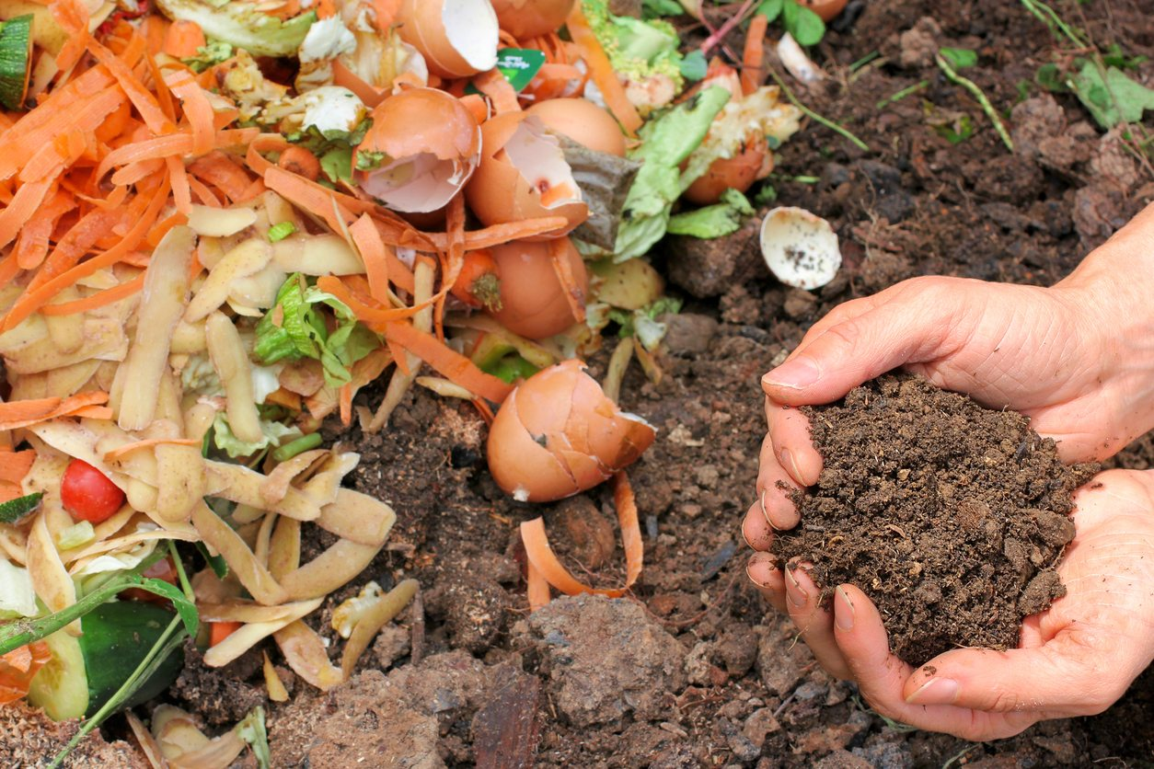

Entry post: (To schedule Friday, May 8th at 10am)
Composting, is it for me?
Do you want to reduce your garden and food waste? Do you want to have healthy, nutrient rich soil? Do you want to do your bit to tackle climate change?
If you answered yes to any of the above, then you’re in luck. We are giving away free compost bins to a few lucky residents. All you need to do is RT this post, maybe include why you want to give composting a try, or tag a friend you think should start composting. Winners will be selected at random and contacted via DM in due course. For details, eligibility and rules of the giveaway please visit: visit: https://www.merseysidewda.gov.uk/2020/04/get-composting-at-home-and-help-cut-waste/

