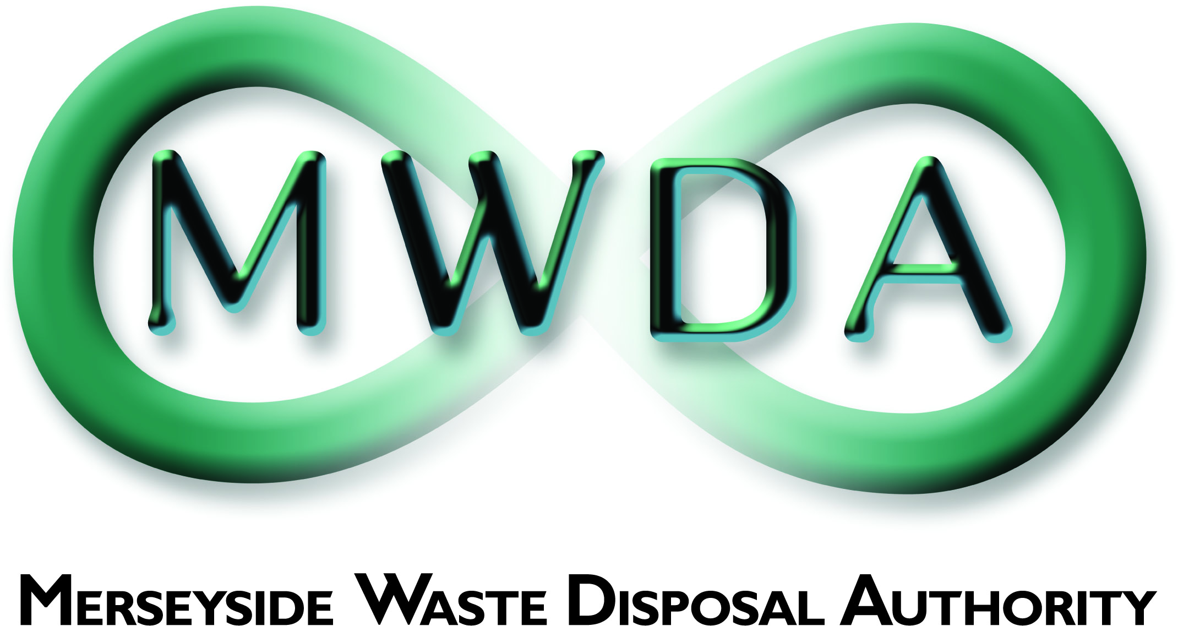
JOB DESCRIPTION
SECTION | Waste Strategy & Development
JOB TITLE | Waste Strategy & Development Manager
GRADE | PO6
SALARY RANGE | £42,683 To £45,591
LOCATION | Mann Island
PRIMARY PURPOSE OF THE JOB | To assist in the management and development of the Authority’s strategic aims and objectives. To manage the Waste Strategy & Development Team.
DIRECTLY RESPONSIBLE TO | Assistant Director of Business Services & Strategy
DIRECTLY RESPONSIBLE FOR | Waste Strategy & Development Team

PRINCIPLE DUTIES

- Manage the Waste Strategy & Development Team, particularly in relation to the circular economy and waste strategies for Merseyside and Halton Waste Partnership.

- To lead on waste minimisation and reuse, strategic funding initiatives and research and development.

- To a provide a comprehensive, and planned programme of circular economy activity that supports and enables the Authority’s vision, circular economy strategies and LCR wider environmental and industrial policies to be realised through effective strategy support service.

- Advise and liaise with elected members on the implementation of the Authority’s policies and strategies as required.

- Ensure effective budget and financial management systems are in place to achieve the Authority’s aims and objectives

- Manage and appraise staff line managed through the setting and monitoring of performance targets and standards to ensure that service-specific and corporate aims and objectives are effectively achieved.

- Manage effective communication between the Waste Strategy & Development Team and elected members of the Authority, the public and external bodies and organisations, supporting positive public relations at all times, to secure successful outcomes.

- Develop effective partnership working with the community, government, local authorities, contractors and other appropriate bodies in order to ensure that the Authority is promoted; its interests are well informed, widely understood and furthered as appropriate.

- Represent the Authority at national, regional and local level, in its dealings with government bodies, local authorities, agencies, the local community, the private sector and any other appropriate organisations as required.

General Statement

The above duties do not include or define all tasks that may be required by the post holder. The duties may vary without changing the general character of the duties or the level of responsibility entailed. These factors are reflected in the grading of the post.

Health and Safety at Work

The Health and Safety at Work Act stipulates that it is the responsibility of every employee to observe all rules governing health and safety and such safety equipment as provided must be used.

Equal Opportunities

The Waste Disposal Authority is an Equal Opportunities Employer and has equal opportunities policies with which you are expected to comply at all times. The Authority condemns all forms of harassment and is actively seeking to promote a workplace where employees are treated with dignity, respect and without bias.

Risk Management

To support and contribute to the delivery of the Authority’s Risk Management Strategy and to effectively manage those strategic and operational risks for which the manager has responsibility.

Sustainable Procurement

To effectively requisition goods and services in line with the Authority’s sustainable procurement policy

 | Date | Name | Post Title
Revised | 7th April 2010 | Paula Pocock | Assistant Corporate Services Manager
Revised | 15th May 2012 | Paula Pocock | Assistant Corporate Services Manager
Reviewed | 19th February 2018 | Jane Nolan | Business Services Manager
Reviewed | 5th June 2019 | Paula Pocock | Assistant Director

