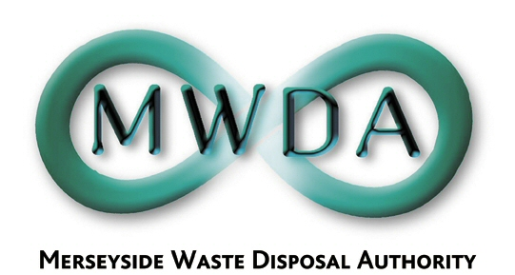

AGENDA

Annual Meeting of the Authority

Friday, 21st June 2019 at 10.30am

Venue: G-10, No. 1 Mann Island,
Pier Head, Liverpool, L3 1BP

Membership:-
Knowsley Borough Council: Cllr T Byron
Liverpool City Council: Cllr T Concepcion
Cllr J Hanson Cllr L Robertson-Collins
Sefton Borough Council: Cllr D Roscoe
Cllr Y Sayers
St. Helens Cllr C Preston Wirral MBC Cllr S Williams
Cllr T Norbury
Halton BC Cllr S Nelson (Observer Status)
Item No. | Title | Page
1 | Appointment of Chair
2 | Appointment of Deputy Chair
3 | Apologies for Absence | -
4 | Minutes of Authority Meeting held on 26th April 2019 | 1
5 | Declaration of Interests by Members and Officers | -
6 | Question(s) from Members under Procedural Rule 9 | 5
7 | Question(s) from Members of the Public under Procedural Rule 10 | 5
8 | Motion proposed by Members under Procedural Rule 15 | 5
9 | Scheme of Delegation & Procedural Rules  WDA/13/19 | 7
10 | Questions on the Discharge of Functions  WDA/12/19 | 19
11 | Appointments and Committees  WDA/14/19 | 23
12 | Outturn Report 2018-19  WDA/15/19 | 37
13 | Halton & MRWA Inter-Authority Agreement  WDA/16/19 | 63
14 | Halton BC HWRC Variations  WDA/17/19

7TH Floor, No 1 Mann Island, Liverpool, Merseyside,L3 1BP
Tel: 0151 255 1444 Fax: 0151 227 1848
Email:enquiries@merseysidewda.gov.uk
www.merseysidewda.gov.uk

