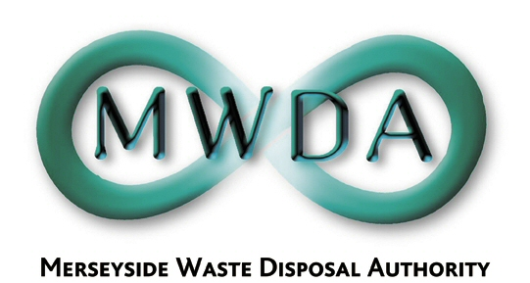

AGENDA

Meeting of the Authority

Friday, 02nd February 2018 at 1.00 pm

Venue: Authority Chamber, No. 1 Mann Island,
Pier Head, Liverpool, L3 1BP

Membership:-
Knowsley Borough Council: Cllr G Morgan (Chair)
Liverpool City Council: Cllr T Concepcion (Deputy Chair)
Cllr C Sung Cllr L Robertson-Collins
Sefton Borough Council: Cllr D Roscoe
Cllr M O’Brien
St. Helens Cllr C Preston Wirral MBC Cllr S Williams
Cllr T Norbury
Halton BC Cllr S Nelson (Observer Status)

Item No. | Title | Page
1 | Apologies for Absence | -
2 | Minutes of Annual Meeting held on 24th November 2017 | 1
3 | Declaration of Interests by Members and Officers | -
4 | Question(s) from Members under Procedural Rule 9 | 5
5 | Question(s) from Members of the Public under Procedural Rule 10 | 5
6 | Motion proposed by Members under Procedural Rule 15 | 5
7 | Timetable of Authority Meetings 2018-19  WDA/04/18 | 7
8 | Budget 2018-19  WDA/05/18 | 13
9 | Treasury Management Strategy Statement 2018/19; Annual Revenue Provision Policy Statement; Annual Investment Strategy; and Treasury Management and Prudential Indicators  WDA/06/18 | 65
10 | Community Fund 2018/19 Allocation  WDA/01/18 | 99
11 | Environmental Management System  WDA/02/18 | 111

7TH Floor, No 1 Mann Island, Liverpool, Merseyside,L3 1BP
Tel: 0151 255 1444 Fax: 0151 227 1848
Email:enquiries@merseysidewda.gov.uk
www.merseysidewda.gov.uk

