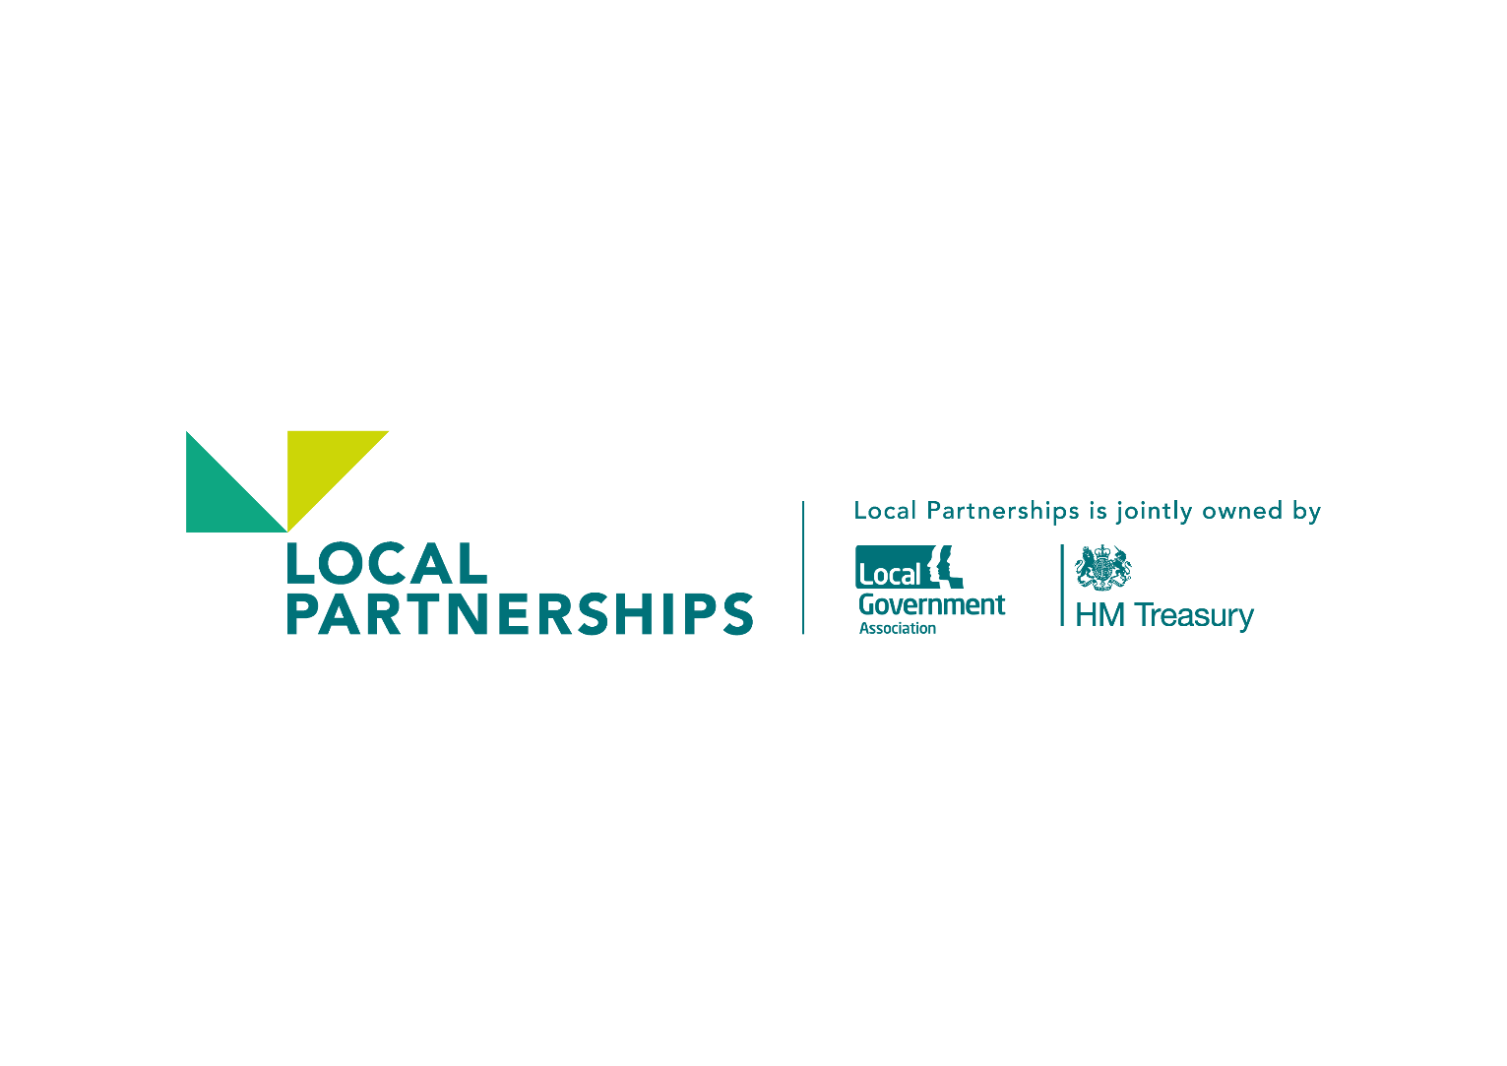

Liverpool City Region

Strategic Review of Waste Management

Version No: Final

Issue Date: 2nd December 2016

Table of Contents

1 Introduction 3

2 Executive Summary 4

3 Project Scope and Objectives 7

4 General Comments and Observations 10

5 Findings from the Reports 11

5.1 Strategy 11

5.1.1 A Future Outside the European Union 11

5.1.2 Circular Economy 11

5.1.3 Resource Focused and Circular Economy Driven Case Studies 12

5.1.4 Direction of Travel of Devolved Administrations in Scotland And Wales 13

5.1.5 Devolution of Powers to Local Authorities 13

5.1.6 Local Authority Powers 13

5.1.7 Changes to Waste Composition and Growth 14

5.2 Review of Wider Economic, Environmental, Transport and Energy Policies for the Region and any Synergies with Waste Management 14

5.3 Joint Working Opportunities 15

5.3.1 Introduction 15

5.3.2 Benefits arising from acting as a Joint Waste Authority 16

5.3.3 Efficiencies and Savings from Joint Working 17

5.3.4 Savings and Comments associated with Specific areas of Joint Working 20

5.4 Innovation in Waste Collection 22

5.4.1 Timelines and Savings 24

5.5 Infrastructure Sharing, Collection Modelling and Depot Rationalisation 24

5.5.1 Assessment of Shared infrastructure 25

5.5.2 Joint Waste Collection Operational Model 26

5.5.3 Depot Rationalisation 29

5.5.4 Summary of Efficiencies and Savings 30

5.6 Review of RRC and WMRC Contracts Managed by MRWA 33

5.6.1 Savings and Efficiencies from the WMRC Contract 34

5.6.2 Savings and Efficiencies from the RRC Contract 36

5.7 Organisational Structures 37

5.8 Funding and the Levy 40

5.9 Summary of savings 42

5.10 Appendices 47

5.10.1 Appendix 1 - The Interaction between the Resource Recovery Contract (RRC) and the Waste Management and Recycling Contract (WRMC). 47

5.10.2 Appendix 2 - Liverpool City Region Waste Strategy and Policy Options 47

5.10.3 Appendix 3 – Innovation in Waste 47

5.10.4 Appendix 4 - Infrastructure Sharing Collection Modelling and Depot Rationalisation 47

5.10.5 Appendix 5 - Review of RRC and WMRC contracts managed by MRWA 47

5.10.6 Appendix 6 – Organisational Options 47

5.10.7 Appendix 7 – Funding and The Levy – Future Options 47

# Introduction

Waste is ubiquitous, there is not a day goes by when we do not discard something, somewhere.

It arises in countless forms; shops and businesses supply an ever-increasing range of products and consumables, grown or manufactured from a myriad of different materials, from practically every corner of the globe. In the majority of cases these products and consumables, or the packing they come in, find themselves being discarded sooner or later, requiring collection.

In contrast the doorstep collection of waste is a very local business, carried out on a regimented and routine basis for every household in the region; it is a feat of logistics and a very visible service compared to other authority activities.

But then, for the majority of people, this visibility tends to fade; historically it was landfilled locally, increasingly it’s recycled and treated and reintegrated back into the economy from where it originated, as a resource.

Waste has in fact become a global commodity. Recycled materials find their way to Europe and the Far East and for that component of waste that currently cannot be recycled this is increasingly being turned into energy, a portion of which is deemed renewable.

Ultimately both of these resources find there way back to our homes and businesses in the form of new products, consumables, electricity and in some cases heat.

This is a most natural process; everything has a life cycle and this feature of waste management is what has triggered the debate around the circular economy and resource management.

Therefore, what was originally a very local enterprise has now grown to a national and increasingly global commercial business; with a supply chain and logistics network that is becoming ever more complex and where prices are often dictated by commodities in the world economy.

So how do local authorities, delivering an essential local service, but subject to increasing global commercial pressures, respond to this challenge. Where economic boundaries, let alone political ones, are continually evolving in response to global pressures and competition.

And how do they do this when also facing the consequences of local, social and demographic change to the communities they serve and the financial pressures this brings on top of austerity. What are the opportunities for waste management to adapt to these changes whilst at the same time maintaining a key local service but achieving significant improvements in efficiency and savings?

This strategic review attempts to answer some of these questions and proposes alternative ways of working in order to make these efficiencies and savings. It seeks to identify a modern and flexible organisational platform that can readily adapt and meet the challenges arising from policy changes or global drivers. Whilst at the same time providing an efficient, integrated and focused waste management service to the community. Indeed an organisation that is complimentary to the ambitions and objectives of the Liverpool City Region Combined Authority.

# Executive Summary

This review is a strategic assessment of the whole waste management system operated across the Liverpool City Region. It has involved collaborative working with the 6 collection authorities and the Merseyside Recycling and Waste Authority (MRWA) that provide waste management services to the region.

Its principle aim has been to identify potential savings and efficiencies and assess over what time period these can be implemented. At the same time it has considered the opportunities for closer working between the authorities and the benefits this might realise.

The evidence uncovered strongly supports the justification for closer working between the authorities. Indeed many of the savings opportunities are predicated on the assumption that this occurs. As the alignment between the authorities increases so do the efficiencies and savings.

The review concluded that there are potential savings in the range of £11m to £19m if all the initiatives identified in this review are implemented. In the short term, between 1 and 2 years, these savings range from £4.5m to £6.7m and can largely be implemented individually rather than jointly. However, the upper range of savings is more likely to be realised if the authorities work together.

The savings increase further over the medium and longer term but become increasingly dependant upon joint working to make them feasible, or in some cases to occur at all. At the same time the savings identified have a wider range of financial outcomes simply because the figures involved are subject to predicting market changes and costs, which introduces uncertainties in projecting forward these figures. Associated with this have been the difficulties of extracting representative figures from the information supplied by authorities to forecast future savings.

The key findings were:

* MRWA run an efficient waste disposal service – there is limited savings potential.
* Significant economies can be gained from ‘joining up’ the entire waste management system.

The savings opportunities can be described as:

1. Greater Collaboration – savings in the range of £2m to £5m by sharing best practice and adopting common charges for green waste and rationalising Household Waste Recycling Centres (HWRCs).
2. Partnership Working – savings £5m to £11m by working together under formal agreements to common standards; for example clinical waste and bulky waste.
3. Integration – Savings £11m to £19m by joining all waste management activity under one organisation; for example joint services, joint procurement, joint back office and digital integration, standardised vehicles.

A clear picture emerges in practically all of the areas examined that working jointly offers the greatest opportunity for savings. This is partly justified by the economies of scale argument but also as a result of removing internal barriers. A joint waste authority (JWA) would allow the region to adopt a fully integrated waste strategy and provide a platform to adapt to any potential changes driven by forthcoming regulation, environmental and sustainability requirements or as a result of economic opportunities within the region; a JWA is also considered essential if the region is to pursue the opportunities that the Circular Economy and Resource Management may bring.

To facilitate these changes the first step will be to implement common collection practices and policies across the region, this apart from anything else, will simplify the service offer for the public and remove anomalies between authorities that make up the region. Having common practices and policies is an enabling initiative: it will allow a more focussed and targeted approach to a range of activities; some specific like clinical waste and bulky waste services whilst others are more general like education, enforcement and wider communications with the public. Coordination in these areas will not only generate concrete savings but also support the less tangible measures of success like behavioural change, which is difficult to measure but ultimately feeds through into better recycling and operational efficiency.

In the latter case common practices and policies will also have a direct impact on operations; activities like the central procurement of vehicles, bins and associated equipment can be based on standard specifications across the region that will drive down procurement, asset and maintenance costs.

Common practices, policies and standardisation will also provide the platform for future innovation. Medium to longer-term opportunities exist to integrate digital systems providing a direct link between the public and operations, improving logistics and customer service response times whilst driving down costs. Perhaps one of the greatest benefits this will deliver is the ability to quickly analyse trends, identify changes in behaviour and deliver targeted responses efficiently.

One significant initiative that a standard approach to vehicle procurement will bring is the transition from diesel to gas powered vehicles. This is an initiative that the region may wish to adopt more widely as it would be a major contributor to the Clean Air Zones, which forms part of the devolution deal. The procurement of gas powered waste vehicles to a common specification across the fleet will bring with it savings in fuel costs as well as the procurement benefits.

Moving on to the actual collection services delivered, a number of scenarios were modelled to evaluate the environmental and economic benefits of moving to a common system across the region. Factors like asset sharing, the optimum location of vehicles and a series of new service offerings were modelled using a combination of GIS based analysis and specialised collection-modelling tools.

Workshops were used to develop these scenarios in order to model the collection systems favoured by the authorities. The goals agreed were ambitious and whilst there were environmental benefits and savings identified in a number of scenarios, these were relatively modest. However, it emerged that by adopting a variant of one of the scenarios, charging for green waste, that a short-term saving in the region of £4m to £5.5m was possible. Further medium to longer-term options were also identified but practically all of these would result in greater benefits if delivered as part of a JWA.

In terms of the recycling, treatment and disposal contracts managed by MRWA an investigation of operational savings was made. For the Resource Recovery Contract (RRC), a combined heat and power project, which is expected to have its first full year of operation in 2017/18, there is little immediate scope for savings. However, the cost per tonne for treatment this offers and the opportunities for income generation make this contract an exceptionally good deal in actual terms but also in comparison with similar projects across the UK. In the medium to longer term once this facility has several thousand hours of uninterrupted operation opportunities do exists. One of the key ones will be to fill any spare capacity that might arise due to increased recycling, as this coukld be a significant source of income.

For the Waste Management and Recycling Contract (WMRC) there are a number of savings opportunities in the short term that relate to optimisation of the Household Waste Recycling Centres (HWRCs) and the use of spare capacity. In the medium to longer term there is also the potential to develop a plastics processing facility to separate individual polymers. Outside of this contract but related is the potential at some stage in the future to develop a food waste treatment facility for the region using anaerobic digestion (AD). This might be a necessity if triggered by future waste regulation or may simply be determined by the authorities as a way forward on environmental grounds and supporting the Circular Economy.

No savings figure has been attributed to this in the review but a business case should be developed such that an informed decision can be taken at the right time. Once again working jointly across all authorities will be essential to ensure that sufficient tonnages of food waste are collected to make an AD plant viable. The collection option has already been modelled in the scenarios noted above.

The preceding paragraphs set out the evidence found for greater joint working. The next part of the review considered the structures that might be adopted to facilitate this. The options investigated ranged from simple levels of cooperation moving towards a position of complete integration of both collection and disposal authorities.

The conclusion reached was that in order to facilitate all of the efficiencies and savings highlighted in the review and to create a platform that equips the organisation to manage future changes and challenges a JWA should be formed. This would become part of the Liverpool City Region Combined Authority (LCRCA) using a governance model similar to that already in place for Mersey Travel. A detailed legal report is provided in support of these findings within the main review.

Finally, a review of the funding system or levy was undertaken. The levy is a complex and, according to feedback during the review, often a controversial subject. The formula currently used works but has a number of drawbacks, which probably don’t incentivise the appropriate behaviours and leads to what has been described as “winners and losers”. There are numerous permutations to the levy formula that could be adopted and these have been set out by the MRWA together with their pros and cons. Ultimately there are no simple solutions whilst the authorities remain in their disparate groups. However, the formation of a JWA, as described in the section on Organisational Structures will largely eliminate this problem and allow a funding formula to be used simply based upon population.

Why would this work? Working, as a JWA, would remove boundaries; performance would be measured on a regional basis but initiatives to improve performance and efficiency would be carried out regionally where they were most needed. Everyone would then share the savings and efficiencies equally.

The establishment of LCRCA provides a unique opportunity for the modernisation of the waste management services in the region. Efficiencies and savings will be gained if a joint approach is adopted; outdated governance and funding structures can be redesigned; opportunities and challenges of the future can be better addressed and systems put in place to change behaviours and encourage communities to reduce waste and improve recycling.

# Project Scope and Objectives

This strategic review of waste management has been commissioned to assess the opportunities that might arise from a closer working relationship between the constituent authorities that comprise the Liverpool City Region.

The high-level terms of reference for the project are set out below as follows:

1. The scope of the Review must include the full ‘start to finish’ process for the collection, treatment and disposal of the city regions’ municipal waste; this includes issues such as tackling resident participation /behaviour and the role of key partners such as local businesses, but does not specifically include the commercial waste sector.
2. The Review should examine the impact of the EU’s firm proposals on “Towards a Circular Economy” outlined in July 2015 on the requirement for medium term compliance with binding targets on recycling of 70% by 2030, mandatory separate collection (including biodegradable waste) by 2020 and limiting the options for incineration and landfill to zero biodegradable and recyclable waste by 2020.
3. The primary purpose of the Review is to develop a suite of options to achieve significant efficiencies and financial savings across the city region in the short (next twelve months), medium (next three years) and longer term; importantly bearing in mind the significant pressure on District Levies (and in Halton the direct costs) until we start to see the benefits of MRWA’s Resource Recovery Contract after 2018/19.
4. It is expected that the Review will examine the current District Levy mechanism (recognising that any change to the levy requires unanimous approval of all Authorities in the MWRA) and Halton’s financial and legal position and make recommendations in terms of how it may be improved to incentivise the necessary efficiencies and financial savings across the city region that will drive the achievement of our waste/ environmental objectives.
5. Mindful of the recent developments in relation to city region devolution and collaborative working, it is expected the Review will also examine the current approach to governance and decision-making and whether it can be improved to ensure it is fit-for-purpose for the future.

In order to consider these key areas Local Partnerships divided the review into a number of tasks, which are set out in the table below, supported by a proposal describing how the work would be accomplished. These tasks were addressed by a combination of background research, GIS modelling of asset locations and vehicle movements, modelling of alternative collection scenarios, reviews of the treatment and recycling contracts managed by Merseyside Recycling and Waste Authority (MRWA) and an examination of the levy together with a review of alternative organisational structures.

The collection authorities and MRWA provided detailed strategic, financial and operational information in support of this work in the form of a series of data proforma; this was supported by a number of internal reports that had already considered some of the topics covered in this review; these are referenced.

In addition a series of workshops was held with the collection authorities and MRWA to validate this data, identify and develop the alternative collection scenarios and feedback some of the results from the investigation. This process was considered invaluable by the project team who were able to check their assumptions and ensure as far as possible that the efficiencies and savings identified in this review were feasible, and would not be ruled out later.

Where no data was available or where the results are dependant on future market prices and costs, assumptions have been made.

Table 1: Tasks undertaken in the review

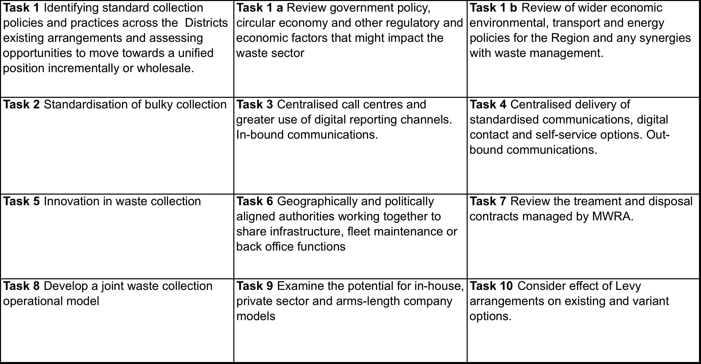

The detailed analysis supporting the recommendations and conclusions of this review are contained in a series of Appendices, which are in fact complete reports in themselves. These reports group together tasks that contain common themes and address the key bullet points in the terms of reference. The reports are titled;

1. Strategy, Practice, Policy and Joint Working Opportunities – this report covers tasks 1 to 4 and considers waste policy and regulations and their impact on services. It deals with bullet points 1 & 2 in the terms of reference. It should be noted that since this commission began the UK has voted to leave the European Union; this is an area that is commented on as it has introduced a certain degree of uncertainty around the area of future waste policy and the circular economy.
2. Innovation in Waste Collection – is a report that considers how technology and IT are impacting waste collections and what benefits this might offer to the authority.
3. Infrastructure Sharing, Collection Modelling and Depot Rationalisation – this report considers the opportunities for savings and efficiencies within the 6 collection authorities. It evaluates the opportunities for sharing infrastructure, joint waste collections (within current authority boundaries) and depot rationalisation. It did not assess the benefits that would arise from rerouting all collection vehicles across the whole city region ignoring the current boundaries. This would be the subject of a much more detailed assessment, which was beyond the scope of this review. Neither did it address communal, high rise and difficult properties (that make up 10% of the housing stock for the region; this issues is commented on in 1 above). This report covers tasks 6 and 8 and bullet point 3 in the terms of reference.
4. Review of RRC and WMRC contracts managed by MRWA – This looked at the opportunity for savings and efficiencies within the forthcoming Resource Recovery Contract (RRC) and the Waste Management and Recycling Contract (WMRC). It also considered the interface issues between these contracts and the waste generated by the collection authorities as it impacts savings and the levy. This report therefore links with the Collection Study above and delivers Task 7 of the review.
5. Organisational Options – This report covers bullet point 5 in the terms of reference and Task 9. It looks at the various organisational structures available depending on the extent on integration and identifies the potential for savings and efficiencies.
6. Funding and The Levy – Future Options; Finally this report considers the existing levy, its complexities and how this might be simplified in a more integrated organisation structure.

# General Comments and Observations

It became very obvious at the early stages of this review that integration of the activities of the waste collection authorities (WCAs) and MRWA was the way forward. This view was largely supported at the workshops to the extent that the participants were keen to discuss how this might occur in practice. It will not come as a surprise that the principle of economies of scale is at play here and applies to many of the activities of the authorities both operational and back office. The reports covering the various areas of business activity elaborate on this factor in much greater detail but suffice to say the closer the approach to an integrated service offering covering the whole LCR the greater are the efficiencies and savings. This we will call the 7 to 1 argument, in that by and large, it is far easier, efficient and economic for a single fully integrated service, to implement an initiative, be that buying a new fleet of vehicles or procuring a new service, in comparison to 7 individual authorities doing the same thing independently.

On this basis the review refers to a fully integrated service as the Joint Waste Authority (JWA), which includes collections, treatment and disposal. Further to this a single body, able to oversee the whole waste function for the LCR, will be far better placed to act strategically and decisively and respond to the policy and commercial challenges it will undoubtedly face in the future as identified in this review.

It was also fairly clear from the results of the analysis that individual authorities had already taken steps to drive out the majority of efficiencies and savings that were under their control. This actually presented some challenges to the review, as sharing assets and services across functions within single authorities brought about these savings. For example, depots where waste collection vehicles were based were often used by other transport and logistics functions within authorities. This meant that moving vehicles from one authority to another to place them closer to their point of use, and therefore more efficient, was prohibited on the grounds of lack of space to park these vehicles.

A point worth making is that whilst this review was limited to the assessment of the waste management assets and services it would, at some future time, be sensible to take into account the rationalisation of a wider group of services based around transport logistics and the assets they utilise to maximise efficiencies and savings.

The final comment to make is that the evidence to support the savings figures and efficiencies identified in this review come from a number of sources. Where it was possible, and the data was readily available from the authorities, actual figures have been used. This applies to the collections modelling work and the savings relating to the reduced collection and disposal costs. Where figures were less certain, for example, concerning organisational restructuring and combining the authorities into a joint body, Local Partnerships has drawn upon its experience of undertaking similar reviews for other regions, where all aspects of their waste management systems have been investigated. This has included the following studies:

* Delivering Waste Efficiencies in the West Midlands – which included a review of 33 authorities;
* Partnering and Efficiencies Report for London – al London Boroughs;
* Delivering Waste Efficiencies in Yorkshire and the Humber – which included 22 authorities;
* Delivering Waste Efficiencies in the North East – 12 authorities; and,
* Delivering Waste Efficiencies in the North West – which was complete in March 2016 and included 4 of the LCR authorities and the MRWA.

# Findings from the Reports

The following sections summaries the key findings of the main reports that make up this review. They describe the key findings, including the savings and efficiencies, the benefits of integration and the timeline.

## Strategy

This section of the review considered the factors impacting waste management activities within the LCR including the role of regulation and legislation, policy and any future waste related targets together with examples of initiatives taken by other cities and regions. It also considers the current powers of the devolved region that relate to waste activities (as opposed to those that might arise in a new organisational structure which are dealt with in section 4.7) and those available to authorities in terms of charging and enforcement.

### A Future Outside the European Union

The vote to leave the European Union has created a large degree of uncertainty not only restricted to the waste sector. It has been reported widely in the press that about 70 per cent of environmental safeguarding comes from European legislation.

Whilst there is uncertainty of the potential impact that our departure from the EU will have on waste related policy and strategy, it is considered unlikely that there will be any fundamental changes in the short to medium term. This suggests that there will be no further significant legislative obligations placed upon the authorities until post 2020 at the earliest, but probably later. More pressing issues linked to trade negotiations and agreements are expected to dominate in the coming years. Therefore, it is recommended that LCR adopt an approach that enables it to influence the future policy direction of England and be in a position to quickly and efficiently respond to changes either brought about by regulation or identified as either an economic, environmental or service related improvement by the region itself.

Acting as a unified body will enable the authorities to target these initiatives far more effectively than operating as individual entities. The Joint Municipal Waste Management Strategy for Merseyside[1] published in 2008 establishes and signposts many actions that collectively would be far easier to implement working formally together; these are discussed further on in this review.

The strategy for the region therefore needs to be updated to reflect changes that have occurred in the external recycling and energy markets and the pressure on finances within the authorities since 2008. At the same time this document should seek to draw all the authorities together to provide a collective action plan for the future. Given the uncertainty resulting from Brexit the authorities should take the opportunity to establish an efficient waste and resource management platform that complies with the current environmental requirements, consolidates its operations around common practices and maximises the benefits that can be derived from the RRC contract. This will create efficiency and short terms savings and place it in a position where it can quickly react to changes in the future, either planned or enforced.

### Circular Economy

LCR has been more proactive than others in starting to incorporate the circular economy, at least within its strategic thinking, and recognises the potential role that a more circular approach can take to job creation, skills development and economic growth, particularly in the green tech field. Opportunities exist in terms of targeting specific material streams (particularly the growth streams such as electronics, plastics and organics) and removing geographical boundaries to support the development of dedicated infrastructure and business networks. The foundations are there, upon which LCR can build and develop a more integrated approach towards waste and resource management.

These opportunities however often require economies of scale to enable viability. They also present a different level of risk compared to the various operational changes identified in this review and this may mean putting capital into projects that, as they are likely to be more innovative, present more risk as well as opportunities.

There are however initiatives that have been identified in this review that would contribute to the circular economy. These have not been fully costed but there are examples from other authorities (a series of case studies are explored in Appendix 2). Perhaps the most interesting one in relation to this review concerns food waste treatment and energy production.

In Section 3 a series of new collection scenarios have been modelled across all authorities, one of which is a separate food waste collection. Upon assessment however this has been rejected at present, simply as it is not cost effective albeit it does provide environmental improvements in terms of increased recycling.

There are 2 main factors causing this; the additional cost of vehicles to collect food waste separately and the cost of treatment. It is the latter issue where there lies a future opportunity to invest in the circular economy. The main reason the cost of food waste treatment is high at present is that there is limited infrastructure available regionally and therefore as a result of a supply and demand imbalance, costs are high. If LCR was to develop a local treatment facility (this would be anaerobic digestion (AD)) it could invest directly in such a scheme and benefit from a lower cost local treatment facility (using public finance) that would be a source of electricity and potentially gas (both fuels that could be used in the future to power vehicles).

This would have to be the subject of a separate business case but the point is that this would probably only be viable if all authorities initiated a food waste collection service at the same time in order to generate sufficient tonnage of waste to drive out the economies of scale in the construction of the AD facility. This has the added advantage of creating local jobs and retaining the resource (energy) within the region.

Such a facility could then form the basis of an Eco park or similar business hub where other waste and resource management activities could be developed.

### Resource Focused and Circular Economy Driven Case Studies

In order to illustrate some of the initiatives undertaken by other cities and regions in addressing the circular economy a number of case studies have been selected. These case studies are from a diverse range of locations but serve to demonstrate that working closely together and having a well thought out strategy can deliver impressive environmental results as well as efficiencies.

The case studies selected were:

* Milan
* Tokyo
* Oslo
* Copenhagen
* Kalundborg
* Flanders

Learning from other cities can be fraught with problems in terms of legislation, finances and cultural differences impacting upon the appropriateness of the comparison, but nevertheless there are always lessons to be learned and innovation to be found from looking at others. The details of the initiatives these cities have implemented are set out in appendix 2. Perhaps the main conclusion to draw from these case studies is the level of cooperation that has occurred between the municipalities, local organisations and business to make these initiatives work.

### Direction of Travel of Devolved Administrations in Scotland And Wales

The examples of the devolved administrations are featured in the review (appendix 2) to illustrate the potential power and authority of devolution in environmental and waste matters. The paths that the devolved administrations in Scotland and Wales have taken are very different to England; however, in both cases they have a clear direction of travel and have put in place appropriate support mechanisms, including financial support and financial penalties, to deliver their strategic priorities. This reinforces the need for LCR to be very clear what its priorities and intentions are and how this fits together with its own devolution agenda.

Suffice to say Wales, which has twice the population of the LCR, has made great strides in its environmental performance since becoming a devolved administration and is now recycling at a level of 60%[2].

### Devolution of Powers to Local Authorities

LCR has a unique opportunity to play a leading role in developing the next stage of devolution. Effectively broadening its remit from simply focusing on the economic growth agenda, and bringing wider social and environmental benefits for LCR. Much of the focus of regional policies recognises the value of taking a coordinated approach and there may be a chance to influence future direction terms of devolution of responsibilities.

In terms of LCR, a second devolution deal was announced alongside the March 2016 budget, where the city region will take on the following additional responsibilities:

* Beginning to plan for integration of health and social care;
* A review of the delivery of children’s services;
* The Apprenticeship Grant for Employers, accompanied by discussions on the use of funding from the apprenticeship levy;
* Additional, unspecified transport and highway powers to accompany the city region’s Key Local Roads Network; and,
* Work on developing a Clean Air Zone.

Liverpool will also pilot 100% retention of business rates revenue as of 1 April 2017, in advance of English local government as a whole retaining 100% of business rates revenue from 2020.

Whilst this does not specifically include the waste function there would seem to be little reason why this should not be included (as is the case in Manchester) as it will contribute to a number of the existing responsibilities. In particular we note the work on developing Clean Air Zones, where there is the opportunity to improve emissions from waste collection vehicles using alternative fuels (see section 4.4 Innovation in Waste Collection), together with additional links to energy (as discussed in section 4.1.2 on the Circular Economy), the environment and jobs. Indeed it would seem a missed opportunity if such an integral service was to be left out.

### Local Authority Powers

LCR should consider the full spectrum of powers available in delivering and enforcing any future service changes, particularly in relation to behaviour change. Although there are limitations and restrictions at present, with discussions centring on the role of local government, it is recommended that LCR maintain a watching brief on policy developments, particularly in relation to charging and enforcement powers.

The issue of enforcement and charging is dealt with in more detail in other sections of this report where the latter, charging for green waste collection and disposal, is proposed as one of the key short-term savings.

### Changes to Waste Composition and Growth

Reductions in paper and glass, increases in cardboard, growth in WEEE and a broader range of plastics, particularly flexible and composites are the trends predicted in the coming years. Being prepared to respond to changes in waste presented for collection is essential in order to maximise potential opportunities that may arise from the processing or management of these waste streams. This will include linking in with wider regional strategies focused on advanced manufacturing and addressing resource use, and utilising the knowledge hub that exists within LCR.

Minimising waste growth is the most effective way of reducing waste costs. As the region grows and new housing stock develops there is the opportunity to ensure that this new stock is designed to accommodate modern waste management techniques and that these new communities participate fully in the schemes available to them. There is an opportunity to use such developments as beacons of good practice for other areas.

## Review of Wider Economic, Environmental, Transport and Energy Policies for the Region and any Synergies with Waste Management

During workshop sessions and feedback from the individual authorities there were a range of different examples reported of activities that ‘fit’ within the priorities and expectations of the LCR and its wider goals as set out within the various regional policies. However at present they are not joined up strategically or coordinated to form a common direction of travel. Nor are they generally being recognised within a broader strategic context.

Linkages with waste and resource management, either directly or indirectly, are numerous in terms of the potential to generate a viable alternative energy/fuel source and its role in a low carbon economy, plus its contribution to job creation and economic growth. There is synergy in terms of the waste agenda maximising the opportunities that retaining the value of resources can bring, and the strong knowledge base and commitment to R&D and scientific exploration as recognised in the various regional strategies and policies, are essential in supporting the process.

As a cautionary note, there are clearly a number of detailed strategies and plans targeting specific issues and challenges within LCR. However, it is not always clear, in a delivery sense, as to how these all fit to together, i.e. where there is overlap, where issues are complementary, where there is synergy etc. Introducing another strategy that is focused on waste and resources without any formal linkages with existing regional strategies and plans would potentially add to that confusion. Therefore, how a waste and resource strategy may support delivery of the wider issues such as employment, skills, training, low carbon etc. should be a key factor in the direction of travel being propose.

Table 2 sets out the synergy between maximising the opportunities from waste and other LCR strategies.

Table 2 LCR Strategies that link with the waste agenda

|  |  |  |  |  |  |  |  |
| --- | --- | --- | --- | --- | --- | --- | --- |
| Opportunities from waste | Sustainable Urban Development Strategy | A Transport Plan for Growth | Innovation Plan | EU Structural and Investment Funds Strategy | Building our Future | Making it: Advanced Manufacturing | Sustainable Energy Action Plan |
| Optimised collection across LCR |  | ✓ |  |  |  |  |  |
| Retaining value of resources across waste stream |  |  | ✓ | ✓ |  | ✓ | ✓ |
| Employment opportunities | ✓ |  |  | ✓ | ✓ | ✓ | ✓ |
| Training opportunities | ✓ |  |  | ✓ | ✓ | ✓ |  |
| R&D: Innovative processing solutions | ✓ |  | ✓ |  | ✓ | ✓ |  |
| Generating alternative fuel/energy sources | ✓ | ✓ |  |  |  | ✓ | ✓ |

## Joint Working Opportunities

### Introduction

On initial viewing the practices and policy across the region were broadly similar, which makes the adoption of a joint approach, appear fairly straightforward. However, upon further investigation there are some variations that need to be addressed, particularly within the detail, in order to have conformity. The current policies and practices of each authority and other matters are set out in detail in the report in appendix 2.

The abiding conclusion, however, was that to enable an efficient and cost effective collection system to operate that can easily adopt new national and regional policies and adapt effectively to new priorities it is proposed that all authorities initially agree to a **single joint collection policy**.

This will form an enabling policy, which will allow other initiatives to be delivered jointly, standardising processes, increasing performance and ensuring systems in place are used effectively. It can also be used as the means of initiating change. A project could be set up, involving all authorities, with the objective of establishing the joint collection policy and the mechanisms by which the other joint working initiatives described below will be implemented.

Figure 1 illustrates this graphically.

The intention is that, although there may be some short term costs attached to implementing a joint collection policy, and the associated joint initiatives made possible by this enabling policy, this will ultimately lead to longer term savings, whether this is through more efficient processes and sharing of resources or through income generation from maximising diversion and using spare treatment capacity as effectively as possible. Without an enabling policy it is doubtful that further progress in joint working could be made rapidly if at all.

Figure 1: Strategic and Policy Options arising from a Joint Collections Policy

To illustrate what this means in practice a summary of all those elements that would need to be incorporated once a joint collection policy was established and the associated benefits once these policies had been adopted, can be found in sections 4.3.2 and 4.3.3. Whilst these actions could be undertaken by agreement of individual authorities it is our view (and this is set out in more detail in appendix 6 on Organisational Structure and summarised in Section 4.7) that this would be easier and more effective if it was done as part of the transition to a Joint Waste Authority.

### Benefits arising from acting as a Joint Waste Authority

Itemised below under key headings are the benefits that would flow from acting as a JWA.

* **A single joint collection policy for all authorities**. This would include a common position[3] with regard to:
  + Arrangements for collection from ‘standard properties’ in terms of placing containers at the curtilage of the property, time of placement, duty on householders;
  + Arrangements for collection from challenging properties, including communal, terraced and hard to reach (tailored policy positions applicable across LCR);
  + Arrangement for assisted collections in terms of the application process, supporting documentation required and review period;
  + Single charging structure for replacement bins, providing a unified policy and pricing structure on replacement containers;
  + Common closed lid/no side waste policy;
  + Single reporting system and response to missed collections; and,
  + Shared approach to enforcement (system of warnings and final issuing of FPN).
* **Centrally coordinated and jointly delivered enforcement team.** This would enable:
  + Single team to provide targeted campaigns/respond to issues as required across LCR;
  + Officers to operate out of satellite depots to provide coverage across LCR or in relation to hotspots or challenging area;
  + Single standardised application of enforcement tools for all authorities.
* **Joint Customer services delivery.** As a minimum this would ensure:
  + Single point of contact for all authorities (made viable through generic collection policy);
  + Increased automation of waste related services in terms of requests, applications and payment;
  + Standardised response to all telephone and online queries;
  + Provision of all service delivery information; and,
  + Provide a single focal point for data and information to be processed from in-cab technology.
* **Joint approach to the collection and management of bulky waste across LCR (with phased involvement from Wirral and Liverpool).** This will include:
  + Procurement of third sector in delivering a reuse orientated service;
  + Unified charging system across the authorities;
  + Standardised application process and duty on householders in terms of the collection.
* **Joint clinical waste strategy.** This will include:
  + Establishing a clear referral system coordinated with public health bodies covering clinical waste collection;
  + Address issues amongst those working in the community, in order to be clear about the advice health professionals are giving out.
* **Joint Procurement Hub.** This will provide:
  + Single coordinated procurement service for all authorities;
  + Potential to maximise economies of scale that can be realised;
  + Coordinated purchasing of items such as bins, fuel, vehicles, agency staff etc.
* **Centralised communications** **for service delivery.** This will ensure:
  + Single, high impact messages linked with coordinated joint collection policy
  + Targeted support as required for challenging properties/areas and in relation to service changes or changes in performance.

### Efficiencies and Savings from Joint Working

The efficiencies and savings arising from these actions would be realised through better use of the service, which would be reflected in increased recycling rates, reduced disposal costs, and additional capacity for sale of third party treatment. In addition, savings would be realised through a potentially reduced kerbside clinical waste service, a common approach to bulky waste, coordinated enforcement and communications to change behaviour, and the ability to jointly procure (whether this is staff, equipment, vehicles etc.).

Placing an accurate figure on these savings is challenging largely due to the many different ways authorities account and allocate these costs within their organisation and where resources are shared and outsourced, how this is apportioned. Where this information was available it has been used to provide a figure. However, where this was not Local Partnerships has drawn on its experience and the results from the 5 regional waste reviews it has carried out in the last 5 years, including the North West.

In terms of savings from joint working those proposed have been assumed to arise under the umbrella of a JWA. It is believed that a combined approach to all the initiatives would generate a saving of between 10 and 15% of the collective overhead dedicated to waste activities and addressed in this section of the review. Identifying the cost of this overhead within each individual authority has not been possible but we believe collectively, including MRWA, this amounts to somewhere between £5m and £7m per annum. Consequently the saving is in the range of £500k to £1.05m. This is a strategic assessment and a more detailed bottom up analysis would be required to validate these figures going forward.

There will also be further operational savings in each of the individual areas reviewed and these are set out in the analysis below at section 4.3.4.

In support of this analysis a qualitative assessment of the likely impacts of the changes proposed on a series of criteria including short, medium and longer term financial benefits has been produced in Table 3.

Table 3: RAG rating of the benefits of moving to a joint collection body

| Impacts | **Enabling Policy** | **Strategic actions facilitated by enabling policy** | | | | | | |
| --- | --- | --- | --- | --- | --- | --- | --- | --- |
| **Joint collection policy** | **Jointly delivered enforcement** | **Centralised communication** | **Joint approach to the collection & management of bulky waste** | **Joint Procurement Hub** | **Joint clinical waste strategy** | **Joint Customer services delivery** | **Increase automation of services** |
| Job creation |  |  |  |  |  |  |  |  |
| Financial benefits (short term) |  |  |  |  |  |  |  |  |
| Financial benefits (medium to long term) |  |  |  |  |  |  |  |  |
| Training/skills development  opportunity |  |  |  |  |  |  |  |  |
| Improvements in reuse/recycling performance |  |  |  |  |  |  |  |  |
| Potential for positive behaviour change |  |  |  |  |  |  |  |  |
| Ease of implementation - short term |  |  |  |  |  |  |  |  |
| Ease of implementation - medium/long term |  |  |  |  |  |  |  |  |
| Relationship to devolved power agenda |  |  |  |  |  |  |  |  |

### Savings and Comments associated with Specific areas of Joint Working

#### Bulky Waste

Incorporating the reuse sector/charities/third sector into bulky waste collection will provide financial savings for Councils in terms of collection and will maximise reuse, diverting tonnage from disposal and creating capacity for third party sale. The wider benefits of reuse can also be realised in terms of job creation, skills development, and meeting a social need for the more vulnerable members of the local community. In addition, standard charges would be applied for all residents and standard communications in terms of the expectations on the householder in supplying goods for reuse. **The savings in this area are estimated to range from £120,000 to £572,000 based on current operating costs and are likely to arise over the medium term** if the schemes are promoted more widely and a greater diversion from disposal is achieved.

#### Customer Service and IT

Adopting a single joint customer services team will streamline the initial point of contact for residents, reducing staffing levels, and providing a standardised service. Adopting a single point of contact would provide the opportunity to extend online reporting systems further allowing a faster response to resident communications. Maximising the role that online and automated services play in communication routes into the authority has the potential to make significant savings. As an example data from an LGA study[4] and data from one of the LCR Councils[5] illustrated the difference in cost between different forms of communications as follows:

Face to Face £5.51-£8.62 per interaction- average £7.07

Telephone £2.53-£4.00 per interaction – average £3.27

Web based £0.14-£0.39 per interaction -average £0.27

Data was not available from the authorities on these interactions but this strongly supports a (further) move towards web-based transactions, particular in combination with other IT developments such as apps where push and pull communications can be used. This is discussed further in the section 4.4 on Innovation in Waste Collections.

#### Centrally coordinated and jointly delivered enforcement team

Adopting a clear strategic approach to managing waste related crimes across LCR would allow enforcement to be utilised alongside education and engagement as a behaviour change tool. At present enforcement appears to be under funded and not being used as a means to address some of the challenging behaviours across the authorities. Incorporating a centrally coordinated and jointly delivered team would provide a single expert resource; this would effectively support the implementation of a single joint collection strategy and could be targeted according to circumstances thereby applying the right level of resource as circumstances dictate.

Under this heading it is worth reporting that there is work being undertaken on selective licensing for private landlords. The use of licenses for Houses in Multiple Occupation (HMOs), which meet certain criteria means that a basic standard has to be applied; there are also Selective Licenses for private landlords, which the authority can impose. For example, Liverpool’s Landlord Licensing Scheme means that from 1st April 2015 all private landlords in the city must obtain a licence for each of their rented properties.

The scheme is being introduced in Liverpool under the government’s selective licensing laws and signing up for it is compulsory. Authorities can use these to request a minimum standard. For example, in Brent the selective license states that the license holder should provide a sufficient number of external rubbish bins for the occupiers to dispose of waste. They are also responsible for ensuring that any kind of refuse which the authority will not ordinarily collect (e.g. large items of furniture, hazardous waste etc.) is disposed of responsibly and appropriately. So building on from this Councils can be much more assertive in terms of expectations of private landlords in relation to waste management.

This links with comments made below at V111 on VIII Flats, Multi-Occupancy and Difficult Properties and could provide the authorities with another vector to enforcement and behaviour change.

#### Joint Clinical Waste Strategy

Clinical waste only requires collection from the kerbside separately to household waste if it is considered to be a risk and therefore hazardous. To ensure collections are appropriate and are required adopting a standard audit and developing a strategy will ensure a common position is adhered to. At present two authorities do not currently collect from the kerbside and another two are in receipt of funds to support a kerbside collection. This leaves two who are providing a separate service with the costs met by the collection authority. Full application of the legislation should be met and it is anticipated that this will result in a cost savings in terms of reduced need for a separate vehicle and crew. **The example given in the main report at appendix 2 showed an annual savings of £100,000/year for a County Council and 4 Authorities.** This would suggest that similar, if not greater, savings are possible across LCR.

#### Joint Procurement Hub

Different frameworks are currently in use and not all councils are convinced that they are securing the best deal through these frameworks. Collectively purchasing through a joint procurement hub will allow for savings to be generated through an increase in the volume of the orders being made (thereby realising economies of scale) and savings in the cost of procurement (one procurement exercise instead of multiple). It has been estimated that 10% savings can be realised on vehicle purchases and 35% on container purchasers when multiple orders are made. Simply put the establishment of a joint procurement hub for all elements of the waste management service will drive out the economies of scale in terms of bulk purchasing and administration, allow for a dedicated team with market knowledge to be developed and provide a more focused response to the needs of operations.

As an example assuming the vehicle fleet across the whole city region is replaced over a period of 7 years (a typical replacement cycle), this currently amounts to 167 vehicles. The average cost of a vehicle at today’s prices is around £160,000, assuming for arguments sake that these are replaced at the rate of 1/7 per year this amounts to 24 vehicles per year at a cost of £3.84m; if a 5% reduction can be achieved for a bulk purchase over this period then this amounts to **a saving of £200k per annum.** It is to be expected that similar savings can be made with consumables and maintenance costs at the same time; **this is estimated as a further £167k**.

Whilst the procurement mechanism may not be through a simple capital spend it is likely that similar concessions can be negotiated for lease arrangements.

The message is however clear; procuring as a JWA will deliver savings.

#### Centralised Communications

Centralised communications would accommodate both in bound and outbound communications. This would mean handling customer enquiries and managing educational campaigns. For example, contamination of recyclate is a big challenge, as is appropriate and effective use of the service by all householders across LCR. Resourcing for communications at the collection level have diminished significantly over recent years. Developing a single coordinated resource to deliver a centralised communications service across LCR enables resources to be shared, engagement activities to be enhanced and use of the service to be improved. The most effective means to deliver this is building on the work of MRWA who have been coordinating waste prevention communication for some time and have a dedicated staff resource to do this.

Savings would also be realised through better use of the services leading to increased recycling and diversion from treatment/disposal, freeing up capacity for third party sale; however, these savings are already accounted for in the modelling.

#### Fly tipping

Illegal disposal of waste is a widespread problem, which has unpredictable costs and resource implications for all authorities. From the data collected from authorities this can cost anything from £50k to over £300k per annum. There is a natural concern that these costs can increase if new schemes are introduced such as charging for green waste or permits at HWRCs. There is no silver bullet to the prevention of fly tipping but a coordinated approach to communications, enforcement and clean up will help focus resources on this issue and develop expertise in dealing with these matters. Once again acting as a JWA will ensure these activities are delivered efficiently. If fly tipping is a collective liability to all authorities of over £1m per annum then there is a sound justification of an invest to save programme aimed at targeting this anti social behaviour.

#### Flats, Multi-Occupancy and Difficult Properties

The main focus of this review was on the 90% of properties that receive a routine collection service. The remaining 10% comprise of households in dense urban areas, particularly multi-occupancy properties and flats. Recycling can be challenging in these locations in terms of securing high levels of participation and achieving effective capture rates without significant contamination. This was readily acknowledged during the workshops and from feedback from individual authorities. The quantity and quality of recyclate from multi-occupancy properties can be difficult to collect; contamination of communal recycling bins remains a significant issue for many. Liverpool has recently run a trial as part of a WRAP funded project, testing the impact of different interventions in flatted accommodation. A number of other trials have also been taking place in other parts of the country, testing the effectiveness of different approaches. The results from this project and others are expected early next year along with a guidance document. It is therefore recommended that any operational changes proposed should build on this evidence base and reflect the good practice that WRAP is establishing through the project and its previous research in this area.

Clearly this challenge is not restricted to one location or one authority however the preferred solution(s) are likely to be the same regardless of location. This again, from an efficiency and knowledge base perspective lends itself to being conducted at a regional level so that any lessons learnt in trials or in practice in one area can be rolled out to others.

As far as this review is concerned no modeling has been undertaken in this area to assess the opportunity for savings or efficiencies, however, from the economies of scale argument and the improving levels of understanding that will be gained from the trials it is believed that there will be opportunities for savings which will result in cost reductions of **between £150k and £350k per annum across the whole region.**

## Innovation in Waste Collection

Developments and improvements in waste related technology and digital systems are occurring all the time. These incremental benefits are being introduced into the market mainly by the private sector as they strive to improve productivity, reduce costs and therefore make themselves more competitive in their commercial markets, and increasingly in the municipal markets. They benefit largely from the economise of scale they are able to achieve across their contracts and fleets as they are working on common IT platforms and have significant purchasing power.

The developments are largely in the field of real time data management, integrated IT systems (web and app systems), customer service interfaces (in coming enquiries and outgoing communications), in cab devices and GIS tracking. They are focused on improving customer response times, reducing administration and transaction costs.

Many authorities have elements of these new digital systems within their current operations but they tend to be sub optimal, vary from authority to authority and do not allow a complete “start to finish” approach such that there are various levels of manual re-keying, which tends to defeat the original purpose to make efficiencies. Another issue is that they are often embedded with other authority services which means that extracting the costs of operation and therefore any savings is extremely difficult. On the other hand it is possible to qualitatively demonstrate the efficiencies that can be derived from new digital systems; reference has been made to these savings in section 4.3.1 with regard to a centralised customer service function. This process is known as ‘channel shift’.

To illustrate this for every 1000 face to face enquiries converted to web based transactions (where this transaction could equally arise from an app) there is an estimated saving of £6,800/pa. This is a crude estimate using average figures but illustrates the potential that is possible with a client base of 1.5m people in the region.

Similarly, there are no figures available in terms of translating a web-based request for a service directly to the operational function in real time i.e. without manual intervention. However, an example might be if a request is received for a replacement bin through the web, which is then automatically scheduled into the next available appropriate vehicle in the vicinity, this will remove any need for any manual intervention and remove the cost of taking the order and then setting up the delivery. Technology like this is already being used in other sectors in particular parcel logistics borne out of the increasing use of web based purchasing,

There are similar arguments about savings concerning other uses of technology for example communicating with the community about changes to services; currently this is done through leafleting and general web based information, but at some stage in the future there will be scope for supporting this with push messaging through apps. Acknowledging the fact that not everyone in the region has a mobile phone, or indeed the app, this could be very beneficial when targeting some groups in the community. For example students, the majority of whom have mobile phones, using messages reminding them when to put their rubbish out and what to recycle; this is also a mechanism for initiating behaviour change. This “channel shift” model is increasingly becoming part of modern life and no doubt will be adopted widely in other areas, so familiarity with use will be growing. There is therefore no reason not to develop this in the LCR.

Complimenting these developments are GPS tracking and telematics monitoring of vehicles during their daily activities, together with real time data capture using data pads enabling operatives to record events as they occur. These are systems that record activity in real time so that the location and activity of vehicles can be monitored and operatives can record and report issues as they arise and can be instructed accordingly. The recoding systems can be simple data entry pads or even cameras. Again these can play a major role in changing behaviour.

As noted above it is difficult to ascribe savings to the adoption of these technologies however it is almost certain that adopting these types of innovation in an established JWA will be much more efficient and cost effective than trying to replicate this over 6 collection authorities. It falls into the category of invest to save and should be the subject of a separate business case as part of the implementation of the wider changes that would accompany the formation of a JWA. The timescales and savings estimates anticipated are reported at the end of this section of the review.

A further area of interest lies in the development of alternatively fuelled vehicles with the aim of reducing operating costs and improving emissions to air (linking to the Clean Air Zone initiative for LCRCA). The technology for natural gas powered vehicles is ready now but is only slowly being adopted due to the timing of fleet management changes and fuelling arrangements. It is however between 10 and 20% cheaper than the equivalent diesel fuel. Other technologies like electric or hydrogen fuel cells are not currently commercially available but it’s an area of transport development that is changing rapidly.

The change to a fleet operating on gas will require detailed planning and assessment, for example fuelling arrangements will need to be arranged at each depot (and the synergy with other transport operations will need to be considered). The choice in the medium term is likely to be to gas from the grid but eventually it may be possible to use biogas if AD facilities are developed locally (ref section 4.1.2 on the Circular Economy). A longer-term vision might be a move to electric or hydrogen powered vehicles but at this stage their development for HGV use is still in its infancy and not advised until the technical challenges are resolved.

### Timelines and Savings

Short term (0-2 years)

Setting up of the Web and App based interface so that the public can report their orders, requests or complaints through this medium and engender channel shift

Development of a common standard for telematics and vehicle data, and vehicle fuelling standard for an alternative fuel specification

Medium term (2-7 years (assuming a full cycle of vehicle replacements)

Procurement of data capable vehicles to facilitate real time monitoring of work in progress and improve fleet maintenance and driver performance.

Development of alternative fuelling capability progressively rolled out in line with fleet replacement profile.

Development of the back office handling methodologies to take web based communications directly to enactors reducing call centre and officer intervention.

**Overall the savings that might be accrued from implementation of these data management systems once fully developed are likely to be £100k-£500kpa**, so long as the full extent of automation is adopted for enquiry handling. The improvements in alternative vehicle fuelling will require capital investment in filling stations and at this stage the cost can only be loosely estimated at between £1-5m but this will yield a **saving in fuel costs of between £500k to £750k each year once fully rolled out** and significantly contribute to reduced emissions.

Once again it is reiterated that these changes should be the subject of separate business case but undertaking this on a regional basis will not only be more cost effective but will capture the synergies that these areas offer to the wider LCR.

## Infrastructure Sharing, Collection Modelling and Depot Rationalisation

This section of the review considered mechanisms whereby the collection authorities could make savings and efficiencies by sharing infrastructure, depot rationalisation and moving to a common collection scheme.

In the latter case a number of collection scenarios were selected in consultation with the collection authorities at the workshops. These aimed to align the collections schemes used by all the collection authorities and were selected on the assumption they would either improve environmental performance in terms of the tonnage of waste recycled and/or make savings.

It should be noted that the modelling of common schemes was carried out within the existing boundaries between the authorities and did not remodel the whole LCR as this would be a significant task and have required specialist software beyond the scope of this commission. If this exercise were to happen Local Partnerships believes this would deliver additional savings as the current boundaries restrict the optimisation and efficient use of vehicles.

Additionally the savings that have been estimated are not solely due to improvements in vehicle efficiency but also as a result of reductions in waste tonnage or the movement of waste from a higher to a lower cost of disposal.

This factor is an extremely complex feature of the interaction between the waste and collection authorities and the contracts managed by the MRWA for treatment that is the RRC and WMRC. In particular, if capacity is freed up in the RRC contract, by increased collection of recycling, this free capacity can attract an income from third party gate fees sold by the contractor. To illustrate this a number of worked examples have been developed, based around the collection scenarios modelled, to provide a more accessible explanation. This will also be referred to in section 4.8 on the Levy. This is set out in appendix 1.

### Assessment of Shared infrastructure

This section examines the potential saving that could be achieved by sharing assets between the authorities. It was carried out using GIS mapping and drive time analysis[6]. It enables a huge amount of data to be managed visually, which was extremely beneficial when discussing the results at the workshops. An example is shown in Figure 2 for illustration:

Figure 2; The potential for depot sharing in the LCR

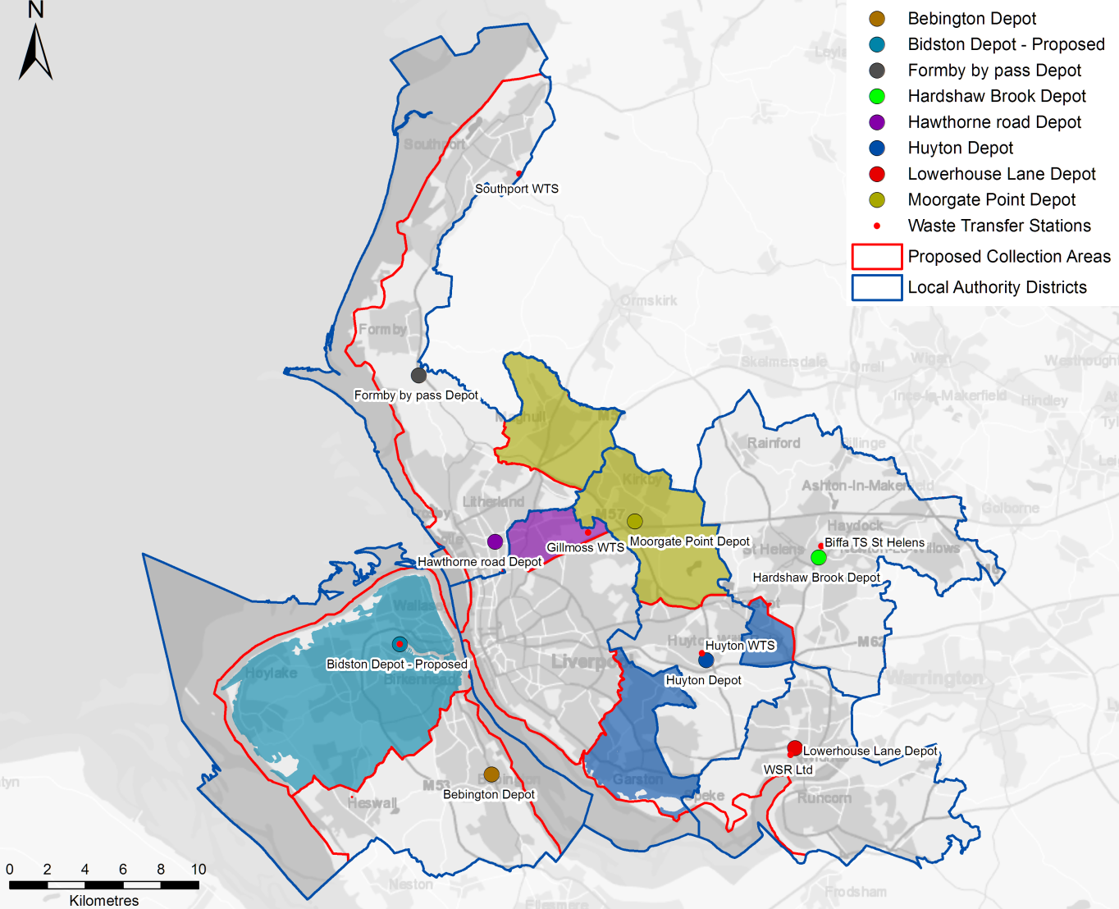

The drive time analysis shows that when considered at the LCR level the vehicle depots are not in optimal locations, which would be expected as the locations are based on the authority area they serve and the historic authority assets in each area.

The analysis also shows that there are areas across the LCR where rounds are not being served by the nearest depot. Therefore there is the potential to share depot assets and serve rounds from the nearest depot.

Based on parameters agreed at workshop 1 and further discussion with officers at workshop 2 and 3, four distinct areas for potential sharing of depot facilities were agreed for detailed assessment:

* 1. Serving the northern parts of the Wirral from Bidston Moss
  2. Realignment around the Liverpool/Sefton boundary
  3. Realignment of areas of south Liverpool and north Knowsley
  4. Serving Rainhill from Huyton

The detailed assessment considered a range of criteria including operational practicality, political acceptability and costs, a RAG system has been used to calibrate these opportunities in the report (appendix 4) as well as an estimate of the potential for savings:

* Realignment around the Liverpool/Sefton boundary and Serving Rainhill from Huyton are unlikely to deliver saving and could result in a net increase in costs.
* Serving the northern parts of the Wirral from Bidston Moss and realignment of areas of south Liverpool and north Knowsley could each deliver operational savings in the region of £40,000 to £50,000 per annum; however this would be offset in the first year by the need to communicate the operational changes to the residents.

Whilst Options a and c could provide some short term savings, if the longer term aim is to move to a JWA, the time and effort to implement the changes may be disproportionate to the savings gained, as a combined waste collection authority would be able to address these issues on a wider basis and not be as constrained by the limited capacity at the existing depots.

In addition to sharing of depot facilities, the option of developing a shared pool of spare vehicles was assessed as, in principle, this has the potential to reduce the overall vehicle requirements across the LCR and hence save costs. However, we conclude that the operational feasibility and H&S issues at present mean that it is currently not a practical option. Although the viability of a shared pool of spare vehicles could change if there was a standardisation of vehicles and depots were rationalised.

### Joint Waste Collection Operational Model

Four collection scenarios were analysed and compared to the current baseline i.e. the existing arrangements at each authority, using an industry standard modelling tool WRAP’s Kerbside Analysis Tool (KAT). These scenarios captured 90% of the housing stock in the LCR, the remaining 10% were comprised of high-rise, multiple occupancy dwellings and difficult to assess properties. The scenarios were selected with the authorities at workshop 1. They are reproduced in table 4.

Table 4: Scenario Summaries

|  |  |  |  |  |
| --- | --- | --- | --- | --- |
|  | **Collection** | **Frequency** | | **Capacity (L)** |
| **Scenario 1** | Residual | 3 weeks | | 240 |
| Food | 1 week | | 23 |
| Dry | 2 week | | 240 |
| Green | 2 week (39 weeks) | | 240 |
| **Scenario 2** | Residual | 2 week | | 140 |
| Food | 2 week | | 23 |
| Dry | 2 week | | 240 (co-mingled) |
| Green | 3 week (39 weeks) | | 240 |
| **Scenario 3** | Residual | 2 week | | 140 |
| Food | 1 week | | 23 |
| Dry | 2 week | | 240 (co-mingled) |
| Green | 2 week (39 week/charged) | | 240 |
| **Scenario 3a** | Residual | 2 week | | 140 |
| Food | 1 week | 1 week (co-collected | 23 |
| Dry | 2 week | 240 (co-mingled) / Sacks & boxes |
| Green | 2 week | | 240 |

This was an extremely detailed and complex part of the review and included running sensitivity analysis. The results and factors that influence them are described in more detail in the report at appendix 4.

The results from the modelling are best illustrated diagrammatically in Figures 3 - 5:

Figure 3: Change in recycling levels occurring according to the scenario

Figure 4: Household collection service costs for core collection systems

Figure 5: Household collection service costs for core collection systems inclusive of treatment contracts[7]

It will be noted that there has been a 4th scenario added to the ones originally selected. This was added due to the fact that the results of the 3 scenarios selected whilst generally improving environmental performance by increasing recycling were economically more expensive than the current arrangements (baseline).

The findings can be summarised as follows: Three alternative common collection systems have been modelled based around high recycling levels as defined at Workshop 1. Collection Scenarios 1 & 2 delivered the highest recycling rate, but were also more expensive than the baseline (business as usual). This arose because the costs of implementing a ‘city region wide’ food waste collection system, more than offset the savings generated by restricting residual waste collections and increasing recycling. The current contractual arrangement at MRWA, whilst providing stability and good value in treatment and recycling costs, does not incentivise food waste collection, as this is basically a pass thought cost. This factor has been commented about in 4.1.2 with regards to opportunities that may arise from investment and the circular economy.

Scenario 3 is modelled to exhibit both **savings (c. £1.2m / annum) and deliver an anticipated increase in recycling rate (c. 1-2%)**. Implementing a charged garden waste service drives these savings, for which there is a varying level of performance modelled through sensitivity assessment in the detailed report. If a charged garden waste service were implemented as a single measure (modelled as Scenario 4 in the analysis), then a greater degree of savings (over the baseline) would be anticipated of **circa £5m per annum across the LCR**.

The savings are also based on an assumption that capacity freed up in the residual treatment recovery contract is sold to third parties. This analysis is described separately in appendix 1.

These levels of saving are only based on using a common collection system and not working together in any other regard, however it is only through having a common collection system that further integration and saving can be realised to its fullest extent.

The analysis has shown a **further £0.5m - £1.4m / annum saving** would be deliverable through shared use of refuse collection vehicles[8] across collection rounds and significant further savings would also be expected to be delivered through a LCR route optimisation programme. In addition, and as described in sections 4.1 of the report, common procurement, communications and reduced management would be anticipated to exhibit added savings based around a common collection client.

### Depot Rationalisation

The location of the current depots is based on servicing an individual authority area and the availability authority sites/assets. There is an opportunity to improve efficiencies and make savings by optimising the location of the depots. 0shows the current depot locations and the drive times from the depots to the different part of each authority area. It highlights that the majority of the LCR can be reached within 25 minutes from the existing depot locations.

Figure 6: Vehicle drive times from existing depots

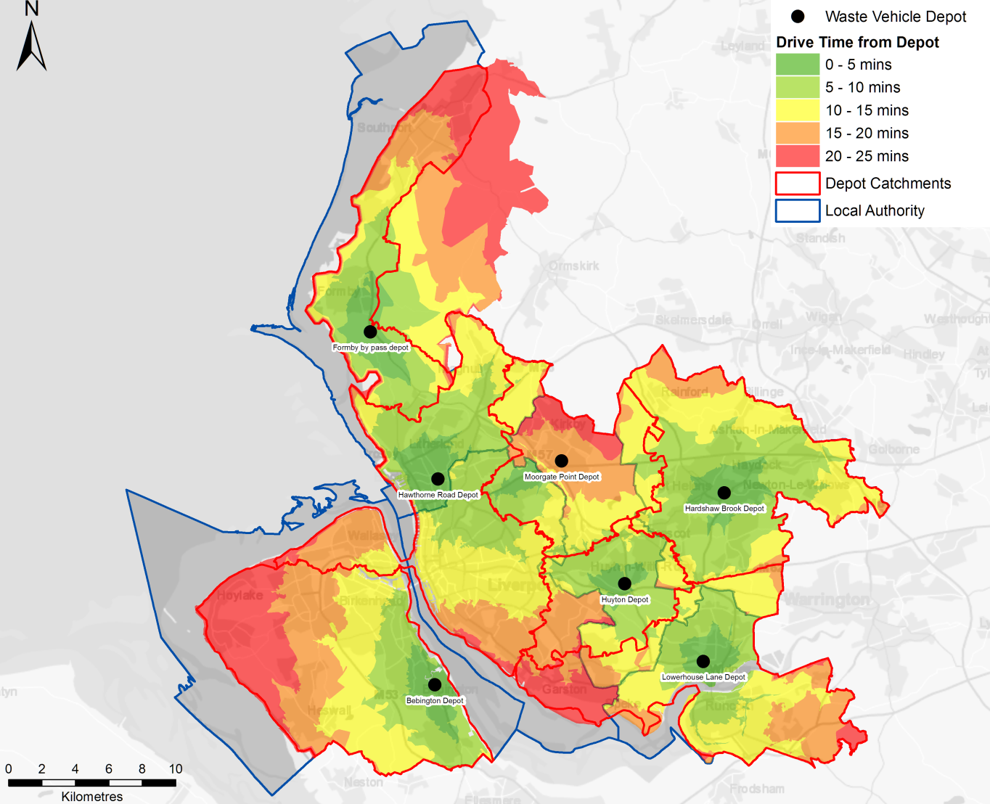

Drive time analysis was used to determine the optimum number of depots across the LCR whilst maintaining drive times that were comparable with the current situation. Two options were considered:

1. Completely optimised, i.e. no locations fixed; and
2. Fixing one of the depots at the Knowsley Rail Transfer Station (RTS), in order to examine the effect of co-locating vehicles at the Knowsley RTS as a potential long term option.

After further analysis Option 2 was discounted in favour of Option 1, which was taken forward for further analysis as explained below.

The operational costs of depots are often accounted for differently by different authorities, due to factors such:

* shared use with other services;
* depot ownership; and
* contact/lease arrangements.

Therefore it was agreed at Workshop 3 that potential depot savings need to be considered as both operational savings as well as potential asset values and that each Authority would provide:

* a range for annual operational costs for each depot; and,
* indicative asset value for each depot.

Reducing the operational locations by five across the LCR has the potential to reduce operational costs for the waste management service. Based on the limited information available, the full extent of this saving is difficult to define but could be up to £0.5m per annum. A detailed business case would need to be developed to properly quantify the potential savings and there are a number of issues that would need to be factored in to the evaluation:

* Whilst consolidating the number of locations related to waste management is likely to provide savings to the waste management service, it may not result in overall saving to the authorities. This is because the majority of the existing depots are shared with other services and if the depots need to be retained for those services, the depot operational costs would need to be fully distributed between those other services.
* Any potential asset value can only be considered if the depots are no longer required by the authorities for other services. Although, reducing the areas needed could allow other co-located services to be moved to smaller authority owned locations and allow the larger depot to be released.
* Co-locating vehicles depots at existing WTS is likely to require a level of capital investment e.g. refurbishment of offices, purchase of additional land for parking etc.
* Capital investment would be needed to develop a new location in catchment area 2. However, given that the Huyton WTS is in poor condition and will need significant refurbishment in the future, there could be the potential to co-locate both activities.

Therefore, the overall operational savings could range **from £0 to £0.5m per annum**. However, depot rationalisation does provide the starting point for wider collection cost savings related to common vehicles and future redesign of routes and route optimisation.

### Summary of Efficiencies and Savings

The benefits and savings that can be achieved through asset sharing and collection system commonality are dependent on the level of integration towards a combined waste collection authority. The further the authorities move towards a JWA the greater the incremental benefits. Table 5 summarises the potential savings that may be realised through a wide variety of savings opportunities, which in some instances be ‘standalone’ or in other instances reliant on other measures (such as joint working across authorities).

Table 5: Potential saving associated with asset sharing and common collection systems

| **Element** | **Description** | **Savings** | **Timescales and interrelationships** |
| --- | --- | --- | --- |
| Depot realignment alone | Serving areas from alternate depots | c. £0.05 -0.1m / annum after first year | This element could be implemented in the short term but if the medium term aim is to move to a more integrated approach across the LCR, the effort of making the changes may be wasted. |
| Introduction of a charged garden waste system (only)[9][1] | For authorities that do not currently charge, a new garden waste subscription service is introduced | c. £4m-£5.5m / annum | The element could be implemented in the short term as a step towards adopting an alternative collection system or as an independent measure with potential for substantial savings but with a negative impact on recycling rates. |
| Alternative collection system | Scenario 3: Restricted residual in 140l bins collected fortnightly, a food waste collection and a charged garden waste service (net including disposal) | c. £0.5m- 2m / annum | Medium term option, which could be delivered on an individual Authority level, but could realise additional saving if:   * adopted as part of a common collection system with shared / joint working practices; or * moving to a combined waste collection authority |
| Vehicles savings as a result of depot realignment | Vehicle operational cost saving by optimising depot locations | c. £0.2 – 0.4m / annum | This element is dependent on adopting the alternative collection system model due use of common vehicles. |
| Depot operational savings | Savings from reducing the number of depots used to serve the LCR | c. £0 – £0.5m / annum | This element would be a medium to long-term option. Whilst not dependent on the adoption of a common collection system and establishing shared or joint working practices, it is likely to yield additional benefits if a common approach is adopted. |
| RCV: Optimum vehicles based on common services | Vehicle savings as a result of all authorities operating common services with the optimum number of vehicles and current operational performance.  (Potential for further saving if route optimisation employed) | c. £0.5 - £0.75m / annum (based on Scenario 3 or 3a) | Benefits reliant on adopting a common collection system.  Medium to long-term option. |
| Food Vehicles: Optimum vehicles based on common services | Vehicle savings as a result of all authorities operating common services with the optimum number of vehicles and current operational performance.  (Potential for further saving if route optimisation employed) | c. £0.12 - £0.26 m / annum | Benefits reliant on adopting a common collection system.  Medium to long-term option. |
| Reduction in spare vehicles requirements | 10-20% reduction on the number of spare vehicles as a result of standardised vehicles and depot rationalisation | c. £0.075 -0.15m / annum | Would be facilitated by the adoption of a common collection system / vehicle specifications, establishing shared or joint working practices and depot optimisation.  Medium to long term option alongside common collection system and depot sharing options. |

Local Partnerships also believes there is a further alternative that would generate immediate savings to the collections scenarios modelled. This would involve the introduction of 3 weekly collection of residual waste. This was modelled as part of Scenario 1 but with food waste, which made in uneconomical. However, if this were done independently, it would reduce residual waste and increase recycling. The cost of the additional recycling treatment is effectively neutral, however the displacement of residual waste from the RRC contract would allow this to be replaced with third party waste. This is potentially going to add a further **£850k to £1.05m** of additional income from selling spare capacity at the RRC and mean the reduction in vehicle numbers by 7, which provides a further **saving of £900k**. However, this comes with a major health warning as moving to a 3 weekly collection without a separate food waste collection is probably not a politically acceptable move, it is however an option, but has not been included currently as part of the overall assessment.

The sharing of existing assets, such as depots and vehicles, would be the logical place to start; however the constraints of local authority boundaries and capacity at depots, combined with the range of different vehicles in use, means that such options have limited short term benefits, especially if the medium term aim is to move to a more integrated approach across the LCR.

There is the potential to target some ‘quick wins’ whilst the medium to long term structure and operational model is developed. This approach would enable the maximum savings to be realised and to also fulfil longer strategic targets and aspirations.

The most significant ‘quick win’, indeed the most substantial individual savings option of those reviewed, is the implementation of a charged garden waste system. This has already been implemented successfully in Wirral and Halton and could be implemented through a single campaign across the LCR. A single campaign would also allow a consistent message to be presented to the public across the LCR, helping to manage the acceptability of what can be a viewed as a negative service change, whilst potentially providing efficiencies in service delivery.

In addition, clarity over the future governance model would also help in the consideration of other issues that would need to be addressed such as:

* the potential and market for third party income to offset any waste diverted from the residual stream as a result of enhanced recycling and the establishment of food waste collections.(as described in appendix 1);
* the potential, subject to contracts, for a more circular approach to food waste management in the LCR, potentially via local anaerobic digestion and innovation in vehicle fuel utilising the biogas (as noted in section 4.1.2 and 4.4);
* round redesign and route optimisation across the LCR (potentially another saving[10]); and
* the ability to respond to future changes (e.g. via legislation, policy) most efficiently manner (as noted in section 4.1.1).

These strategic measures will also enhance recycling rates and encourage greater resource use within the LCR, consistent with the aims and objectives of the MWP.

## Review of RRC and WMRC Contracts Managed by MRWA

The treatment and disposal of the residues generated by the collection authorities are by and large managed through the Merseyside Recycling and Waste Authority (MRWA). Currently MRWA has two significant contracts in place to manage separate aspects of the service:

* Waste management and recycling contract (WMRC) that provides management of the Household Waste Recycling Centres (HWRCs), Materials Recycling Centres (MRF) and transfer stations and any subsequent haulage of the waste to treatment or disposal; and,
* Resource Recovery Contract (RRC) that provides disposal of the residual waste principally via energy from waste (EfW) and landfill of untreatable wastes. This contract will commence during the summer 2016 and is expected to be fully operational by October 2016.

In addition and prior to the full operation of the RRC contract, there are a number of smaller contracts that deal with specific waste streams for landfill and treatment of the residual waste. For the purpose of this review it is assumed that the RRC will be fully operational prior to any future savings initiative recommended and therefore the analysis has been based upon the costs of operating this contract.

The review of these contracts has been undertaken to assess where there are opportunities to achieve savings through renegotiation of the terms of the contract with the contractor. The approach taken has been to examine the contracts for savings as set out in Treasury guidance that has been adapted by Local Partnerships for the Waste Operational Saving Programme (WOSP)[11]. The broad subject headings of the areas investigated are listed below; these are examined in detail in the main report at appendix 5. Each area was firstly examined to determine if there was any opportunity for savings and secondly to estimate the potential value that may be achieved. The subjects covered were:

* Change in law reserve
* Lifecycle maintenance profiles
* Refinancing
* Capital contribution
* Third party income sharing
* Asset utilisation
  + Increased through put
  + Reduced service provision
  + Extended range of materials captured
* Increased diversion
* Performance management framework
* Insurance provisions

In addition, to these subjects, the overall rates agreed in the contract are benchmarked against similar contract rates using information available to Local Partnerships to assess whether there is any potential to approach the contractor regarding renegotiation these rates.

In summary both of these contracts have been procured with a view to obtaining certainty over prices in the long term and that these prices are relatively predictable. It should be noted that both the RRC and the Waste Recycling and Management Contract (WRMC) are relatively long-term contracts and therefore the opportunity to renegotiate prices or savings within these contracts is limited. In the case of the RRC contract this remains in place until 2044. The long-term nature of these contracts serves to pay off the large amount of capital invested in the project (much like a mortgage) but also provides the authorities with a very competitive gate fee compared to the national market.

This is illustrated in Figure 7, which shows the gate fees for a range of operational EFWs in England compared the gate fee for the RRC contract; it can be seen that it is one of the lowest prices.

Figure 7: Gate fees for a range of operational EFWs in England

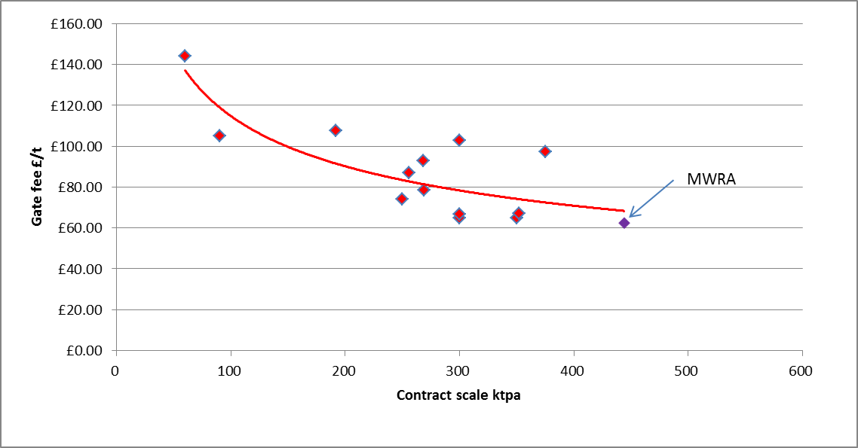

MRWA

### Savings and Efficiencies from the WMRC Contract

This contract is with Veolia which runs until 2029. The savings investigated and potential value is set out together with the recommended actions in Table 6 .

Table 6: Potential savings from the WRMC contract.

|  |  |  |  |
| --- | --- | --- | --- |
| **Savings opportunity** | **Value** | **Issues** | **Actions/Comments** |
| **WMRC contract** | | | |
| Change in law reserve | Nil | Risk totally retained by contractor. | None |
| Life cycle profile | Nil | No saving potential due to limited life of outstanding loans. | None |
| Refinancing/capital injection | Nil to £2m | This option largely depends on whether Veolia will negotiate or not. Recent experience suggests they won’t. Simply a replacement of corporate debt with cheaper public debt. | Would require £16m of capital based on an invest to save basis. |
| Third part income sharing adjustment | Impossible to estimate the savings available | Exposes the authority to market downturn condition | Not recommended |
| Payment terms | <£50k/pa | Some opportunities have already been explored and taken up. Further cashflow improvements may have value, but overall benefit will be small | Investigate further. |
| Contract term | Unknown and only available from 2029 | Extending the current contract would lock in current prices to some extent. As the capital is largely paid off there would be limited scope to offer savings now.  Will remove the opportunity for competitive bid process to test prices. | Investigate further. It may be worthwhile having this conversation with Veolia to test their appetite. |
| Performance management framework | Minimal | Possible poor performance permitted. | Investigate further. Requires a review of the KPIs so that redundant ones can be negotiated away. |
| Insurance | N/A |  | This risk sits with Veolia |
| MRF costs  Polymer sorting | £0k-£1.0m/pa | Will require some investment to upgrade sorting equipment. Highly dependent on international plastic prices | Worth a discussion with Veolia as to the technical capacity given changes in technology and the costs/value. |
| Additional capacity | £500k-£1.5m/pa | Dependent on being able to source 3rd party dry recyclates and the ultimate capacity of the plant. | Initiate discussion with Veolia to assess limit of capacity given space and maintenance requirements. |
| HWRC opening hours | Up to £200k/pa | Will require political support as decreasing service level is contentions | Initiate soundings with stakeholders |
| HWRCs rationalisation | £200k-£1m/pa | Will require political support as decreasing service level is contentions | Initiate soundings with stakeholders |
| Controls on access | Up to £300k/pa | Is a zero sum gain for the public purse as waste is household waste. May lead to “tit for tat” restrictions on neighbouring sites. | Further assessment of external use and use of sites outside area by residents |

Whilst there is the opportunity to make savings from this contract a negotiating strategy needs to be developed, as the contractor is unlikely to fully participate in any discussions unless there is a financial advantage for them. The expansion of the MRF, a polymer recycling facility and an extension to the contract are the areas where they are likely to be interested and cooperate, however the authority should investigate these options thoroughly and understand what levers and enablers it has before embarking on any negotiation.

At the same time the authority can use this opportunity to press the contractor for better prices in the market for waste streams that they sub-contract out; for example the treatment of food waste.

### Savings and Efficiencies from the RRC Contract

As this contract has only recently been agreed there is very little opportunity for any savings, however, listed in Table 7 are the areas examined.

Table 7: Savings opportunities investigated in the RRC contract.

|  |  |  |  |
| --- | --- | --- | --- |
| **Resource Recovery Contract** | | | |
| Change in law reserve | Nil |  | No action |
| Lifecycle profile | Nil | Profile has been optimised whilst there may be options at the end of the contract, this is too far in the future to assess. | No action |
| Refinancing/capital injection | £1.5m pa | Taking on £122m of debt with PWLB | Worth investigation once full operation is achieved and all construction risks are full resolved. |
| Authority Voluntary Termination | Cost | The significant amount of compensation payable to the contractor makes this impractical. | This is not a savings measure. |
| 3rd party income share | Nil | Renegotiation of the 3rd party income share to provide a greater proportion to MWRA would result in a reduced guaranteed income and therefore greater risk. | Not recommended given current uncertainty in energy prices. |
| Insurance review | Unknown | Essentially a precautionary measure to ensure that the insurance cost review is conducted correctly and that the savings (if any) are correctly allocated. | Prepare data for insurance review prior to the due data for the review and ensure that specialist advice is secured. Check the joint insurance review report in detail. |

## Organisational Structures

The full value of the initiatives discussed in this report can only be realised if new ways of working are facilitated by a new organisational form. This should enable a delivery model that is simple to manage and free of the constraints of external transactional mechanisms e.g. the current levy, which creates a barrier to optimal delivery of a universal waste service. Similarly, the current internal budget constraints associated with differential service provision need to be removed and replaced with a universal service. Merging of current activity into a new organisational structure will reduce decision-making interfaces and enable greater efficiencies and effectiveness in the delivery of the overall regional service. This section of the review focuses solely on the organisational forms and the senior management arrangements to deliver cost savings. The full report can be found in appendix 6.

The wider benefits of combining the waste services come from five key areas. These are:

* Savings in operational management and delivery e.g. round optimisation, rationalisation of depots etc.;
* Savings that accrue from the enhanced scale of the operation, common purchasing, adopting best practice etc.;
* leveraging new commercial opportunities e.g. delivering new recycling infrastructure to support the local circular economy;
* appropriate use of the disposal facilities; and
* finally there are important decisions to be taken about the structuring of the services delivery organisation, its governance and management arrangements in order to realise these savings.

This section addresses the last of these.

The combining of the waste services can be achieved in several ways that can be summarised as follows:

* informally by collaborating on particular tasks or skills;
* organisationally – using delegation of functions under administrative powers;
* contractually through an inter-authority arrangement;
* structurally in setting up a body that as a company; and,
* using new legislative powers under the Cities and Local Government Devolution Act 2016 to provide for waste collection and disposal functions to be delivered by the LCRCA.

Variants and combination of these arrangements, listed in the order of increasing benefit, have the potential to deliver savings but it is the last two which have the greatest potential. The choice of the preferred arrangement will be subject to several key considerations;

* fairness;
* funding required including borrowing powers;
* fit with the governance of the participating bodies and future bodies;
* flexibility and longevity;
* appropriate influence; and,
* decision making and priorities etc.

The exact balance of these and other factors is an internal matter for participating bodies. However, critically the new organisational arrangement will either need to be: hosted by one of the existing Councils; established as a separate legal structure; or hosted by the Combined Authority. Given the pan Liverpool City Region impact the clear preference would be a transfer of waste functions to the Combined Authority. This would not only provide a stable platform for the delivery of savings but would generate the greatest overall savings while enabling the new body to respond more effectively to changes in the external waste environment and policy initiatives like the Circular Economy.

There are specific legal issues that will require detailed assessment (see Annex A to appendix 6), and financial issues that will need further work e.g. VAT charging on commercial waste services. Overall the costs savings from the reduced staff requirements and streamlined back office functions would be in the range of £400-£700k pa but the costs of the transition is likely to be in the range £500k-£1M.

The total waste service is split into six waste collection authorities residing within the constituent councils and one single purpose statutory waste disposal authority as illustrated in Figure 8.

Figure 8.

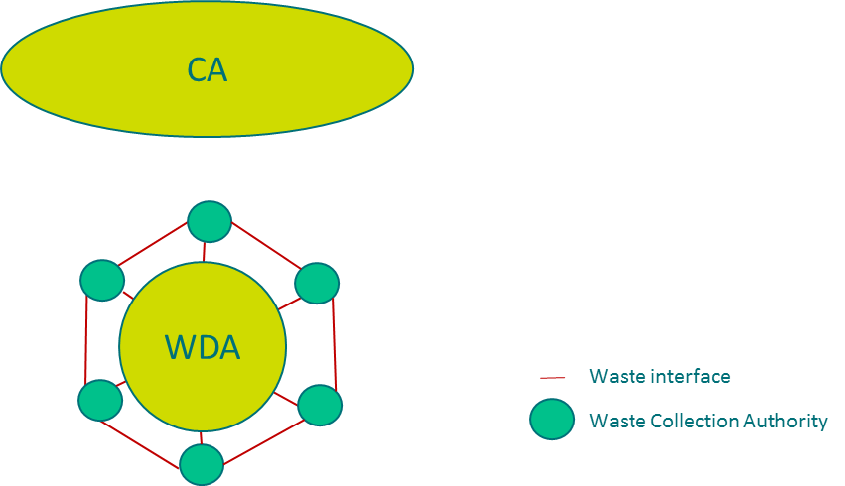

Historically there has been limited joint working across the waste collection authorities and particularly with the waste disposal authority. The current barriers to further joint waste working across the wider waste system (collection and disposal) are;

* differing priorities and costs in relation to the waste collection systems operated by the constituent councils;
* lack of common standards, policies, vehicles, bins across the waste collection authorities;
* limited formal forums to agree joint way forward;
* a disposal levy arrangement that fails to adequately reward individual improved recycling performance; and,
* too many interfaces in relation to decision making within the total waste system etc.

Added to this there are inefficiencies in way the current arrangements are undertaken, such as:

* duplication of resources in key tasks e.g. procurement, communications etc;
* lack of consolidation of key expertise in areas such as enforcement, training, growth of commercial opportunities etc.; and,
* failure to take opportunities to keep waste disposal facilities full with public waste for the benefit of the public purse etc.

Further there are opportunities to:

* rationalise depots;
* optimise collection rounds;
* improve fleet maintenance function; and,
* streamline management resources etc.

Many of these issues have already been identified in the earlier sections of this review; this is simply setting them out clearly so that the benefits of moving towards a joint waste authority are set out in one place. The review considers four principal organisational forms with sub options for some of the areas. The various forms of joint working are:

* specific activities co-ordinated via voluntary arrangements;
* shared procurement and contracting;
* single waste collection authority; and,
* a joint waste management authority.

The financial savings related to changing the organisational form are modest, these relating solely to adjustments in management costs. It is the influence of the new organisational forms on scale, behaviours, common practices and decision making that is key in the delivery of savings. Financial savings in the management costs relate to:

* legal and administrative costs of £10-50k per procurement;
* 10% of the procurement team budget relating to the procurement budgets of vehicle, bins etc.;
* £100-200k/year in support services costs; and,
* £300k-£500k/year created from savings in fleet management team costs.

Key savings are realised by the removal of organisational interfaces. A good example here is the saving of £2m/year that could arise if a joint WCA company could expand it functions in terms of commercial waste collections to fully exploit the spare capacity within the RRC contract.

We believe that value is created by new organisational forms in five key areas, these being:

* the creation of a stable environment that enables a common cost effective approach, reduces interfaces, while simplifying transactional mechanisms between the parties and providing for clear governance and oversight;
* efficiency e.g. standardisation, consolidating knowledge, rationalisations, productivity, management etc.;
* developing trading potential e.g. commercial waste, charging, expanding geographical coverage etc.;
* optimisation of the use of existing infrastructure with public waste eg EfW and other treatment facilities being fully used for the public benefit; and,
* responsiveness to change e.g. changing working practices, processes, responding to legislative change, circular economy, changes in economic balance of solutions etc.

Each form is assessed against these headings in the report. The favoured organisational form is the creation of a joint waste management body, covering collection and disposal, within the Liverpool City Region Combined Authority as illustrated in Fig. 9

Figure 9.

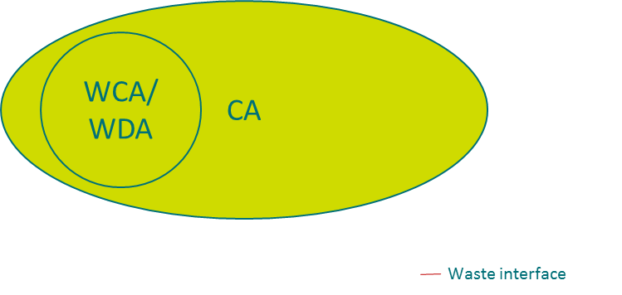

This enables all the savings opportunities identified in the report to be realised. Key to delivery is clarity of governance oversight, the removal of interfaces and distorting financial mechanisms, elimination of a local view of costs that is replaced by a whole system view of costs. This will also open new trading opportunities and it will allow the new joint body to concentrate resources on problem areas e.g. enforcement. It will further facilitate the consolidation of expertise to consider new infrastructure needs and new legislative powers that improve the potential for the circular economy.

## Funding and the Levy

The levy is a funding mechanism for recovering the costs of recycling, treatment and disposal of waste collected by the authorities. MRWA, who manage these contracts, incur these costs and then reallocate them to the authorities through the levy.

The levy itself cannot change these costs, which are determined by the payment terms of the contracts themselves and the tonnage of waste collected; the levy is simply a formula for reallocating them back to the authorities. The current reallocation has been established on the principle of the polluter pays[12], i.e. the authorities are charged according to the tonnage of waste they collect, the larger that tonnage the higher that authority’s levy and vice versa. This is in effect an incentive to reduce the tonnage of waste collected.

The levy for each authority is calculated using a formula that was agreed unanimously (Halton pay according to a separate agreement as they are not part of MRWA). The formula currently applied has been adapted from a basic formula laid out in the regulations[13] with the aim of providing as fair and equitable allocation of costs back to each authority as possible.

The formula can be simply stated as:

|  |  |  |  |  |  |  |  |  |
| --- | --- | --- | --- | --- | --- | --- | --- | --- |
| Tonnage based costs | + | Recycling credit costs | + | Population bases costs | + or - | abatement | = | Total cost of levy |

The tonnage based costs are the sum of the treatment, landfill and recycling costs divided by the total tonnage to give an average price per tonne; this means that there is no differentiation between treatment, landfill and recycling costs from the authorities perspective. The recycling credit costs are the tonnes of waste not sent to MRWA for treatment such as green waste; this is determined by a formula and does not necessarily reflect the actual cost of treatment. The population based costs are those costs that are not attributable to an individual authority’s tonnages such as household waste recycling centres (HWRCs), closed landfill sites and the administrative costs of the Authority divided by the population for each authority.

The abatement provides the means for adjusting tonnage figures. When the budget is set it uses historical tonnage figures but forecast costs. So for example the 2016/17 budget is based upon tonnage figures from 2014/15 but costs forecast for 2016/17. The abatement is then used to adjust these figures once the 2015/16 tonnage figures are known. There is therefore a two year lag between the budget and the actual figures.

This situation is not ideal and introduces some distortions into the way the levy is allocated. For example if one authority commits significant effort to decrease the tonnage of waste they collect by a higher proportion than all the other authorities it is not rewarded according to the total amount it has reduced but by the average for all authorities.

To compound this, the cost reduction that the authority might anticipate from reducing their tonnage of waste may be cancelled out by increases in costs for other parts of the service that have been budgeted for the year ahead.

Another factor is that there is no differential between the costs of recycling waste compared to the cost of residual treatment or landfill; they are both charged at the same average cost i.e. the tonnage based cost as described above. A further complication is that the residual and recycling contracts have banded prices this means that a reduction in tonnage may have the perverse effect of increasing the average price per tonne of the waste and this then is fed thought to the authorities as a higher average price per tonne. This would not matter if the cost of the two services was the same but generally recycling has been cheaper than residual treatment. There is therefore currently no incentive to recycle more waste, as there is no significant price advantage.

Consequently the charging system itself can hinder the performance of the wider LCR as individual authorities may, understandably, choose to make a decision (about collection services) solely based upon achieving the best outcome for themselves, which may in fact include doing nothing. The report at appendix 7 considers the pros and cons of alternative formulas to the current levy but the reality is that none of these are particularly simple or more effective.

However, if the collection authorities combine together as a JWA then the situation changes significantly. In taking this step the boundaries between the authorities dissolve, performance for recycling and other environmental measures is undertaken at the LCR level and service levels provided to the public would be based on a single collection policy as set out in 4.2. This would mean every household would receive the same bins, frequency of collection etc.; it would be a uniform service over the whole region.

This would then favour a levy based on population. This approach removes the distortion of using tonnage-based information that is 2 years out of date but maintains the principle of the “polluter pays” but at a regional level. Any campaign or change in the waste service that reduced cost would be carried out on a regional basis and then flow through equally to all the authorities. In fact this would facilitate more targeted use of resources to address specific issues in particular areas or groups of the community be that enforcement, education or wider communications.

Ultimately this would be a far fairer system, simple, easy to understand, easy to administer, fewer time lag issues and as population tends to change slowly it should be predictable without a many shocks.

## Summary of savings

Table 8 below provides a summary of saving with details of their description and the projected timeline. There are also comments on the interrelationship between savings as some are reliant upon other actions, largely to do with closer integration of the services, whilst others are measures that are an either or depending upon the overall direction of travel towards a JWA. The savings are then summarised in terms of value in Table 9. This shows whether the savings can be expected in the short, medium of long term and the range of savings that have been estimated. These are then summed to show the range of total savings. Short term is treated as less than 2 years, medium term is 2 to 5 years and longer term is 5 years to 8 years.

Table 8: Summary of savings

|  | **Element** | **Description** | **Savings** | **Timescales and interrelationships** |
| --- | --- | --- | --- | --- |
| 1 | Efficiencies from joint working arrangements | Merging the individual authorities into one combined joint waste authority. | 10 to 15% of collective overhead dedicated to waste.  £500k to £1.05m per annum. | The transition from individual authorities to a JWA would be a short to medium term enterprise (1 to 4 years) but there would be incremental benefits along the. The fact that this is likely to unlock the full range of savings makes it one of the key tasks to plan out and implement. |
| 2 | Bulky waste | Developing a new model for dealing with bulky waste. | Estimated to range from £120k to £572k per annum. | The full potential of this initiative are likely to increase if the scheme is promoted more widely. It can be implemented immediately. |
| 3 | Clinical waste | Auditing clinical waste collections to ensure only the hazardous component has a specialised collection whilst other non-hazardous material is collected as part of the normal weekly routine. | Estimated £100k per annum. | This is an action that could be taken immediately independently or collectively albeit it is believed the most benefits would arise from acting as a JWA. |
| 4 | Joint procurement hub | The savings associated with the administrative function are included in 1 above. These are savings related to fleet procurement, consumables and other maintenance. | Estimated annual saving of £367k | This assumes the fleet is replaced on a rolling programme over a period of 7 years. Savings would arise in the medium to longer term. |
| 5 | Flats, Multi Occupancy and Difficult Properties | Improvement in the capture and quality of recyclate leading to savings in residual waste treatment costs. | Estimated savings between £150k and £350k | This is likely to be a medium term project and could be rolled out as individual authorities or as a JWA. The benefits are likely to rise if a joined up approach is adopted as there will be increased learning from implementation leading to lower costs and results are likely to occur more rapidly. |
| 6 | Channel shift | Integration of data systems and adoption of more web based communications and transactions with the public. These savings would be in addition to those achieved by joint working. | Estimated to be between £100k and £500k depending on the extent of integration. | This is a medium to longer-term initiative and would be largely dependant upon establishing a JWA as a platform to develop digital integration. IT projects are notoriously complex and the preference would be for a stand-alone platform (similar model to Mersey Travel) operated centrally and based upon common collection policies.  It is likely that this will also contribute to mitigating future costs that are currently unforeseen. For example if the roll out of a new service is required this would make planning, implementation and communications far more efficient. |
| 7 | Converting to a gas fuel collection fleet, | This initiative would combine an improvement to air emissions and reduced fuel costs by switching from diesel to gas powered vehicles. | Estimated savings are a reduction in fuel costs of between 10and 20% amounting to savings of £500 to £750k per year once fully rolled out across the fleet. | This is linked to item 4 and assumes the fleet would be rolled out over a period of 7 years depending upon when replacement vehicles were required. This is a medium to longer term saving. |
| 8 | Depot realignment alone | Serving areas from alternate depots | c. £0.05 -0.1m / annum after first year | This element could be implemented in the short term but if the medium term aim is to move to a more integrated approach across the LCR, the effort of making the changes may be wasted. |
| 9 | Introduction of a charged garden waste system (only)[14][1] | For authorities that do not currently charge, a new garden waste subscription service is introduced | c. £4m-£5.5m / annum | The element could be implemented in the short term as a step towards adopting an alternative collection system or as an independent measure with potential for substantial savings but with a negative impact on recycling rates. |
| 10 | Alternative collection system | Scenario 3: Restricted residual in 140l bins collected fortnightly, a food waste collection and a charged garden waste service (net including disposal) | c. £0.5m- 2m / annum | Medium term option, which could be delivered on an individual authority level, but could realise additional saving if:   * adopted as part of a common collection system with shared / joint working practices; or * moving to a JWA authority |
| 11 | Vehicles savings as a result of depot realignment | Vehicle operational cost saving by optimising depot locations | c. £0.2 – 0.4m / annum | This element is dependent on adopting the alternative collection system model due use of common vehicles. It is therefore a medium term option. |
| 12 | Depot operational savings | Savings from reducing the number of depots used to serve the LCR | c. £0 – £0.5m / annum | This element would be a medium to long-term option. Whilst not dependent on the adoption of a common collection system and establishing shared or joint working practices, it is likely to yield additional benefits if a common approach is adopted. |
| 13 | RCV: Optimum vehicles based on common services | Vehicle savings as a result of all authorities operating common services with the optimum number of vehicles and current operational performance.  (Potential for further saving if route optimisation employed) | c. £0.5 - £0.75m / annum (based on Scenario 3 or 3a) | Benefits reliant on adopting a common collection system.  Medium to long-term option. |
| 14 | Food Vehicles: Optimum vehicles based on common services | Vehicle savings as a result of all authorities operating common services with the optimum number of vehicles and current operational performance.  (Potential for further saving if route optimisation employed) | c. £0.12 - £0.26 m / annum | Benefits reliant on adopting a common collection system.  Medium to long-term option. |
| 15 | Reduction in spare vehicles requirements | 10-20% reduction on the number of spare vehicles as a result of standardised vehicles and depot rationalisation | c. £0.075 -0.15m / annum | Would be facilitated by the adoption of a common collection system / vehicle specifications, establishing shared or joint working practices and depot optimisation.  Medium to long term option alongside common collection system and depot sharing options. |
| 16 | Capital injection into WRMC contract | Would replace the capital invested by Veolia with public debt and benefit from the lower cost of borrowing, | Estimated up to £1.5m. Probability factor applied to success 20%. Value £300k | This savings would be entirely dependant upon Veolia being willing to cooperate. Market experience suggests this is unlikely so the probability of this happening is very low. It would be a short to medium term option. |
| 17 | WRMC Payment terms | The aim of this is to reduce the payment terms to zero days thereby releasing cash otherwise tied up. | Estimated less than £50k/annum | This is simply the difference between the contracts costs of capital compared to the Authorities. It could be undertaken in the short term. |
| 18 | WRMC Polymer sorting | Invest in equipment to undertake further processing of plastics into their separate polymers. May need to be supported by initiatives to increase the volume of plastic recycling as the kerbside. | Estimated savings are dependant upon volume, market price for plastics and capital repayment costs. Potential up to £1.0m/annum | This project would link to developments around the circular economy but would represent a higher risk investment due to the volatility in plastics prices. It would be a medium to longer-term project. |
| 19 | WRMC Additional MRF capacity | Introducing 3rd party dry recyclate into the MRF | Estimated savings £500 to £1.5m/annum dependant upon volume. | Medium to longer term initiative and dependent upon the collection scenarios adopted by the authorities as they increase dry recyclate tonnage. Could be linked to growth of trade waste operations. Alternatively could be an arrangement with another authority outside of the city region. |
| 20 | WRMC HWRC opening hours | Managed programme of reducing opening hours during periods of low utilisation. | Estimated up to £200k/annum. | Short to medium term initiative. |
| 21 | WRMC HWRCs rationalisation | Closure of sites that are inefficient and/or surplus to requirement | Estimated from £200k to £1m/per annum. | Short to medium term initiative. |
| 22 | WRMC Control access to HWRCs | Potential to restrict access to resident only. | Estimated up to £300k/per annum | Short to medium term initiative. Elements 20, 21 and 22 are linked and should be the subject of a separate business case to determine which combination offers the best compromise between savings and service levels. Consequently the collective savings are assumed to range from £250k to £500k per annum. |
| 23 | RRC Refinancing/capital injection | This assumes replacing 30% of the debt in the project with public finance and benefiting from the reduction in interest charges. | Estimated to be up to £1.5m but depends on interest rates and SWAP breakage costs at the time. | This is a medium to longer-term option and should not be considered until the RRC has been operating reliably for several years. It should be the subject of a business case at the prevailing market rates the time. |
| 24 | RRC Increased contract waste | This saving has been modelled in the collection scenarios where residual waste tonnages are reduced in favour of recycling.  If however, the authorities choose to go to 3 weekly collection without food waste collection then there is potentially a reduction in the residual waste of 14,000tonnes. | Assuming a 14,000tpa reduction in residual waste and this replaced by third party income there is the potential to receive additional income of £0.54m | This savings is unlikely to occur without the corresponding increase in food waste collection but serves to illustrate the benefits of waste reduction overall in the RRC contracts assuming this is replaced by the contractor. |
|  |  |  |  |  |

Table 9: Summary of savings



## Appendices

### Appendix 1 - The Interaction between the Resource Recovery Contract (RRC) and the Waste Management and Recycling Contract (WRMC).

### Appendix 2 - Liverpool City Region Waste Strategy and Policy Options

### Appendix 3 – Innovation in Waste

### Appendix 4 - Infrastructure Sharing Collection Modelling and Depot Rationalisation

### Appendix 5 - Review of RRC and WMRC contracts managed by MRWA

### Appendix 6 – Organisational Options

### Appendix 6 – Funding and The Levy – Future Options

**Contact details**

Duncan Powell, Director, Local Partnerships

Email: duncan.powell@local.gov.uk

Tel: 020 7187 7379

**Disclaimer**

This report has been produced and published in good faith by Local Partnerships and Local Partnerships shall not incur any liability for any action or omission arising out of any reliance being placed on the report (including any information it contains) by any organisation or other person.  Any organisation or other person in receipt of this report should take their own legal, financial and/or other relevant professional advice when considering what action (if any) to take in respect of any associated initiative, proposal or other arrangement, or before placing any reliance on the report (including any information it contains).

**Copyright**

© Local Partnerships LLP 2016

1. http://www.merseysidewda.gov.uk/wp-content/uploads/documents/Main%20Joint%20MWMS%202008.pdf
2. This includes bottom ash from EfWs, which is not applicable in England. Removing this element probably brings the total to nearer 55%.
3. Note: despite the use of ‘standard approach to service deliver and charging, the Authorities may wish to jointly adopt a disaggregated approach to charging, with a lower or nil rate offered to those on low-incomes or on disability benefit. Using a JWA approach would make the implementation of any such initiative much easier.
4. Local Government Association, Transforming local public services using technology and digital tools and approaches, June 2014
5. Wirral provided the following costs for customer interaction: telephone £ 2.75, web £ 0.14
6. This is also used by other functions within the authorities and at some stage in the future data on all activities at households should be able to be held at this level by the authorities
7. It should be noted that total treatment costs are not included in this figure, only the difference from the baseline recycling / treatment / disposal cost, including whether any additional third party capacity sales can be realised
8. Further savings may be made for more specialist vehicles (e.g. food waste collection, etc.).
9. [1] This has been modelled as a sensitivity only, as it is part of a more comprehensive collection system change (Scenario 3) as agreed at Workshop 1.
10. The potential to reroute all vehicle across LCR ignoring current boundaries has not been modeled as it was out of scope. However, subject to a wide range of assumptions, there could possibly be savings in the region of a further £0.5 to £1.0m
11. The WOSP is a national savings programme supported by Defra to find savings in waste PFI/PPP projects.
12. As set out in the Joint Waste Strategy for Merseyside and Halton
13. The Joint Waste Disposal Authorities (Levies) (England) Regulations 2006 Section 4 Apportionment of Levies
14. [1] This has been modelled as a sensitivity only, as it is part of a more comprehensive collection system change (Scenario 3) as agreed at Workshop 1.