Appendix 1
The Interaction between the Resource Recovery Contract (RRC) and the Waste Management and Recycling Contract (WRMC).

  - Version No: Final
  - Issue Date: December 2016
1 Introduction 3
1.1 WRMC 3
1.2 RRC 4
1.3 How costs vary between the two contracts 5

Introduction
The cost of waste recycling, treatment and disposal in the Liverpool City Region is made up of a combination of prices. These prices are set out within the contracts that are managed on behalf of the Districts by MRWA. The pricing structures within these contracts have been negotiated to provide a large degree of price certainty over the duration of the contract. Where the cost of price certainty would have been prohibitive other mechanisms have been introduced to manage this risk. These factors include indexation, gain share, market testing and benchmarking and are largely subject to changes in external market prices. These interactions and the impact they have on costs are complex so it is important therefore that these are set out clearly and that all parties understand the implications of increasing or decreasing the tonnage of the various waste streams collected.
It should be noted that both the RRC and the WRMC are relatively long term contracts and therefore the opportunity to renegotiate prices within these contracts is limited. In the case of the RRC contract this remains in place until 2044. The long-term nature of this contract serves to pay off the large amount of capital invested in the project (much like a mortgage) but also provides the authority with a very competitive gate fee compared to the national market.
The recycling contract on the other hand is less capital intensive and therefore this contract is shorter term but nevertheless still has until 2029 until its natural termination.
This review will explain the overall costs of the contracts managed by MRWA and how these are allocated to the districts via the levy funding mechanism.

WRMC
The WRMC consists of
- Operation of the HWRC service
- Operation of the transfer stations
- Haulage of waste from these sites to the disposal or treatment options
- Operation of two MRFs for dry recyclate at Gilmoss and Bidston
- Responsible for the treatment of the green waste and food waste delivered by councils for composting or AD,

The HWRC and transfer station cost are largely fixed. The transport cost varies according to the distances travelled.
The cost make up of the MRFs consists of a base charge and then a variable charge that is applied if the tonnage processed exceeds the facility capacity of 150,000 tonnes in aggregate between Gilmoss and Bidston. The variable charge is £4.11/t indexed (approx. £4.90 in 2017/18).
In addition to this, the additional recyclates will contribute to the 3rd party income sharing mechanism and this is explained further below.
Food waste delivered to the WMRC is sent to a 3rd party anaerobic digestion (AD) processor and is treated effectively as a pass through cost. The current charge is £54.38/t for the first 1000 tonnes and £44.03/t for further tonnage. These gate fees are regularly renegotiated dependant on market conditions.
The income sharing mechanism is a very important part of the payment mechanism. This provides a sharing of the revenues when these exceed the defined threshold values.
- The income assessed in three tranches
  - MRF recyclates
  - Recyclates from HWRCs and compost
  - 3rd party waste
- The value of income from MRF recyclates is compared to the guarantee (£2.6m) and if there is more income this is shared on a sliding scale of
  - 50% to MRWA for the income up to 50% of the guarantee
  - 60% of the income from 50% to 75% of the guarantee
  - 75% of the income from 75% to double the guarantee
  - and 80% of income more than double the guarantee
  - If the income is less than the guarantee there is no impact on MRWA
The value of the variable element of the income share goes up or down with the market. Current market conditions have depressed the value of recyclate recently and thus the income has been lower than in previous years.

RRC
The RRC contract allows for a small amount of untreatable waste to be landfilled, and the rest is sent to the combined heat and power waste facility on Teesside.
The payment mechanism is made up of three principle elements, the unitary charge, pass through costs, and income sharing.
The unitary charge is the main tonnage based cost in the contract and is split into 3 bands:
Band 1 begins at £92.36/t; 30% of this amount is then indexed over the life of the contract.
Band 2 begins at £5.10/t; it is fully indexed over the life of the contract.
Band 3 begins at £70/t; it is fully indexed over the life of the contract.
The tonnage of waste in each Band varies over the life of the contract. This is shown in the diagram below.
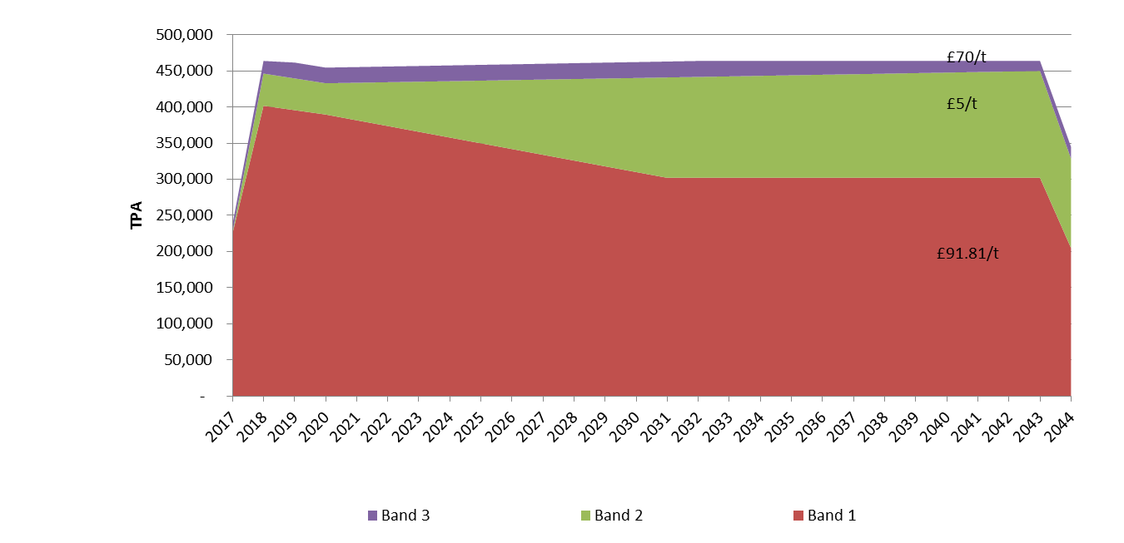
The amount of residual waste predicted for 2017/18 is 430,000 tonnes; this means the unitary charge costs would be made up of 401,744tonnes x band 1 of £92.36 plus the band 2 tonnage of 28,257 x £5.10 giving an average cost of £37.25m.
The second element of cost is the pass through costs, which are made up from the costs of ash management, landfill gate fee, landfill tax and the business rates. These are affected by the total tonnage processed and any increase in landfill tax and landfill gate fees, but as the plant is likely to operate at its maximum capacity all the time the costs will be relatively stable and current estimates are this would be approximately £4.2m per year, comprising £1.8m of landfill tax, £0.5 landfill costs, £0.8m of ash costs and £1.2m rates.
The final part is the income share. This is made up from the income from energy sales and 3rd party waste and has a guaranteed element but is then shared when the income exceeds the guarantee. The guaranteed income is just over £12.4m.
The overall 3rd party income is derived from energy sales and third party gate fees. For energy sales changes could arise from increases (or decreases) in the quantity of energy produced (unlikely to change once the plant is fully operational) or the market price for power or heat. Excess energy income above the guarantee is shared 50:50 with the contractor. Income derived from 3rd party waste using up any spare capacity is dependant on the gate fee achieved in the market. The amount of excess income over the guarantee from 3rd party waste that is shared depends on which Band it is contributing to. In Band 1 the authority gets all of the income after the contractors costs have been accounted for, in Band 2 80% of the income and in Band 3 50%.
Adding together these three elements gives the overall costs for the initial year assuming 430kt of waste is delivered. The costs for the year 2030 have been calculated for comparison (note this makes assumptions about inflation and other market related prices); this is set out below.
2018 2030
Unitary charge £37.5m £31.7m
Pass through costs £4.2m £5.7m
Income sharing -£12.4m -£12.4m
Total £29.3m £25.0m
Average gate fee £68.14/t £58.14/t

How costs vary between the two contracts
Given below are some worked examples to illustrate how changes in recycling levels and waste reduction impact on the aggregate costs. These examples should be used with extreme caution as the sharing mechanism is dependant upon a number of factors that would need to be calculated at the time.

Example 1
The introduction of 3 weekly collection of residual waste leads to a decrease of residual waste to the RRC contract of 30,000tpa and an increase of 22,000tpa of dry recycling to the WRMC contract with 8,000tpa of waste being lost to the system.
The WMRC contract will receive 22,000t for the MRFs which will be charged at the adjustment rate of £4.91 (£4.11 indexed) a cost of £108k.
The additional recyclate will contribute to the income sharing payment and the total amount of income shared will depend on the market rate for recyclate, if this exceeds the guarantee then this will provide income. To illustrate this using a recyclate value of £20/t (as an aggregate) the total income would be £440k; this would be shared 50:50 with the contractor to provide a potential income of £220k. Clearly if the recyclate market improves there will more income to share.
Combining the additional cost for treatment and the gain share gives a net benefit to the Authority of £112k.
The impact of reducing 30,000t to the RRC contact and assuming this is all within Band 2, would lead to a reduction of 30,000t @ £5.10/t or £153k.
At the same time this would create spare capacity that could be filled by the contractor supplying additional 3rd party waste to match this “lost“ tonnage.
If the contractor collects the 30,000tpa of waste to fill the plant, the gate fee would be shared at the band 2 rate of 80% of the net gate fee received. The financial model uses a value of £70/t and if we assume this value, £56/t would be returned to the authority in the sharing mechanism, a amounting to a sum of £1.68m. This is illustrated in the table below.
 | Contractor supplied C&I
Recycling MRF costs | -£0.11m
Recycling income share | £0.22m
RRC unitary charge reduction | £0.15m
RRC income share | £1.68
Council income from C&I collection | 0
Total MWRA impacts | £1.94m
Council impacts | 0
Total benefit | £1.94m

Example 2
30,000t of food waste to be collected for AD. This would result in a reduction of 30,000t of residual waste, which would have the same impact on the RRC as in example 1. However, the cost for AD in the WRMC contract is as high as the Band 2 cost in the RRC and has no income share element.
Food waste processing in the WMRC is a pass through arrangement in that the treatment is provided by a 3rd party and the payment passes through the Veolia contract. The current rates are; the first 5,000t are charged at £54.38/t and any additional tonnage is charged at £44.03/t. These are negotiated rates and will vary over time as the market conditions change. The additional 30,000t supplied would cost £1.32m. This would be offset by the £1.83m or £2.1m (see above) for the income share from the RRC giving a net benefit of £0.51m. Thus the benefit is less than for the dry recyclates diversion due to the higher cost of AD.

 | Contractor supplied C&I
AD costs | -£1.32m
RRC unitary charge reduction | £0.15m
RRC income share | £1.68
Council income from C&I collection | 0
Total MWRA benefit | £0.51m
Council impacts | 0
Total benefit | £0.51m

Contact details
Duncan Powell, Director, Local Partnerships
Email: duncan.powell@local.gov.uk
Tel: 020 7187 7379

Disclaimer
This report has been produced and published in good faith by Local Partnerships and Local Partnerships shall not incur any liability for any action or omission arising out of any reliance being placed on the report (including any information it contains) by any organisation or other person. Any organisation or other person in receipt of this report should take their own legal, financial and/or other relevant professional advice when considering what action (if any) to take in respect of any associated initiative, proposal or other arrangement, or before placing any reliance on the report (including any information it contains).

Copyright
© Local Partnerships LLP 2016

