Infrastructure Sharing Collection Modelling and Depot Rationalisation

  - Version No: Final
  - Issue Date: December 2016

LIMITATION: This report has been prepared by Resource and Waste Solutions Partnership LLP (RWSP) on behalf of and for the exclusive use of RWSP’s client, and is subject to and issued in connection with the provisions of the agreement between RWSP and its client. RWSP accepts no liability or responsibility whatsoever for or in respect of any use of or reliance upon this report by any third party.

1 ASSESSMENT OF SHARED INFRASTRUCTURE 3
1.1 Current Assets 3
1.2 Asset Sharing Opportunities 6
1.3 Conclusions 20
2 JOINT WASTE COLLECTION OPERATIONAL MODEL 21
2.1 Methodology and Assumptions 21
2.2 Baseline 22
2.3 Scenario 1 23
2.4 Scenario 2 25
2.5 Scenario 3 26
2.6 Scenario 3a 26
2.7 Sensitivities to be Applied 27
2.8 Results 28
2.9 Summary 33
3 DEPOT RATIONALISATION 34
3.1 Introduction 34
3.2 Assessment of Drive Time Impacts 36
3.3 Assessment of Rationalisation Options 38
4 CONCLUSIONS AND OVERALL SAVINGS 43
5 Annex 1 46
5.1 GIS and Spatial Analysis 46
5.2 Data Sources 46
5.3 Location Analysis for LCR 48

ASSESSMENT OF SHARED INFRASTRUCTURE
This section examines the potential saving that could be achieved by sharing assets between the Councils as opposed to the integration of collection services, which is considered in Section 2.

Current Assets
Each Council was asked to provide details of their current operational depots to allow potential asset sharing opportunities to be identified. A summary of the information provided is presented below.

Collection Vehicle Depots
There are currently seven collection vehicle depots utilised by the Councils. Their locations are shown in Figure 1 with a summary of current capacity, in terms of RCV, staff parking and office space, along with any site constraints provided in 0.
Current collection vehicle depot locations
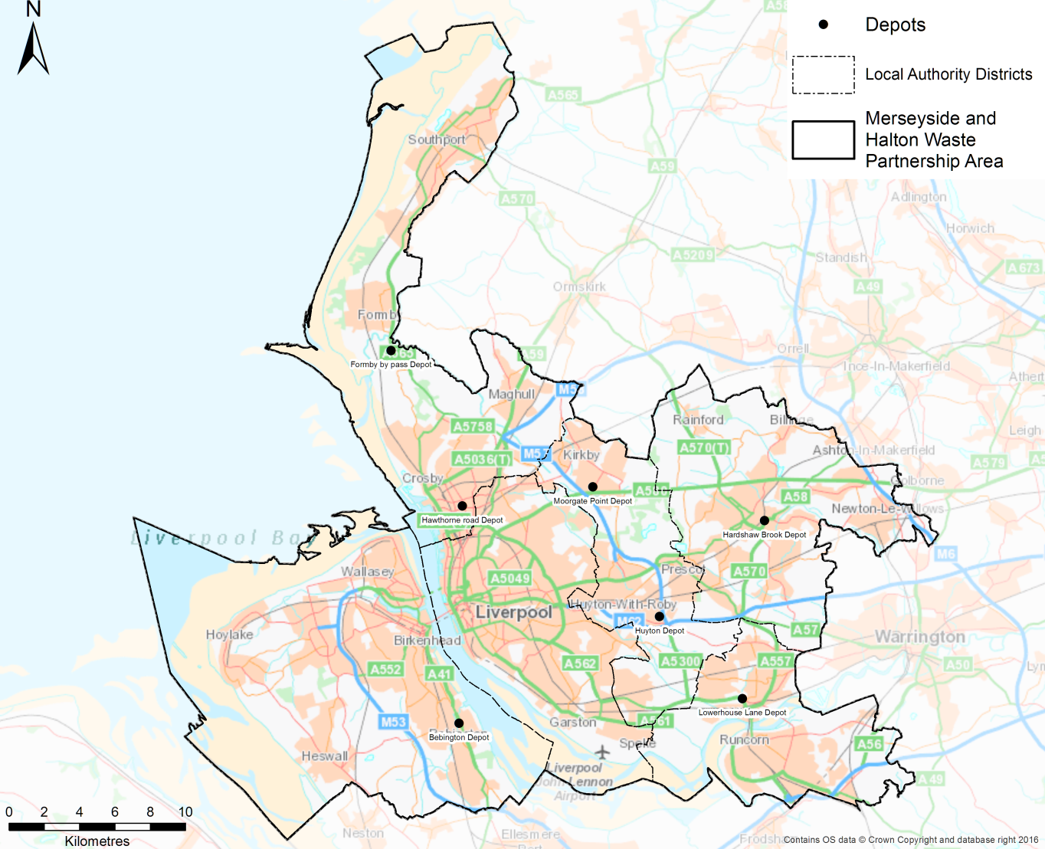

Table 1 Current collection vehicle depot locations and capacities
Council | Depot | Collection vehicle parking | Staff parking | Office Space | Comments
Halton | Lowerhouse Lane  Widnes  WA8 7AW | At capacity | At capacity | At capacity | Shared with a number of other services including Vehicle maintenance, MOT/Taxi Testing, Street Cleansing, Open Spaces operations  There is no opportunity for expansion of the site
Knowsley | Huyton Depot  Huyton Business Park  Stretton Way  L36 6JF | Small amount of spare capacity but RCV parking at a premium | At capacity | Some spare office space | Shared with Streetscene, parks and cemeteries, fleet and logistics plus private sector tenants e.g. SSE, VOSA and Tarmac
Liverpool | Moorgate Point  Moorgate Road  L33 7XW | Small amount of spare capacity | Small amount of spare capacity | No details | Shared with vehicle maintenance (Munserve contractor)
Sefton | Hawthorne Road  Bootle  L20 9PR | At capacity | Charged @ £20/month  At capacity | At capacity | Main administration depot for Cleansing operations, plus base for vehicles and equipment  Land surrounding depot is extremely contaminated
 | Formby by pass  North End Lane  Formby  L38 4JB | At capacity | At capacity | At capacity | Small depot for vehicle storage and minor admin
St. Helens | Hardshaw Brook  Parr Street  WA91 1JR | Over capacity | At capacity | At capacity | Shared with vehicle maintenance, parks and landscapes, grounds maintenance workshop, street cleansing, highway maintenance including gritting and fleet management  Also fuelling of all council vehicles
Wirral | Bebington  Biffa Waste Service  Dock Road South  Wirral  CH62 4SQ | At capacity | At capacity | At capacity | Biffa’s facility and includes their commercial operation  Also hosts street cleansing vehicles as well
The capacity of the existing depots was discussed with operational staff at Workshop 1, where it was confirmed that capacity at the existing depots is a major constraint.

Existing Tipping Point
A combination of MRWA facilities and private sector sites accept waste from the Councils. Their locations are shown in Figure 2 . The wastes accepted in 2015-16 summarised in 0.
- Current collection vehicle depot locations
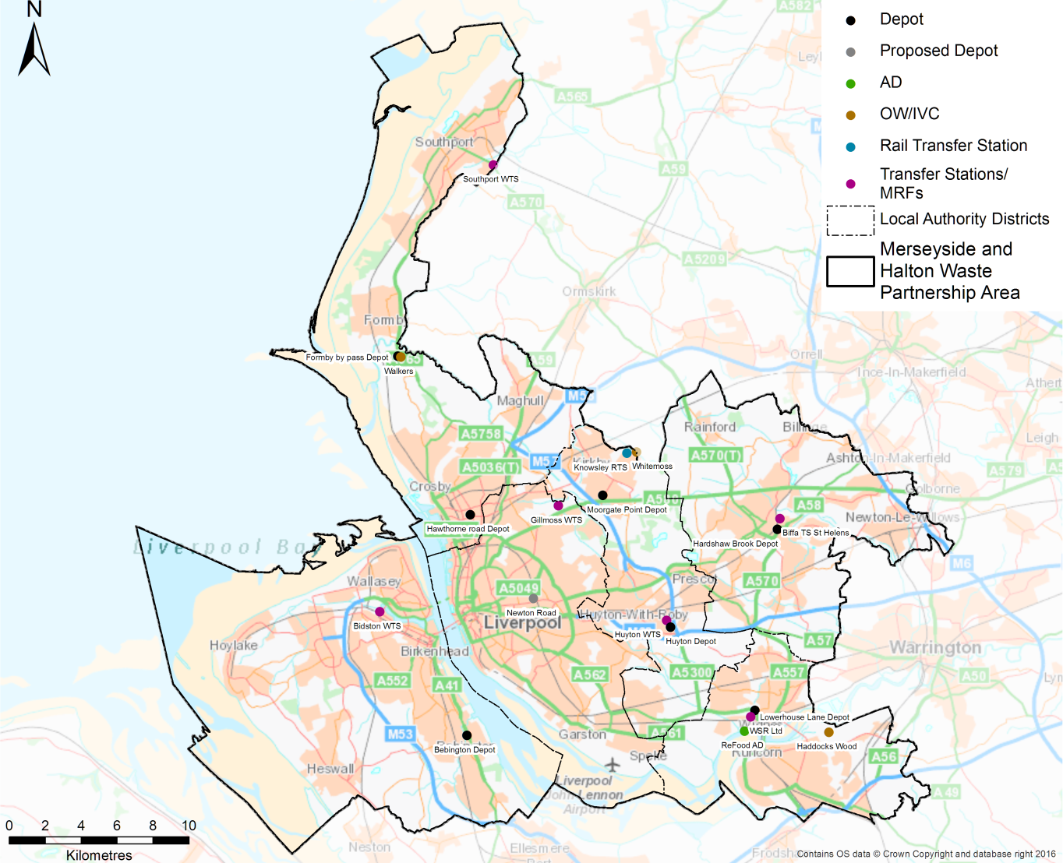

Table 2 Summary of current tipping points – 2015-16 tonnages (greater than 1kt)
Site | Residual | Recycling | Garden | Food | Comments
MRWA Gillmoss WTS / MRF | Knowsley: 8.6kt  Liverpool: 77.2kt  Sefton: 38.8kt  St Helens: 11.0kt | Halton: 9.3kt  Knowsley: 12.1kt  Liverpool: 28.5kt  Sefton: 5.1kt | n/a | n/a | WTS will need refurbishment in the future
MRWA Huyton WTS | Knowsley: 27.1kt  Liverpool: 37.4kt  St Helens: 29.2kt | n/a | n/a | n/a | Oldest site and in poor condition and will need significant refurbishment in the future
MRWA Southport WTS | Sefton: 24.7kt | Sefton: 2.9kt | n/a | n/a | Greater quantity of dry recyclables now received from Sefton since the switch to co-mingled.  The site has some subsidence issues.
MRWA Bidston WTS / MRF | Wirral: 71.7kt  Liverpool: 5.8kt | Wirral: 27.7kt | n/a | n/a | Residual waste from Liverpool no longer set to Bidston Moss.  Potential for RCV parking
MRWA Knowsley RTS | n/a | n/a | n/a | n/a | Not operational in 2015-16
Widnes Skip and Reclaim WTS | Halton: 28.2kt | n/a | n/a | n/a
Biffa WTS St Helens | n/a | St Helens: 14.3kt | n/a | Sefton: 1.0kt  St Helens: 3.2kt | Food waste is contract waste via Veolia and can be sent to Biffa (Poplars) or Refood depending on the market price.  Food waste from Halton’s trial going to ReFood
ReFood AD | n/a | n/a | n/a | Sefton: 1.0kt
Whitemoss OW – Kirkby | n/a | n/a | Knowsley: 7.3kt  Liverpool: 16.8kt  Sefton: 1.8kt  St Helens: 9.7kt  Wirral: 12.8kt | n/a | Wirral’s garden waste is bulked at Bulters Waste Management, WTS in Wallasey
Walkers North End Farm OW - Formby | n/a | n/a | Sefton: 16.2kt | n/a
Veolia Haddocks Wood OW / IVC | n/a | n/a | Halton: 4.7kt | n/a | No longer used, Halton’s garden waste now goes to Whitemoss at Kirkby

Asset Sharing Opportunities
Based on the evaluation of the baseline data (business as usual) provided by the Councils and the mapping of current infrastructure and round data, two principal asset sharing opportunities related to the collection operations were identified:
- Serving rounds from the nearest depot; and
- Developing a shared pool of spare vehicles.
Set out below are detailed descriptions of the options along with assessments of the cost, benefits, issues, risks, constraints and timescales.

Serving rounds from the nearest depot
Average drive-time analysis using GIS mapping (see Annex 1) was used to develop an initial assessment of the areas were rounds are not being served by the depot nearest to them, as illustrated in Figure 3 . The initial assessment was tested with operational staff at Workshop 1 and a series of parameters were agreed to identify which rounds could realistically be served from an alternative depot:
- Vehicles could be relocated to alternative depots to ensure that rounds were still served by vehicles from their Council as opposed to being served by another Council’s vehicles.
- Depot capacities are constrained, with limited space to accommodate additional vehicles, therefore the number of vehicles based at any given depot need to be broadly similar to the current number.
- The proximity to the existing tipping points need to be considered and ideally the existing tipping points retained.
- Only complete rounds would be served from alternative depots as moving part rounds would require a redesign of routes and route optimisation, which is beyond the scope of this study.
Initial assessment of potential rounds that could be served by an alternate depot
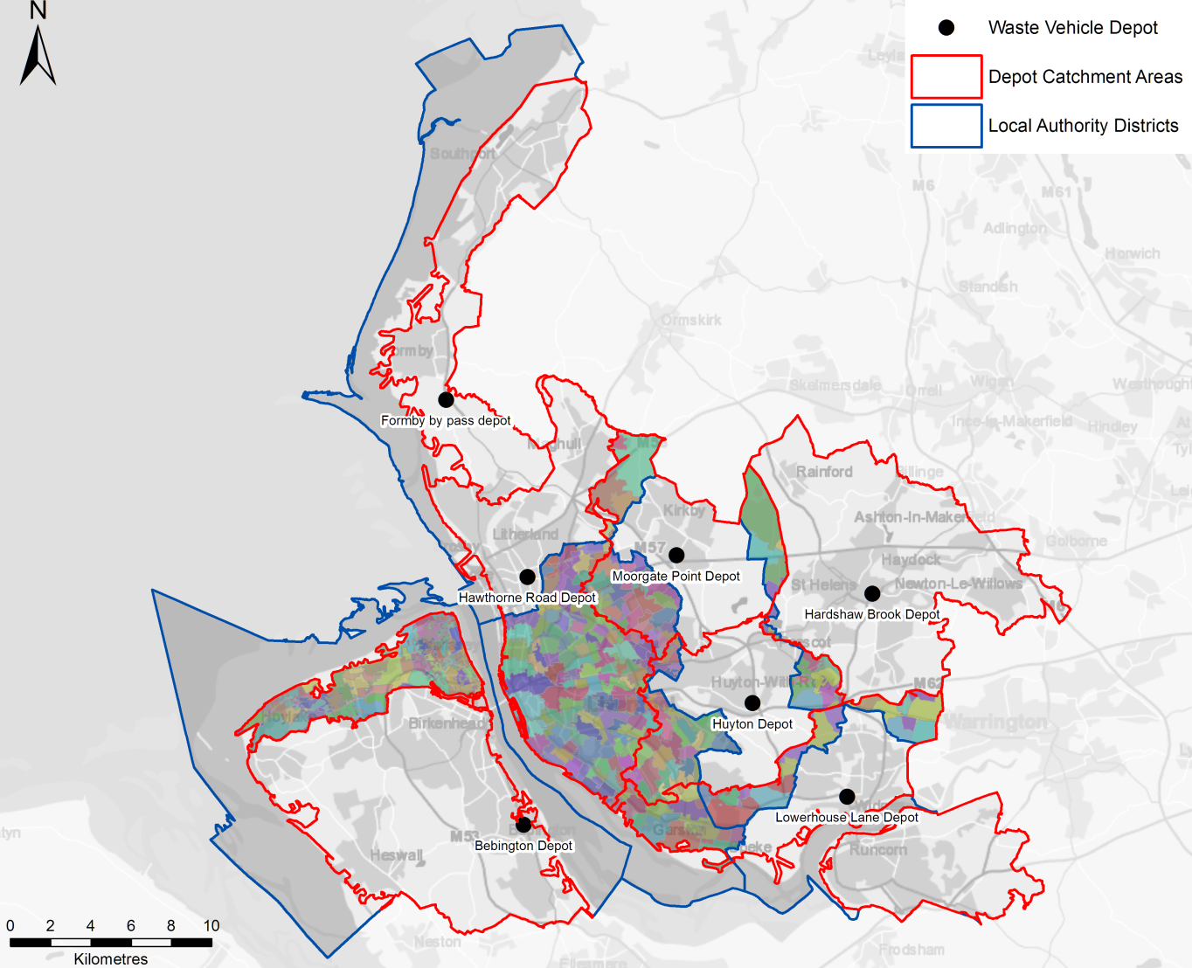
Based on the feedback and the agreed parameters from Workshop 1, the initial assessment was revised to produce depot sharing areas that in particular reflected the capacity constraints at existing depots. Following further discussions at Workshop 2, this process resulted in four distinct areas for potential sharing of depot facilities being identified, as illustrated in Figure 4 :
- Serving the northern parts of the Wirral from Bidston Moss;
- Realignment around the Liverpool/Sefton boundary;
- Realignment of areas of south Liverpool and north Knowsley; and
- Serving Rainhill from Huyton.
Revised depot sharing for Red-Amber-Green assessment
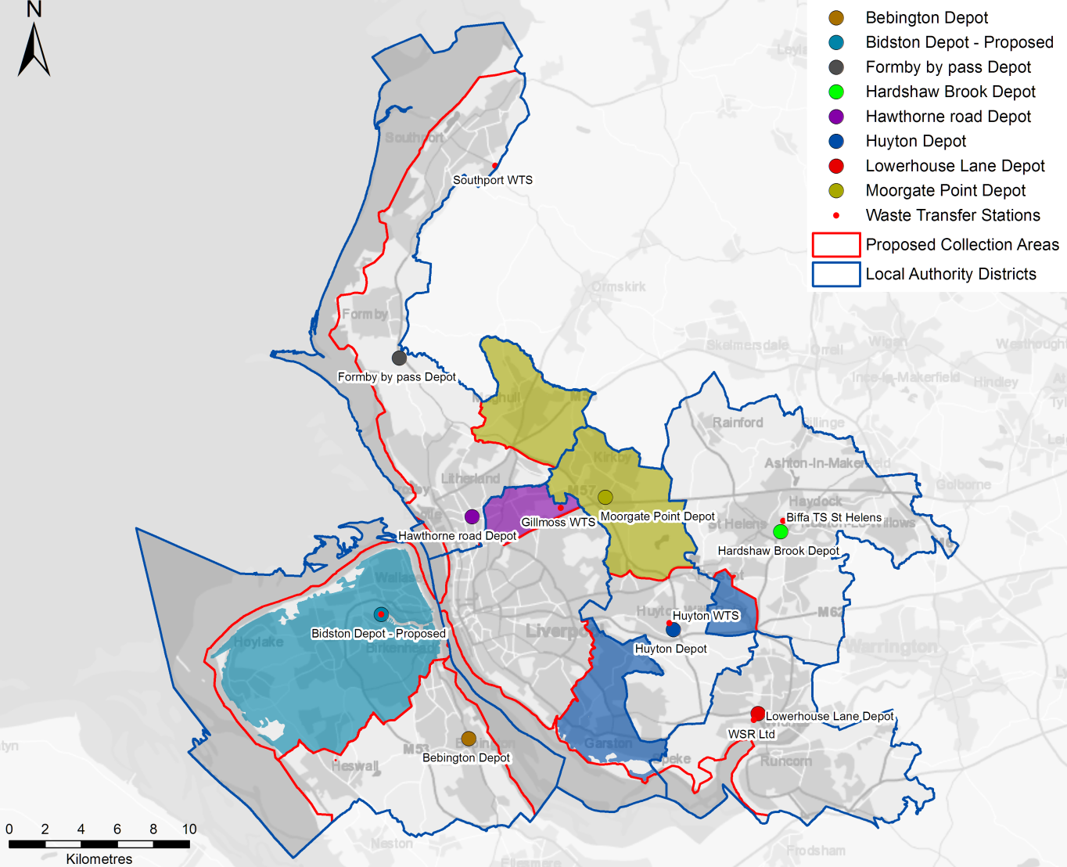

A RAG (Red Amber Green) assessment was used to evaluate these options. The RAG assessment considered a range of criteria including operational practicality, political acceptability and costs. 0 provide a full list of issues considered along with the RAG grading criteria.
Table 3 RAG Assessment Grading Criteria
Element | Grade | Criteria
Political acceptability |  | No political acceptability issues anticipated
 |  | Notable political acceptability issues anticipated
 |  | Significant political acceptability issues anticipated
Collection vehicle storage |  | Adequate space to accommodate increase in collection vehicle storage
 |  | Notable change in collection vehicle requirements
 |  | Insufficient space to accommodate additional collection vehicle requirements
Staff parking |  | Adequate parking to accommodate increase in staff parking requirements
 |  | Notable change in staff parking requirements
 |  | Insufficient parking to accommodate additional staff parking requirements
Office/welfare area space |  | Adequate office space to accommodate office space requirements
 |  | Notable change in office space requirements
 |  | Insufficient office space to accommodate additional office space requirements
Operational practices |  | No implications related to operational practices anticipated
 |  | Notable implications related to operational practices anticipated
 |  | Significant implications related to operational practices anticipated
Labour relations issues |  | No labour relations issues anticipated
 |  | Notable labour relations issues anticipated
 |  | Significant labour relations issues anticipated
Health and safety (H&S) implications |  | No H&S implications issues anticipated
 |  | Notable H&S implications issues anticipated
 |  | Significant H&S implications issues anticipated
Capital expenditure to upgrade depots |  | No capital expenditure required
 |  | Capital investment between £0 and £500,000 required
 |  | Capital investment greater than £500,000 required
Depot operational costs |  | Depot operational cost savings
 |  | No change in depot operational cost
 |  | Increase in depot operational cost
Vehicle and crew savings ¹ |  | Savings greater than £250,000
 |  | Savings between £0 and £250,000
 |  | No saving
Vehicle maintenance costs |  | Savings in vehicle maintenance costs
 |  | No change vehicle maintenance costs
 |  | Increase in lease costs
Land sale or acquisition costs |  | Income from the sale of land
 |  | No sale or acquisition costs
 |  | Land acquisition costs
Staff relocation costs |  | No relocation costs
 |  | Relocation costs between £0 and £50,000 required
 |  | Relocation costs greater than £50,000 required
Communication cost |  | No additional communication costs
 |  | Communication costs between £0 and £25,000 required
 |  | Communication costs greater than £25,000 required
Total Cost |  | Savings greater than £1,000,000
 |  | Savings between £0 and £1,000,000
 |  | No net saving
¹ Calculated as drive time savings compared to the baseline as modelled (see Section 2)

Serving the northern parts of the Wirral from Bidston Moss
Option | 1a |  | Name |  |  | Serving the northern parts of the Wirral from Bidston Moss
Figure A: Optimum coverage  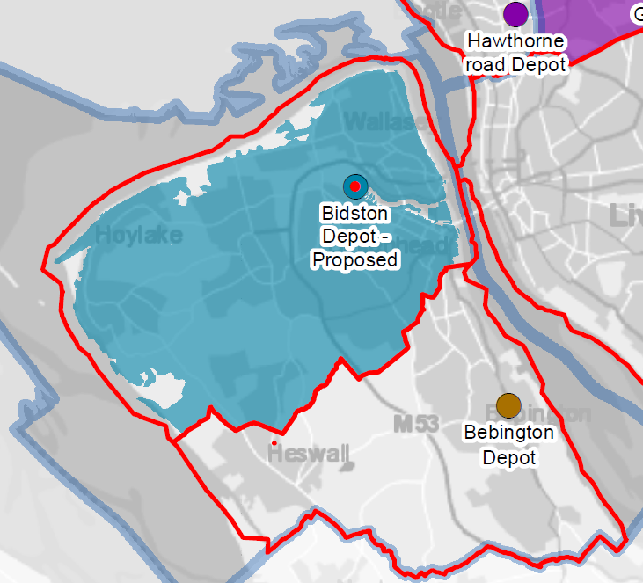 |  |  |  |  |  |  | Figure B: Coverage based on depot capacity  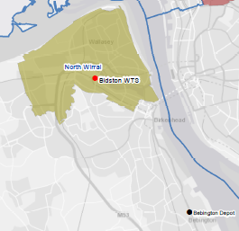
Description | The Bidston Moss MRF/WTS is significantly closer to a large proportion of households on the Wirral than the Bebington depot. At Workshop 1, the potential to relocate a number of vehicles from the Bebington depot to Bidston Moss was identified as a potential option. Figure A highlights the optimum coverage i.e. the areas best served by each depot based on the drive time analysis.  Discussions with MRWA highlighted that there would only be space at the Bidston Moss to park a maximum of 5 to 6 collection vehicles. Therefore, the area covered by the round reallocation needed to be reduced, as shown in Figure B.  If it is assumed that 6 vehicles can be accommodated at Bidston Moss, this means 30 residual rounds and 30 recycling rounds could served from Bidston Moss, i.e. over a fortnightly collection cycle each vehicle can cover 10 rounds in a two week period.  Key benefits from relocating 5 to 6 collection vehicles to Bidston Moss would be drive time saving from vehicle depot to rounds and at the end of the working day as the vehicles would park at their tipping point.
Benefits and Constraints |  | Grading |  |  | Rationale and commentary
Political acceptability |  |  |  |  | Existing site within the ownership of MRWA and vehicles serve the Council area in which they reside.
Collection vehicle storage |  |  |  |  | The option is based on the estimated number of collection vehicles that can be accommodated at the site. However if additional space was available at the site a greater number of rounds could benefit from short drive times.
Staff parking |  |  |  |  | Current indications are that there is no/limited additional space for collection crew parking as there is no surplus parking for cars. Discussion could be held with Veoila about what could be accommodated at the site.
Office/welfare area space |  |  |  |  | Current indications are that there is no/limited additional office and welfare space for collection crews. Discussion could be held with Veoila about what could be accommodated at the site.
Operational practices |  |  |  |  | There would be no change in the tipping point for either residual or recycling collections.  The rounds covered by the reallocation operate on Thursdays and Fridays, however the rounds operating from Bidston Moss would need to collect Monday to Friday. This would mean that collection days would need to be adjusted and this would cover a wider area than just the area where rounds had been reallocated, potential up to half the Council area.  Isolation from vehicle maintenance team could cause issues if problems are identified during morning vehicle safety checks.
Labour relations issues |  |  |  |  | Collection crews would be remote from management structures; therefore there may be a need to review supervision procedures.  Collection crews would effectively be based at a different location to their current operational base which may require a relocation payment to cover any addition transport costs associated with getting to and from work. This may be able to be accommodated by using staff that live closer to Bidston Moss than Bebington.
Health and safety (H&S) implications |  |  |  |  | Crews would be using the vehicles they have been trained on and RCVs already use the site, so after initial site induction related to the start/end of the working day no H&S implications issues anticipated. Risk assessments / procedure related vehicle safety checks would need to be reviewed and safe systems of work agreed.
Cost element |  | Grading |  |  | Rationale and commentary
Capital expenditure to upgrade depots |  |  |  |  | Only requirement is vehicle parking, therefore no capital expenditure anticipated.
Depot operational costs |  |  |  |  | As this option relates to the overnight parking of vehicles, it is assumed there would be no significant change in the depot operational costs.
Vehicle and crew savings |  |  |  |  | Drive time savings would not be sufficient to reduce vehicle requirements but could result in operational cost savings (e.g. fuel) in the region of £50,000 per annum.
Vehicle maintenance costs |  |  |  |  | There would be no vehicle maintenance on site, so whilst there would be no additional costs for the provision of additional maintenance staff and equipment, there may be operation practicalities around vehicle repair and servicing which would need to be undertaken through the Bebington Depot.
Land sale or acquisition costs |  |  |  |  | Bidston Moss owned by MRWA and current proposal relates to the utilising existing space on site, therefore no sale or acquisition costs anticipated.
Staff relocation costs |  |  |  |  | Staff relocation costs would depend on where the staff actually live. If staff that live closer to Bidston Moss than Bebington could be moved there would be no relocation costs. If this was not the case, given the small number of vehicles involved it is anticipated that the relocation cost would be relatively low.
Communication cost |  |  |  |  | Changes to collection days would need to be communicated with up to 80,000 households. If a cost of £0.50 per household for communicating the changes is assumed, there would be a one off cost in the region of £40,000.
Total Cost |  |  |  |  | Overall cost savings could be in the region of £50,000 per annum however this would be offset in the first year by the need to communicate the operational changes to the residents and any staff relocation costs.
Timescales |  | Potential short term option, given the number of vehicles involved and the fact that the site is owned by MRWA.
Overall Assessment |  | The benefits of this option are constrained by the space currently available at Bidston Moss for the parking of collection vehicles and staff vehicles as well as office and welfare space for collection crews. In addition, there would be no vehicle maintenance on site, which could cause operational practicalities around vehicle repair and servicing.  The option could deliver operational savings in the region of £50,000 per annum, however this would be offset in the first year by the need to communicate the operational changes to the residents and any staff relocation costs.  Bidston Moss would provide a better operation location for about two thirds of the Wirral’s fleet if space could be made available to accommodate the vehicles and staff.

Realignment around the Liverpool/Sefton boundary
Option | 1b | Name |  | Realignment around the Liverpool/Sefton boundary
Description | This option relies on balancing the round allocation with the capacity at the vehicle depots, as the key constraining factor is capacity at depots. Therefore, there is a need to have similar number of vehicles and to serve similar numbers of households from each depot as at present given space constraints.  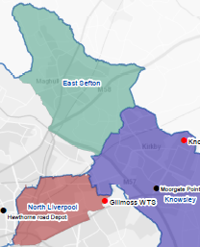  Parts of Liverpool are significantly closer to Hawthorne Road than Moorgate Point therefore accommodating part of Liverpool’s fleet at Hawthorne Road would deliver drive time savings, mainly related to the drive time from the depot to rounds in the morning. However, Hawthorne Road is presently very restricted in terms of capacity, which means that some of Sefton’s Fleet would need to be based elsewhere. Parts of northeast Sefton are closer to Moorgate Point, however to create the depot space needed for the Liverpool vehicles a larger area covering Maghull would need to be served from Moorgate Point.  The two areas equate to 20 residual/recycling rounds from Liverpool and 16 residual/recycling rounds from Sefton, which would mean switching the depot for 4 vehicles from each fleet.  If capacity could be released at Hawthorne Road, e.g. relocating the specialist transport team buses which are currently based at Hawthorne Road, the area around Maghull would be best served from Hawthorne Road. In addition, a larger area of northwest Liverpool would be better served from Hawthorne Road, if additional capacity could be released.
Benefits and Constraints |  | Grading |  | Rationale and commentary
Political acceptability |  |  |  | Potential political concerns over a vehicle being stored and operated outside the Council area.
Collection vehicle storage |  |  |  | Same number of vehicles relocated to each depot, therefore no changes in capacity at depots
Staff parking |  |  |  | Same number of vehicles relocated to each depot, therefore no changes in capacity at depots
Office/welfare area space |  |  |  | Same number of vehicles relocated to each depot, therefore no changes in capacity at depots
Operational practices |  |  |  | There would be no change in the tipping points for either residual or recycling waste collections.  The reallocated rounds from Sefton are predominately Tuesday collections with the rounds from Liverpool being Thursday collections. This would mean that collection days would need to be adjusted in both Sefton and Liverpool and this would cover a wider area than just the area where rounds had been reallocated.  Vehicles would be remote from current maintenance team and isolation from vehicle maintenance could cause issues if problems are identified during morning vehicle safety checks.  Other operational implications:  - Sefton collect garden waste on a Monday using the whole fleet, so the practicality of vehicles being based at Moorgate Point all week would need to be considered;  - Liverpool operates weekly collections in certain areas which might have implications for the balance of rounds moved.
Labour relations issues |  |  |  | Collection crews would be remote from management structures; therefore there may be a need to review supervision procedures.  Collection crews would effectively be based at a different location to their current operational base which may require a relocation payment to cover any additional transport costs associated with getting to and from work. This may be able to be accommodated by using staff that live closer to the alternate depot.
Health and safety (H&S) implications |  |  |  | Crews would be using the vehicles they have been trained on and RCVs already use the sites, so after initial site induction related to the start/end of the working day no H&S implications issues anticipated.  Risk assessments / procedure related vehicle safety checks would need to be reviewed and safe systems of work agreed.
Cost element |  | Grading |  | Rationale and commentary
Capital expenditure to upgrade depots |  |  |  | No capital expenditure anticipated
Depot operational costs |  |  |  | Same number of vehicles relocated to each depot, therefore no changes in cost or any cross charging between authorities assumed.
Vehicle and crew savings |  |  |  | The overall drive time savings are limited, partly due to the need to serve Maghull from Moorgate Point and the and relative proximity of the depots to the tipping point. There could be some operational cost savings (e.g. fuel) but these would be marginal i.e. less than £1,000 per annum.
Vehicle maintenance costs |  |  |  | No change in vehicle maintenance costs anticipated because similar numbers of vehicles would be maintained.
Land sale or acquisition costs |  |  |  | No changes to the depot footprint, so no sale or acquisition costs anticipated.
Staff relocation costs |  |  |  | Staff relocation costs would depend on where the staff actually live. If staff that live closer to the alterative depot could be moved there would be no relocation costs. If this was not the case, given the small number of vehicles involved it is anticipated that the relocation costs would be relatively low.
Communication cost |  |  |  | Changes to collection days would need to be communicated with up to 60,000 households. If a cost of £0.50 per household for communicating the changes is assumed, there would be a one off cost in the region of £30,000
Total Cost |  |  |  | There are limited drive time savings meaning that no operational savings are anticipated and when communications costs are factored in, it could result in a net cost increase.
Timescales |  | Potential short term option, given the number of vehicles involved and that similar number of vehicles would be relocated.
Overall Assessment |  | The overall savings from this option would be limited due to the limited space available at Hawthorne Road and the need to balance the number of vehicles being moved between depots. In addition, there are a number of operation issues that would need to be overcome e.g. operational days change, the Monday garden waste collections in Sefton and weekly collections in parts of Liverpool.  This option is unlikely to deliver saving and could result in a net increase in costs.

Realignment of areas of south Liverpool and north Knowsley
Option | 1c | Name |  | Realignment of areas of south Liverpool and north Knowsley
Description |  | 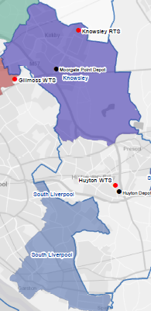  This option relies on balancing the round allocation with the capacity at the vehicles depots, as the key constraining factor is capacity at depots. So there is a need to have similar number of vehicles and to serve similar numbers of households from each depot as at present given space constraints.  A significant number of rounds in both Liverpool and Knowsley are closer to the other authority’s depot i.e. the south Liverpool and Kirkby areas. Relocating vehicles would provide drive time savings from vehicle depot to rounds and at the end of the working day as vehicle depots are closer to the tipping points.  There is the potential to serve approximately 25 of Knowsley’s residual and recycling rounds from Moorgate Point and approximately 30 of Liverpool’s residual and recycling rounds. This equates to relocating 5-6 vehicle from each depot.
Benefits and Constraints |  | Grading |  | Rationale and commentary
Political acceptability |  |  |  | Potential political concerns over a vehicle being stored and operated outside the Council area.
Collection vehicle storage |  |  |  | Comparable numbers of vehicles relocated to each depot, therefore no changes in capacity at depots
Staff parking |  |  |  | Comparable numbers of vehicles relocated to each depot, therefore no changes in capacity at depots
Office/welfare area space |  |  |  | Comparable numbers of vehicles relocated to each depot, therefore no changes in capacity at depots
Operational practices |  |  |  | There would be no change in the tipping points for either residual or recycling collections.  The reallocated rounds from Knowsley are predominately Thursday and Friday collections with the rounds from Liverpool being Monday and Tuesday collections. This would mean that collection days would need to be adjusted in both Knowsley and Liverpool and this would cover a wider area than just the areas where rounds had been reallocated.  Vehicles would be remote from current maintenance team and isolation from vehicle maintenance could cause issues if problems are identified during morning vehicle safety checks.  Liverpool operates weekly collections in certain areas which might have implications for the balance of rounds moved.
Labour relations issues |  |  |  | Collection crews would be remote from management structures; therefore there may be a need to review supervision procedures.  Collection crews would effectively be based at a different location to their current operational base which may require a relocation payment to cover any additional transport costs associated with getting to and from work. This may be able to be accommodated by using staff that live closer to the alternate depot
Health and safety (H&S) implications |  |  |  | Crews would be using the vehicles they have been trained on and RCVs already use the sites, so after initial site induction related to the start/end of the working day no H&S implications issues anticipated.  Risk assessments / procedure related vehicle safety checks would need to be reviewed and safe systems of work agreed.
Cost element |  | Grading |  | Rationale and commentary
Capital expenditure to upgrade depots |  |  |  | No capital expenditure anticipated
Depot operational costs |  |  |  | Similar numbers of vehicles are relocated to each depot, therefore no changes in cost or any cross charging between authorities assumed.
Vehicle and crew savings |  |  |  | Drive time savings would not be sufficient to reduce vehicle requirements but could result in operational cost savings (e.g. fuel) in the region of £40,000 per annum
Vehicle maintenance costs |  |  |  | No change in vehicle maintenance costs anticipated because similar numbers of vehicles would be maintained.
Land sale or acquisition costs |  |  |  | No changes to the depot footprint, so no sale or acquisition costs anticipated.
Staff relocation costs |  |  |  | Staff relocation costs would depend on where the staff actually live. If staff that live closer to the alterative depot could be moved there would be no relocation costs. If this was not the case, given the small number of vehicles involved it is anticipated that the relocation costs would be relatively low.
Communication cost |  |  |  | Changes to collection days would need to be communicated with up to 80,000 households. If a cost of £0.50 per household for communicating the changes is assumed, there would be a one off cost in the region of £40,000
Total Cost |  |  |  | Overall cost savings could be in the region of £40,000 per annum however this would be offset in the first year by the need to communicate the operational changes to the residents and any staff relocation costs
Timescales |  | Potential short term option, given the number of vehicles involved and that similar number of vehicles would be relocated.
Overall Assessment |  | This option could delivery operational savings in the region of £40,000 per annum however this would be offset in the first year by the need to communicate the operational changes to the residents and any staff relocation costs.

Serving Rainhill from Huyton
Option | 1d | Name |  | Serving Rainhill from Huyton
Description |  | 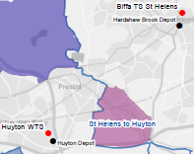  The Rainhill area of St. Helens is closer to the Huyton Depot than the Hardshaw Brook Depot. Therefore there is the potential to locate residual and garden waste vehicles from St. Helens at the Huyton Depot. The Huyton Depot is also adjacent to the Huyton WTS which is the tipping point for the residual waste fleet from that part of St. Helens. Recycling vehicles could not be considered as part of this option because of the different collection scheme (i.e. kerbside sort as opposed to co-mingled) and the use of the Biffa TS as the tipping point.  There are a small number of rounds that are covered with in this area, approximately 5 - 6 residual / garden waste rounds, although from the mapping data there may be slight variations on some of the individual rounds.  Based on the number of rounds identified one vehicle could be based at the Huyton Depot covering residual waste one week and garden waste on the alternate week. This would mean transferring the closest five rounds for each service.  This relocation does highlight an example where there could be greater efficiencies if the Rainhill area was served by Knowsley vehicles.
Benefits and Constraints |  | Grading |  | Rationale and commentary
Political acceptability |  |  |  | Potential political concerns over a vehicle being stored and operated outside the Council area.
Collection vehicle storage |  |  |  | Considering this change in isolation, i.e. accommodating one additional collection vehicle, space for vehicle, parking as staff should be adequate.  However if the realignment of South Liverpool and North Knowsley were to be carried out then may be a need to reorganise depot arrangements in Huyton and potential use the Link Road site
Staff parking
Office/welfare area space
Operational practices |  |  |  | There would be no change in the tipping points for either residual or garden waste collections.  For the residual rounds, there would be savings in both the drive time to the round in the morning and the time from tipping point to depot at the end of the working day. For the garden waste rounds, there would be a drive time saving to the round but no time saving in the drive time from the Whitemoss composting facility back to the depot.  Some changes to collection days would be required as there are no residual waste collections in the Rainhill areas on Fridays. One or two rounds may need to be reallocated to a Friday which would require communications with residents affected. This would also require a one or two recycling round to be changed to a Friday as all collection take place on the same day.
Labour relations issues |  |  |  | Collection crews would be remote from management structures; therefore there may be a need to review supervision procedures.  Collection crews would effectively be based at a different location to their current operational base which may require a relocation payment to cover any additional transport costs associated with getting to and from work. This may be able to be accommodated by using staff that live closer to Huyton than Hardshaw Brook
Health and safety (H&S) implications |  |  |  | Crews would be using the vehicles they have been trained on and RCVs already use the site, so after initial site induction related to the start/end of the working day no H&S implications issues anticipated.  Risk assessments / procedure related vehicle safety checks would need to be reviewed and safe systems of work agreed.
Cost element |  | Grading |  | Rationale and commentary
Capital expenditure to upgrade depots |  |  |  | Only requirement is vehicle parking crew accommodation for one vehicle, therefore no capital expenditure anticipated.
Depot operational costs |  |  |  | Given that this option results in only one vehicle relocating, it is assumed there would be no changes in cost or any cross charging between authorities.
Vehicle and crew savings |  |  |  | The overall drive time savings are limited, due to only one vehicle being relocated. There could be some operational cost savings (e.g. fuel) but these would be marginal i.e. less than £1,000 per annum.
Vehicle maintenance costs |  |  |  | Both authorities operate Mercedes vehicles with Zoeller bin lifts, so there is potential for the maintenance to be covered by the Huyton Depot. Potential for a nominal maintenance charge or vehicle could return to current depot for maintenance.
Land sale or acquisition costs |  |  |  | This option relates to the utilising exist space on site, therefore no sale or acquisition costs anticipated.
Staff relocation costs |  |  |  | Staff relocation costs would depend on where the staff actually live. If staff that live closer to the Huyton depot than Hardshaw Brook depot could be moved there would be no relocation costs. If this was not the case, given the small number of vehicles involved it is anticipated that the relocation costs would be relatively low.
Communication cost |  |  |  | Changes to collection days would need to be communicated with approximately 5,000 households. If a cost of £0.50 per household for communicating the changes is assumed, there would be a one off cost in the region of £2,500
Total Cost |  |  |  | There are limited drive time savings meaning that no operational savings are anticipated and when communications costs are factored in, it could result in a net cost increase.
Timescales |  | Potential short term option, given the limited nature of the change.
Overall Assessment |  | The operational savings from this option would be limited due to the limited nature of the change.  This option is unlikely to deliver saving and could result in a net increase in costs.

Developing a shared pool of spare vehicles
Option | 2 | Name |  | Shared spare vehicle pool
Description |  | There are currently between 25 and 30 spare RCVs across the city region, therefore there is the potential to develop a shared pool of spare vehicles to reduce the number of spare vehicles needed.
Benefits and Constraints |  | Grading |  | Rationale and commentary
Political acceptability |  |  |  | No political acceptability issues anticipated
Collection vehicle storage |  |  |  | A central location would need to be identified to store the spare vehicles, with sufficient space for 20-25 vehicles.  At present, there is no space at the existing depots to accommodate the full pool of pool of spare vehicles.
Staff parking |  | n/a |  | Limited staff parking anticipated as the central location would only be a vehicles storage depot and crew parking would not be required as they would continue to operate out of the existing depots.
Office/welfare area space |  | n/a |  | Limited office/welfare area space anticipated as the central location would only be a vehicle storage depot
Operational practices |  |  |  | At present there are a number of operational issues which place constraints on this option in the short and early medium term:  - There is no consistent vehicle specification across the city region, with a range of different vehicle types, designs and capacities currently being used.  - Different vehicle specifications have implications of staff training.  - Predicating demand for spare vehicles is difficult due to factors such a breakdowns, seasonality, servicing/MOTs. Therefore there is potential for no suitable vehicle being available from the pool if the demand for spare vehicles was high.  - Access to vehicles at a remote location could have implications for service delivery due to time to get spare vehicle from the central location.  - Isolation from vehicle maintenance teams could cause issues if problems are identified during vehicle safety checks when a vehicle is being collected from the central location.
Labour relations issues |  |  |  | There could be crew issues associated with using an unfamiliar vehicle type/specification (see H&S implications)
Health and safety (H&S) implications |  |  |  | Each Council has incorporated different health and safety measures into the vehicle specifications e.g. reversing cameras. Harmonisation of such measures would need to be agreed.  Crews would need to be trained on a variety of different vehicles. Infrequent use of a different vehicle design could increase the likelihood of accidents.
Cost element |  | Grading |  | Rationale and commentary
Capital expenditure to upgrade depots |  |  |  | A new central location would be required; ideally it would be an existing Council facility/asset e.g. Link Road in Knowsley. It is likely that some capital expenditure would be required to make a site suitable as a vehicle storage depot e.g. enhanced security and fencing.
Depot operational costs |  |  |  | A central spare vehicle depot would be an additional depot as there is no space at the existing depots.
Vehicle and crew savings |  |  |  | Whilst there would be no savings related to crew cost, there would be savings associated with a reduction in the number of spare vehicles. A 10-20% reduction on the number of spare vehicles would save between £75,000 and £150,000 per annum, when the costs of vehicle purchase are annualised.
Vehicle maintenance costs |  |  |  | Whilst there maybe some small savings in maintenance consumables e.g. oil, brake pads etc., the reduction in the number of vehicles is unlikely to reduce the number of maintenance staff / equipment required. In addition any savings in consumables could be offset by the fact vehicles are stored in a remote location.
Land sale or acquisition costs |  |  |  | This would depend on whether an existing Council facility/asset was available. If no centrally located site was available, as site would need to be bought or leased.
Staff relocation costs |  |  |  | No staff relocation costs anticipated
Communication cost |  |  |  | No communication costs anticipated
Total Cost |  |  |  | Any potential savings would be dependent on the set up and operational costs associated with a new cost of a vehicle storage depot.
Timescales |  | The operational practicalities, particular associated with consistent vehicle specification, would mean that this would be a medium to long term option.
Overall Assessment |  | In principle, having a shared pool of spare vehicles has the potential to reduce the overall vehicle requirements across the LCR and hence save costs. However the operational feasibility and H&S issues at present means that it is currently not practical option.  Although the viability of a shared pool of spare vehicles could change, if there was a standardisation of vehicles and depots were rationalised.

Conclusions

Serving rounds from the nearest depot
The drive time analysis shows that when considered at the LCR level the vehicle depots are not in optimal locations, which would be expected as the locations are based on the Council area they serve and the historic Council assets in each area.
The analysis also shows that there are areas across the LCR where rounds are not being served by the nearest depot. Therefore there is the potential to share depot assets and serve rounds from the nearest depot.
Following discussion with Officers at Workshop 1, a series of parameters were agreed to identify which rounds could realistically be served from an alternative depot:
- Vehicles would be relocated to alternative depots to ensure that rounds were still served by vehicles from their Council as opposed to being served by another Council’s vehicles.
- Depot capacities are constrained, with limited space to accommodate additional vehicles, therefore the number of vehicles based at any given depot need to be broadly similar to the current number.
- The proximity to the existing tipping points needed to be considered and ideally the existing tipping points retained.
- Only complete rounds would be served from alternative depots as moving part rounds would require a redesign of routes and route optimisation, which is beyond the scope of this study.
Based on these parameters and further discussion with Officers at Workshop 2 and 3, four distinct areas for potential sharing of depot facilities were agreed for detailed assessment:
  - Serving the northern parts of the Wirral from Bidston Moss
  - Realignment around the Liverpool/Sefton boundary
  - Realignment of areas of south Liverpool and north Knowsley
  - Serving Rainhill from Huyton
The detailed assessment considered a range of criteria including operational practicality, political acceptability and costs and shows that:
- Realignment around the Liverpool/Sefton boundary and Serving Rainhill from Huyton are unlikely to deliver saving and could result in a net increase in costs.
- Serving the northern parts of the Wirral from Bidston Moss and realignment of areas of south Liverpool and north Knowsley could each deliver operational savings in the region of £40,000 to £50,000 per annum; however this would be offset in the first year by the need to communicate the operational changes to the residents.
Whilst Options a and c could provide some short term savings, if the longer term aim is to move to a combined waste collection authority, the time and effort to implement the changes may be disproportionate to the savings gained, as a combined waste collection authority would be able to address these issues on a wider basis and not be as constrained by the limited capacity at the existing depots.

Developing a shared pool of spare vehicles
In addition to sharing of depot facilities, the option of developing a shared pool of spare vehicles was assessed as, in principle, this has the potential to reduce the overall vehicle requirements across the LCR and hence save costs. However, we conclude that the operational feasibility and H&S issues at present mean that it is currently not a practical option. Although the viability of a shared pool of spare vehicles could change if there was a standardisation of vehicles and depots were rationalised.

JOINT WASTE COLLECTION OPERATIONAL MODEL
This section examines the cost savings that could be derived from adopting a Joint Waste Collection service across the LCR with one collection client.

Methodology and Assumptions
A modelling exercise, using WRAP’s Kerbside Analysis Tool (KAT) was undertaken to assess the indicative collection costs incurred by all Councils, and the potential changes of alternative collection systems. This analysis is supplemented by the application of the cost implications to management of the waste (e.g. by recycling, treatment or disposal). These latter aspects are bound by contractual arrangements predominantly managed by MRWA.
Four collection options have been modelled, including the baseline (Scenario 0) and three alternative systems (Scenarios 1-3), with the aim of evaluating ‘common’ collection systems. The addition of a variation on Scenario 3 where St Helens Council’s current kerbside sorted recycling service is maintained. This is Scenario 3a in the results. A summary of the scenarios is shown in 0
Table 4 Scenarios Summaries
 | Collection | Frequency |  | Capacity (L)
Scenario 1 | Residual | 3 weeks |  | 240
 | Food | 1 week |  | 23
 | Dry | 2 week |  | 240
 | Green | 2 week (39 weeks) |  | 240
Scenario 2 | Residual | 2 week |  | 140
 | Food | 2 week |  | 23
 | Dry | 2 week |  | 240 (co-mingled)
 | Green | 3 week (39 weeks) |  | 240
Scenario 3 | Residual | 2 week |  | 140
 | Food | 1 week |  | 23
 | Dry | 2 week |  | 240 (co-mingled)
 | Green | 2 week (39 week/charged) |  | 240
Scenario 3a | Residual | 2 week |  | 140
 | Food | 1 week | 1 week (co-collected | 23
 | Dry | 2 week |  | 240 (co-mingled) / Sacks & boxes
 | Green | 2 week |  | 240
The analysis identifies the service delivery for the core collection service, and the likely LCR-wide implications, as well as highlighting where spare capacity and possible closer collaborative working could be adopted to increase service efficiency.
A number of assumptions were made for the modelling exercise, as explained in the following sections. These include the projected tonnage implications for treatment methods as a result of service changes, for example increased recycling as a result of restricted residual waste service relative to other available collection services.

Kerbside Analysis Tool (KAT)
The KAT, created and updated by WRAP, was used to model the current collection systems and desired alternatives. The most recently available version was used and all modelling conducted by KAT trained professionals. Where provided by the relevant Council bespoke vehicle specifications were applied.
Each Council was provided with a KAT pro-forma to enable them to provide as accurate as possible information regarding the current service performance, operation and requirements. The pro-formas allowed data provision for each of the service areas, including for each:
- Vehicle requirements;
- Vehicle specifications / costs / operational parameters and performance;
- Operational and capital costs, financing arrangements and infrastructure procurement details;
- Collection tonnages;
- Round data; and
- Staffing levels.
A number of assumptions were made to supplement the information provided. These were made using industry experience or data from other authorities where applicable and discussed with project partners in Workshop 2 of this project. Further assumptions were made in the modelling of alternative solutions based on industry practice, either in the form of WRAP guidance or prior experience from comparable authorities.

Baseline
A baseline scenario was developed for all six Councils. Each Council was provided with an opportunity to submit further details and agree assumptions. For Liverpool City Council an extensive reworking of the model was undertaken to take account for substantial collection variances across the City, including frequency of collections for less accessible terraced properties.

Residual waste stream
The majority of residual waste collections in the LCR are operated on a fortnightly basis, with the exception of Liverpool where 29023 properties are serviced at a higher frequency. For the purposes of this KAT model these properties were excluded following discussions with Liverpool City Council, which highlighted that it would be problematic to change the collection systems for these properties due to numerous local considerations. On this basis, with a lack specific tonnage data available, these properties and a proportional quantity of Liverpool’s residual waste tonnage were removed from the model. Despite this, over 95% of properties have their waste collection service modelled in this appraisal (657,189 of 686,212).
An assortment of collection vehicles was used in the modelling, specific to each Council area dependent on the volume/payload information provided. Where necessary the default KAT vehicles were altered to reflect the operational volumes and payload provided.
The driver contribution and number of loaders provided by each Council was used where provided. Otherwise KAT default values were applied. For all operational timings (e.g. loading time) the KAT default was used unless specific data was provided.

Dry Recycling stream
For five of the six Council areas a co-mingled fortnightly recycling system was modelled, with St Helens the exception where a weekly ‘kerbside sort’ service is provided. The latest tonnage data was applied to these models, as provided by the Councils. The majority of properties serviced by the co-mingled recycling service were modelled to have 240 litre wheeled bins. Where Councils indicated that the vehicles were used for other services (e.g. refuse or garden waste) these were modelled as such.
For St Helens there are 11 vehicles that operate on one shift, and four which double shift. In these cases, the operational costs were increased pro-rata.
Set out rates were queried with the Councils after a number of forms returned with a 100% participation rate. It was assumed that the set-out rate of 65% and participation of 75% be applied in line with that reported by similar authorities. The participation rate remained 75% in St Helens; however a lower set-out rate of 60% was applied reflecting higher frequency and type of collection service.
Contamination rates were used as provided by the waste disposal authority (av. 16.6%), with the exception of St Helens who reported a lower (10%) contamination rate associated with their recycling collection.

Garden waste stream
Two of the Councils offer a charged garden service on a fortnightly basis (Wirral and Halton). In these cases, a higher degree of certainty surrounded the participation and service pattern figures. Sefton was modelled as a three weekly service, with the remaining authorities collecting on a fortnightly basis. In each case the collection was modelled as delivered to the specified number of properties. Service operation was modelled in accordance with the provided number of weeks per annum.
Contamination rates were used as provided by the authorities where applicable. For authorities which did not provide a contamination rate, 5% was applied, as per the KAT default and mid-range of those provided by respondents.

Food waste stream
Food waste was modelled alongside the kerbside sort recycling service for St Helens. Food waste services were also modelled for Sefton (fortnightly) and Halton (weekly trial) using the data provided by the authority.

Scenario 1
Scenario 1 was modelled for all authorities. The scenario involves a 3 weekly residual collection service using 240l wheeled bins, a weekly food service using kitchen and kerbside caddies, a fortnightly co-mingled dry recycling service using 240l wheeled bins, and a fortnightly (free) garden service offered 39 weeks of the year using 240l wheeled bins.
A number of assumptions were made based on the service changes this entailed from the baseline service, as detailed below.

Dry Recycling
A 5% increment increase in participation was applied to all authorities for the dry recycling service to reflect the reduced frequency of the residual collection. There is limited information / evidence available on this aspect due to a relatively early shift towards this type of (3 weekly) system, with no industry benchmark established; however WRAP guidance assumes an 8% participation increase in dry recycling where residual waste moves from weekly to fortnightly, and as all Councils in Merseyside are already operating on a fortnightly basis a further increment would be anticipated, but potentially of a lower magnitude, therefore 5% was modelled for the move from 2 weekly to three weekly. These assumptions were discussed in Workshop 2. In the case of St Helens, it was assumed that any increase in participation due to accessibility of the service (i.e. changing to a co-mingled service) was cancelled out by the reduced frequency of the collection (from weekly to fortnightly).
A 2.5% increase in contamination was applied to all Councils, with the exception of St Helens, to reflect the increased usage of the service and increased pressure to divert materials from the residual service. A further sensitivity was conducted concerning alternative contamination rates (see section 2.8.5). In the case of St Helens, it was assumed that the contamination rate would match that of the other five Councils.
A 5% increase in capture per participating household was applied to all Councils to reflect the increased pressure on households to divert materials away from the residual stream. This is consistent with industry experience and WRAP guidance. A further 5% increase in capture was applied to St Helens to reflect that the service is easier to use for participants as they are no longer required to separate materials into different containers.

Garden Recycling
For Sefton, St Helens and Liverpool the captured material was adjusted to reflect a move to 39 working weeks. In each case 50% of the pro-rata tonnage was removed to reflect the seasonality of the collection weeks to be affected. In Wirral and Halton an 85% set-out rate and 95% participation rate was used, to match those of the other Councils. For Wirral a captured tonnage of 10kg/household/collection was applied in line with the highest tonnage capture of the other Councils based on analysis of multiple indices of deprivation and most equivalent Councils. In the case of Halton 9kg/household/collection was chosen on the same basis. Where the charged garden service has been made available to all in Wirral and Halton it is assumed that 1/3rd of the additional tonnage is from the residual stream with the remainder sourced from other sources (HWRC and home composting etc.).
An increase in frequency for the garden waste collection from 3 weekly to fortnightly in Sefton was modelled to incorporate a 5% increase in capture and reflect the increased frequency of the garden recycling service. For Knowsley a 5% increase in captured material was also applied to reflect introduction of larger capacity wheeled bins. These assumptions were discussed in Workshop 2.

Food Recycling
Food recycling tonnage projections were initially based on the WRAP ready reckoner for food waste. This method of estimation relies on use of the multiple indices of deprivation indicator. The results of this exercise greatly overestimated the tonnages to be capture in St Helens and Sefton, and therefore these results were discounted. A capture rate if 1.21 kg/hh/week was used based on the experience of St Helens. St Helens falls in the middle of the Councils in the LCR as measured by indices of deprivation and therefore it was considered that this figure was appropriate for this strategic study to be representative of all Councils.
Participation rates were set at 40% (30% set-out) in Liverpool and Knowsley, 45% (35% set-out) in St Helens and Halton) and 50% (40% set-out) in Wirral and Sefton based on previous experience in comparable local authorities. An increase in capture of 5% (above 1.20715kg) was applied to all Councils to reflect the reduced residual waste collection service. A 5% contamination rate was applied, in line with the KAT default value. These assumptions were discussed in Workshop 2.

Scenario 2
Scenario 2 was modelled for all Councils. The scenario involves a fortnightly residual collection service using 140l wheeled bins, a fortnightly food service using kitchen and kerbside caddies, a fortnightly co-mingled dry recycling service using 240l wheeled bins, and a three weekly garden service offered 39 weeks of the year using 240l wheeled bins.
A number of assumptions were made based on the service changes this entailed from the baseline service, as detailed below.

Dry Recycling
A 5% increment increase in participation was applied to all Councils for the dry recycling service to reflect the reduced frequency of the residual collection. There is limited information / evidence available on this aspect due to a relatively early shift towards this type of (restricted capacity, fortnightly) system, with no industry benchmark established; however WRAP guidance assumes an 8% participation increase in dry recycling where residual waste moves from weekly to fortnightly, and as all Councils in the LCR are already operating on a fortnightly basis a further increment would be anticipated, but potentially of a lower magnitude, therefore 5% was modelled for the move from 2 weekly to ‘restricted 2 weekly’. These assumptions were discussed in Workshop 2. In the case of St Helens, it was assumed that any increase in participation due to accessibility of the service (i.e. changing to a co-mingled service) was cancelled out by the reduced frequency of the collection (from weekly to fortnightly).
A 2.5% increase in contamination was applied to all Councils, with the exception of St Helens, to reflect the increased usage of the service and increased pressure to divert materials from the residual service. A further sensitivity was conducted concerning alternative contamination rates (see section 2.8.5). In the case of St Helens, it was assumed that the contamination rate would match that of the other five Councils.
A 5% increase in capture per participating household was applied to all authorities to reflect the increased pressure on households to divert materials away from the residual stream. This is consistent with industry experience and WRAP guidance. A further 5% increase in capture was applied to St Helens to reflect that the service is easier to use for participants as they are no longer required to separate materials into different containers.

Garden Recycling
A 5% reduction in capture was applied to all Councils, relative to Scenario 1, to reflect the reduced frequency (from fortnightly to three weekly) of the garden recycling service for all Councils, with the exception of Sefton which is as per the baseline service.

Food Recycling
The reduction in food waste collection frequency from weekly to fortnightly in this scenario (relative to Scenario 1) means a 5% reduction in participation and 5% reduction to per household capture was applied to all authorities, to reflect the reduced frequency of the food recycling service. The modelled tonnage in this instance was greater in Sefton than the baseline despite being a similar service. This is assumed to be a correct assumption reflecting that the current Sefton service is opt-in, whereas the proposed Scenario 2 collection will be automatically provided to all households.

Scenario 3
Scenario 3 was modelled for all Councils. The scenario involves a fortnightly residual collection service using 140l wheeled bins, a weekly food service using kitchen and kerbside caddies, a fortnightly co-mingled dry recycling service using 240l wheeled bins, and a fortnightly charged garden service offered 39 weeks of the year using 240l wheeled bins.
A number of assumptions were made based on the service changes from the baseline, as detailed below.

Dry Recycling
As Scenario 2.

Garden Recycling
Opt-in participation of the charged garden service was set at 45% of currently eligible properties, based on an average of the data provided by Wirral and Halton and industry experience. An alternative take-up model has been developed as a sensitivity (see section 2.8.5) to reflect the impact of differing levels of take-up. The tonnage capture of materials (for Knowsley, Liverpool, Sefton and St Helens) was set at 63.41% of previous collection tonnages, reflecting the performance of Halton and Wirral.
Where the charged garden service has been introduced it is assumed that 1/3rd of the tonnage difference is displaced into the residual stream with the remainder equally displaced to other sources (HWRC and home composting.). Experience in Wirral & Halton (reported at Workshop 2) was that a lower than 1/3rd displacement into the residual stream was observed, this level of diversion into residual waste was therefore halved (to 1/6th) as sensitivity 4.
A charge for the garden service of £35 per household per annum has been applied. Sensitivity 3 explores and alternative lower charge.

Food Recycling
As Scenario 1.

Scenario 3a
Scenario 3a matches Scenario 3 with the exception of food waste and recycling in St Helens where the baseline assumptions and collection system are applied.

Treatment Costs for All Scenarios
For each alternative scenario the cost differential has been calculated using the contract thresholds and a simplified model of the (Veolia & Suez) contractual costs as material is moved from one waste stream to another, for instance when material is diverted from the residual waste stream into the recycling collection. This charge includes the benefits attributable to selling any newly released spare capacity. The sale of spare residual waste treatment capacity is £70 / tonne, which is designed to be an attractive price to the market. No additional costs have been assumed for collection of third party waste, although it is assumed that additional trade waste collection costs would be recharged to the customer.

Sensitivities to be Applied
After discussion of the assumptions applied for the different scenarios, at Workshop 2, four additional sensitivities were suggested and applied in the subsequent modelling. These are explained below.

Dry Recycling Contamination
Sensitivity 1a applies a further 2.5% contamination rate over and above those applied in Scenarios 1-3a, to model the performance and financial effects of higher than expected contamination of the dry recycling service. This reflects concerns of the Councils that contamination is rising rapidly at present. Conversely, Sensitivity 1b reflects an improvement in performance to a historic best case 8% contamination. It should be noted that this will require additional communication and monitoring efforts which have not been accounted for in this financial assessment, and also that the 8% contamination rate was achieved at a time when fewer materials were collected and therefore potentially more clarity surrounded the collection system at point of use.

Charged Garden Take-up
This sensitivity assumes that there is a 35% take-up of the charged garden service modelled in Scenarios 3 and 3a (the alternative being a 45% take up). In this instance the collection tonnage has not been altered as this was based on actual experience from Wirral and Halton, however the model reflects substantially lower income and lower service operational demands from visiting fewer properties.

Garden Charge Reduction
This sensitivity explores the financial impact of a reduced income from the garden charge, with the household charge set at £25. This has been applied to both Scenario 3/3a and Scenario 3/3a with Sensitivity 2 (reduced take-up).

Garden Displacement
A sensitivity analysis was conducted to explore the effect of lower diversion of materials from the garden stream into the residual waste stream when a charge is introduced. Conversely, for Scenarios 1 and 2 in the case of Halton and Wirral, this reduces the amount of material removed from the residual stream into the non-charged garden collection. For this sensitivity, 1/6th of the material was displaced rather than 1/3rd.

Charged Garden Only
A further option was modelled in which charged garden waste collection is introduced into the baseline (current) service. This option did not affect Halton or Wirral where charged garden waste collection services are already in place. The assumptions applied for the other authorities are consistent with Scenario 3 for the displacement of garden waste, ie partly into the residual stream and partly to other outlets. The same take-up and charging assumptions were made as Scenario 3. This option is displayed in the results as ‘Scenario 4’.

Results

Introduction
The results of this modelling exercise give an indicative cost differential from the baseline service. This is illustrated in Figure 6 & Figure 7 . The headline cost differential incorporates numerous factors, including operational collection costs (inclusive of maintenance, staffing and depot management), collection infrastructure costs, treatment costs, and, where applicable, income from garden collection charging schemes. The assessment does not include ancillary costs, for examples, communications or enforcement budgets which may need to be increased (at least in the initial phase of any change) to deliver performance in line with the scenarios, e.g. introduction of food service, or change in collection weeks / frequency / day.
The assessment also provides an indicative recycling performance indicator comparative to the baseline, which is split between dry recycling and organics recycling where appropriate.

Recycling Performance
The largest increase in overall recycling rate occurs for Scenario 1, however all alternative scenarios, with the exception of Scenario 4, represent an improvement over the current system, region wide. A primary driver for the increased performance is the assumed city wide food waste collection, supported by a restriction in residual waste capacity. In Scenario 4, where a charged garden service alone is introduced, there is a drop in performance of 2.8% due to the lower tonnage of garden waste collected from those Councils where a charge is introduced. This impact will be mitigated by the amount of garden waste that is diverted into HWRCs.
For Scenario 1 there is an 5.7% increase in performance, with a substantial 4.5% increase for Scenario 2. For Scenario 3 the recycling rate increase is tempered by a reduction in garden waste tonnage collected as a result of the charged garden service introduction region wide.
For some Councils, for example Halton and Wirral, there is a significant recycling improvement from the baseline, over 10% for Scenario 1, due to the additional garden waste tonnage re-introduced into the service (via assumed free collections).
In the case of Sefton and St Helens the benefit of additional food and dry recycling is less than the reduction in collected garden material in Scenarios 3/3a, resulting in a reduction in overall performance for these Councils when a charged garden collection service is introduced alongside the other service changes. For these Councils the fewer service changes from the baseline to Scenarios 1 and 2 mean that there is a very modest improvement in recycling performance.
It is important to note that the increases illustrated in Figure 5 do not include other waste services, e.g. fly-tipping, street cleansing and HWRC figures. They also exclude some tonnages collected weekly, or more frequently, in Liverpool, which will result in a slight reduction in the headline improvement figures. The figures illustrated represent the core collection service only, noting that this is 95% of the collected properties in the LCR.
Recycling rate change associated with modelled service changes
For Sensitivity 1a, where contamination in the dry recycling scheme increases there is a drop in recycling rate by 0.5% in Scenarios 1, 2 and 3, and 0.4% for Scenario 3a. Conversely, for Sensitivity 1b where the contamination rate of dry recycling falls to 8% there is an increase in performance by 1.6% for Scenarios 1, 2 and 3, and 1.5% for Scenario 3a. There is no change in recycling rate associated with other sensitivities although these can have financial impacts as discussed below.

Vehicle Requirements
Vehicle requirements increase for each scenario relative to the baseline, with the exception of Scenario 4, although there is a reduction in non-food vehicle requirements in each scenario. This is unaffected in the sensitivity analysis with the exception of Sensitivity 2, where there is a slight reduction in vehicle requirement for the garden waste element of the service. In some instances, this is due to a reduction in serviced households, i.e. for Scenarios 3 and 3a with reference to garden waste service. In other scenarios a reduction in frequency, primarily to the residual service, enables a reduction in vehicle requirements. In Scenario 4, a saving of 9 RCVs is made for the garden waste services across the LCR versus the baseline. This is not offset by increases to tonnages collected through the residual collection service within the model.
In each of the scenarios there is room for further savings through sharing of vehicles for rounds on the periphery of two adjoining authority areas. 0 demonstrates the vehicle requirements as modelled in KAT. The number in brackets is the number of vehicles required to operate the service, and the preceding number the number of vehicles purchased based on individual authority working.
Table 5 Vehicle requirements
 |  | Baseline | Scenario 1 | Scenario 2 | Scenario 3 | Scenario 3a | Scenario 4
 | RCVs | 146 (143.7) | 150 (142.6) | 158 (151.1) | 147 (142.9) | 139 (135.1) | 137 (134.3)
 | Romaquip | 15 (15) | 0 | 0 | 0 | 15 (15) | 15 (15)
 | Food | 6 (5.7) | 67 (65.3) | 35 (32.5) | 67 (65.3) | 58 (55.9) | 6 (5.7)
 | Total | 167 (164.4) | 217 (207.9) | 193 (183.6) | 214 (208.2) | 212 (206) | 158 (155)
Sensitivity 2 | RCVs | - | - | - | 147 (141.1) | 133 (128) | -
 | Romaquip | - | - | - | 0 | 15 (15) | -
 | Food | - | - | - | 67 (65.3) | 58 (55.9) | -
 | Total | - | - | - | 214 (206.4) | 206 (198.9) | -
The annual cost of a single refuse collection vehicle (RCV) in the model, inclusive of staffing, fuel, maintenance, operation and overheads ranges from £160k to £197k for a 20-22m³ capacity vehicle. These differences are a reflection of the details provided by local authorities, with key variations being number of loaders per vehicle, vehicle purchase cost, depreciation period, financing cost and supervision / maintenance costs. The larger c. 30m³ vehicles operating in Sefton had a per vehicle cost of £216k – £228k depending on the scenario.
Reducing the spare capacity across the region by sharing vehicles can therefore provide substantial savings. In Scenario 1, if 7 of the 7.4 vehicle equivalents spare capacity was utilised there is potential to save £1.12m-£1.38m on the RCV fleet. This is the maximum potential saving, however it is possible that a significant, but lower magnitude, of saving can be realised through sharing vehicles alone. Some of the restrictions on sharing capacity can include the isolation of particular authorities, the service delivery pattern meaning vehicle spare capacity is only available on select days (e.g. 4 day working) and vehicle fitting requirements differing between authorities. For Scenario 2, the maximum potential annual saving range is £960k – £1.18m, for Scenario 3 £640k – £787k, and for Scenario 3a £480k – £590k. The benefit of shared vehicles in Scenario 4 would be c. 2 RCVs, i.e. £300 – 400k per annum.
When considering an alternative collection system incorporating food waste collection (i.e. Scenarios 1, 2, 3 and 3a) there is also the potential to derive some savings from a joint collection system across the LCR boundaries in terms of numbers of food waste vehicles required. The annual cost of a single food collection vehicle in the model, inclusive of staffing, fuel, maintenance, operation and overheads ranges from £121k to £133k. In Scenario 2 and Scenario 3a joint working via a single integrated collection system would deliver a potential efficiency saving of £240k - £265k per annum (versus working individually). In Scenario 1 and Scenario 3 the savings potential from joint working would be anticipated to be of a lower order, at £121k - £133k per annum.

Financial Performance
In the cost modelling both Scenario 1 and 2 increased costs for the entire LCR area. These costs had more impact on some Councils than others, for example the impact on Wirral was more substantial due to the move away from a charged garden service, and therefore reduction in income coupled with additional service delivery costs through additional vehicle (and staffing) requirements. Scenario 3, and variant 3a, performed better than the baseline, predominantly for the same reason.
The core collection costs, including income from the garden charge, but excluding all other costs associated with disposal, treatment, contracts, HWRC services, street cleansing etc. are displayed in Figure 6 .
Household collection service costs for core collection systems

In order to fully assess service costs for the region as a whole the contracted disposal and treatment cost impacts are included. These were derived utilising a contract headroom capacity and charges as detailed in Appendix 1. The contract costs discriminate in favour of Scenario 1, and Scenario 2 to a lesser extent. For Scenarios 3 and 3a the contract cost increase is cancelled out by sale of the increased capacity at £70/tonne. For Scenario 4 an additional factor in the contract cost is a loss in revenue from spare capacity sales. The core collection services cost, inclusive of contract adjustments and sale of capacity, are illustrated in Figure 7 . This demonstrates that the treatment costs have a dampening effect on the increased costs associated with Scenario 1 and Scenario 2, a broadly neutral effect on costs to Scenarios 3 and 3a, and a negative effect on the total service cost for Scenario 4.
Household collection service costs for core collection systems inclusive of treatment contracts

Figure 7 illustrates the positive and negative effect of the collection costs, the treatment / recycling contract costs or savings and the impact of third party revenue sales. The total net effect of which is illustrated by the dark blue bar, representing the total costs to LCR of each scenario. This net cost is also shown separately in Table 6 for clarity.
Scenario | Net cost (Millions)
Baseline | £32.210
Scenario 1 | £35.980
Scenario 2 | £36.000
Scenario 3 | £30.910
Scenario 3a | £30.860
Scenario 4 | £26.780
Table 6 Indicative Net costs of Waste collection and impact on treatment costs of the scenarios

The ‘total waste management’ costs of Scenarios 1 and 2 are greater than the current baseline (by c. £3.8m per annum), discounting the potential of sensitivities to improve the competitiveness of the alternative options. For Scenarios 3 and 3a, there is a small saving of £1.3m per annum (or c. 4%). This represents the benefit of adopting the same collection system, but continuing to operate independently (as individual Council services) does not include any of the benefits that could therefore follow on from joint working, procurement etc., which could represent a higher degree of additional savings. For Scenario 4, a saving of c. £5.5m is identified, however it should be noted, as identified in the sensitivity analysis, that a lower level of uptake and a lower charge than modelled can reduce revenues from the charged garden waste option by up to £3m.
Any operational collection cost or savings exhibited, as illustrated by Figure 6 , will vary from Council to Council, but the estimated net savings are presented. The addition of food waste collections, which is only collected on a limited basis in the current service (baseline), is the most significant cause of the increased service costs modelled, with the collection part of this service costing up to c. £8m/annum in Scenario 1.
To set the cost impact of food waste collection into some context, if Scenario 3 was delivered with a lower frequency (fortnightly collection system for food waste, as per the current Sefton frequency, and as modelled in Scenario 2) the potential savings associated with collection infrastructure reduction far outweighs the additional residual collection infrastructure burden, and is projected to deliver further savings of £2 – 3.5m against the baseline. This saving does not take into account alterations to the treatment contract, although these are envisaged to be of a lower magnitude. There would however be a significant reduction in recycling rate benefit associated with this, with a drop of 0.75% across the region compared with Scenario 3. This does demonstrate however that it is possible to enhance overall recycling rates and save at least £3m by altering the collection system.
Furthermore, if the charged garden waste collection was implemented in advance of the other elements of Scenario 3 (i.e. Scenario 4), for all Councils with the exception of those that already offer it (Halton & Wirral), then a net saving over the baseline of up to £5.5m per annum would be envisaged, however there would be a fall in recycling rate in response (as indicated in Figure 5 ), corresponding to the amount of waste diverted to home composting or the residual stream (as tested in sensitivities below). The amount of garden waste diverted into the HWRCs however would still contribute towards the LCR recycling rate, where separated, and this would be expected to mitigate the reduction in the recycling rate resulting from the introduction of a charged garden waste service. This projection is subject to the sensitivities surrounding take-up and charge as discussed for the other scenarios.

Sensitivity Analysis
Sensitivity Analysis was applied to scenarios 1, 2 3 and 3a only. The impact of the sensitivity analysis on collection costs is summarised below.
Sensitivity 1a, where the contamination rate was increased, had a relatively uniform impact on total service costs, with an extra region wide cost ranging from c. £17k in Scenarios 1, 2 and 3 to c. £14k in Scenario 3a. Sensitivity 1b had a larger impact due to the higher differential between the modelled contamination rate (16.6%) and the revised rate (8%). A saving of c. £71k is forecast for Scenarios 1, 2 and 3, with a small drop in benefit to c. £58k for Scenario 3a.
For Sensitivity 2 a reduction in incomes from 10% of households results in a net loss of £1.26m compared with Scenario 3/3a. For Sensitivity 3 a reduction in income from a smaller charge (£25) results in a net loss of £2.33m compared with Scenario 3/3a. Where both a lower uptake and lower charge are modelled a net loss, compared with Scenario 3/3a, of £3.22m occurs.
For Sensitivity 4, where the displacement of garden waste into the residual stream is reduced, there is a significant variance in results. For Scenario 1, where garden waste increases in Halton and Wirral, and a lower proportion of the material is removed from the residual, there is a benefit of c. £72k. For Sensitivity 2 there is no change in service costs. A small cost of c. £12k is associated with the displacement of a lower proportion of the waste in Scenario 3/3a associated with the lower efficiency of the resulting residual service.

Summary
Three alternative common collection systems have been modelled based around high recycling levels as defined at Workshop 1. Collection Scenarios 1 & 2 delivered the highest recycling rate, but were also more expensive than the baseline (business as usual). The increase is largely driven by implementing a ‘city region wide’ food waste collection system, which more than offsets the savings generated by restricting residual waste collections and increasing recycling. The current contractual arrangement, whilst representing both stability and good value in treatment and disposal costs, does not incentivise food waste collection in particular.
Scenario 3 (and its variant with St Helens Council retaining its current dry recycling system), is modelled to exhibit both savings (c. £1.2m / annum) and deliver an anticipated increase in recycling rate (c. 1-2%). The savings in this case are driven by implementing a charged garden waste service, for which there is a varying level of performance modelled through sensitivity assessment. If a charged garden waste service was implemented as a single measure (modelled as Scenario 4 in the analysis), then a greater degree of savings (over the baseline) would be anticipated of c.£5m per annum across the LCR.
The savings are also based on an assumption that capacity freed up in the residual treatment recovery contract is sold at £87.50/ tonne to third parties.
These levels of saving are only based on using a common collection system and not working together in any other regard, however it is only through having a common collection system that further integration and saving can be realised to its fullest extent.
The analysis has shown a further £0.5m - £1.4m / annum saving would be deliverable through shared use of refuse collection vehicles across collection rounds and significant further savings would also be expected to be delivered through a LCR route optimisation programme. In addition, and as described in sections Appendix 2 of the report, common procurement, communications and reduced management would be anticipated to exhibit added savings based around a common collection client.

DEPOT RATIONALISATION

Introduction
The location of the current depots is based on servicing an individual Council area and the availability Council sites/assets. Figure 8 shows the current depot locations and the drive times from the depots to the different part of each authority area. It highlights that the majority of the LCR can be reached within 25 minutes from the existing depot locations.
Vehicle drive times from existing depots
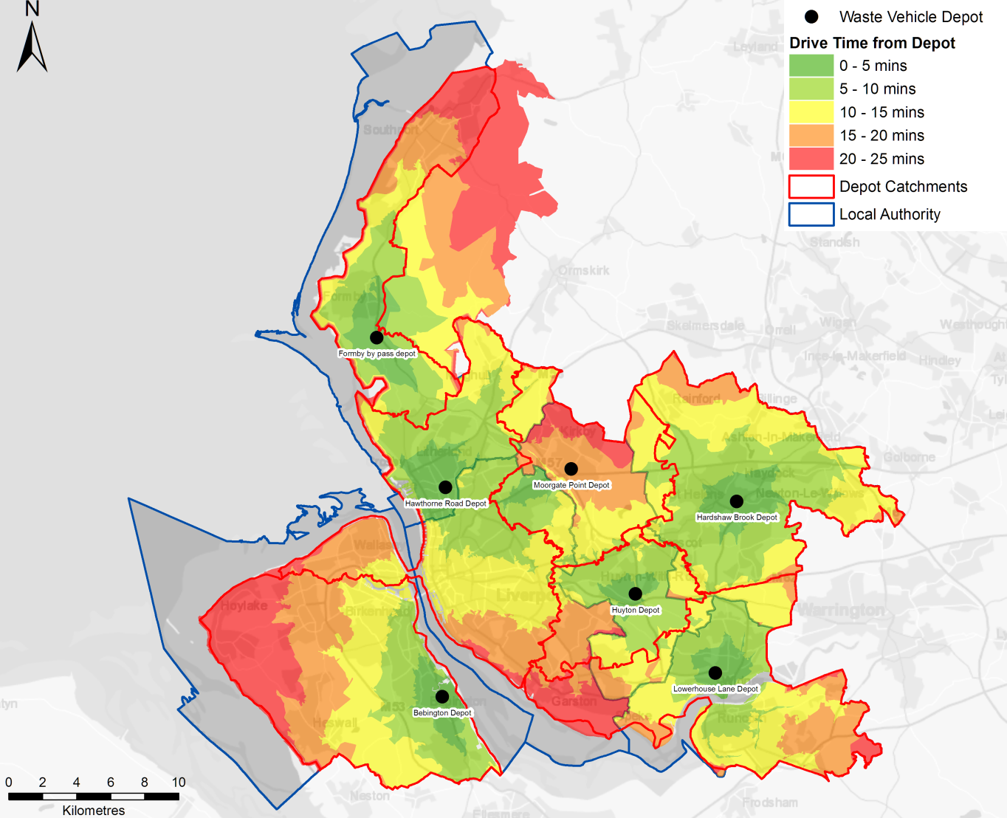

Drive time analysis was used to determine the optimum number of depots across the LCR whilst maintaining drive times that were comparable with the current situation. Two options were considered:
- Completely optimised, i.e. no locations fixed; and
- Fixing one of the depots at the Knowsley Rail Transfer Station (RTS), in order to examine the effect of co-locating vehicles at the Knowsley RTS as a potential long term option.
Figure 9 presents the drive time analysis for Option 1, the completely optimised option. It shows that the majority of the LCR could be reached within 25 minutes from four strategic depots.
Figure 10 presents the drive time analysis for Option 2, the fixed depot at the Knowsley Rail RTS. It again shows that four strategic depots could service the city region, although the time to reach some areas of the LCR would be increase to 30 minutes.
Option 1 - Depot rationalisation drive time analysis
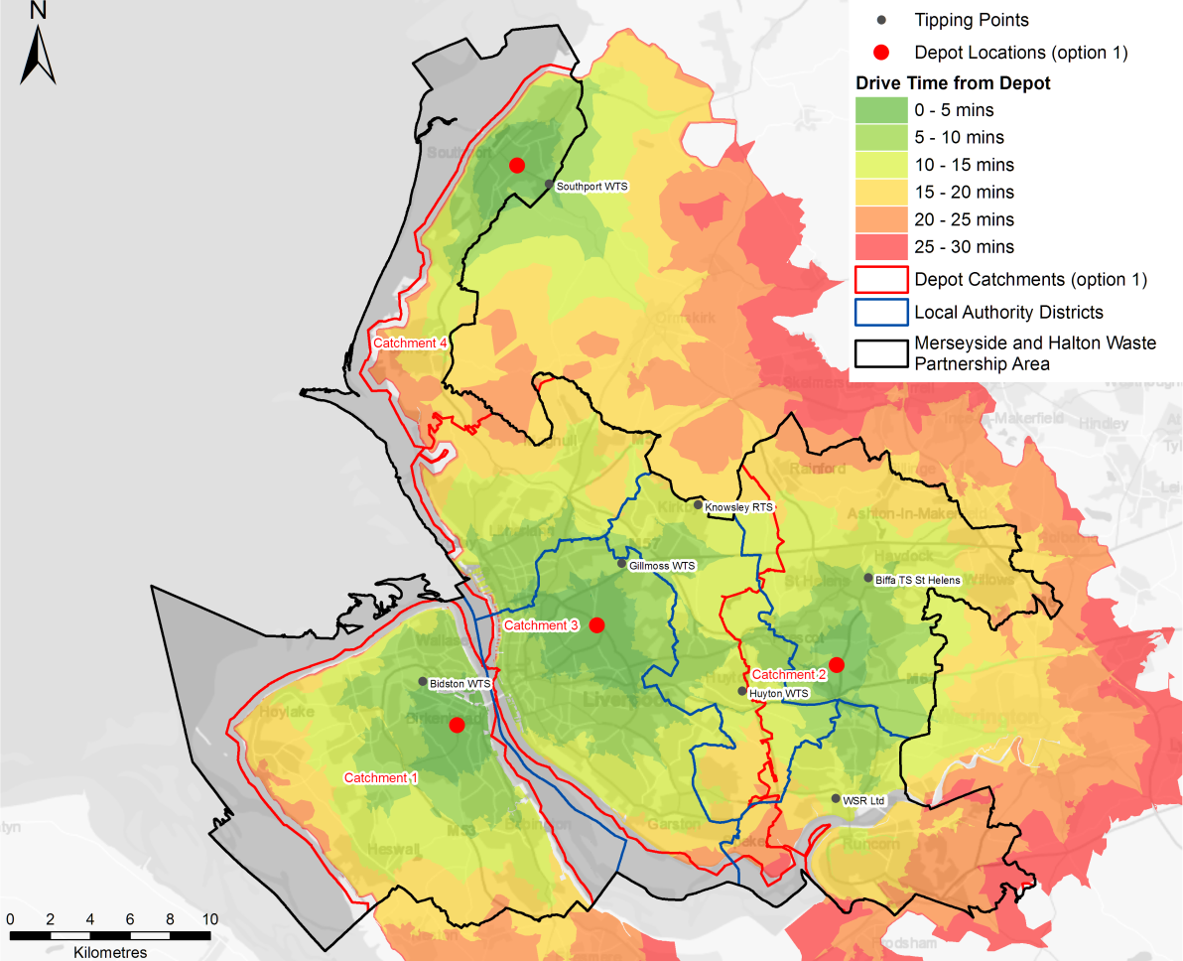
Option 2 - Depot rationalisation drive time analysis
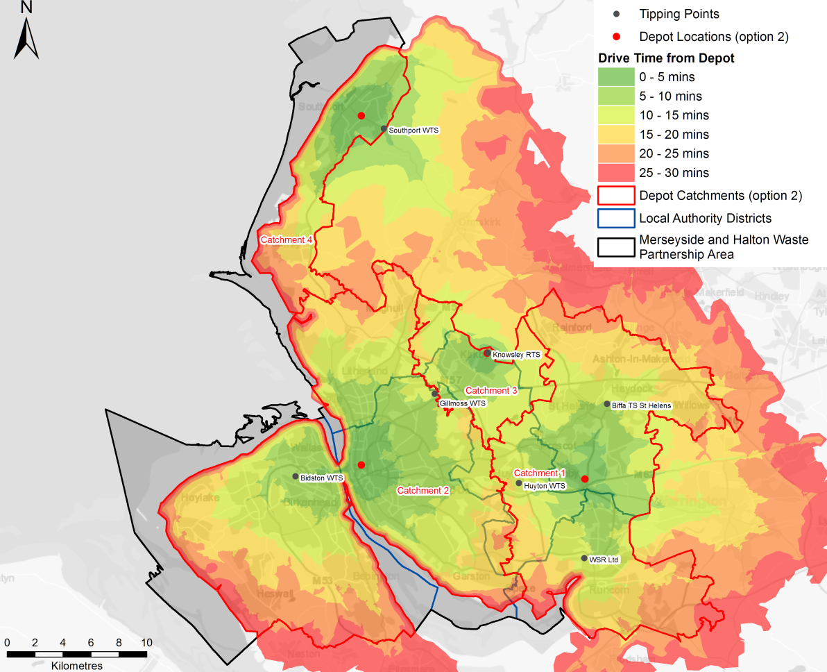

Assessment of Drive Time Impacts
The assessment is based on the assumption that the current round and tipping points do not changes and there is no redesign of routes and route optimisation (which are beyond the scope of this study).
Based on these assumptions there are two key elements that need to be considered when assessing the drive time impacts associated with the two options:
- The drive time from depot to the start of a round;
- The drive time from tipping point to depot at the end of the working day.
The drive time from round to tipping point during the day is not affected as the same tipping points for each round would remain unchanged.

Drive time from depot to round
The assessment of the average drive is based on the LCR area as a whole but clearly changing depot locations would have different travel time impacts for individual Councils. The average drive time from depot to round has been calculated for the current situation and both options. The average drive time is the mean of the time taken from the depot to the mid-point of each round. The results are presented in table 7.
Table 7 LCR -Average drive time from depot to round
 | Current | Option 1 | Option 2
Average drive time from depot to round | ~12mins | ~10mins | ~12mins
The results highlight that Option 1 provides a marginal improvement on an LCR basis.

Drive time from tipping point to depot
There are numerous combinations of tipping point to depot journeys, all of which would be affected by relocating depots. The ideal scenario is to co-locate tipping points to depots provided that the location is centrally located within a catchment area.
Table 8 provides a summary of the current tipping point to depot journeys for residual and recycling vehicles, the equivalent journeys under each option and drive time differences. Table 9 provides the equivalent data for garden waste vehicles.
The tables show that for the majority of journeys the differences in the journey times for Option1 are better than for Option 2 when compared with the current situation. This is because the Knowsley RTS is on the boundary of the LCR and a vehicle depot located at the Knowsley RTS would have a relatively small catchment area, which in turn distorts the other catchment areas.

Table 8 Tipping point to depot journeys – time differentials for residual and recycling vehicles
Current tipping point to depot journeys | Option 1 |  |  |  |  | Option 2
 | Journeys |  |  | Time difference |  | Journeys |  |  | Time difference
Southport WTS to Formby by pass depot | Southport WTS to Catchment 4 location |  |  | -17 mins |  | Southport WTS to Catchment 4 location |  |  | -17 mins
Gillmoss WTS to Hawthorne Road | Gillmoss WTS to Catchment 3 location |  |  | -2 mins |  | Gillmoss WTS to Catchment 2 location |  |  | +2 mins
Bidston WTS to Bebington Depot | Bidston WTS to Catchment 1 location |  |  | -9 mins |  | Bidston WTS to Catchment 2 location |  |  | -6 mins
Gillmoss WTS to Moorgate Point | Gillmoss WTS to Catchment 3 location |  |  | +2 mins |  | Gillmoss WTS to Catchment 2 location |  |  | +6 mins
Huyton WTS to Moorgate Point | Huyton WTS to Catchment 3 location |  |  | +6 mins |  | Huyton WTS to Catchment 2 location |  |  | +11 mins
Huyton WTS to Huyton Depot | Huyton WTS to |  | Catchment 3 location | +13 mins |  | Huyton WTS to |  | Catchment 2 location | +18 mins
 |  |  | Catchment 2 location | +14 mins |  |  |  | Catchment 1 location | +13 mins
Gillmoss WTS to Huyton Depot | Gillmoss WTS to Catchment 3 location |  |  | -12 mins |  | Gillmoss WTS to Catchment 2 location |  |  | -8 mins
Widnes S&R WTS to Lowerhouse Lane Depot | Widnes S&R WTS to Catchment 2 location |  |  | +10 mins |  | Widnes S&R WTS to Catchment 1 location |  |  | +9 mins
Gillmoss WTS to Lowerhouse Lane Depot | Gillmoss WTS to Catchment 2 location |  |  | -5 mins |  | Gillmoss WTS to Catchment 1 location |  |  | -4 mins
Huyton WTS to Lowerhouse Lane Depot | Huyton WTS to Catchment 2 location |  |  | -4 mins |  | Huyton WTS to Catchment 1 location |  |  | -5 mins
Gillmoss WTS to Hardshaw Brook | Gillmoss WTS to Catchment 2 location |  |  | +5 mins |  | Gillmoss WTS to Catchment 1 location |  |  | +6 mins
Huyton WTS to Hardshaw Brook | Huyton WTS to Catchment 2 location |  |  | -5 mins |  | Huyton WTS to Catchment 1 location |  |  | -6 mins
Biffa TS St Helens to Hardshaw Brook | Biffa TS St Helens to Catchment 2 location |  |  | +7 mins |  | Biffa TS St Helens to Catchment 1 location |  |  | +8 mins
> 5 min saving |  | ± 5 min |  |  |  |  | > 5 min increase
Table 9 Tipping point to depot journeys – time differentials garden waste vehicles
Current tipping point to depot journeys | Option 1 |  |  |  |  | Option 2
 | Journeys |  |  | Time difference |  | Journeys |  | Time difference
Whitemoss (Kirkby ) to Hardshaw Brook | Whitemoss (Kirkby ) to Catchment 2 location |  |  | +5 mins |  | Whitemoss (Kirkby ) to Catchment 1 location |  | +6 mins
Whitemoss (Kirkby ) to Huyton Depot | Whitemoss (Kirkby ) to |  | Catchment 3 location | -9 mins |  | Whitemoss (Kirkby) to Area 1 location |  | +1 mins
 | Whitemoss (Kirkby ) to |  | Catchment 2 location | 0 mins
Whitemoss (Kirkby ) to Moorgate Point | Whitemoss (Kirkby ) to Catchment 3 location |  |  | +7 mins |  | Whitemoss (Kirkby ) to Catchment 2 location |  | +11 mins
Whitemoss (Formby) to Formby by pass depot | Whitemoss (Formby) to Catchment 4 location |  |  | +17 mins |  | Whitemoss (Formby) to Catchment 4 location |  | +17 mins
Whitemoss (Formby) to Hawthorne Road | Whitemoss (Formby) to Catchment 3 location |  |  | +6 mins |  | Whitemoss (Formby) to Catchment2 location |  | +6 mins
> 5 min saving |  | ± 5 min |  |  |  |  | > 5 min increase

Assessment of Rationalisation Options
Based on the drive time analysis the assessment focuses on Option 1.
Under Option 1, the drive time analysis shows that the majority of the LCR can be served with 25 minutes from four strategic depots. Therefore there is the potential to reduce the number of current operational depots. The analysis also shows that two of the strategic locations are located close to existing transfer stations:
- The location in catchment area 1 is close to Bidston Moss WTS; and
- The location in catchment area 4 is close to Southport WTS.
Therefore co-locating these vehicle depots at the WTS transfer station could further reduce the number of facilities need to serve the LCR.
In addition, Liverpool City Council is currently developing a business case for the relocation the existing Moorgate Point depot to a site at Newton Road (L13 3HS off Prescot Road in Stoneycroft / Old Swan). This site is in close proximity to the location in catchment area 3, as highlighted in Figure 11 .
If it assumed that:
- the vehicle depot for catchment area 1 can be co-located at Bidston Moss WTS;
- a new location to the east of Rainhill is identified for catchment area 2;
- the proposed Liverpool City Council depot at Newton Road serves catchment area 3; and
- the vehicle depot for catchment area 4 can be co-located at Southport WTS.
The following vehicle depots would no longer be required for waste management services:
- Lowerhouse Lane Depot
- Moorgate Point Depot
- Hardshaw Brook Depot
- Huyton Depot
- Bebington Depot
- Hawthorne Road Depot
- Formby by pass Depot
This would result in a net reduction of 5 locations related to waste management services in the LCR
Option 1 - Depot rationalisation locations including Newton Road location
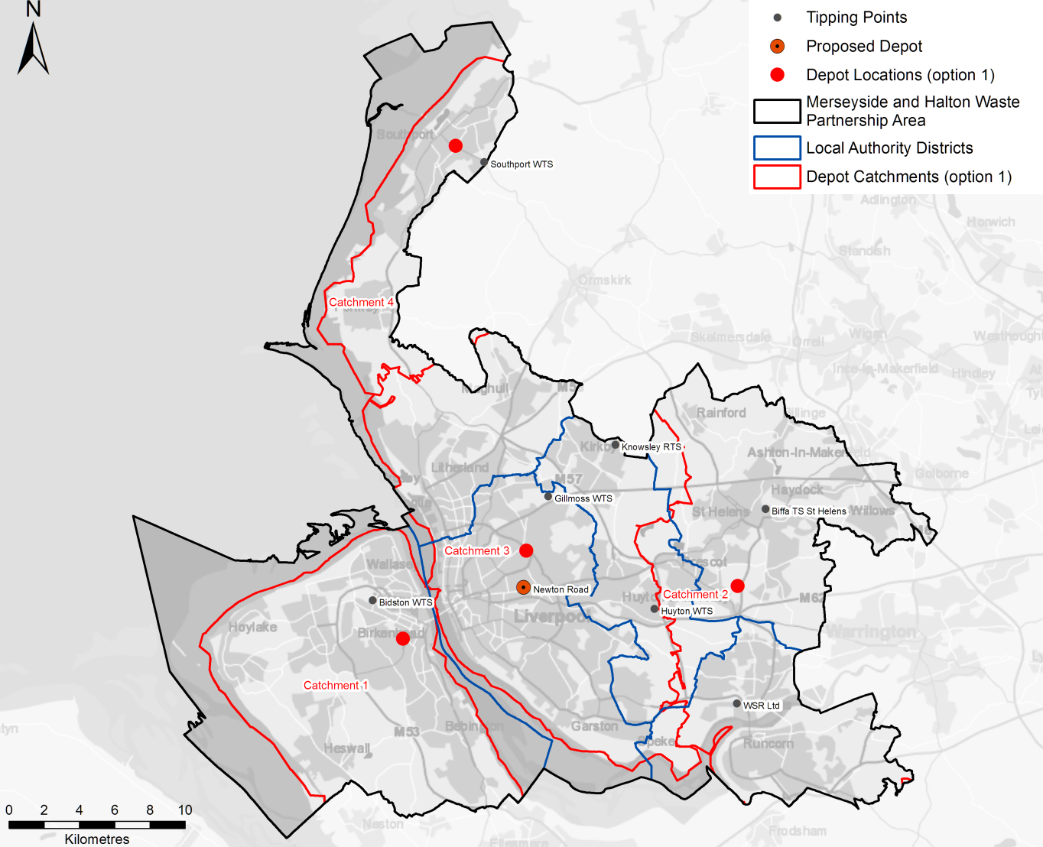

Benefits and constraints
Table 10 sets out the potential benefits and constraints by catchment area based on the current collection operations with the potential cost benefits discussed in Section 3.3.2. The implications of the modelled common collection options on the depot capacity are summarised in Section3.3.3.
Table 10 Benefits and constraints of depot rationalisation
Catchment Area | Benefits | Constraints
1 | Bebington Depot would no longer be required for Council waste services.  Increased drive time savings as two thirds of the rounds are closer to Bidston Moss and all vehicles would end their day at the tipping point.  Bidston Moss is a MRWA asset. | Wirral services are contracted-out to Biffa, and the Bebington Depot is a Biffa depot. Therefore operational saving would need to be negotiated with Biffa.  Space would be required of approximately 40 RCVs at Bidston, currently space for 5-6 vehicles has been identified.  Capital expenditure likely to be required to upgrade facilities at Bidston Moss (i.e. staff welfare) and acquire land for parking (both RCVs and staff)  Veolia currently operate the site, so operation changes would need to be agreed / negotiated with them.
2 | Hardshaw Brook and Lowerhouse Lane Depots would no longer be required for Council waste services. In addition, the new location would accommodate some vehicles that serve Knowsley.  Hardshaw Brook and Lowerhouse Lane Depots are both space constrained. | A new site would need to be identified with capacity for approximately 70 RCVs and associated staff parking and office space.  The areas south of the River Mersey (Runcorn area) have some of the longer drive times both to round and from tipping points to the optimal location. In addition, with the development of the second Mersey cross both bridges across the Mersey will become toll bridges, which would add cost to all journeys to and from the Runcorn area. Therefore there may be a need to consider a satellite depot/tipping point to serve Runcorn and the surrounding area.  Limited drive time savings.
3 | Newton Road Depot would replace Moorgate point, Hawthorne Road Depot would no longer be required for Council waste services and the majority of vehicles from the Huyton Depot would be based here. The Huyton Depot would also no longer be required for Council waste services as a result of the combined effects of Options 2 and 3.  Drive time savings as a result of depot being located to closer to areas of higher population density. | Space would be required for approximately 100-110 RCVs and associated staff parking and office space. Information from Liverpool City Council indicates that there is capacity to park 100 RCV or similar plant. With the potential for further capacity if the highways function is relocated.  This would be a large depot, with a significant number of vehicles based at one location. There could be operational practicalities and traffic issues particular at the start of the when vehicles are going out to rounds at the same time.  Some capital investment is likely to be needed at the Newton Road Depot
4 | Formby by pass depot would no longer be required for Council waste services.  Would provide some drive time savings due to greater population density in Southport.  Southport WTS is a MRWA asset. | Space would be required of approximately 12 RCVs at Southport WTS along with associated staff parking.  Southport WTS is an old facility and is likely to require capital expenditure required to upgrade depot.  Veolia currently operate the site, so operation changes would need to be agreed / negotiated with them.

Potential cost benefits
The operational costs of depots are often accounted for differently by different Councils, due to factors such:
- shared use with other services;
- depot ownership; and
- contact/lease arrangements.
Therefore it was agreed at Workshop 3 that potential depot savings need to be considered as both operational savings as well as potential asset values and that each Council would provide:
- a range for annual operational costs for each depot; and
- indicative asset value for each depot.
Table 11 provides a summary of the data provided by each Council.
Table 11 Current Depot Annual Operational Costs and Potential Asset Value
Council | Depot | Annual Operational Cost | Potential Asset Value | Comments
Halton | Lowerhouse Lane | ~£185k | £0.55m, based upon an evaluation in April 2014 | The Refuse Collection Service is charged 26.7% of the overall depot costs i.e. £187,540
Knowsley | Huyton Depot | ~£40k | £1.860m | The operational saving relate to area the Waste Management Service occupies
Liverpool | Moorgate Point | Awaiting information | Leased from Salt Modwins with purchase option | Site currently under review with potential closure in two years and relocation to Newton Road Depot
Sefton | Hawthorne Road | ~£125k | Not known but neighbouring site (some 2 times bigger) has recently been purchased by a builder for ~£2m | Operational cost of ~£250k share by four users, which is split by the area used. The waste management and street cleansing service pays around 56% of the cost.
 | Formby by pass | ~£40k | Not known
St. Helens | Hardshaw Brook | No information provided | No information provided
Wirral | Bebington | No information provided | No information provided

Reducing the operational locations by five across the LCR has the potential to reduce operational costs for the waste management service. Based on the limited information available, the full extent of this saving is difficult to define but could be up to £0.5m per annum. A detailed business case would need to be developed to properly quantify the potential savings and there are a number of issues that would need to be factored in to the evaluation:
- Whilst consolidating the number of locations related to waste management is likely to provide savings to the waste management service, it may not result in overall saving to the Councils. This is because the majority of the existing depots are shared with other services and if the depots need to be retained for those services, the depot operational costs would need to be fully distributed between those other services.
- Any potential asset value can only be considered if the depots are no longer required by the Councils for other services. Although, reducing the areas needed could allow other co-located services to be moved to smaller Council owned locations and allow the larger depot to be released.
- Co-locating vehicles depots at existing WTS is likely to require a level of capital investment e.g. refurbishment of offices, purchase of additional land for parking etc.
- Capital investment would be needed to develop a new location in catchment area 2. However, given that the Huyton WTS is in poor condition and will need significant refurbishment in the future, there could be the potential to co-locate both activities.
Therefore the overall operational savings could range from £0 to £0.5m per annum. However, depot rationalisation does provide the starting point for wider collection cost savings related to common vehicles and future redesign of routes and route optimisation.

Implications of common collection options on depot capacity
The depot rationalisation assessment has been based on the existing vehicle fleet and vehicle numbers. However, if one of the common collection options were to be adopted the number of vehicles could increase by 25 to 50 vehicles depending on which scenario were to be adopted. This has implications for both the current depots and any rationalisation options.
Table 12 highlight the additional vehicles required by each Council under the different common collection scenarios. It suggests that Knowsley and St. Helens should be able to accommodate the additional vehicles based at their current depots. Whereas, based on the reported capacity constraints at existing depots, the remaining Councils could potentially struggle to accommodate the additional vehicles.
Table 12 Additional vehicles required by each Council under the common collection models
Council | Scenario 1 | Scenario 2 | Scenario 3 | Scenario 3a
Halton | 3 | 2 | 3 | 3
Knowsley | 2 | 1 | 1 | 1
Liverpool | 18 | 11 | 20 | 20
Sefton | 9 | 4 | 8 | 8
St. Helens | 0 | -2 | 0 | -2
Wirral | 17 | 10 | 15 | 15
The implications of the alternative collection scenarios for the depot rationalisation are that a large fleet of food waste vehicles would be required to service this new collection system and so increase the vehicle parking capacity and associated staff parking and office space. The implications for the catchment areas discussed in section 3.3.1 are:
- Catchment Area 1 (the Wirral area): An additional 10 to 17 vehicles to the 40 or so vehicles associated with the existing services;
- Catchment Area 2 (the east of the LCR): Limited impact of 1 to 2 vehicles
- Catchment Area 3 (the greater Liverpool area): An additional 10 to 17 vehicles to the 100-110 RCVs associated with the existing services.
- Catchment Area 4 (the Southport area): An additional 2 to 4 vehicles to the approximate 12 vehicles associated with the existing services.
However, it should be noted that redesign of routes and route optimisation could reduce the overall number of rounds and vehicle requirements and hence the depot capacity requirements.

CONCLUSIONS AND OVERALL SAVINGS
The benefits and savings that can be achieved through asset sharing and collection system commonality are dependent on the level of integration towards a combined waste collection authority. The further the Councils move towards a combined waste collection authority the greater the incremental benefits. Table 13 summarises the potential savings that may be realised through a wide variety of savings opportunities, which in some instances be ‘standalone’ or in other instances reliant on other measures (such as joint working across Councils)
- Table 13 Potential saving associated with asset sharing and common collection systems
Element | Description | Savings | Timescales and interrelationships
Depot realignment alone | Serving areas from alternate depots | c. £0.05 -0.1m / annum after first year | This element could be implemented in the short term but if the medium term aim is to move to a more integrated approach across the LCR, the effort of making the changes may be wasted.
Introduction of a charged garden waste system (only)^{[1]} | For Councils that do not currently charge, a new garden waste subscription service is introduced | c. £4m-£5.5m / annum | The element could be implemented in the short term as a step towards adopting an alternative collection system or as an independent measure with potential for substantial savings but with a negative impact on recycling rates.
Alternative collection system | Scenario 3: Restricted residual in 140l bins collected fortnightly, a food waste collection and a charged garden waste service (net including disposal) | c. £0.5m- 2m / annum | Medium term option, which could be delivered on an individual Council level, but could realise additional saving if:  - adopted as part of a common collection system with shared / joint working practices; or  - moving to a combined waste collection authority
Vehicles savings as a result of depot realignment | Vehicle operational cost saving by optimising depot locations | c. £0.2 – 0.4m / annum | This element is dependent on adopting the alternative collection system model due use of common vehicles.
Depot operational savings | Savings from reducing the number of depots used to serve the LCR | c. £0 – £0.5m / annum | This element would be a medium to long term option. Whilst not dependent on the adoption of a common collection system and establishing shared or joint working practices, it is likely to yield additional benefits if a common approach is adopted.
RCV: Optimum vehicles based on common services | Vehicle savings as a result of all authorities operating common services with the optimum number of vehicles and current operational performance.  (Potential for further saving if route optimisation employed) | c. £0.5 - £0.75m / annum (based on Scenario 3 or 3a) | Benefits reliant on adopting a common collection system.  Medium to long-term option.
Food Vehicles: Optimum vehicles based on common services | Vehicle savings as a result of all authorities operating common services with the optimum number of vehicles and current operational performance.  (Potential for further saving if route optimisation employed) | c. £0.12 - £0.26 m / annum | Benefits reliant on adopting a common collection system.  Medium to long-term option.
Reduction in spare vehicles requirements | 10-20% reduction on the number of spare vehicles as a result of standardised vehicles and depot rationalisation | c. £0.075 -0.15m / annum | Would be facilitated by the adoption of a common collection system / vehicle specifications, establishing shared or joint working practices and depot optimisation.  Medium to long term option alongside common collection system and depot sharing options.

The sharing of existing assets, such as depots and vehicles, would be the logical place to start; however the constraints of local authority boundaries and capacity at depots, combined with the range of different vehicles in use, means that such options have limited short benefit, especially if the medium term aim is to move to a more integrated approach across the LCR.
There is the potential to target some ‘quick wins’ whilst the medium to long term structure and operational model is developed. This approach would enable the maximum savings to be realised and to also fulfil longer strategic targets and aspirations.
The most significant ‘quick win’, indeed the most substantial individual savings option of those reviewed, is the implementation of a charged garden waste system. This has already been implemented successfully in Wirral and Halton and could be implemented through a single campaign across the LCR. A single campaign would also allow a consistent message to be presented to the public across the LCR, helping to manage the acceptability of what can be a viewed as a negative service change, whilst potentially providing efficiencies in service delivery.
The bulk of the other savings are derived from adopting a common collection system and establishing shared or joint working practices, with the optimum savings offered by forming a combined waste collection authority. To realise these savings, an agreed action plan needs to be developed; however, such an action needs to be based on a clear understanding of the future governance as the staged implementation of common vehicle specifications, shared infrastructure and optimised depot locations could vary depending on the governance model adopted.
In addition, clarity over the future governance model would also help in the consideration of other issues that would need to be addressed such as:
- the potential and market for third party waste to offset any waste diverted from the residual stream as a result of enhanced recycling and the establishment of food waste collections, which has the potential of businesses in the LCR to benefit from the RRC contract;
- the potential, subject to contracts, for a more circular approach to food waste management in the LCR, potentially via local anaerobic digestion and innovation in vehicle fuel utilising the biogas;
- round redesign and route optimisation across the LCR; and
- the ability to respond to future changes (e.g. via legislation, policy) most efficiently manner.
These strategic measures will also enhance recycling rates and encourage greater resource use within the LCR, consistent with the aims and objectives of the MWP.

Annex 1

GIS and Spatial Analysis
A key aspect of this project is taking a wider view of waste collection across the LCR geographic area. It is a large administrative area of over 900km² encompassing 6 local authorities with approximately 700,000 residential properties, with three key waste collection services for recycled, garden and residual waste (Figures 1 – 3). To help identify potential savings and efficiencies in waste collection through partnership working across the six councils, the real distribution and proximity of households and waste collection facilities was examined without the constraints of the established council area boundaries.
There were 4 aspects of geographic analysis that needed to be examined:
- Current distribution of waste collection facilities, depots and existing rounds;
- ‘Catchment areas’ of existing depots;
- ‘Catchment areas’ from existing depots if collection across council boundaries is allowed; and
- Optimised depot locations to best serve the entire LCR area with the minimum number of facilities.
Supporting this analysis, statistics relating to existing and potential drive times and the number of properties serviced by each round were required. This would allow the potential accrued benefits of re-allocating collection rounds to be assessed in terms of the following three factors:
- ‘depot to round’ travel time;
- ‘round to tipping point’ travel time; and
- ‘tipping point to depot’ travel time.
To this end, extensive use was made within this project of GIS (Geographical Information System) technologies to integrate, map and analyse the extensive data supplied by the six Councils involved in this project. The key tool used was ESRI’s ArcMap software with information being compiled into a geodatabase to allow efficient access and processing of detailed data over the large LCR.

Data Sources
Initial mapping for the project was undertaken using ‘open source’ information available from the Ordnance Survey and Office of National Statistic (ONS), including background mapping, Council boundaries, ‘openroads’ road network and 2011 Census data. Additional information was supplied from Wirral Council for the whole of the LCR under a ‘Contractors License’, providing access to the OS data available to the Councils under the Public Service Mapping Agreement (PSMA):
- OS Address Base – individual property location information. A point data set identifying every single commercial and residential property in Merseyside.
- OS Integrated Transport Network (ITN) – detail road network information.
- OS Codepoint Polygons - postcode areas for individual unit postcodes.
MRWA provided information on vehicle depots and tipping points/ waste transfer stations. These locations were verified by double checking on aerial imagery and OS mapping so that precise locations of the depots and tipping points could be mapped, an essential aspect for the following analysis of drive times and catchment area analysis. It is worth noting that provision of postcode and road name information as location of depots often does not give enough level of accuracy when locations need to be used for more detail analysis. The double checking of locational information provided a detailed accurate location of all the waste facilities that can be used for future work (see Table 2).
Additional information from each of the six Councils was also provided for the waste rounds (see below).

Waste Round Information
Each of the six Councils provided information on the areas served by waste rounds for residual, recycling and garden waste. Four of the Councils provided this information as geo-referenced property addresses with attribute information identifying the rounds each property was allocated to. Two Councils (Wirral and St. Helens) provided information for rounds in the form of spreadsheets listing the streets (or part streets) serviced by each round.
Property addresses – The waste round information was variously supplied either as a single spreadsheet file listing each ‘georeferenced’ property and round number for each of the three types of collection, or as separate spreadsheets for each waste collection type. The ‘Geo-referenced’ records took the form of OS grid co-ordinates, enabling each of the properties to be mapped accurately as a series of colour coded dots representing the properties within each waste round.
Street spreadsheets – Waste rounds were defined by the streets (or part streets) that comprised each round. These were either provided as multiple spreadsheets, one spreadsheet ‘tab’ per waste round, or as single spreadsheets for each waste collection type. For each of these data supply options, the spreadsheet data first had to be ‘cleansed’ to produce a column of data representing the actual street name so this could later be used to ‘match’ with the OS street name data.
Due to time constraints, it was not possible to split the actual streets at the correct locations to identify accurately the round boundaries so rounds defined in this way gave only approximate locations. Additionally, where several streets with the same name exist within the Council area, these could be mis-classified to the wrong rounds. During later stages of the project, rounds defined by streets were identified manually based on examining the allocated round ID by street and taking a ‘maximum frequency’ approach to identifying the round area (i.e. defining the round based on the round ID most frequently occurring in the area).

Road Network and Road Speed information
A key aspect of this project was identifying areas that are best served from a neighbouring vehicle depot rather than the existing depot currently used by the Council. This was accomplished through ‘drive time analysis’ (Section 1.2.1 and Figures 4 and 5), but to accomplish this, the following key datasets were required:
- Correct locations of all waste facilities (depots and tipping points);
- Road network with correct junction topology (i.e. road segments are correctly joined at junctions to allow correct modelling of traffic flow); and
- Appropriate traffic speeds are allocated based on road type and road conditions.
Waste Facility Locations (see Table 1) – As mentioned in 1.1.1 above, the address information for depots and tipping points was double checked against OS mapping and aerial imagery to ensure the correct actual facility location was identified.
Road Network – The OS Openroads dataset was used which provides a topologically correct road network i.e. road segments are joined correctly at junctions so that correct traffic flow and routing can be modelled. This aspect is important for dual carriageways and motorways where the representation of two road segments crossing may not mean that access is possible from one road to the other.
Traffic Speeds (see table 2) – The different road types identified in the OS Openroads network were allocated assumed traffic speeds for both private cars and waste collection vehicles. It should be noted that no account is taken of any localised traffic congestion areas as a more detailed traffic modelling approach is beyond the scope and budget of this project. As no other traffic speed information was available that covered the area consistently, it was decided that applying the assumed traffic speeds consistently over the LCR area would provide a consistent and transparent basis for all subsequent drive time analysis.

Location Analysis for LCR

Drive time and Catchment Area Calculations
Drive time and catchment area calculations were undertaken using ArcMap “Network Analysis” Module that created “Service Areas” (drive time zones) based on the road network and assigned traffic speeds. These drive time zones defined all the areas that were quicker to reach from any given depot and from this, the catchment area boundary for each of the depots could be derived. This was undertaken for all the depots and tipping points. In addition, Origin-Destination matrices were calculated giving the time from each depot to the start of the collection rounds and from each tipping point to depot giving an indication of ‘return to base’ times. The Origin-Destination drive times for the rounds were based on the mean drive time from depot to the centre point of each round area, and the average for all the rounds serviced by a depot calculated.

Round Re-Allocation Areas
The areas where possible re-allocation of rounds was feasible were identified by overlaying the depot catchment areas over the Council boundaries (Figure 8). Any depot catchment areas located in neighbouring Councils signified were rounds could be re-allocated from that Council to that depot.
Defining the actual rounds to be re-allocated involved referring to the original supplied round information (either property locations served by rounds or streets comprising the rounds). The postcode polygons that coincided with waste collection rounds were selected and where necessary, split and merged, to define a coherent area for the waste rounds. This provided a quick and efficient way to define the general areas to be re-allocated which were consistent with existing Council information on collection rounds without needing to go down to the level of detail of identifying individual houses or streets.
Once the rounds had been re-allocated, the origin-destination matrix for depots, rounds and tipping points was re-calculated to identify the accrued drive time saving made by adjusting the rounds. Again, this was based on the average drive time from the centre point of the rounds serviced by the depot they are now serviced from.

Depot Rationalisations
As part of the process to identify potential efficiencies in service delivery, an examination of where depots should be located in an ‘idealised’ scenario was undertaken. This was to identify where, ignoring current depot locations, it would best to site depots so that the largest area of the LCR could be serviced by three or four depots while minimising drive time.
The GIS used a matrix of ‘possible’ depot locations based on a 1km x 1km grid and assessed the drive time to the collection ‘destinations’ based on an aggregated number of households within each 1km x 1km grid. This gave a ‘household weighted’ locational analysis, favouring siting depots closest to the areas with the most households.
The resulting analysis was repeated for several scenarios as detailed in Section 3 and shown in Figures 10a and 10b.
Table 1
Waste facilities – Depots and Tipping points
Facility Type | Facility Name | Address1 | Address2 | Address3 | Postcode | Xco | Yco
AD | ReFood AD | Desoto Road | West Bank Dock Estate | Widnes | WA80PB | 350109 | 384051
Depot | Lowerhouse Lane Depot | Lowerhouse Lane |  | Widnes | WA8 7AW | 350690 | 385207
Depot | Moorgate Point Depot | Moorgate Point | Moorgate Road |  | L33 7XW | 342218 | 397193
Depot | Hardshaw Brook Depot | Parr Street |  |  | WA91 1JR | 351948 | 395292
Depot | Huyton Depot | Huyton Business Park | Stretton Way | Merseyside | L36 6JF | 345991 | 389849
Depot | Bebington Depot | Biffa Waste Services Ltd | Dock Road South | Wirral | CH62 4SQ | 334628 | 383804
Depot | Hawthorne road Depot | Hawthorne Road |  | Bootle | L20 9PR | 334825 | 396115
Depot | Formby by pass Depot | North End Lane |  | Formby | L38 4JB | 330784 | 404928
HWRCs | Ravenhead HWRC | Burtonhead Road |  | St. Helens | WA9 5EA | 351252 | 394328
HWRCs | Sefton Meadows HWRC | Sefton Lane |  | Maghull. | L31 8BT | 336219 | 401825
HWRCs | South Sefton Recycling Park | Irlam Road | Bootle | Merseyside | L20 4AE | 333657 | 395255
HWRCs | Southport HWRC | Foul Lane |  | Southport | PR9 7RG | 336156 | 415605
HWRCs | West Kirby HWRC | Greenbank Road |  | West Kirby | CH48 5HL | 321877 | 387776
HWRCs | Bidston HWRC | Wallasey Bridge Road |  | Birkenhead | CH41 1EF | 329616 | 390765
HWRCs | Catterbridge HWRC | Mount Road | Clatterbridge | Wirral | CH63 4JZ | 332009 | 383040
HWRCs | Formby HWRC | Altcar Road |  | Formby | L37 8DL | 331082 | 406803
HWRCs | Kirkby HWRC | Depot Road | Knowsley Industrial Park | Kirkby | L33 3AR | 343851 | 399497
HWRCs | Newton-Le-Willows HWRC | Junction Lane |  | Newton-le-Willows | WA12 8DN | 357558 | 395003
HWRCs | Otterspool HWRC | Jericho Lane |  | Liverpool | L17 5AR | 337408 | 386031
HWRCs | Rainhill HWRC | Tasker Terrace |  | Rainhill | L35 4NX | 349307 | 391489
HWRCs | Old Swan HWRC | Cheadle Avenue | Old Swan | Liverpool | L13 3AF | 338569 | 391571
HWRCs | Huyton HWRC | Wilson Road |  | Huyton | L36 6AD | 345769 | 389818
HWRCs | Picow Farm HWRC | Picow Farm Road |  | Runcorn | WA7 4UD | 350253 | 382364
HWRCs | Johnsons Lane HWRC | Johnsons Lane |  | Widnes | WA8 OSJ | 353444 | 385967
OW/IVC | Haddocks Wood | Warrington Road | Runcorn | Cheshire | WA7 1RE | 354815 | 383984
OW/IVC | Whitemoss | North Perimeter Road, | Kirkby | Merseyside | L33 3AP | 344094 | 399601
OW/IVC | Walkers | New Causeway | Formby | Merseyside | L38 1QA | 330958 | 404886
Proposed Depot | Newton Road |  |  |  |  | 338352 | 391432
Rail Transfer Station | Knowsley RTS |  |  |  |  | 343557 | 399539
WTS/MRFs | Gillmoss WTS | Bridgehouse Lane |  | Liverpool | L10 5HA | 339746 | 396605
WTS/MRFs | Huyton WTS | Ellis Ashton Street | Huyton | Merseyside | L36 6BN | 345776 | 390216
WTS/MRFs | Bidston WTS | Wallasey Bridge Road |  | Birkenhead | CH41 1EB | 329773 | 390696
WTS/MRFs | Southport WTS | Foul Lane | Southport | Merseyside | PR9 7RG | 336113 | 415584
WTS/MRFs | WSR Ltd | Ditton Road | Widnes | Cheshire | WA8 0PA | 350462 | 384844
WTS/MRFs | Biffa TS St Helens | Navigation Road | Pocket Nook | St Helens | WA9 1LR | 352083 | 395888

Table 2
OS Openroads – Road Types and Speeds
Type | Form Of Way | Waste Collection Vehicle Speed (MPH) | Waste Collection Vehicle Speed (KPH) | Private Car Speed (MPH) | Private Car Speed (KPH)
A Road | Collapsed Dual Carriageway | 38 | 61 | 40 | 64
A Road | Dual Carriageway | 38 | 61 | 40 | 64
A Road | Roundabout | 5 | 8 | 5 | 8
A Road | Single Carriageway | 28 | 45 | 30 | 48
A Road | Slip Road | 5 | 8 | 5 | 8
B Road | Collapsed Dual Carriageway | 28 | 45 | 30 | 48
B Road | Dual Carriageway | 28 | 45 | 30 | 48
B Road | Roundabout | 5 | 8 | 5 | 8
B Road | Single Carriageway | 25 | 40 | 25 | 40
B Road | Slip Road | 5 | 8 | 5 | 8
Motorway | Collapsed Dual Carriageway | 45 | 72 | 65 | 105
Motorway | Dual Carriageway | 45 | 72 | 65 | 105
Motorway | Roundabout | 5 | 8 | 5 | 8
Motorway | Single Carriageway | 45 | 72 | 65 | 105
Motorway | Slip Road | 5 | 8 | 5 | 8
Not Classified | Collapsed Dual Carriageway | 25 | 40 | 25 | 40
Not Classified | Dual Carriageway | 25 | 40 | 25 | 40
Not Classified | Pedestrianised Street | 0 | 0 | 0 | 0
Not Classified | Roundabout | 5 | 8 | 5 | 8
Not Classified | Single Carriageway | 20 | 32 | 20 | 32
Not Classified | Slip Road | 5 | 8 | 5 | 8
Unclassified | Collapsed Dual Carriageway | 25 | 40 | 25 | 40
Unclassified | Dual Carriageway | 25 | 40 | 25 | 40
Unclassified | Pedestrianised Street | 0 | 0 | 0 | 0
Unclassified | Roundabout | 5 | 8 | 5 | 8
Unclassified | Single Carriageway | 15 | 24 | 15 | 24
Unclassified | Slip Road | 5 | 8 | 5 | 8

Contact details
Duncan Powell, Director, Local Partnerships
Email: duncan.powell@local.gov.uk
Tel: 020 7187 7379

Disclaimer
This report has been produced and published in good faith by Local Partnerships and Local Partnerships shall not incur any liability for any action or omission arising out of any reliance being placed on the report (including any information it contains) by any organisation or other person. Any organisation or other person in receipt of this report should take their own legal, financial and/or other relevant professional advice when considering what action (if any) to take in respect of any associated initiative, proposal or other arrangement, or before placing any reliance on the report (including any information it contains).

Copyright
© Local Partnerships LLP 2016

Excluding high rise / bespoke collections and other service elements like bring sites, street cleansing, trade waste.
ICP Online Tool Assumptions, WRAP 2015
Technical Appendix to Kerbside Modelling, applying 5% reduction in recycling recognition rate for weekly refuse versus fortnightly refuse, WRAP 2008
i.e. the average collected tonnage per collection was established, and the amount deducted from the collection was half of thirteen weeks equivalent to reflect lower yield of garden waste across the winter period.
ICP Online Tool Assumptions, WRAP 2015
Technical Appendix to Kerbside Modelling, applying 5% reduction in recycling recognition rate for weekly refuse versus fortnightly refuse, WRAP 2008
The HWRC figure is applied in the costs to the LCR in the total service costs calculation, The Home Composting figure is not included in any cost calculations.
It should be noted that total treatment costs are not included in this figure, only the difference from the baseline recycling / treatment / disposal cost, including whether any additional third party capacity sales can be realised
Further savings may be made for more specialist vehicles (e.g. food waste collection, etc.).
[1] This has been modelled as a sensitivity only, as it is part of a more comprehensive collection system change (Scenario 3) as agreed at Workshop 1.
All maps and figures are stored electronically in folder - 20161201 Appendix 4 Annex 1 Maps and Diagrams

