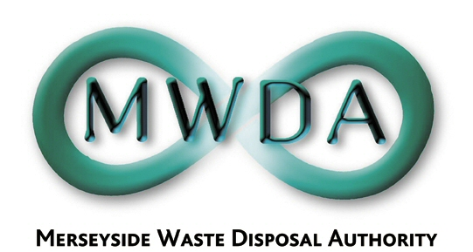

AGENDA

Annual Meeting of the Authority

Friday, 23rd June 2017 at 1.00 pm

Venue: Authority Chamber, No. 1 Mann Island,
Pier Head, Liverpool, L3 1BP

Membership:-
Knowsley Borough Council: Cllr G Morgan (Chair)
Liverpool City Council: Cllr T Concepcion (Deputy Chair)
Cllr C Sung Cllr L Robertson-Collins
Sefton Borough Council: Cllr D Roscoe
Cllr M O’Brien
St. Helens Cllr C Preston Wirral MBC Cllr S Williams
Cllr T Norbury
Halton BC Cllr S Nelson (Observer Status)

Item No. | Title | Page
1 | Appointment of Chair | -
2 | Appointment of Deputy Chair | -
3 | Apologies for Absence | -
4 | Minutes of Authority Meeting held on 21st April 2017 | 1
5 | Declaration of Interests by Members and Officers | -
6 | Question(s) from Members under Procedural Rule 9
7 | Question(s) from Members of the Public under Procedural Rule 10
8 | Motion proposed by Members under Procedural Rule 15
9 | Scheme of Delegation and Procedural Rules  WDA/16/17
10 | Questions on the Discharge of Functions  WDA/15/17
11 | Appointments and Committees  WDA/17/17
12 | Internal Audit – Follow Up of Recommendations  WDA/19/17
13 | Outturn Report 16/17  WDA/18/17
14 | Resource Recovery Contract – Progress Update  WDA/20/17

7TH Floor, No 1 Mann Island, Liverpool, Merseyside,L3 1BP
Tel: 0151 255 1444 Fax: 0151 227 1848
Email:enquiries@merseysidewda.gov.uk
www.merseysidewda.gov.uk

