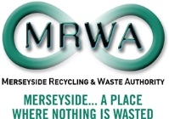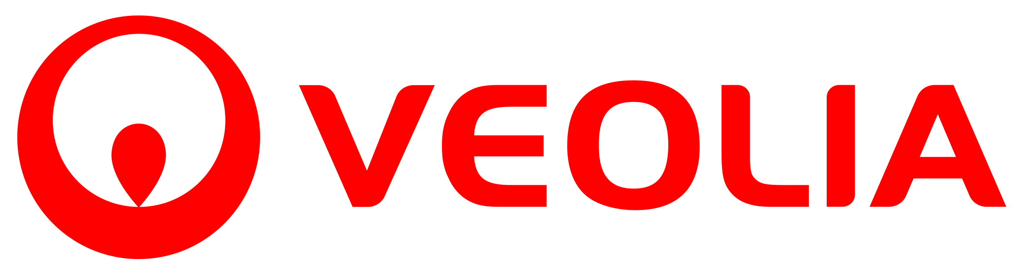

Community Fund
2015/16 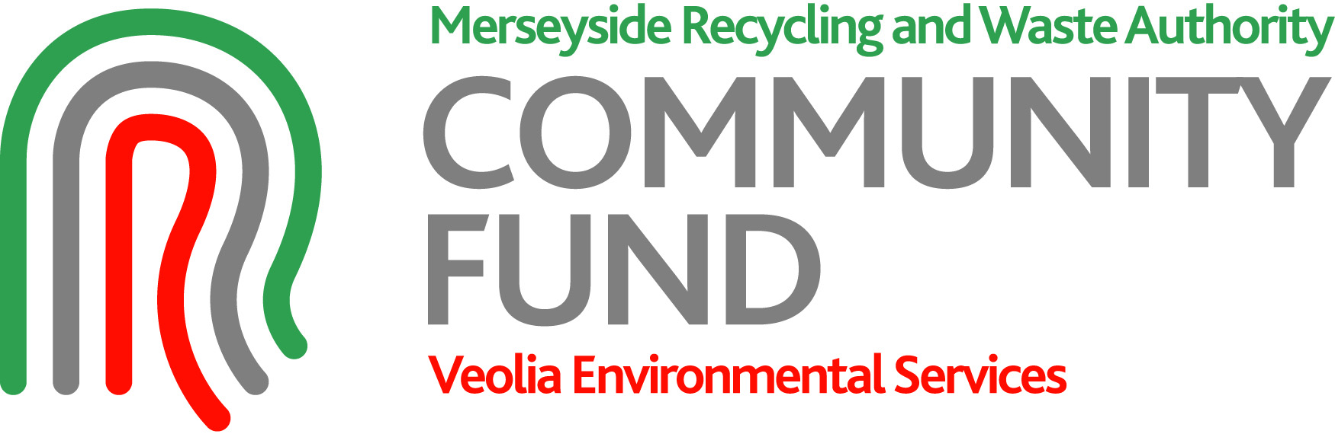

This Application Pack contains the following documents:

- Guidance and Frequently Asked Questions (this document)

- Stage 1 (Expression of Interest) form

- Terms and Conditions

A Stage 2 Application form will be provided to applicants invited to submit a full application after the Expression of Interest stage (Stage 1).

Introduction

The Community Fund 2015/16 is a Merseyside Recycling and Waste Authority and Veolia Environmental Services initiative to support the Merseyside and Halton Community and Voluntary Sector (CVS) for projects which deliver sustainable waste management.

What’s on offer?

This year’s fund is a total of £110,000 and will be split as follows:

- £57,000 to be allocated for regional (i.e. Merseyside and Halton) wide projects with a maximum award of £25,000 for any one project.

- £48,000 to be awarded, to a maximum of £8,000, per project at individual district level.

- Any unspent funding in the regional pot will be reallocated to district level projects.

The aim is to provide greater support and ensure projects give the best value for money and make a real contribution to sustainable waste prevention, repair & reuse and recycling.

Applicants must be able to demonstrate their idea will work and satisfy criteria on:

- Improving waste prevention, reuse, repair and recycling
- Reducing carbon emissions
- Engaging residents
- Creating jobs and volunteering opportunities
- Generating social benefits and creating added value.

Who can apply?

You can apply for a grant under the Community Fund 2015/16 if you are a:

  - Registered Charity
  - Not-for-profit organisation (including social enterprises)
  - Community, Neighbourhood or Voluntary group
  - Faith group delivering community work
  - School, College or University

The term Community Voluntary Sector (CVS) is used throughout to collectively
describe the above groups.

The kind of projects we want to support

The aim of the Community Fund is to support community projects which can deliver waste prevention, reuse, recycling and carbon benefits. We are interested in projects that have the potential to become models of good practice in sustainable waste management and help to change people’s behaviour.

Projects will address Local Authority Collected Municipal Waste, i.e. waste from households, as well as other wastes, which because of its nature or composition is similar to waste from households.

What we won’t pay for

- Day to day running or on-going staffing costs
- Activities that start or happen before we confirm funding
- Anything that is the responsibility of a Local Authority dealing with waste materials
- Activities dealing with Commercial and Industrial waste and any other waste which is not Local Authority Collected Municipal Waste (see above)
- Projects that mainly financially benefit an individual
- Activities with Political affiliation and aims
- The VAT element of your project that you can recover.

The Application Process

Applications must be submitted on the official application forms or they will not be accepted.

Applications will be considered only on the information you provide in your application so please ensure you include all relevant information and data.
The application process will be split into 2 stages. Stage 1 is open to all relevant organisations, whilst Stage 2 is by invitation only following assessment of Stage 1 applications.

- STAGE 1 : Expression of Interest Form

Applicants should include as much relevant detail as required in this form, but appendices can be included to highlight relevant background data. Answer boxes can be expanded if you need more space.
This stage of the application should provide sufficient detail on project outputs to allow us to invite organisations to submit final (Stage 2) applications. Project management and planning details are not requested at this stage.

In addition to the Stage 1 form, you must provide paper copies of the following information by the Stage 1 deadline (4th March) or we will not be able to consider your application. Please include copies of your organisations:

- Official letterhead
- Banking details – Your BACS information: account name, number, sort code and branch. Include these details on your official letterhead paper
- Insurance details – copies of your organisations public liability insurance and other relevant insurance details.

These details are important as we need to ensure that any fund payments are made to legitimate organisations.

Some guidance on the specific questions in the Stage 1 form can be found below:

Waste prevention, reuse, repair and recycling
Give the estimated amount of waste expected to be prevented, recycled, re-used or repaired during your project (in tonnes). These will be items that are prevented from becoming waste in the first place or are diverted from landfill. Food waste awareness and training is not a priority activity for Community Fund support this year as we are investing in this activity via other sources of funding. This exclusion does not include provision of home composters or kitchen caddies for food waste collection. Prevention can include use of composters and initiatives to change people’s behavior e.g. to reduce junk mail or other household items that might otherwise enter the waste stream.

(See the Supporting Information at the end of this document for a list of standard weights for a range of items).

Carbon benefit

The estimated amount of reduction in carbon dioxide emissions from the project (in tonnes) will mainly be through waste prevention, reuse and repair, recycling (all of which divert waste from landfill) or reduction in travel. Waste materials have different levels of carbon impact.

(See the Supporting Information at the end of this document for a list which may help you identify the materials that maximise carbon benefits in your application).

Project engagement

Give the number of people your project is committed to engaging through involvement in the project and/or attendance at events. You should also provide a figure that estimates the number of people your project will reach through wider engagement, for example through publications, social media, etc.

Jobs and volunteering

This is the estimated numbers of full time and part time jobs created or safeguarded, and /or opportunities for recognised volunteering. Separate figures for each type are required. Identify the potential for skills development in managing resources and waste.

Social benefit

What are the social benefits this project may bring through sustainable waste management e.g. through enhancing local places and the local environment, providing support to vulnerable members of the community, etc.

Further benefits

This is the added value of your project and can include support such as the
in kind assistance of people, resources or funding from other organisations, or any other economic, social or environmental benefits which you believe will occur from the project and have not been identified elsewhere in the application.

- STAGE 2 : Application Form

Following Stage 1, Authority members will agree on which projects that maximise the priority outputs will be invited to submit a Stage 2 application. We anticipate that this decision will be made in late April 2015.

A final Application form will be provided to applicants invited to submit a detailed application after the Expression of Interest stage (Stage 1). Stage 2 will ask for details of your project plan, project management and risk management processes. Additional information can be included at this stage, but we will not be able to accept anything that affects or changes the output information provided at Stage 1.

Applicants invited to this stage will be asked to return their completed application no later than 2 working weeks from the date of the invitation to submit the Stage 2 form.

Application Period

The Community Fund will be available for submission of Stage 1 applications from TUESDAY 10TH FEBRUARY 2015 until 23.59pm WEDNESDAY 4TH MARCH 2015.

Funding Offers

Projects meeting the Fund’s requirements after the Stage 2 application will be contacted with a formal offer of funding, including required project outputs. Signed acceptance of the offer and agreed outputs will be required before funding can be provided.

It is anticipated that successful projects will be offered funding in May 2015 and that projects will receive funding and be able to start delivery during June 2015.

Summary of Application process

10th February 2015 | Applications open (Stage 1)
4th March 2015 | Applications close (Stage 1)
April 2015 (after 24th) | Decision on which projects will move forward to Stage 2. Invitation to submit Stage 2 application issued
May 2015 | Funding offers to successful projects. Unsuccessful projects notified
June 2015 | Projects commenced
March 2016 | Projects completed

More information on the Community Fund 2015/16 is available in the Frequently Asked Questions (FAQ’s) section below.

FREQUENTLY ASKED QUESTIONS (FAQs)

Who is the Merseyside Recycling and Waste Authority (MRWA)?
MRWA is responsible for the disposal of municipal waste on Merseyside. Established in 1986, following the abolition of Merseyside County Council, it is a statutory Authority that works with all the local authorities on Merseyside – Knowsley, Liverpool, Sefton, St Helens and Wirral. MRWA takes the lead in advocating recycling, waste minimisation and safe and effective disposal of waste for Merseyside residents.
Who is Veolia Environmental Services Ltd?
Veolia is a leading waste management company in the UK and as a contractor to the Authority manages the facilities and Household Waste Recycling Centres across Merseyside and Halton. Veolia is committed to protecting the environment and improving the lives of the communities in which it operates.
Why is Halton included in the Fund?
Halton Borough Council has the statutory responsibility for the collection, treatment and disposal of municipal waste in its area and forms part of the Liverpool City Region. As the responsible body for waste in its area, Halton works with MRWA and the Merseyside districts as the Merseyside and Halton Waste Partnership.
What geographical area does the Community Fund cover?
The Fund covers the Merseyside and Halton Waste Partnership. This includes the five Merseyside local authority areas as above and Halton.
All projects must benefit communities within the local authority area(s) they cover.
Can you submit an application if any of the organisations involved in the application are based outside Merseyside and Halton?
Yes, but applications will only be accepted if the project directly benefits Merseyside and Halton communities and reduces the impact of Local Authority Collected Municipal waste in the Partnership area.
What funds are available this year?
The total pot is £110,000 including £57,000 for Merseyside and Halton wide projects and £48,000 for District only projects. The remaining £5,000 will support admin and communications activities.
Why has the application process for this year’s Fund been split into 2 stages?
Last year’s Fund received a high number of applications which meant that the Fund was over-subscribed and we were unable to support many proposed projects. Unsuccessful applicants put a lot of effort into their detailed applications without reward. The new approach includes an Expression of Interest form which reduces the detail required from initial applicants. The best applications most likely to be funded will then be invited to provide more detail in a full application.
Can you submit more than one application per project?
Yes, but each application will be based on its own merits and subject to the same evaluation criteria based on the maximum outputs.
Can you submit an application for a project which covers commercial and industrial or construction and demolition waste?
No. All applications must relate to Local Authority Collected Municipal Waste i.e. waste from households, as well as other wastes, which because of its nature of composition is similar to waste from households. This includes waste collected from schools.
Can you submit an application for a project which does not directly focus on sustainable waste management but will deliver wider environmental and community improvements?
No. The project must deliver the outputs as set out in the evaluation criteria in the application form. Wider environmental, social and economic benefits can be included as added value of the project.
Why is one of the criteria about reducing carbon emissions?
Reducing carbon emissions is a key objective and driver within the adopted Joint Recycling and Waste Management Strategy for Merseyside. There are significant opportunities to support the low carbon economy through sustainable waste management. These include avoiding sending bio-degradable waste to landfill and the embedded carbon benefits within recycling.
Can you submit an application for a project which is already in receipt of financial support from the Authority in the same financial year?
No.
Can you submit an application after the deadline of 11.59pm on 4th March 2015?
No.
Do projects have to be completed by 31 March 2016?
Yes. Successful applicants will be required to provide a report when the project is completed. For those projects which will not be completed until the end of March 2016, the applicant will provide a progress update by mid-March 2016 followed by an end report within six weeks of project completion.
Can you submit an application for a project which extends across more than one financial year?
Yes, an applicant can plan to continue the project beyond the current financial year. However, projects would only receive an award on an annual basis so eligible organisations would apply for funding in each additional year that the Fund exists. The application would need to meet the revised or reaffirmed evaluation criteria established and would be in competition with other projects submitted for each year.
Can you appeal against a decision not to award funding?
No, the decision of the Authority on the amount of grant is final.
What will happen if you don’t complete the project or fail the meet the agreed outputs in the application?
All awards will be subject to the Authority’s Financial Procedural Rules. A service level agreement (SLA) will be made with successful applicants including arrangement for payment in advance of goods and services being received. This SLA will be based on committed outputs within the applications and establishes a mechanism to allow the Authority to seek recompense from the applicant should the project outputs not be met.
When may the Authority announce a further round of the Community Fund?
The Authority agrees its budget at the first meeting of each calendar year. If Members agree to continue with the Community Fund an announcement will be made shortly after that.

SUPPORTING INFORMATION

Please see the tables below for information on the average weights and carbon values of some common items and materials.

Average Weight Values.
Calculated from research carried out by the Furniture Re-use Network

Note: 1 tonne is 1000Kg.( e.g. armchair = 0.035 te)

Items | Weight in Kg | Items | Weight in Kg
Armchair | 35 | Desk | 27
Bed (single) | 15 | Dining Table | 20
Bed (double) | 92 | Hi-fi unit | 12
Bed (king) | 120 | Ironing board | 7
Bunk/cabin bed | 50 | Lawn mower | 15
Bicycle | 15 | Mattress | 15
Bedroom unit | 50 | Piano | 100
Bookcase | 18 | Sideboard | 38
Cabinet | 15 | Sofa | 40
Dining Chair | 7 | Stool | 5
Chest of Drawers | 25 | Suite (3P) | 80
Coffee Table | 15 | Wardrobe | 38
Cupboard | 40

Carbon Value for Materials (this list is not exhaustive)

For assessment purposes the following carbon only metric is used to score 2015/16 projects and calculated by B x C = D

A  Material | B  Conversion Factor.  ( Based on DEFRA’s Waste Data Flow) | C  Your anticpated tonnage | D  CO2  equivalent tonnes saved
Metal | 3.965
Textiles | 5.987
Plastic | 1.156
Furniture | 0.921
Paper & Card | 0.873
WEEE ( i.e. Waste Electrical & Electronic Equipment) | 1.482
Food waste | 0.489
Garden waste | 0.272
Glass | 0.233
Example
Glass | 0.233 | 4 | 0.932 Tonnes CO2 saving

