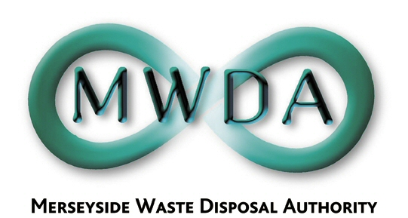

AGENDA

Special Meeting of the Authority

Friday, 24th October 2014 at 2.00 pm

Venue: Members’ Chamber, No. 1 Mann Island,
Pier Head, Liverpool, L3 1BP

Membership:-

Knowsley Borough Council: Cllr G Morgan (Chair)
Liverpool City Council: Cllr T Concepcion (Deputy) Cllr A Foxley
Cllr L Robertson-Collins
Sefton Borough Council: Cllr K Cluskey
Cllr P Hardy
St. Helens: Cllr A Cunliffe
Wirral MBC: Cllr S Williams
Cllr I Williams
Halton BC: Cllr S Nelson (Observer Status)

Item No. | Title | Page
1 | Apologies for Absence | -
2 | Declaration of Interests by Members and Officers | -
3 | Question(s) from Members under Procedural Rule 9 | 1
4 | Motion proposed by Members under Procedural Rule 15 | 3
5 | Exclusion of Public:  Recommendation that the Public be excluded from the meeting during consideration of the following items for the reason stated:  Information relating to the financial or business affairs of any particular person (including the Authority holding that information) (Paragraph 3 of Schedule 12A)
6 | Interim Residual Waste Treatment Opportunity  WDA/33/14 | 5

7th Floor, No 1 Mann Island, Liverpool L3 1BP
Tel: 0151 255 1444 Fax: 0151 227 1848
Email:enquiries@merseysidewda.gov.uk
www.merseysidewda.gov.uk

