

**Communications and Media Toolkit**

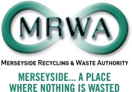 

**Date of Issue: SEPTEMBER 2014**

**Introduction**

**We recognise that effective communications are a key aspect to the success of your project, but also that some of you will be more experienced in delivering communication than others.**

This toolkit, and the support we are offering, we hope will help ensure that all of your projects will have the basic skills and information so that you can all communicate effectively regardless of your experience.

We all have a role to play – you to start to look at planning and delivering your communications - and us here at the Authority in offering support and advice.

All of this year’s Community Fund projects will need to communicate to others for lots of reasons:

* **Getting people to support you by coming to your events/ participating in the service that you offer and donating or buying your products/signing up to workshops**
* **Publicly showing funders and partners that you are doing a good job/being successful**
* **Supporting future success of the project by building your public reputation**

This toolkit we hope will give you an insight into the many ways that you can communicate and give your project some basic guidance on how to deliver those communications from getting stories into local newspapers, developing social media, giving ideas for the kind of things that journalists want, and showing you how to get your stories and pictures published.

**Communications contacts:**

* **Colette Gill**

Senior PR and Communications Officer

Merseyside Recycling and Waste Authority

Tel: 0151 255 2527

Email: Colette.gill@merseysidewda.gov.uk

* **Jon Flinn**

DHA Communications

Tel: 0151 709 0505

jon@dhacommunications.co.uk

**Planning**

**Planning your communications – launches, press releases, events, tweets etc – will make sure you get maximum mileage out of all your activities**

**Follow these simple four steps:**

* Plan what you are going to communicate - start by plotting the important activities/events you know about for each month of your project.
* Decide who you need to communicate to most (public/local council/funders etc).
* Work out how you’re going to get your messages across to each of these stakeholders. Don’t just think about social and traditional media. If you want to target parents, are there school bulletins you could use? If you want to attract participants to a women-only workshop, look out for other women’s organisations and ask if they can help with publicity.
* Finally, create a small grid which plots all this activity and use it to plan your communications to maximum effect.

Here’s an example:

**EXAMPLE ACTIVITY GRID**

|  |  |  |  |  |  |
| --- | --- | --- | --- | --- | --- |
| **Month** | **Event and or communication** | **Media / Channel** | **Audience** | **Plan/Launch/Review** | **Note** |
| **September** |  |  |  |  |  |
|  | Funding announced | Press release/social media |  |  |  |
|  | Office move | Social media |  |  | Photos of new office |
|  | New volunteers start at project | Social media |  |  | Photos of new team for FB an d Twitter |
| **October** |  |  |  |  |  |
|  | Social media appeal | Social media |  |  | Campaign to get 500 likes/Twitter followers in one month |
|  | Workshops start | Social media/press release |  |  | Tweet before, during and after event |
|  | Work with new partner | Social media/press release |  |  | Encourage partner to promote your collaboration too |
| **November** |  |  |  |  |  |
|  | Project milestone | Press release/social media |  |  | Think of strong photo |
|  | Visit by local councillor | Press release/social media |  |  | Create picture opportunity and tweet positive comment from councillor afterwards |
|  | Advertise project public event | Press release/social media/other organisations’ bulletins and networks |  |  | Draft press release well in advance and design mini social media campaign to get message out |

**Developing a basic Communications Plan**

**Basic Communications Plan Template**

* A communication plan is a tool to establish agreement among stakeholders in an organization to address a business or project objective.
* The plan ensures consistency of messaging across a range of channels sets expectations and builds confidence.
* The size and length of a plan can vary greatly based on the objectives. This basic communications plan template provides a beginning framework for addressing issues and helps facilitate discussion.

|  |  |
| --- | --- |
| **Target completion date** | * This date is when activities will be completed by, usually after the Review phase. * Distribution dates for individual communications can be provided in an activity grid. |
| **Background** | * The background section should provide stakeholders enough information about the project to understand the need for this communications plan. * The background is an introduction to what the plan’s objective is. |
| **Objectives** | * In a short set of statements, outline what the plan’s objectives are, and how they will address the action stated in the background section. |
| **Key messages** | * Using bullet points, succinctly list each key message this plan will communicate. * These may vary according to audience. * What is the evidence, proof and support of each key message? * Ensure that each key message is aligned with the projects overall brand messaging and objectives |
| **Risks** | * Outline each of the risks associated with this plan and the actions taken to mitigate these risks. * Outline scenarios including if the communications plan does not proceed, if distribution dates are not met, or if audiences do not receive the right key messages. * Are there governance or reputational risks? |
| **Impact** | * Are there any financial impacts or risks associated with this plan? |
| **Stakeholders - primary** | * Identify the primary group of stakeholders for the project – include anyone who needs to be made aware of any of the key messages, e.g any internal staff or external advocates |
| **Stakeholders -secondary** | * Identify the secondary group of stakeholders for the project – include anyone who needs to be made aware of any of the key messages. |
| **Media** | * The media will be a key influencer to all audiences, outline which media. * This may include trade publications, daily newspapers, consumer media, and broadcast, among others. |
| **Channels** | * Provide an overview of which channels of communication will be utilized in this plan to reach audiences. * Use the schedule at the end of the plan to specify which communications piece will distribute via which channel.   Mail Email Newsletter Website  Phone Intranet Meeting Social Media |
| **Responsibilities** | * Specify each individual who will produce, be consulted and sign off on communications before distributing. * Outline responsibilities for each which may include agreeing to the overall approach and key messages, and/or signing off on individual communication pieces. * Also list which individuals or groups where additional support is required but who are not signing off on content. |
| **Review** | * How will the communications results be measured, reviewed and reported? * What are the key performance indicators for communications? * How will findings be addressed or implemented for future communication plans? |

**Ideas for press releases**

**Local journalists want stories about all kinds of things. The secret to getting coverage for your project is to try and anticipate what they want.**

Here are some ideas:

* Stories about money. Simply saying you have won £X,000 from the Community Fund will be of interest to local media (though make sure you add in vital detail about who you are and what you want to do with the money)
* Stories which affect the lives of local people and are relevant to them eg. giving them training opportunities, new skills, free school uniforms, recycled furniture
* Milestones: Whatever you’re doing, try and measure it in milestones eg project has been running 100 days or has helped its 500th person/received its 10th order. Milestones are simply nice round figures which show your success – journalists love them.
* Appeal: If you need help – money or new premises you could do an appeal type press release (‘Local recycling project today appealing for help to find new base’]
* Something quirky: A story about teaching kids to knit using plastic bags instead of wool is different and unexpected so will appeal to journalists.
* Link your project to well-known local people eg a local councillor (or celebrity if you know one!)
* First, biggest, best etc: If you can say that your project is the first of its kind in Merseyside, your borough, or even your town, it will interest the journalist because they love superlatives eg ‘The first ever furniture recycling scheme to train unemployed teenagers has opened in Halton this week..’
* Pictures. Journalists love pictures – especially ones with children in - and sometimes it doesn’t matter what the story is like, if the picture is interesting and decent quality that is enough for newspapers (check section on taking pictures for journalists).

**PRACTICAL CONSIDERATIONS**

* **What – what is the story about?**
* **Who – who is the story about?**
* **Where – where is the event/project/activity located?**
* **When - when is, or has, the event/project activity taking or taken place?**
* **Why – why is the event/project/activity happening?**
* **Quote – a supporting quote from an individual at the project or someone befitting from the project**
* **Contact – where to contact the project for more details – including website/social media**

**Template press release - EXAMPLE 1**

***[insert Community Fund logo and your own logo (if you have one) here]***

***[insert date here]***

**WITH PICTURE**

**£X,000 CASH BOOST TO RECYCLE SCHOOL UNIFORMS**

A *[insert name of borough]* scheme to recycle school uniforms is set to *[launch/expand/reach out to hundreds of homes]* after winning *[how much?]* from the region’s Recycling and Waste Authority.

The *[name of scheme]* recycling scheme based in *[where?]* will collect unwanted uniforms from local schools and set up collection points in local churches so they can be re-distributed to pupils.

The scheme was one of just *[x]* projects awarded funding from Merseyside Recycling and Waste Authority (MRWA) annual Community Fund and will run for a *[insert length of project].*

Project leader *[insert job title and name]* said: “School uniforms are incredibly expensive and many families – especially ones with several children – really struggle to kit out their kids for school.

“The grant is great news for us because it means we can help even more people and keep even more textiles out of landfill.”

MRWA Chief Executive Carl Beer said: *“[name of project]* really is a win/win idea and a really worthy Community Fund recipient. It keeps unwanted textiles out of landfill and helps struggling households manage the rising costs of school at the same time.”

Mums and dads interested in using the uniform service can get details of the collection points on the *[insert name of project]* website [*www.webaddressneeededhere.org.uk*](http://www.webaddressneeededhere.org.uk)

**ENDS**

**Media enquiries to *[insert name and mobile phone no]***

**Picture Caption**

The attached picture shows project leader *[insert name]* and staff *[insert names]* sorting uniforms ready for collection.

**Note to Editors**

1. *[name of project]* was set up in [when?] after [insert detail about how and why project was set up]
2. The MRWA 2014 Community Fund awarded a total of £110,000 to a mix of large and small projects across Merseyside and Halton.

**Template press release – EXAMPLE 2**

***[insert Community Fund logo and your own logo (if you have one) here]***

***[insert date here]***

**WITH PICTURE**

**UNIFORM PROJECT HAILED A SUCCESS AFTER REACHING 300 PARENTS**

A *[insert borough]* project set up to help recycle textiles is celebrating a milestone after helping 300 parents kit their children out with school uniforms.

The *[insert name of project]* launched [when] after winning a *[how much]* grant from a community fund set up by Merseyside Recycling and Waste Authority (MRWA).

The project is marking a major milestone after handing out pre-loved uniforms to 300 *[name of borough]* parents in just *[how many months].*

Project leader *[insert job title and name]* said: “It’s been an amazing success but then we knew the demand was always there – it’s just a question of collecting the uniforms in one place and making sure parents know we exist.”

The project has used school bulletins and local radio to help get their message out and has set a target to ‘recycle’ a total of *[how many]* uniforms by the end of March.

MRWA Chief Executive Carl Beer said: “The Community Fund is not just about reducing the waste that goes to landfill. It’s about helping families in many other ways the success of this project really makes the point.”

**ENDS**

**Media enquiries to *[insert name and mobile phone no]***

**Note to Editors**

1. *[name of project]* was set up in *[when?]* after *[insert detail about how and why project was set up]*
2. The MRWA 2014 Community Fund awarded a total of £110,000 to a mix of large and small projects across Merseyside and Halton.

**Template press release – EXAMPLE 3**

***[insert logo community fund logo and your own logo (if you have one) here]***

***[insert date here]***

**WITH PICTURE**

**RECYCLING PROJECTS GETS HELPING HAND**

[insert name of borough] recycling champions got a helping hand when a local councillor dropped in to find out how they are reaching out to hundreds of families and helping cut waste at the same time.

The [insert name of project] launched [when] after winning a [how much] grant from a community fund set up by Merseyside Recycling and Waste Authority (MRWA).

[insert local authority name] Councillor [who], a member of the Waste Authority, dropped in to check on progress and lend a helping hand at the [insert location/base of project] this week.

He said: “The [name of project] is exactly what the Community Fund is all about. It’s a really impressive project that is clearly making a massive difference – not just by diverting textiles from landfill but by helping families struggling to manage the spiralling costs of kitting out their children for school.”

Project leader [who?] said: “The Community Fund support has made all the difference so it was great to be able to show Councillor [who] exactly how the money is being spent and the difference it is making.”

**ENDS**

**Media enquiries to [insert name and mobile phone no]**

**Picture Caption**

Councillor [who] is pictured with project leader [who] as they sort recycled uniforms at the [where] project.

**Note to Editors**

1. [name of project] was set up in [when?] after [insert detail about how and why project was set up]
2. The MRWA 2014 Community Fund awarded a total of £110,000 to a mix of large and small projects across Merseyside and Halton.

**Taking pictures for promotion**

**The right picture can sell a story - that’s why including a great image with media and press releases can really help your project appeal to journalists looking for stories. Times have changed - newspaper and magazines never used to take submitted pictures – but they will now publish good quality images supplied with stories.**

**There are some simple rules to follow to stand a chance of getting your picture used:**

* Set the camera's resolution to take high quality photos at the highest resolution possible.
* Make sure the pic is in jpeg format the resolution is high (around 250kb or more usually works, depending on size of the image).
* Try and take pictures of people doing things – not just standing still facing the camera – but don’t crowd the picture with loads of people.
* Keep the picture ‘tight’ – in other words, fill the frame with the action/people that you want to show and don’t include loads of wasted space unless it is for effect.
* Keep the picture in focus and light.
* Include children where appropriate (and where you have parental permission)
* Try and get the picture to tell the story. If it is about kids learning to knit using plastic bags as wool, you need a photo of them in their classroom in action with knitting needles and bags. If it’s a story involving gardening, you need nice close up pics of people digging or planting – not a load of folk stood indoors doing nothing.
* Make the picture as interesting as possible. If you’re recycling old furniture, a picture of staff peeping out from behind a towering of desks, chests of drawers and wardrobes could work really well. If you’ve got dozens of bedding plants to plant, a picture of you kneeling down with the plants on a table could work too!
* Think about other jpegs which journalists could use. Last year a journalist was happy reproducing the following poster produced by a Halton project because it was colourful and in jpeg format and helped ‘tell the story’.

**A note about permissions and consent for photography**

**Guidelines**

The following are guidelines regarding permissions and consent in relation to photography, but at all times bear in mind common sense. e.g. - if photographing a field and someone happens to be walking across this but their face cannot be seen it may not be necessary to complete a form.

**Inform people**

* Context of the image
* Intended use of image

**Taking photos**

* Written permission may be required from all persons in photograph but if it is a large group it may be preferable to ask if one is able to sign for all
* If people are identifiable (even if in a large street scene for example) permission is required from all persons
* Inform group/individual images will be used in context
* Ensure a consent form has been signed
* If a specific house/property is being identified permission from the owner must be sought

**Children and vulnerable adults**

* Permission must be sought from parent and/or carer and consent form must be signed

**Does the Data Protection Act stop me taking photos?**

The Data Protection Act is unlikely to apply in most cases where photographs or videos are taken in schools and other educational institutions. If photos are taken for personal use they are not covered by the Act. Photos taken for official school use may be covered by the Act, so pupils and students should be advised why they are being taken.

**Examples**

**Personal use**: A parent takes a photograph of their child and some friends taking part in the school Sports Day to be put in the family photo album. These images are for personal use and the Data Protection Act does not apply. Grandparents who are invited to the school nativity play and wish to video it - these images are for personal use and the Data Protection Act does not apply.

**Official use**: Photographs of pupils or students are taken for building passes. These images are likely to be stored electronically with other personal data and the terms of the Act will apply. A small group of pupils are photographed during a science lesson and the photo is to be used in the school prospectus. This will be personal data but will not breach the Act as long as the children and/or their guardians are aware this is happening and the context in which the photo will be used.

**Media use:** A photograph is taken by a local newspaper of a school awards ceremony. As long as the school has agreed to this, and the children and/or their guardians are aware that photographs of those attending the ceremony may appear in the newspaper, this will not breach the Act.

**EXAMPLE CONSENT FORM**

**Photography Consent Form (Example)**

To be completed by individual(s) (parents/guardians if subject is less than 18 years of age) who appear in any photographs taken. **[INSERT PROJECT NAME]** would like to take your photograph for promotional purposes. These images may be sent out to the media with a press release, used for our publications or on our website.

**Person(s) in photograph**

**I agree to allow [INSERT PROJECT NAME]** **to take photographs of me and grant permission for these to be used by the [INSERT PROJECT NAME]** **and its project partners in publications, press articles, promotional material and websites, exclusively for non-profit-making purposes.**

**Name (please print):** ……………………………………………………………………………………………………………

**Contact email address and telephone number:** ……………………………………………………………………

Signed: ……………………………………………………… Date: ……………………………………….

I also agree to my name being published in any associated publicity if required.

□ Yes □ No

**We will not use the images taken, or any other information you provide, for any other purpose.**

**Permission of parent/guardian if person photographed is less than 18 years of age.**

**I agree to allow [INSERT PROJECT NAME]** **to take photographs of the child(ren) in my charge and grant permission for these to be used by [INSERT PROJECT NAME] in publications, press articles, promotional material and websites, exclusively for none profit-making purposes.**

Name of child (please print): ……………………………………………………………………………………….

Age: ……………….. Parent/Guardian name (please print): ………………………………………………

Contact email address and telephone number:………………………………………………………………………..

Signed: ……………………………………………… Date: ……………………………………….

I also agree to the child’s name being published in any associated publicity if required.

□ Yes □ No

**We will not use the images taken, or any other information you provide, for any other purpose.**

**Have a look at the following pictures taken of recycling projects to see what works**

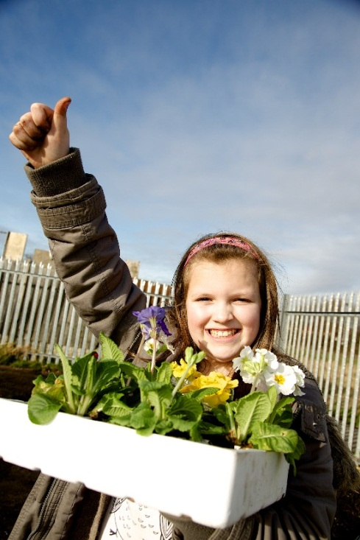

**WHY IS IT GOOD**

* Really positive image
* Smiling face
* Features a child
* Nice and tight image
* Colourful

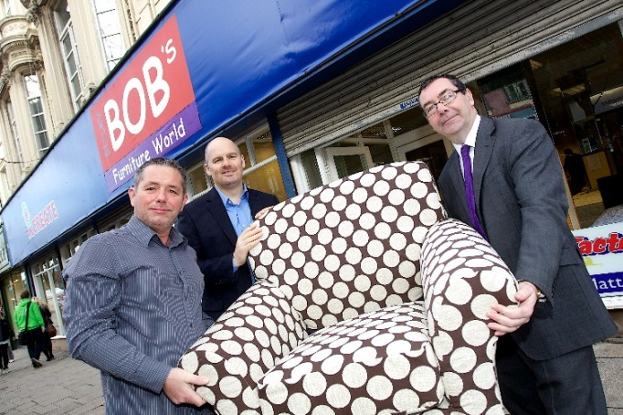

**WHY IS IT GOOD?**

* Nice tight picture which tells the story (with Bulky Bob sign in background) and features people from three main organisations the story is about.
* It’s unusual – 3 men in suits carrying a chair down a street

**WHY IS IT GOOD?**

* Nice close/tight photo
* Not too many people
* Lots of action (knitting) and interaction between subjects
* Smiling kids
* Nice colour

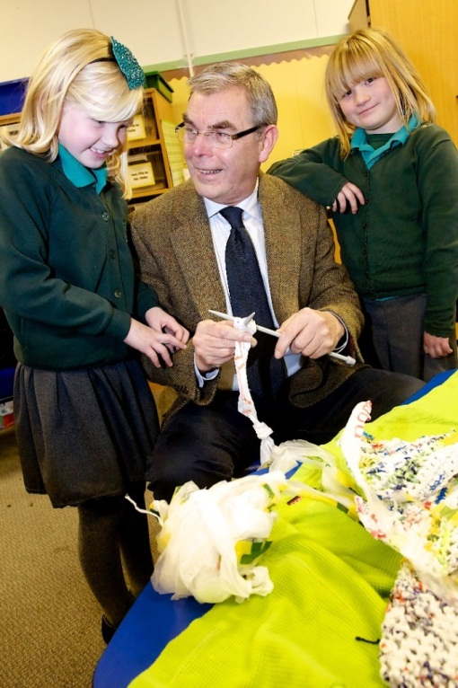

**Sending press releases**

**Making sure that your press release gets to the right person is key. Journalists are busy people – but they’re also often disorganised and only focus on whatever story they’re working on at time.**

**The way that journalists produce and publish has changed significantly in the past few years. News is now more immediate and has numerous outlets – not just newspapers, television and radio,**

**Follow these simple tips when sending your press release (and photo) to a journalist:**

* Make sure the journalist covers the area that your story is about. It’s an obvious point but if your story is about Knowsley feel free to send to the Echo and Radio Merseyside as well as the Knowsley Challenge – but don’t send it to the Wirral News or Runcorn World!
* Follow the basic layout shown on the template press releases with most interesting bit of the story in the first paragraph and include your phone number at the end.
* With pictures, make sure you send them as attachments not embedded in email. Also remember, they need to be reasonably high resolution for newspapers (anything from 250b to 1mb is usually okay – depending on the size of the picture)
* Email the story/picture to the chosen journalist and then phone them to make sure they have got the email – it’s another way of drawing it to their attention and making sure that it really has landed in their inbox.
* Make sure your story really is new! If you’re sending a story to a weekly newspaper and it’s about something that happened last month they won’t be interested.
* Equally, if you’re story is about advertising a future event, make sure you send it to the journalist in time.

**Media contacts list**

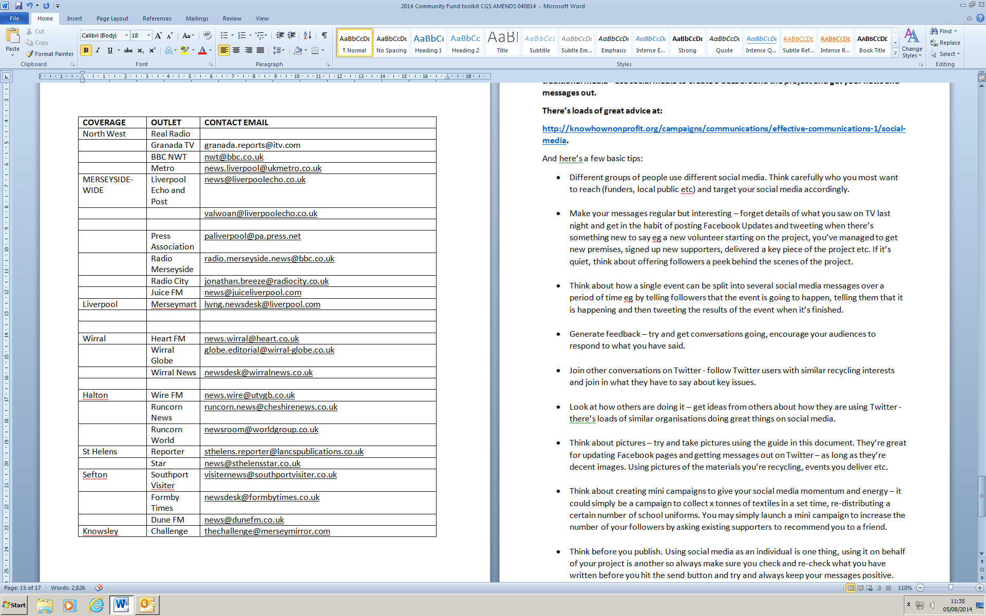

**Social Media**

Social Media makes it much easier to produce information, tell stories, share ideas, and participate in new communities. It includes new tools such as blogs, forums and wikis and is increasingly referred to as 'social media'.

It offers new ways to link people together, build networks and sustain virtual communities who can publish their own photos, videos and news. It could create opportunities for you to develop new services and campaign for change, but without care may further marginalise the people you work with.

Whatever you do it is being used by a wider cross section of the public so it is important that you consider what role it could play in the future development of your services.

Press releases are a great way of reaching lots of people in one go but don’t just rely on the traditional media - use social media to create a buzz around the project and get your news and messages out.

There’s loads of great advice at:

<http://knowhownonprofit.org/campaigns/communications/effective-communications-1/social-media>.

And here are a few basic tips:

* Different groups of people use different social media. Think carefully who you most want to reach (funders, local public etc) and target your social media accordingly.
* Make your messages regular but interesting – forget details of what you saw on TV last night and get in the habit of posting Facebook Updates and tweeting when there’s something new to say eg a new volunteer starting on the project, you’ve managed to get new premises, signed up new supporters, delivered a key piece of the project etc. If it’s quiet, think about offering followers a peek behind the scenes of the project.
* Think about how a single event can be split into several social media messages over a period of time eg by telling followers that the event is going to happen, telling them that it is happening and then tweeting the results of the event when it’s finished.
* Generate feedback – try and get conversations going, encourage your audiences to respond to what you have said.
* Join other conversations on Twitter - follow Twitter users with similar recycling interests and join in what they have to say about key issues.
* Look at how others are doing it – get ideas from others about how they are using Twitter - there’s loads of similar organisations doing great things on social media.

* Think about pictures – try and take pictures using the guide in this document. They’re great for updating Facebook pages and getting messages out on Twitter – as long as they’re decent images. Using pictures of the materials you’re recycling, events you deliver etc.
* Think about creating mini campaigns to give your social media momentum and energy – it could simply be a campaign to collect x tonnes of textiles in a set time, re-distributing a certain number of school uniforms. You may simply launch a mini campaign to increase the number of your followers by asking existing supporters to recommend you to a friend.
* Think before you publish. Using social media as an individual is one thing, using it on behalf of your project is another so always make sure you check and re-check what you have written before you hit the send button and try and always keep your messages positive.

**Social Media terms explained – a quick summary**

**Social media is the term commonly given to websites and online tools which allow users to interact with each other in some way – by sharing information, opinions, knowledge and interests. Social media involves building communities or networks, encouraging participation and engagement.**

As an organisation it’s important not to rush into the use of particular social media tool or website just because others are, but to consider how its use complements your message and existing ways of working and communicating. Once this is clear each tool should be considered for its suitability.

The tools fall into ten broad categories which are summarised below; words in **BOLD** are examples of tools providing that service.

* **Audio Sharing.** A **podcast** is a news feed with a media sound file attached that can be picked up by a feed reader for you to listen to on your PC, an MP3 player or iPod at your convenience. They can be recorded on specialist equipment or simply on many mobile phones and uploaded to websites such as **Odeo**. Using **ipadio** to record a podcast on your phone also give a transcription. Podcasts can be edited using free **Audacity** software.
* **Blog – (weB log).** Many blogs provide commentary or news on a particular subject, cause or issue; others function as more personal online diaries where entries are displayed in reverse chronological order. A typical blog includes images, and links to other blogs and media. Popular blogging tools include **Wordpress, Blogger** and **Weebly. Tumblr** generates a blog from short media snippets. (More Info: <http://bit.ly/One-page-blogging>)
* **Video Sharing -** Websites such as **YouTube, Vimeo** or **BlipTV**. Upload and share videos from a digital camera or mobile phone. They can be included on your own website and **tagged** for sharing and easy searching by visitors. Conversations develop from comments about video content or message. **Ustream** or **Qik** can be used to create a live video stream from an event (More Info: <http://bit.ly/One-page-Video>)
* **Microblogging (Twitter).** A social networking service that allows users to send up to 140 characters “updates” as SMS text-based posts. It is ideal for keeping in touch with groups of people or canvassing a wide range of people about a particular topic or question. (More Info: <http://bit.ly/Twitter-for-support-orgs>)
* **RSS and Feed readers. RSS (Really Simple Syndication)** is just a technical way content is formatted ready for a **feed reader** or **news feed** program (such as **Bloglines** or **Google Reader**) to pick up and deliver to your reader or as an email in your inbox. Feeds are automatically picked up to be read at leisure without you having to visit each website individually. **RSS** feeds are often denoted on websites with an orange RSS symbol. (More Info: <http://bit.ly/RSS-Support-orgs>).To be instantly notified by e-mail when your organisation or a particular keyword is mentioned you can set up a Google Alert. (More Info: <http://bit.ly/One-page-alerts>)
* **Photo Sharing (Flickr).** An online photo storage website which also includes tagging and commenting so photos taken by many people but **tagged** with the same terms can be viewed in a single pool. (More Info: <http://bit.ly/One-page-flickr>)
* **Social Networking -**Websites such as **Facebook**, **LinkedIn** or **MySpace**. These community websites link people who share interests and activities or who are interested in exploring the interests and activities of others. They provide various ways for users to interact, such as chat, messaging, email, video, voice chat, file sharing, discussion groups, blogging and more. **Bebo** and **MySpace** are similar with an appeal to a younger audience.
* Using **Ning, Grou.ps** or **SocialGo** you are able to create your own social network for free, but check as they may make a charge to use all features and some premium content.
* **Social Bookmarking -**Websites such as **Del.icio.us** or **Digg**. These are a way to access bookmarks you save or that others have **tagged** and saved about a subject that interests you. (More Info: <http://bit.ly/One-page-bookmarking>). When content is **tagged** (which can be with a **hashtag** in Twitter, or by **keywords** in other social networking sites) it makes searching and aggregating content so much simpler. (More Info: <http://bit.ly/One-page-tagging>) **Bit.ly** is used to shorten long web addresses and also allows you to view how often the link has been clicked.
* **Social Collaboration and Productivity Tools.** Software such as **Google Docs** or **DropBox** which allow a dispersed groups of people to work collaboratively towards shared aims, share a document or participate in an online event or conference.
* Create, edit, and link pages together in a variety of document formats or create collaborative websites.
* Other applications enable you to share in discussions and meetings on-line (**WebEx**), hold audio (**Skype**) or video conferences (**ooVoo**), schedule a meeting collaboratively (**Doodle**), share slide presentations (**Slideshare**) or share printed format documents (**Scribd** or **myebook**). **Eventbrite** features a full range of features for planning, ticketing and managing any free events you deliver.
* **Wiki.** Websites such as **Wikispaces** or **Wetpaint** allow users to easily create, edit, and link pages together. Wikis are often used to create collaborative websites or allow a dispersed group of people to work collaboratively on building documents. Perhaps the most popular example is **Wikipedia**. (More Info: <http://bit.ly/One-page-wiki>)

**Branding and Acknowledgements**

**Branding and Standard Text Guidelines**

**The Authority has developed a specific logo for use by Community Fund projects. This logo should be used on all materials relating to the project that is being funded. In addition there are standard texts that should be used on documents, media releases etc which acknowledge the funding etc.**

**INTRODUCTION**

* The Community Fund logo has been specially designed and should not be altered. Three versions of the logo have been produced – colour, mono and a reversed-out version. Guidance is provided in this document for use of all of the logos.
* To ensure visual consistency the logo must never be adjusted, redrawn or modified in any way. The logo should be given prominence published materials in printed and electronic format.
* This document also includes standard text that should be used when describing MRWA and the Community Fund.

**USING THE LOGO**

**LOGO ONE (COLOUR)**

In the main this is the default logo and should be used on most communications.



**LOGO TWO (MONO)**

When printing in black and white the new logo can be used in the mono version which will reproduce cleanly on a light coloured background.



**LOGO THREE (REVERSED –OUT)**

If the logo is to be used on a dark or black background please consult the Communications Team for advice.



**MINIMUM SIZE AND SPACING**

When the Community Fund logos are used on a page, poster or any piece of design or document it must have positioned correctly on the page. Therefore there are some specifications on the minimum size of the logos. If your document or communications are:

* A5 = the logo should be minimum 40 mm width
* A4 = the logo should be minimum 50 mm width
* A3 = the logo should be minimum 70 mm width
* Pop up stand – the logo should be minimum 480 mm width
* Web/email = 120 pixels width
* Other sizes or applications please seek advice from the MRWA Communications Team

The sizes indicated above are **MINIMUM** sizes and where possible it is recommended that the logo is used larger than this.

The minimum sizes are indicated to ensure legibility of the logo at all times

**SPACE AROUND THE LOGO**

* Regardless of where the logo is used there must be a minimum area of clear space around it which is equal to 1X - as indicated on the diagram below.
* The 1X measurement is equal to half the height the logo itself.
* For instance: If you are using the logo and its height on your document is 4cm (40mm) then the clearance space at the top, sides and bottom of the logo needs to be 20mm.



**STANDARD TEXT**

There are two pieces of standard text which projects may use:

**The Community Fund**

This project, supported by the Merseyside Recycling and Waste Authority and Veolia Environmental Services through the Community Fund 2014-2015, aims to make real difference to levels of waste produced in communities around Merseyside by engaging residents, promoting economic growth and permanently changing consumer waste habits. The Community Fund has been established to reduce household waste, benefit local communities and ensure value for money for council tax payers.

**Merseyside Recycling and Waste Authority**

Merseyside Recycling and Waste Authority (MRWA) is a statutory authority which, with its District Council partners, takes a lead in advocating and delivering recycling, waste prevention, and the safe and effective disposal of household waste for Merseyside’s residents.

**QUERIES AND QUESTIONS**

Any questions or queries regarding the use of the logos should be directed to the Communications Team:

**Colette Gill MRWA Senior Communications Officer**

**Tel: 0151 255 2527 Email: Colette.gill@merseysidewda.gov.uk**