Community Fund
2012 /13

Guidelines
And
FUND 3

Application Form

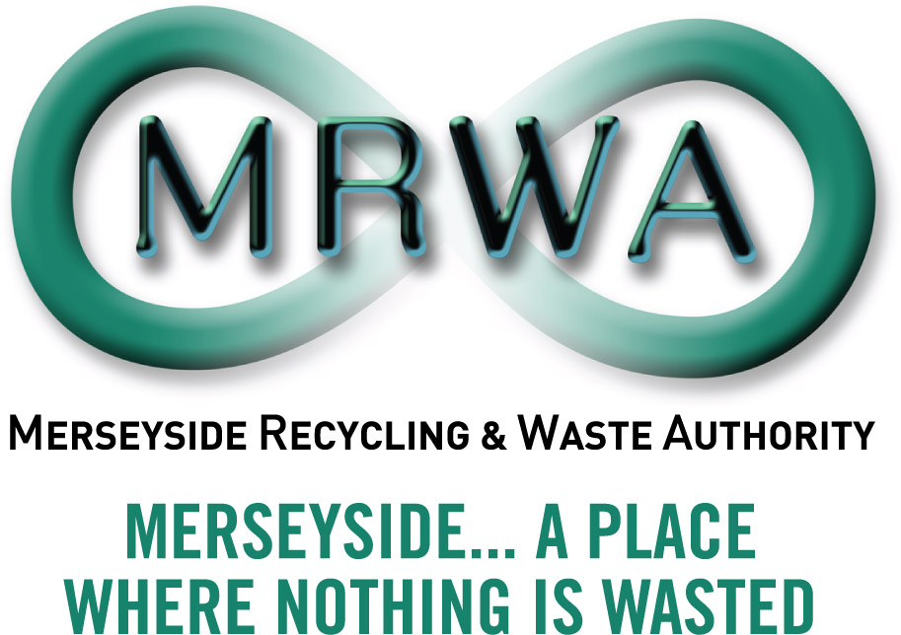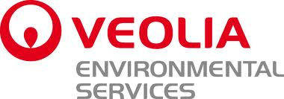

Introduction:

The Community Fund 2012/13 is a Merseyside Recycling and Waste Authority and Veolia Environmental Services (referred to throughout as ‘the funders’) initiative to improve and strengthen the position of the Merseyside Community and Voluntary Sector (CVS) in relation to waste management. It aims to support the local community on Merseyside in carrying out projects at the local level that involve waste issues.

What’s on offer

This year we have improved our support for the Merseyside community sector and have a total fund of £60,000. There are three pots of funding available. An organisation will only be awarded for one project.

Fund 1 For school projects £50 to £500. We have a total of £10,000 for school projects that demonstrate sustainable improvements for the school community. Application is on a first come first served basis until all of the funding is allocated for this financial year. There is a Fund 1 application form available.

Fund 2 For projects up to £3,000 the application period is from the 1st July 2012 to 30th August 2012 with project evaluation of bids against the key fund priorities. The aim is to award projects by mid September 2012.. There is a Fund 2 application form available

Fund 3 For projects £3,000 to £7,000 you will be required to submit a full and detailed project plan. Fund 3 will be available for application from 28th May until 29th June 2012. Your project will be evaluated against key funding priorities by a panel that will include Authority Members. The aim is to award projects by the end of July 2012.

Your project will score higher if you can demonstrate you will achieve added value by working in collaboration with other partners, e.g. statutory authorities or other organisations. You will also score higher if you can demonstrate how your project will continue after the awarded funding.

This document concerns Fund 3 applications.

Who can apply

You can apply for an award under the Community Fund 2012/13 if you are;

  - 3rd sector not-for-profit,
  - Community Interest Company (C.I.C),
  - Community work of faith group,
  - Company limited by guarantee,
  - Constituted group,
  - Co-Operatives
  - Friendly Society,
  - Neighbourhood group,
  - Provident Society,
  - Registered Charity,
  - School project
  - Social Enterprise,
  - Voluntary group.

The term CVS is used throughout to collectively describe the above groups.

The kind of activity we want to support

The aim of Fund 3 is to support community projects which demonstrate waste prevention, reuse, recycling and carbon benefits. We are interested in projects that are new and have innovative approaches to sustainable waste management and that meet two or more of the key fund priorities (see more detail of this in the guidance notes below)

What we won’t pay for

- Day to day running or ongoing staffing costs
- Activities that start or happen before we confirm funding
- Material that is currently collected by the Local Authorities )

- Projects that mainly benefit an individual
- Activities with Political affiliation and aims
- VAT that you can recover

To recap Key Dates:

Funding available |  |  | Application Period
 | Who can apply | How much is available | Launch | Close
Fund 1 | Schools | £50 to £500 | 1st September 2012 | 30th March 2013 or when total has been awarded whichever comes sooner
Fund 2 | C&VS and schools | Upto £3,000 | 1st July 2012 | 30th August 2012
Fund 3 | C& VS, partnerships and schools | £3,000 - £7,000 | 28th May 2012 | 29th June2012

NOTES FOR GUIDANCE For Fund 3 Projects

Note: You do not have to return these guidance notes with your application. Please keep for information and to use for your evaluation report.

- Your Project
This section is where you tell us the name of your project and a brief summary of what you want to do.

Contact Details

This section is where you will provide details and information about your organisation/group.

Project Plan – the why, what, and how

This is where you tell us your detailed project plan and what waste resource related activity your organisation is interested in undertaking. The key is planning how the project will come together.

- Agree what you want to achieve, what supports your project.

- Cover everything that is needed – time, money, people, skills, roles, responsibilities and resources.

- Managing the project –the who and the when

You need to consider how your project will be managed, from conception to conclusion and beyond.

- Appoint all members of your project team and identify who is doing what and when. You may wish to demonstrate this using a family tree or other such diagram. Show who is in control of the costs and the all the elements needed to bring your project to success. You may wish to demonstrate this on a ‘flow chart’ or a ‘family tree’ to identify all the roles and responsibilities included for your project.

- Highlight key events, timescales. You may wish to demonstrate this with a calendar or a gantt chart. Consider how you will keep everyone involved up to date with progress.

- It will help your funding application if you can identify if and how the project will keep going once the initial project is finished.

- How will you minimise and manage risk? Have you completed a health & safety / risk assessment?

- Does insurance cover you for what you are planning to do? You should have sufficient public liability insurance to cover the project.

- Do you need permissions or permits from building / land owners, Local Authorities or other organisations? These must be in place before we can consider your application.

- If your project or event involves children or vulnerable adults have you checked child protection requirements? Do you need a child protection policy? Anyone
working unsupervised with these groups must have an enhanced Criminal Records Bureau check.

- For advice on environmental law the Environment Agency has a free service: www.environment-agency.gov.uk/netregs

- Have you considered disability and accessibility? For advice see www.drc-gb.org

- Project Benefits.

Your project must meet at least two of the following key fund priorities.

- Preventing the creation of waste

- Reducing the amount of waste generated and sent to landfill

- Increasing the reuse of materials

- Increasing recycling

- Reducing carbon emissions

Whilst considering and including the above you should tell us how your project will

  - provide environmental benefits
  - provide economic benefits
  - provide any social or local community benefits.

Where possible be specific, identify measurable impacts and outcomes e.g.

  - The amount of any expected increase in re-use, recycling tonnage, savings etc
  - The amount of waste diverted from landfill
  - The number of people you will train, provide with knowledge or skills
  - Secure jobs or create job opportunities or volunteer places
  - Any expected savings in energy or water consumption
  - Any carbon reduction benefits

- Costs

After careful consideration you will know the total cost of the project, how much Community Fund you are applying for and if you have sourced other funding to contribute to the overall project costs.

Identify your detailed budget. Include all the costs of the project. Include all contributions to the project, both financial and in-kind support. The more detail about costs you can provide the better.

We will fund up to 100% of the total project costs, although ‘matched funding’ is encouraged. The fund cannot be matched with other funding from MRWA or Veolia ES.

The fund may support applications to purchase equipment but leasing arrangements are preferable.

- Monitoring and Evaluation

The funders must demonstrate the benefits of the Community Fund, what it achieves and how it meets the needs of the CV Sector. It will be a requirement of the funding that satisfactory records are provided. You will need to explain how you intend to measure and record the project.

Funding is subject to completion of an evaluation report. At the end of your project we would like a review with your comment on

- What worked well,

- What not so well and barriers to progress

- How you feel the project made a difference.

- Photos – before, during and after.

- Personal stories and feedback from people who have been involved.

- Press releases and any media coverage your project attracts.

- Communications

Communications is a key part of your project funding. You should aim to maximise how you promote and tell people about your project.

Acknowledgement of the funding should be included in your communications/press releases leaflets and publicity material etc. Copies of the funders electronic logo’s will be provided with guidelines on how to use. A quotation from the funders for use in your media release can be supplied on request.

As part of the funding you are agreeing to the use of photographs from your project. These should be supplied electronically and to as high-resolution specification as possible. The funders request photographs of any activities, launches, events etc – these images could be used in publication, media releases, on our website, newsletters and in stories etc. and we will notify you when and how we use photographs of your project.

You should note the standard guidelines in relation to the use of photographs in particular the use of images of children and young people and the correct permissions obtained.

MRWA do not currently have a twitter or facebook account but would appreciate inclusion on your website, blogs or other social media accounts.

Applying for funding

Complete this Fund 3 funding application form with as much detail as possible. If you require a paper copy of this application please contact enquiries@merseysidewda.gov.uk or download from the website www.merseysidewda.gov.uk or telephone 0151 255 1444

Consider also;

- Closing dates and decision times.

- Obtain permissions or approvals before submitting your application

- Identify additional funding?

- Are all the elements in place for the project to progress once funding has been granted?

- The project must be completed and invoiced by the middle of March 2013.

If your project is successful

You will be informed by an offer letter which, when you sign and return to the funders, will form an agreement to the terms of the project funding. The letter will detail the level of funding the project has been awarded and any conditions attached to that funding.

Monies will normally be paid retrospectively on provision of VAT receipts and an invoice for the agreed project costs.

75% of the monies may be given in advance on provision of an appropriate service level agreement between the Authority and the community organisation with associated caveats on costs and deliverables being achieved. Should these deliverables not be attained a mechanism to allow recompense to the Authority must be agreed prior to any monies being issued.

The funders will not meet any additional costs that the project may occur outside of the agreed project funding. Under spent projects will receive the actual project costs.

If your project is unsuccessful

You will be informed by letter with a short explanation to why on this occasion your project could not be supported.

Intentionally Left Blank

For Office Use FUND3
Ref No
Date

APPLICATION FORM FOR FUND 3 PROJECTS

- Your Project

Please tell us the title of your project and a brief summary of project
(In no more than 30 words)

Contact Details

Name of your organisation.

The name and telephone number of the main contact that will be responsible for the project.

Address | Address of your Organisation
Postcode: | Postcode:
Telephone | e-mail
Website address

The name and address of any other organisations involved in your project

Please indicate which district(s) of Merseyside your project will include
Knowsley | Liverpool | Sefton | St Helens | Wirral

For Office Use FUND 3
Ref No
Date

Project Plan

- Managing the project.
Risk Assessment Health & Safety, Legal Considerations
How have you considered the risks involved with your project?
Do you need insurance to cover your organisation for this project?
Do you need to obtain permissions from building owners etc?
If your project requires it are staff / volunteers CRB checked? – please tell us who carried out the check and the date

- What are the benefits in doing your project?

Environmental Benefits
Economic Benefits
Social Benefits
Other

How will the project continue once the funding is finished?

- Costs

Please detail below how you will spend the Community Fund, provide as much detail as possible. If you are able to claim back V.A.T for items purchased do not include the VAT on these items in your application.
Item |  | Cost
Total
Other Funding.
Please detail any other funding you have for your project
Item |  | Cost
Total
In Kind Support
Please detail any other support you have for your project
 |  | Value
Total
What is the total cost of your project
How much funding are you applying for from the Community Fund 2012/13.

- Monitoring and Evaluation

What information will you record for your project
How will you measure and demonstrate success

- Communications

What communication methods will you use to promote and tell people before, during and after your project
Do you have a webpage, facebook, twitter newsletter or other social media and how will you use these for your project.
What other opportunities would you consider to publicise your project

Declaration

- I am authorised to make this application on behalf of my organisation

- I confirm that the information contained in this application is correct

- I will abide by the Terms and Conditions of the enclosed funding offer

- I give permission for the funders to record details of my organisation electronically and to contact my organisation by phone, post or e-mail with information about other waste related activities and funding opportunities

- I will acknowledge the funding award in any communications materials , website, newsletters etc and agree that the funders can use the project for media information

- I agree to provide the funders with a report when the project is completed, or with a progress update by mid March 2013 followed by an end report six weeks after project completion

- I agree to return all money to the funders if, for any reason, the project does not take place or fails to be completed as agreed by 31st March 2013

I confirm that I understand and agree to abide by all the terms and conditions of this funding offer.

Signed
On behalf of
Date

Disclaimer Security of data
The information that you supply as part of your application for funding under Fund 3 of the Community Fund 2012/13 may not be secure if it is transmitted by e-mail or via the Internet. This is particularly significant if signatures and financial information or staff details are included. We do not have the necessary data encryption software to protect the information so would advice that applications are returned by post. If you send applications electronically you accept any potential risk.

Please sign, keep a copy of your application for your records, and return the Fund 3 Application Form only to

Merseyside Recycling and Waste Authority,
6th Floor, North House,
17 North John Street,
Liverpool,
L2 5QY.

For further information or help with filling out this application please contact enquiries@merseysidewda.gov.uk or telephone 0151 255 1444

Terms & Conditions

Please retain for your records

If the funders make a funding offer it is subject to your agreement of the following terms and conditions.

- The funders do not accept responsibility for any maintenance/ loss/ damage/theft or injury that may occur in connection with the project or to any equipment

- Funding will be offered by letter which will have an acknowledgement slip that should be signed by an authorised signatory and returned by e-mail or by post within four weeks of receipt of the award letter before monies are released

- All receipts relating to project must be kept for three years from receipt of payment in case they are required by our auditors for accounting purposes.

- If for any reason the project does not go ahead you must return the funding together with a written explanation on why as soon as you know the project cannot proceed.

- As with most grant awards the funders require you to tell us how you spent the funding and what difference it has made. You are required to provide a short end report on completion of your project. If your project will not be finished by then a progress report will also be required in mid March 2013.

NB. Future applications for funding will not be considered if a progress report has not been received.

- Your project will be used for news stories, on our website, in our annual plan and to encourage others to apply etc.

- Acknowledgement of the funding body should be included in any communications/press releases and media. A copy of the funders logo’s in electronic format will be provided with guidelines on usage. A quotation from the funders for use in media release will be supplied on request. We will use pictures, quotes and case studies on our website, newsletters and in stories. The funders would appreciate inclusion on your school website, blogs or other social media accounts

- Please be aware that further conditions may apply to your funding offer and these will be stated in your offer letter

Subject to the successful evaluation of all projects and Member approval to short list
Dates are subject to arrangement of Authority Members for the Assessment Panel

