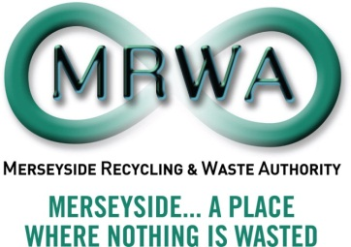

Freedom of Information / Environmental Information Requests

Disclosure Log 2012

No | Date | Type and Details of request | Source of request | Result of request | Response Date | Within 20 working day limit
1 | 27.01.12 | Freedom of Information request (via WhatdoTheyKnow.com) requesting information on servers, IT and IT contracts | Member of the public | Information supplied in full | Acknowledgement 27.01.12  Final response 14.02.12 | Yes
2 | 22.02.12 | Freedom of Information request – information on Marketing budgets and outsourcing of communications tasks | Marketing Agency | Information supplied in full | Acknowledgement 22.02.12  Final response 6.03.12 | Yes
3 | 27.04.12 | Freedom of Information request for information on private healthcare cost provide as part of remuneration | Media group | Information supplied | Acknowledgement 27.04.12  Final response 27.04.12 | Yes
4 | 7.06.12 | Freedom of Information request for information on the development of the Energos facility in Knowsley and the disposal of smoke alarms | Member of the public | Information supplied | Acknowledgement 7.06.12  Final response  7.06.12 | Yes
5 | 24.09.12 | Freedom of Information request for all information that the Authority’s holds in relation to the following reference- Langton Branch Dock Line , Cutting rear of Walton Prison to Ormskirk Railway Line, Merseyside | Member of the public | Information supplied | Initial response 24.09.12  Final response 24.09.12 | Yes
6 | 7.011.12 | Freedom of Information request for street cleansing data | Member of the public | Information supplied | Initial and final response 7.11.12 | Yes

