Community Fund
2012 /13

Application Form
FUND 1-Schools

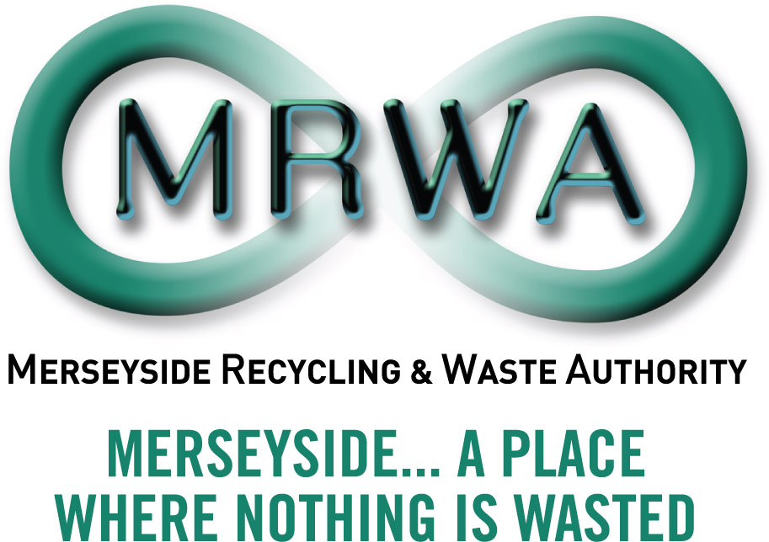

INTENTIONALLY LEFT BLANK

Introduction:

The Community Fund 2012/13 is a Merseyside Recycling and Waste Authority and Veolia Environmental Services (referred to throughout as ‘the funders’) initiative to improve and strengthen the position of the Merseyside Community and Voluntary Sector (CVS) in relation to waste management. It aims to support the local community on Merseyside in carrying out projects at the local level that involve waste issues This year the funding has been allocated in three parts.

This document concerns Fund 1 School applications only

Fund 1 is for school projects of £50 to £500. We have a total of £10,000 for school projects that demonstrate sustainable improvements for the school community. Application is on a first come first served basis, for projects which meet our Key Funding Priorities, until all of the funding is allocated for this financial year.

The kind of activity we want to support

The aim of Fund 1 is to support school projects which demonstrate waste prevention, reuse, recycling and carbon benefits. We are interested in projects that are new and have innovative approaches to sustainable waste management and that meet two or more of the following Key Fund Priorities which;

- Prevent the creation of waste

- Reduce the amount of waste generated and sent to landfill

- Increase the reuse of materials

- Increase recycling

- Reduce carbon emissions

Where possible be specific, identify measurable impacts and outcomes e.g.

  - The amount of any expected increase in re-use, recycling tonnage, savings etc
  - The amount of waste diverted from landfill
  - The number of people you will provide with knowledge or skills
  - Any expected savings in energy or water consumption
  - Any carbon reduction benefits

What we won’t pay for

- Day to day running or ongoing staffing costs
- Activities that start or happen before we confirm funding
- Material that is currently collected by the Local Authorities )

- Projects that mainly benefit an individual
- Activities with Political affiliation and aims
- VAT that you can recover

Intentionally Left Blank

For Office Use:
Ref No
Date
Boxes will expand
- Name of your School
Address
Merseyside District (please tick) |  | Knowsley | Liverpool | Sefton | St Helens | Wirral
Phone: |  | e-mail :
Fax: |  | Website:

- The Lead Person for the project
Position in school
Contact address if different to above
Phone

- How many young people are involved in your project in each of these age groups
3-5 years |  |  |  |  |  | 11-13 years
6-7 years |  |  |  |  |  | 14-16 years
8-10 years |  |  |  |  |  | 17-18 years
- How many adults are involved
School staff |  |  | Parents |  | Volunteers |  |  |  | Trainers /Experts

- Tell us what are you planning to do and when you will do it? Please use no more than 700 words.(the box will extend or include additional paper if needed)

- What will your project deliver?
- How will your project make a difference to your school / community?

- How will you tell people about your project please include what you will do before your project starts, during the project and after it is finished?

- How will your project continue after the funding is finished?

- How will the project be managed?

- Costs
Please tell us about all the costs for your project | Amount requested from MRWA schools fund  (Note min.£50 to a maximum of £500)
Please tell us about all the costs for your project | Total Cost of your project
Please tell us about all the costs for your project | Will you bring anything in addition?  e.g. other funding, in- kind support or volunteers

Declaration

- I am authorised to make this application on behalf of my school

- I confirm that the information contained in this application is correct

- I will abide by the Terms and Conditions of the funding offer

- I give permission for the funders to record details of my school electronically and to contact my school by phone, post or e-mail with information about other waste related activities and funding opportunities

- I will acknowledge the funding award in any communications materials , website, newsletters etc and agree that the funders can use the project for media information

- I agree to provide the funders with a report when the project is completed, or with a progress update by mid March 2013 followed by an end report six weeks after project completion

- I agree to return all money to the funders if, for any reason, the project does not take place or fails to be completed as agreed as soon as possible and by no later than the 15th March 2013

Acceptance must be shown by the Head Teacher or the designated lead teacher/officer signing the duplicate copies of this declaration on behalf of your school. Please retain one copy for your records and return the other to Chris O’Brien at the above address in order for monies to be released to you.

I confirm and agree to abide by all the terms and conditions of funding offer

Name …………………………………………………………………………………

School …………………………………………………………………………………

Position Held in School …………………………………………………………….

Project Title ………………………………………………………………………….

Date ……………………………………………………………………………………

Please return this application by e-mail to chris.obrien@meresysidewda.gov.uk

Intentionally Left Blank
Terms & Conditions
Please retain for your records.

If the funders make a funding offer it is subject to your agreement of the following terms and conditions;

- The funders do not accept responsibility for any maintenance/ loss/ damage/theft or injury that may occur in connection with the project or to any equipment.

- All receipts relating to project must be kept for one year from receipt of payment in case they are required by our auditors for accounting purposes.

- If for any reason the project does not go ahead you must return the funding together with a written explanation on why the project was unable to proceed as soon as possible and by no later than the 15th of March 2013.

- As with most grant awards the funders require you to tell us how you spent the funding and what difference it has made. You are required to provide a short end report on completion of your project with feedback from participants together with photographs (with relevant parental permission obtained). The report is required by mid March 2013 or by six weeks after the project is completed whichever first occurs.

- If your project will not be finished by then a progress report will also be required in mid March 2013.

NB. Future applications will not be considered if a progress report has not been received.

- Acknowledgement of the funders should be included in any project activity /communications/press releases / newsletters and media. A copy of the funders logo’s in electronic format will be provided with guidelines on usage. A quotation from the funders for use in media release will be supplied on request. We will use pictures, quotes and case studies on our website, newsletters and in stories.

- The funders would appreciate inclusion on your school website, blogs or other social media accounts.

- Your project will be used for news stories, on our website, in our annual plan and to encourage others to apply etc.

