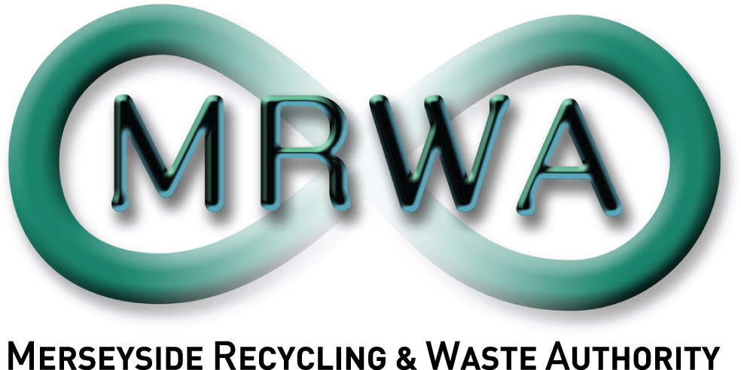
Reproduced from Ordnance Survey Mapping with the permission of the controller of Her Majesty’s Stationery Office © Crown Copyright.
Unauthorised reproduction infringes Crown Copyright and may lead to prosecution or civil proceedings. Merseyside Waste Disposal Authority LA07635X

Site Address: South Sefton Recycling Park, Irlam Road, Bootle, L20 4AE

South Sefton Household Waste Recycling Centre


