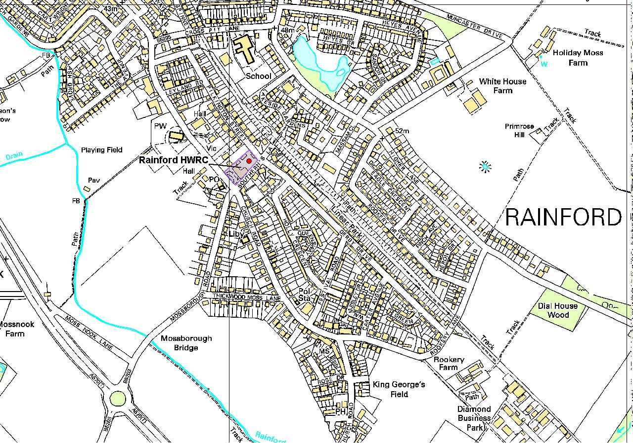
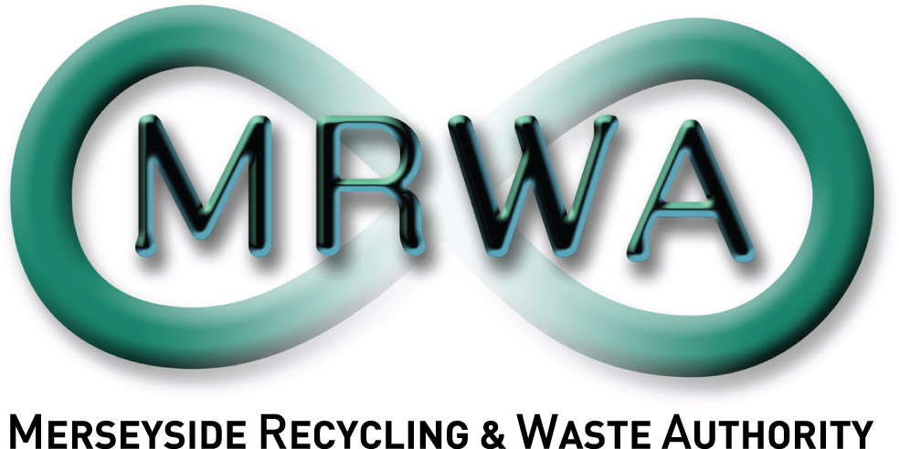
Site Address: Rainford HWRC, Southern’s Lane, Rainford, St Helens, WA11 8EY.

Rainford Household Waste Recycling Centre
Reproduced from Ordnance Survey Mapping with the permission of the controller of Her Majesty’s Stationery Office © Crown Copyright.
Unauthorised reproduction infringes Crown Copyright and may lead to prosecution or civil proceedings. Merseyside Waste Disposal Authority LA07635X

