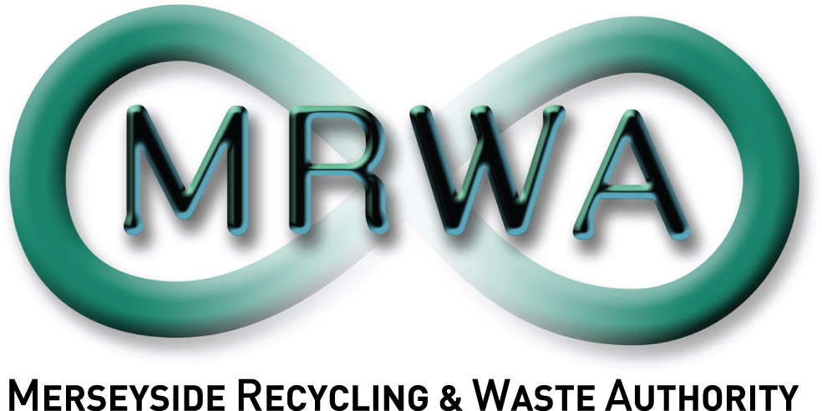
Bidston Moss Household Waste Recycling Centre
Site Address: Bidston, Wallasey Bridge Road, Wallasey, Wirral, CH41 1EB.

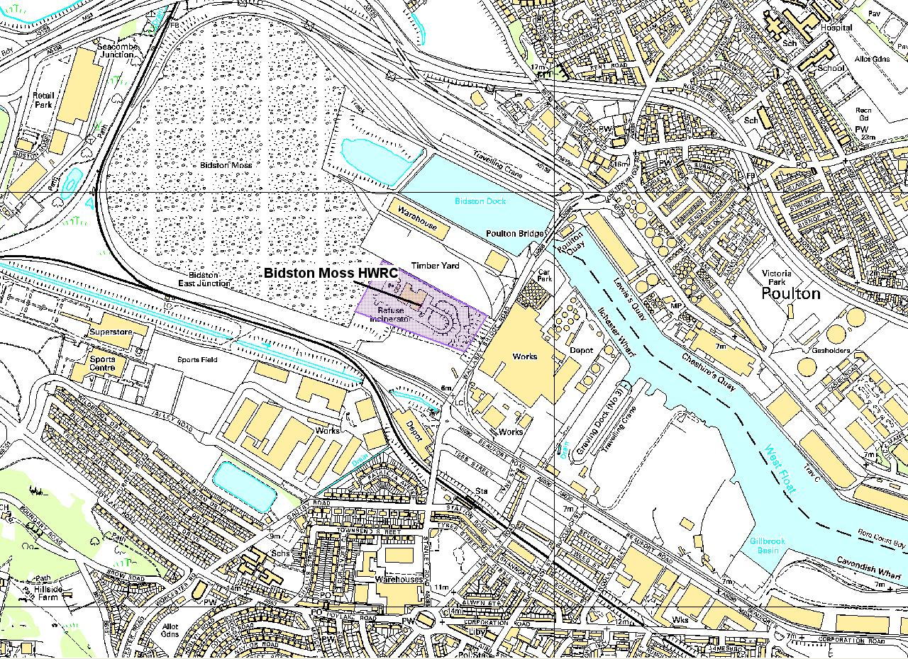
Reproduced from Ordnance Survey Mapping with the permission of the controller of Her Majesty’s Stationery Office © Crown Copyright.
Unauthorised reproduction infringes Crown Copyright and may lead to prosecution or civil proceedings. Merseyside Waste Disposal Authority LA07635X

