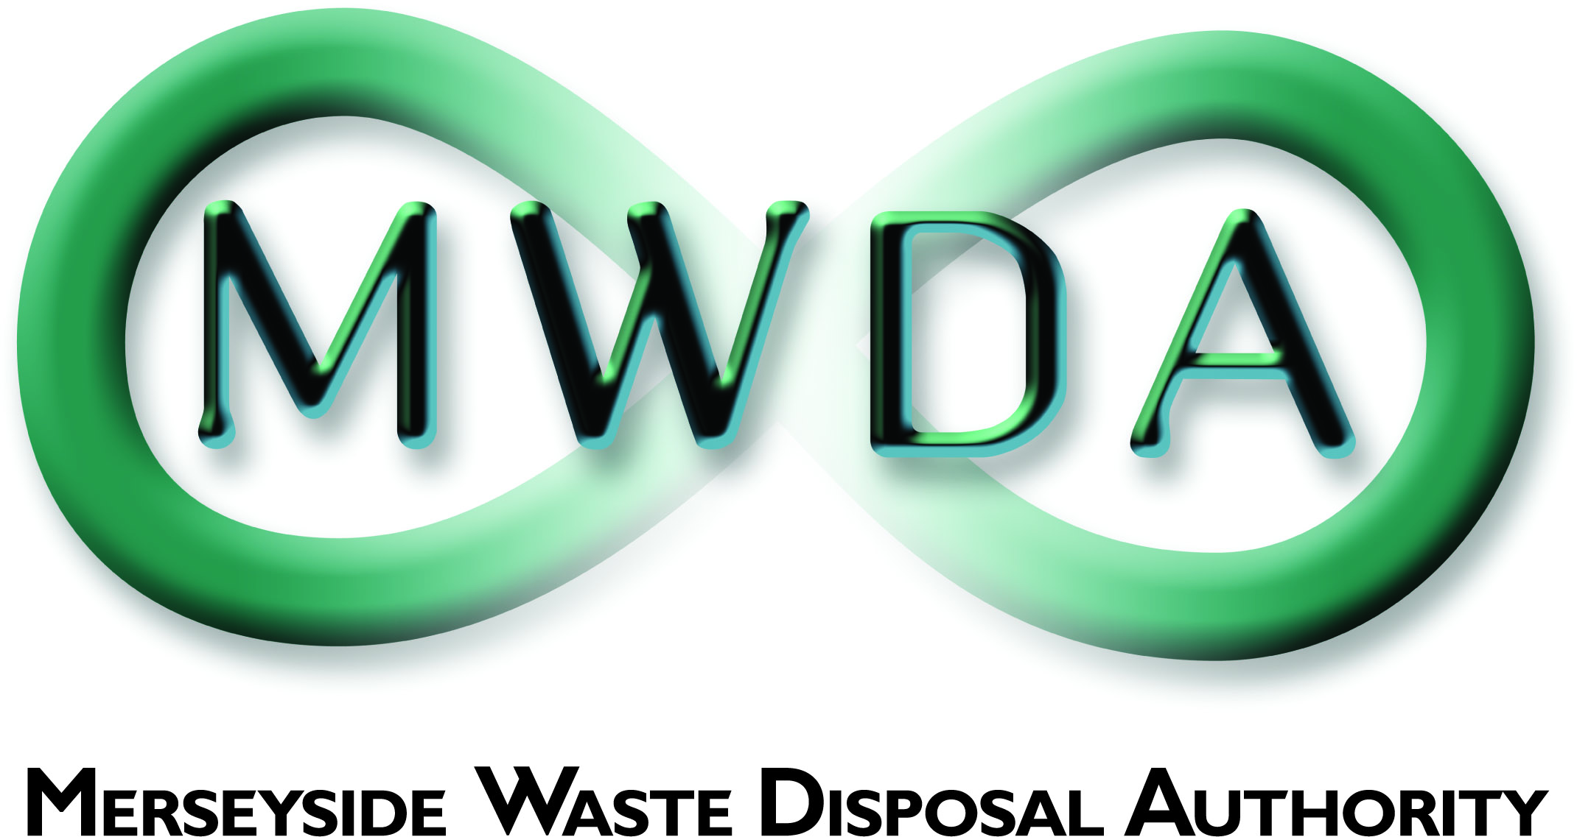
JOB DESCRIPTION
SECTION | Estates Management
JOB TITLE | Environmental Officer
GRADE | Scale 6 – SO1
SALARY RANGE | £24,799 - £28,785
LOCATION | Mann Island  Liverpool
PRIMARY PURPOSE OF THE JOB | To assist the Estates Manager in providing a planning, design, contract procurement, maintenance and monitoring service with particular regard to environmental monitoring of the Authority’s waste management facilities
DIRECTLY RESPONSIBLE TO | Environmental and Planning Officer
DIRECTLY RESPONSIBLE FOR | NA

PRINCIPAL DUTIES

1. Provide scientific and technical support, and undertake environmental monitoring and assessment service in respect of the Authority's waste management facilities.

2. Maintain database records and compile reports to support systems/function provided by the Estates Management Section.

3. Assist in the preparation of environmental monitoring programmes for the Authority’s waste management facilities.

4. Assist in the preparation of designs and specifications and supervision of works particularly with regard to environmental monitoring, maintenance or control works.

5. Assist in the procurement of goods and services relating to the Authority’s waste management facilities and environmental monitoring infrastructure and equipment.

OTHER DUTIES

- To comply with the requirements of the Authority’s accredited ISO 14001: 2015 Environmental Management System for activities associated with the monitoring and maintenance of its waste management facilities and associated office activities.

- Keep abreast of legislation pertaining to the functions of the post.

- To maintain personal and professional development to meet the changing demands of the post, and participate in appropriate training activities.

- Any other duties consistent with the level of responsibility of the post which may arise given the variable nature of the Section's functions.

A full valid driving licence is essential for this role

General Statement

The above duties do not include or define all tasks that may be required by the post holder. The duties may vary without changing the general character of the duties or the level of responsibility entailed. These factors are reflected in the grading of the post.

Health and Safety at Work

The Health and Safety at Work Act stipulates that it is the responsibility of every employee to observe all rules governing health and safety and such safety equipment as provided must be used.

Equal Opportunities

The Waste Disposal Authority is an Equal Opportunities Employer and has equal opportunities policies with which you are expected to comply at all times. The Authority condemns all forms of harassment and is actively seeking to promote a workplace where employees are treated with dignity, respect and without bias.

Sustainable Procurement

To effectively requisition goods and services in line with the Authority’s Sustainable Procurement Policy

 | Date | Name | Post Title
Revised | 25th April 2019 | Tony Byers | Estates Manager

