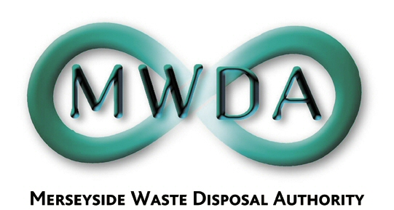

Applications for the following position are invited from suitably qualified candidates: -

ENVIRONMENTAL OFFICER
Post Ref: - EO
Salary: £24,799 – £28,785

Merseyside Waste Disposal Authority wishes to recruit an Environmental Officer to undertake environmental monitoring at its waste management facilities. The role entails working outdoors as part of a small team, collecting data and samples, along with analysis and reporting.

Applications are sought from suitably qualified candidates with a relevant environmental qualification or experience in the field of environmental monitoring.

A full valid driving licence is essential for this role.

Application packs are available from: -

Merseyside Waste Disposal Authority
7th Floor, No1 Mann Island
Liverpool
L3 1BP

Tel (0151) 255 1444
Fax (0151) 227 1848
Email enquiries@merseysidewda.gov.uk

Closing date for the return of completed application forms is 26th May 2019

Please note CV only applications will not be accepted.

Merseyside Waste Disposal Authority is an equal opportunities employer.

